Weekly Iraq .Xplored report
02 March 2019

Prepared by Risk Analysis Team, Iraq

garda.com

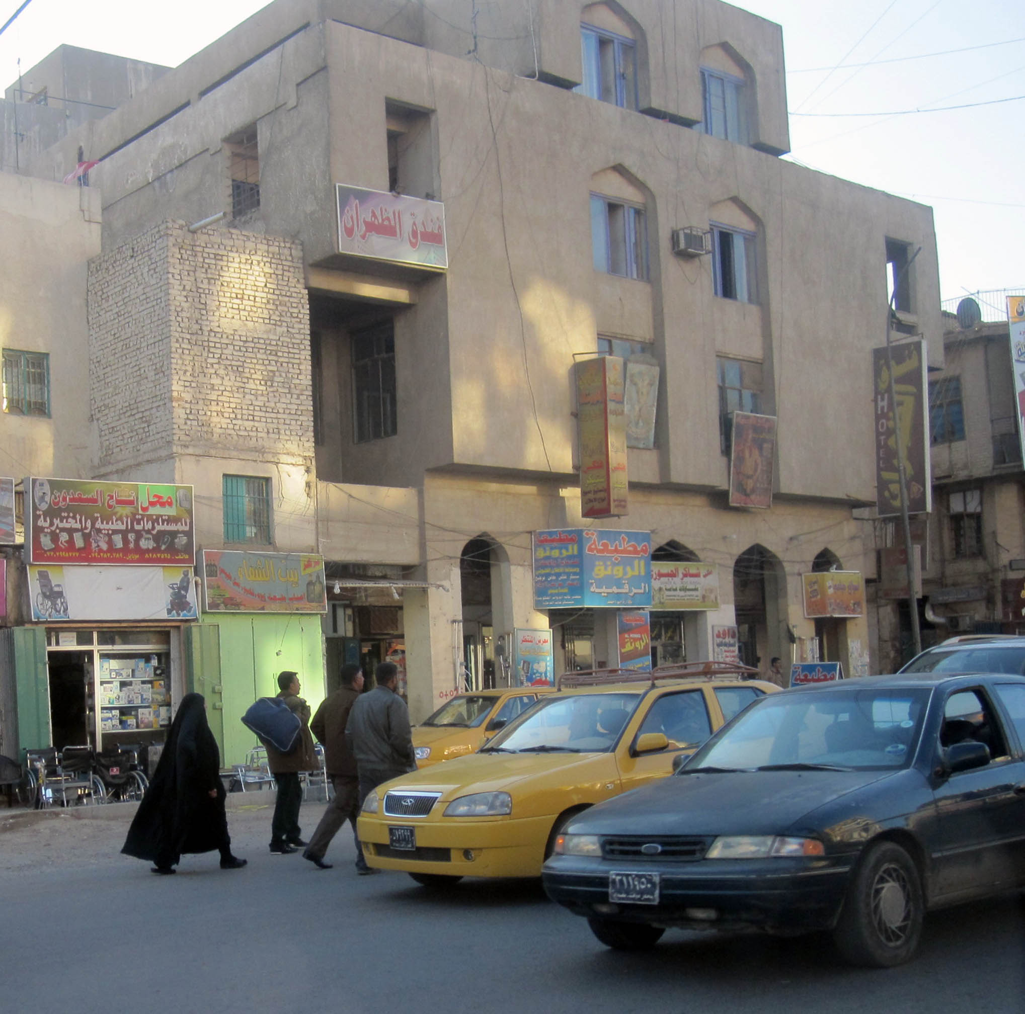

TABLE OF CONTENTS

TABLE OF CONTENTS 2
Activity Map 3
OUTLOOK 4

Short term outlook 4

Medium to long term outlook 4
Significant events 5

No progress on cabinet positions despite rumours 5

President of Iran to visit Baghdad on March 11 5

Iranian Foreign Minister returns to position after offering resignation 5
THREAT MATRIX 5
OVERVIEW 6

Political & Security 6
WEEKLY OPERATIONAL ASSESSMENT 7

Countrywide Military/Security Situation 7
ACRONYM LIST 12
GARDAWORLD INFORMATION SERVICES 13
GARDAWORLD 13

This report is an abridged version of GardaWorld Weekly Iraq .Xplored February 09, 2019. To subscribe to the full versions of the daily/weekly Iraq .Xplored reports, or for enquires relating to other GardaWorld services, please contact daniel.matthews@garda.com

Disclaimer: The information and opinions expressed in this Report are the views of GardaWorld and constitute a judgment as at the date of the Report and are subject to change without notice. The information and opinions expressed in this Report have been formed in good faith on the basis of the best information and intelligence available at the time of writing, but no representation or warranty, express or implied, is made as to its accuracy, completeness or correctness. GardaWorld accepts no liability arising out of or in connection with the comments made or the information set out in this Report and the reader is advised that any decision taken to act or not to act in reliance on this Report is taken solely at the reader’s own risk. In particular, the comments in this Report should not be construed as advice, legal or otherwise.

Activity Map

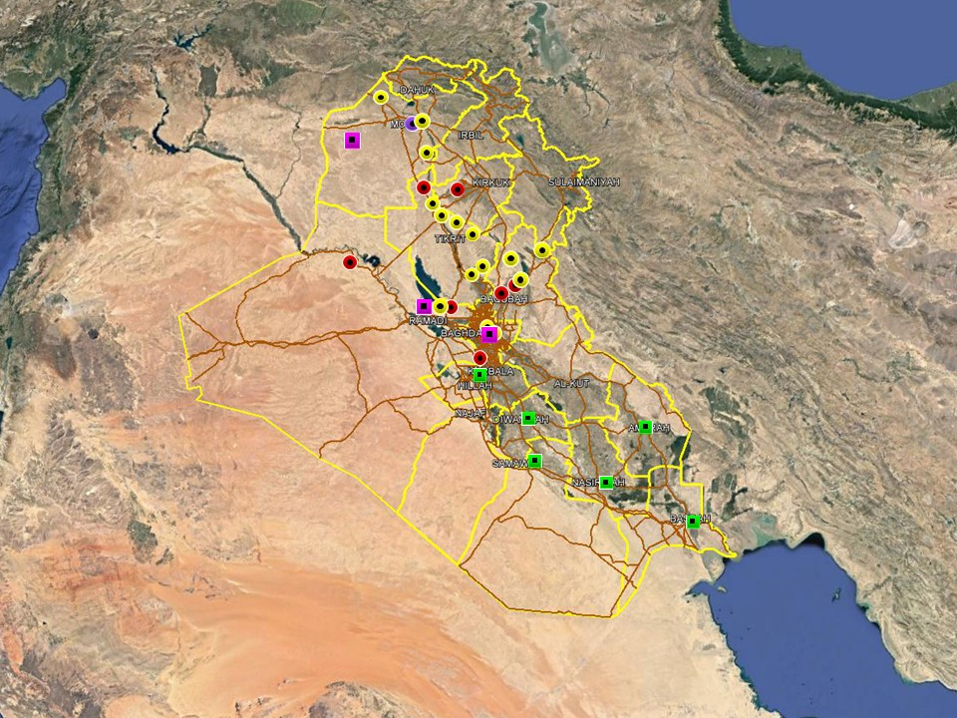

OUTLOOK

Short term outlook

- Hostile rhetoric towards the US from pro-Iranian and hardline Shia factions underline heightened anti-US sentiments following President Trump’s comment about continued US troop presence to counter Iran. This is not unprecedented however and is unlikely to affect commercial operations on the ground. The GoI’s response also highlight that US-Iraqi relations remain driven by pragmatic recognition of the necessity of continued western military and commercial support which is unlikely to change.

- PM Mahdi’s office announced that parts of the International Zone will soon be open for public access for 24hrs each day, without specifying a date. The protest by families of ISF ‘martyrs’ on January 23, saw the crowd pass through ECP 5 to the south of the International Zone (IZ) but were halted before entering the IZ proper. Although the IZ was not breached, this event serves as a reminder that the drawing down of some physical security measures around the IZ may embolden demonstrators to attempt to march into the IZ during future protests.

- Political tensions remain high in Basra following a number of protests in Basra City. On January 18, 2019, the latest in a series of demonstrations calling for the dismissal of the Governor was dispersed by ISF using tear gas. Further protest activity, with an associated risk of violence, can be expected in Basra City in the short term as long as political tensions remain high.

- IS activity is expected to remain high in the northern provinces, including Nineveh, Kirkuk and Diyala province, especially in the rural areas. The group is likely to continue its asymmetric campaign through hit and run attacks, targeted assassination and terrorism to challenge ISF control in these areas. While the group is assessed to retain intent to stage attacks in Baghdad and the southern provinces, its capability in restricted as evidenced by a continuing decline in high-profile attacks in these areas.

- Political focus now remains on the four Cabinet of Minister positions that remain unresolved, including those of the Defence and Interior Ministers. Opposition from Moqtada Al-Sadr’s Sairoun alliance to the selection of partisan figures for the remaining posts means that there is an associated risk of demonstrations as tensions remain high, especially in Baghdad.

Medium to long term outlook

- Sectarian violence can be expected to continue in areas of Northern Iraq which remain permissive to IS operations, including Nineveh, Salah al-Din, Diyala and southwestern Kirkuk. Attacks will continue to target security checkpoints and outpost, especially in Sunni dominated areas controlled by Shia dominated security forces.

- Islamic State activity will continue to dominate security reporting with focus on the potential resurgence of an insurgent campaign in northern and western Iraq. Despite ongoing ISF efforts to clear remaining IS pockets, the group retains a degree of freedom of movement in the desert regions of Anbar, near the Syrian border, and along the Hamrin Mountains.

- Low-level incidents related to criminality, personal disputes and tribal tensions are likely to continue in Basra and the southern region. Long-term tensions are also expected to be driven by the return of militia factions expecting material and social rewards for their contribution in the campaign against IS.

Significant events

No progress on cabinet positions despite rumours
Ongoing negotiations between al-Fatah and Sairun Alliance have yet to resolve the deadlock over the remaining cabinet positions. Despite continuing negotiations, the process of completing the cabinet remains slow and apart from rumours and occasional statements by low-level MPs from the two sides, there have been no concrete indications that Ameri or Sadr are willing to compromise on their respective positions, especially when it comes to the Minister of Interior.

President of Iran to visit Baghdad on March 11
Iranian news outlets confirmed that President Hassan Rouhani will visit Baghdad on March 11, following days of unconfirmed but widespread reports that the visit would take place sometime in March. Most observers believe that the visit will primarily focus on trade relations in an effort to resist US pressure on Iraq to comply with the sanction’s regime.

Iranian Foreign Minister returns to position after offering resignation
Iran’s Foreign Minister Javad Zarif returned to his position and resumed duties after announcing his resignation earlier in the week. According to Iranian state media, the resignation was rejected by President Rouhani who reportedly said it would be ‘against the country’s national interests.’

THREAT MATRIX

Region | Political | Terrorism | Militancy | Crime | K&R
KRG* | Moderate | Low | Moderate | Low | Low
North** | Moderate | High-Extreme | High | High | High
Baghdad | Moderate | Moderate | Moderate | Moderate | Moderate
Anbar | Moderate | High | High | High | High
South*** | Moderate | Low | Moderate | Moderate | Moderate
Threat Scale | Minimal | Low | Moderate | High | Extreme

* KRG – Dohuk, Erbil & Sulaymaniyah
** North – Nineveh, Salah ad-Din, Kirkuk & Diyala
*** South – Babil, Wasit, Karbala, Najaf, Diwaniyah, Dhi Qar, Muthanna, Maysan & Basra

OVERVIEW

Political & Security

No progress on cabinet positions despite rumours
Ongoing negotiations between al-Fatah and Sairun Alliance have yet to resolve the deadlock over the remaining cabinet positions, with Sairun MP Mudhar Khazal al-Ezairjawi saying the two sides still haven’t agreed on any new candidates. Al-Ezairjawi said both sides agree on the need to find a speedy resolution and that meetings continue in the joint committees set up in accordance with their previous agreement however no new nominations have been submitted. The statement appears to contradict comments from another Sairun MP, Mohammed Ghazee, who earlier in the week claimed the two alliances agreed to put forward two new names for the position of Interior Minister and Defence Minister.

President of Iran to visit Baghdad on March 11
Iranian news outlets confirmed that President Hassan Rouhani will visit Baghdad on March 11, following days of unconfirmed but widespread reports that the visit would take place sometime in March. Most observers believe that the visit will primarily focus on trade relations in an effort to resist US pressure on Iraq to comply with the sanction’s regime. This follows high-level by Foreign Minister Javad Zarif to Baghdad in February and President Barham Salih’s visit to Tehran in December 2018. Separately, Iran’s commercial attaché to Baghdad Nasser Behzad announced a 45% increase in the export of non-oil commodities to Iraq over the previous year, adding that Tehran plans to increase exports even further over the coming year. According to the statistics presented by Behzad, 38% of Iranian products exported to Iraq between March 2018 and February 2019 came via the KRG Region. Behzad also disclosed a fourfold growth in organizing exhibitions for introducing Iranian products in Iraq and said that “57 percent of Iranian products are exported to three countries namely: Iraq, China and the United Arab Emirates.”

Iranian Foreign Minister returns to position after offering resignation
Iran’s Foreign Minister Javad Zarif returned to his position and resumed duties after announcing his resignation earlier in the week. According to Iranian state media, the resignation was rejected by President Rouhani who reportedly said it would be ‘against the country’s national interests.’ In a statement, Zarif thanked ‘the Iranian nation and government officials’ for their show of support in the wake of his initial announcement and pledged to continue to protect the national interests of the country. Earlier in the week, Zarif announced his resignation in a statement on social media which thanked the people of Iran and apologized for his ‘inability to continue serving’. Further clarifying his decision to resign, Zarif reportedly said he hoped it would allow the Ministry to ‘restore its proper statutory role’, amidst reports that he has become increasingly frustrated with individuals and organs outside the Ministry who are interfering on foreign policy issues. However, some 135 Iranian MPs reportedly submitted a letter requesting Zarif’s return to the post. Unconfirmed reports claimed Supreme Leader Ayatollah Khamenei also opposed Zarif’s resignation which, if true, was likely a more important reason for Zarif’s return. Quds Force Commander Qassem Soleimani also backed Zarif as ‘the main official responsible for foreign policy’ and reiterated his continuing support alongside other senior security officials.

President Salih met with Saudi King Salman in Egypt
Early in the week, President Barham Salih met with Saudi King Salman on the sidelines of the Arab-European Summit in Sharm el-Sheikh where leaders of the EU and Arab League met to discuss ways to enhance cooperation. The meeting was largely protocol but Salih stressed Iraq’s keenness to enhance cooperation and pursue a ‘policy of openness’ with all its neighbours in the interest of furthering peace and stability in the region. For his part, Salman expressed Saudi Arabia’s willingness to expand cooperation with Iraq in a number of fields.

WEEKLY OPERATIONAL ASSESSMENT

Countrywide Military/Security Situation

Northern Provinces
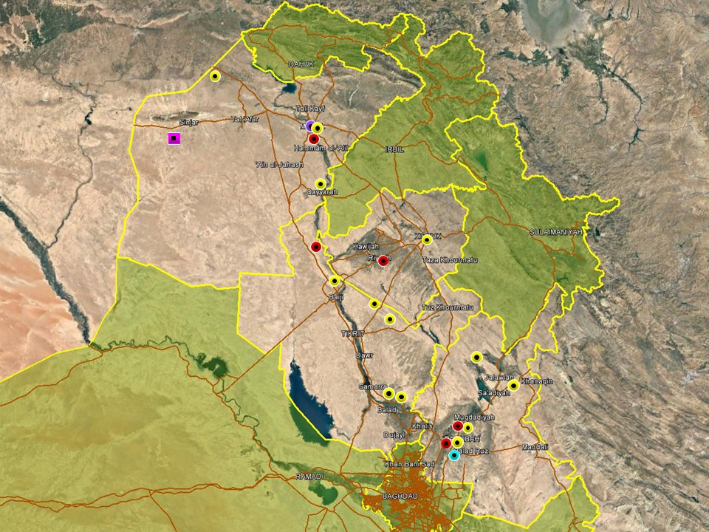

The most significant incident in the northern region this week took place in Mosul City where a VBIED detonated near Mosul University on February 28, killing four civilians and injuring another 26 according to casualty figures reported by national media. The follows a relative absence of high-impact attacks in Mosul City in recent months but corroborates the assessment that militants retain capability to penetrate the city. A number of IS-related incidents and developments were noted in the surrounding districts as well this week: on the same day, four PMU members were separately wounded when an IED detonated in Hadra district, southwest of the provincial capital. Earlier in the week, suspected IS militants shot and killed a civilian and abducted another in al-Milawtha area of west Mosul and later in the week PMU forces reportedly repulsed an IS infiltration attempt in Hazar area. These developments correlate with a reported increase in IS cross-border infiltration attempts from Syria in western Nineveh in recent months, which raises the outlook of a general increase in IS activity thereby posing a long-term security challenge for the province. A Peshmerga commander, speaking with a Kurdish media outlet, warned this week about the return of an increasing number of IS members from the Syrian border who are relocating to Sinjar district and other rural areas of the province.

A general decline in recorded incidents was noted in Kirkuk province this week, with no significant developments noted. IS militants were reportedly behind the demolition with IEDs of four houses in Hawijah district belonging to security elements, including PMU-affiliated Sunni tribal fighters. The houses were empty at the time of the detonations and no casualties were reported. Meanwhile, Major General Saad Harbia, clarified this week that the main Federal security forces in the province, including Counter-terrorism Service, Federal Police, 61st Army Division and Sunni tribal factions of the PMUs will fall under his command as part of the newly set up Kirkuk Joint Operations Command Centre. The purpose of the new command centre is to enhance the coordination of the security effort in the province.

In Salah al-Din, an increase in IS activity was noted in the northern areas of the province, including three separate assaults near oil concessions and infrastructure reported during the week. PMU and OPF were reported to have repulsed separate attacks on Ajil and Alas oilfield on February 26 and 27 respectively, with casualties reported on both sides but few further details released. An IS assault was also reported on February 25 near Baiji refinery, initially claiming that ISF repulsed the attack following clashes lasting three hours. The initial report cited Qandil al-Jibouri, Salah al-Din police commander, however in a subsequent statement security officials denied that an attack took place and said ‘shots were fired by mistake.’ The incident was widely reported and the initial statement by the police commander adds credibility to the report. Elsewhere, ISF and PMU repulsed separate infiltration attempts in Balad district, southeastern Salah al-Din, where local security officials have expressed concerns about increased IS activity recently.

No significant changes were noted this period in Diyala province where hostilities remain high, driven by a mix of IS activity, sectarian violence and local disputes. Insurgent cells continue to launch attacks in the northern areas, around Khanaqin and Lake Hamrin, targeting civilians and security forces in an ongoing effort to undermine the security situation. Multiple incidents were also recorded in the Diyala River Valley between Baqubah and Muqdadiyah, involving SAF and IED targeting the local population. In response, ISF carried out security operations in Abu Saida district while airstrikes reportedly targeted IS hideouts in al-Waqif basin. Further south, two civilians were reportedly killed, and four others wounded when mortar shells impacted outside Buhriz district, south of Baqubah. IDF is relatively unusual in the area however IS sympathisers are known to retain a presence in the area around Baqubah.

Anbar Province
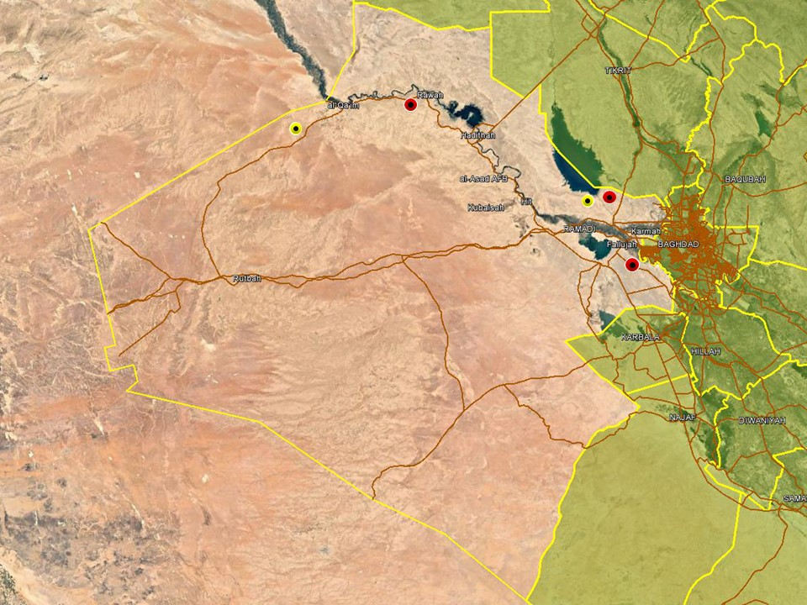

Five fishermen were reportedly killed by IS militants in the vicinity of Lake Tharthar on February 23, according to local media reports which claim the victims were from Najaf province. In addition, three PMU members were wounded when gunmen opened fire during the subsequent evacuation of the bodies. A member of the Anbar Security Committee in the provincial council said IS were behind both incidents. A few days later, three PMU members were injured when a roadside IED detonated near their vehicle in the same district, prompting the 7th and 27th PMU Bd to launch a security operation near the lake to track down IS sleeper cells in the region north of Ramadi. A subsequent statement claimed several IS militants had been arrested. Further west, ISF foiled multiple infiltration attempts during the week by IS militants to enter Iraq from across the Syrian border, arresting an unspecified number of IS members according to a statement issued by ISF. PMU forces affiliated with the al-Abbas Combat division commenced a large-scale security operation in Nukhaib towards the Saudi/Iraq border. In a subsequent statement released later on February 25, they announced that more than 500 kilometres of desert had been secured. This comes in response to the kidnapping and killing of six civilians picking truffles in the area last week.

Capital Region (Including Baghdad City)

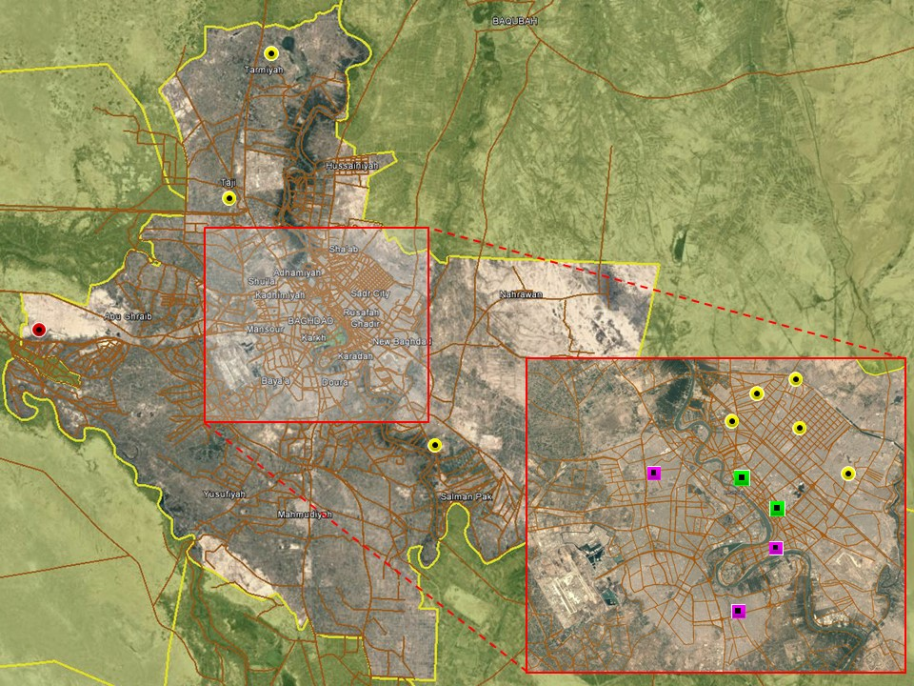

There were no significant security developments noted in Baghdad City this week, with hostile activity as usual confined to less affluent areas in the eastern areas of the capital. As such, low-level SAF was recorded in New Baghdad, Adhamiyah and Sadr City, likely related to local disputes and intra-Shia tensions rather than IS terrorism. ISF released several victims of kidnappings in separate raids during the week, including in the districts of Karada, Mansour and Doura. Arrest operations targeting criminality dominated reporting trends as usual, the vast majority of which concerned minor criminality and arrests under article IV terrorism. Minor protests were also reported during the week, predominantly in the central districts of Karadah, Rusafah and Karkh over local grievances. In the beginning of the week, the PMU Security Directorate announced the closure of another fraudulent HQ and arrested several individuals impersonating PMUs in Jadiriyah area of Karada.

Another, relatively calm reporting period was noted in the provincial areas this week with few hostile incidents recorded. As usual, violence was confined to typically violent areas: one civilian was shot and killed on February 25 in Taji district while another civilian was killed by gunmen in Nahrawan district, east of Baghdad. In the west, a roadside IED also detonated in al-Nuaimiyah area, killing three civilians and wounding another three along the Baghdad/Anbar provincial boundary.

Southern Provinces

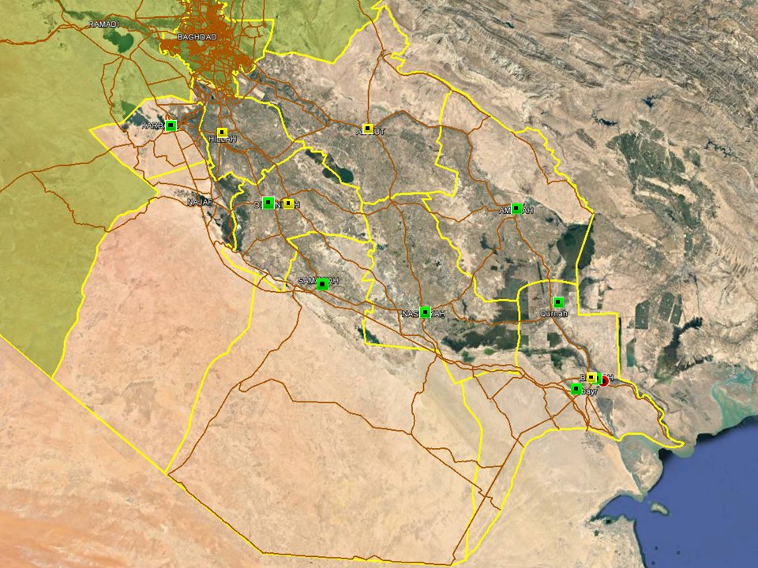

In terms of recorded violence, a very calm reporting period was noted in the southern provinces with few incidents reported. In Jurf al-Sakhar, two PMU members were injured when a roadside IED detonated near their vehicle, underlining the continued presence of Sunni-insurgent sympathisers in the district. ISF launched a reconnaissance operation in the southwestern desert areas of the province to enhance security measures along the border with Anbar province. Overall reporting was otherwise characterised by local protests and arrest operations targeting criminality, with no significant developments noted in the region as a whole. Protest activity continues to be subdued overall and related to local grievances.

In Basra, an IED detonated outside a civilian residence in Bara City, causing material damage but no casualties, on February 28. Hostilities in the province were otherwise subdued and daily reporting trends characterised by local protest activity, ususally involving no more than dozens. Demonstrators gathered outside the provincial council as usual on Friday afternoon, demanding employment opportunities and improvements in local services but the vast majority of demonstrations were driven by local grievances. This also applied for the provincial areas. A protest march was also reported between Zubayr and Burgesiya by dozens of civilians demanding jobs; ISF blocked the road as protesters attempted to march towards the Mirbad gate. In Qurna district, north of Basra City, farmers also staged a protest demanding assistance to save their crops from inundation.

ACRONYM LIST

AII - Area of Intelligence Interest
AKA - Also Known As
AO - Area of Operations
APC - Armored Personnel Carrier
APIED - Anti-Personnel IED
AQ - Al-Qaeda
AT - Anti-Tank
ATGW - Anti Tank Guided Weapon
AVIED - Anti-Vehicle IED
BBIED - Body Borne IED
Bde - Brigade
Bn - Battalion
BXP - Border Crossing Point
CET - Convoy Escort Team
CLC - Concerned Local Citizens
CoP - Chief of Police
CP - Check Point
C-PERS - Captured Personnel
CPX - Complex Attack (attack using multiple weapon systems)
CQA - Close Quarter Assassination/Attack
DBS - Drive by Shooting
Div - Division
DoD - Department of Defense
DoS - Department of State
DoS - US Department of State
ECP - Entry Control Point
EFP - Explosively Formed Projectile
EOD - Explosive Ordinance Disposal (Bomb Squad)
ERW - Explosive Remnants of War
FoM - Freedom of Movement
GoI - Government of Iraq
HCN - Host Country National
HG - Hand Grenade
HME - Home Made Explosive
HMG - Heavy Machine Gun
HVT - High Value Target
IC - International Community
IDF - Indirect Fire (i.e.: rockets, mortars)
IDP - Internally Displaced Persons
IEC - Independent Electoral Commission
IED - Improvised Explosive Device
IM - International Military
IOC - International Oil Company
IRAM - Improvised Rocket Assisted Mortar
IRL - Improvised Rocket Launcher
IS - Islamic State
IVCP - Illegal Vehicle Check Point
IVO - In Vicinity Of
IZ - International Zone
KIA - Killed in Action
LN - Local National/Iraqi Civilian
MAIED - Magnetically attached IED (aka UVIED)
MIA - Missing in Action
MoD - Ministry of Defense
MoF - Ministry of Finance
MoFA - Ministry of Foreign Affairs
MoHE - Ministry of Higher Education
MoI - Ministry of Interior
MoJ - Ministry of Justice

MoO - Ministry of Oil
MoT - Ministry of Transportation
MSR - Main Supply Route
NFDK - No Further Details Known
NGO - Non-Governmental Organization (aid/charity)
NSTR - Nothing Significant To Report
OCG - Organized Crime Group
OPF - Oil Protection Force
PAX - Person, Persons or Passenger
PBIED - Person-Borne Improvised Explosive Device (UN Term)
PMF – Popular Mobilisation Forces
PoI - Point of Impact (for IDF)
PoO - Point of Origin (for IDF)
PSAF - Precision Small Arms Fire
PSC - Private Security Company
PSD - Private Security Detail
RCIED - Remote-Controlled IED
RPG - Rocket Propelled Grenade
RTA - Road Traffic Accident
SAF - Small Arms Fire
SAFIRE - Surface to Air FIRE
SF - Special Forces
SVBIED - Suicide Vehicle Borne IED
SVEST - Suicide Explosive Worn Vest
TCN - Third Country National
TCP - Traffic Control Point
Technical - An improvised weapon-mounted pick-up truck
TTP - Tactics, Techniques and Practices
UVIED - Under Vehicle IED
UXO - Unexploded Ordnance
VBIED - Vehicle Borne IED
VCP - Vehicle Checkpoint
WIA - Wounded in Action

GARDAWORLD INFORMATION SERVICES

From our management offices and field offices in strategic locations our constant monitoring of the high-risk environments in which we work is conveyed through our range of .Xplored™ risk analysis reports. The reports contain detailed updates, delivering current and relevant ground-truth information to assist both our personnel and our clients in their decision-making.

Our wider risk management solutions provide members of the defense, diplomatic, development, oil & gas and infrastructure sectors operating in potentially high-risk and complex environments with a comprehensive range of risk analysis, intelligence, crisis response, and training services. These services are designed to provide clients with the proactive capability to remain aware in potentially hostile environments and identify risks while strengthening their reactive capacity in emergency situations.

Our current regular reporting geographies include: Nigeria, Mali, Libya, Iraq, Afghanistan and Yemen on a daily, weekly, fortnightly, and monthly basis.

Through our constant monitoring and predictive threat analysis our Information Services team help you plan for, manage, and respond to risks.

For more information on our .Xplored reports or for information about our special-to-task reports tailored to individual client requirements, please contact us: informationops@garda.com or contact our regional representative iraq.ram@garda.com (Mobile: +964 7823 783 972)

For more information on how our services can support your business in Iraq contact:
Daniel Matthews, Senior Director Iraq daniel.matthews@garda.com

GARDAWORLD

A global leader in comprehensive security and risk management

GardaWorld International Protective Services is the international security division of GardaWorld Security Corporation, the world's largest privately owned security company with over 62,000 global staff.

We support clients in emerging, complex and high-risk markets around the world with static security, security consulting, risk analysis and reporting, crisis management and business continuity, mobile security, close protection, training and kidnap for ransom and extortion response solutions.

We work across multiple business sectors to provide protection and security for clients in the extractives, aerospace and defense, critical infrastructure, government and diplomatic and development sectors to secure employees, assets, and reputation so clients can focus solely on running daily operations and growing their business.

Discover more about the markets we serve and to learn how our international security solutions can help you contact us today: gwinfo@garda.com

Middle East
International Protective Services Headquarters
Office 2502, Tower 2, Currency House
DIFC, PO Box 482069
Dubai, United Arab Emirates

United States
1101 Wilson Boulevard
Suite 1725
Arlington, VA, 22209
United States

UK
5th Floor
1, London Bridge
London
SE1 9BG

Europe
37-39 rue des Deux Eglises
1000 Brussels
Belgium

garda.com

