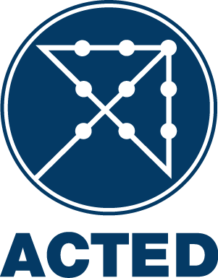

INTERNATIONAL CALL FOR TENDER
T/Trucking-Services/Erbil/18-02-2014/001

ACTED (Agency for Technical Cooperation and Development), implementing the project Multiple Projects Apply under Various donors funding is inviting suppliers to submit offers for each batch for the following Trucking services in Kurdistan for a period up to 6 months, at fixed price , Iraq :

The aim is to sign a framework agreement for a period up to six months for trucking services in Kurdistan for the different ACTED projects.
- All combinations of trips in the tables below, for trucks of 2 metric ton, 4 metric ton, 6 metric ton with a crane, 6 metric ton, 12 metric ton and 20 metric ton. All prices should be mentionned for all combinations and all trucks (please see the detailed destinations and the Instructions to bidders).
- To be able to cover other potential locations, bidders should also give a price per kilometre for the 6 different types of trucks mentionned below (2 metric ton, 4 metric ton, 6 metric ton with a crane, 6 metric ton, 12 metric ton and 20 metric ton). This rate will be mentionned in the framework agreement and trips not included in the tables below will be charged based on the kilometre rate times the distance of the trips.

The tender will be conducted using ACTED standard bidding documents, open to all qualified suppliers and service providers. The Bidding Documents (in English) may be collected free of charge by all interested bidders at the following address(es):
ACTED representative office in Erbil ; 6th Street at the right after Ainkawa chekpoint, House number 240/1/71/, Ainkawa, Erbil, Kurdistan, Iraq

A pre-tender information session will be organized on 20/02/2014 at 12:00 pm in ACTED representative office in Erbil, 6th Street at the right after Ainkawa chekpoint, House number 240/1/71/, Ainkawa, Erbil, Kurdistan, Iraq. Participation of interested bidders to the information session is preferable but not compulsory.

All bids must be submitted before on 28/02/2014 at 12:30 pm at the address(es) mentioned above in a sealed envelope or by E-mail at iraq.tender@acted.org, Cc tender@acted.org. Late Bids will be automatically rejected.

ACTED will not be responsible for any costs or expenses incurred by the Bidders in connection with the preparation and submission of their bids to ACTED.

A tender opening session will take place on 28/02/2014 at 12:30 pm in the ACTED representative office in Erbil ; 6th Street at the right after Ainkawa chekpoint, House number 240/1/71/, Ainkawa, Erbil, Kurdistan, Iraq. The presence of bidders’ representative is allowed. For all inquiries regarding this tender, please contact the ACTED representative office in Erbil not later than 27/02/2014 at 17:00H, by E-mail at iraq.tender@acted.org, Cc tender@acted.org.

