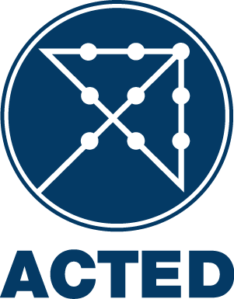
Translation Services

NATIONAL CALL FOR TENDER
T/Translation Services/Erbil/01-05-2014/002

ACTED (Agency for Technical Cooperation and Development), implementing the project Translation Services under Various donors funding is inviting suppliers to submit offers for each batch for the following services for a duration of one year to establish a framework agreement :

No. | Item Specifications & product stage | Packaging | Measuring Unit | Quantity
1 | Translation Services | Typegraphed translated document with stamp and signature to certify the translation. No hand-written translation will be accepted. | One Sided A4/Letter Page | 1
2 | Translation Services: For sizes different then A4, the multiple of A4 will apply. For Example, A3 will be twice the price of A4, A5 half the price of A4. | Typegraphed translated document with stamp and signature to certify the translation. No hand-written translation will be accepted. | Any Other Size than A4 | 1

The tender will be conducted using ACTED standard bidding documents, open to all qualified suppliers and service providers. The Bidding Documents (in English) may be collected free of charge by all interested bidders at the following address(es):
- ACTED representative office in Erbil ; 6th Street at the right after Ainkawa chekpoint, House number 240/1/71/, Ainkawa, Erbil, Kurdistan, Iraq or at www.acted.org under the section “Tenders”.

- A pre-tender information session will be organized on 06/05/2014 at 12:00H in ACTED representative office in Erbil; 6th Street at the right after Ainkawa chekpoint, House number 240/1/71/, Ainkawa, Erbil, Kurdistan, Iraq.
Participation of interested bidders to the information session is preferable but not compulsory.

All bids must be submitted before on 13/05/2014 at 12:30H at the address(es) mentioned above in a sealed envelope or by E-mail at iraq.tender@acted.org, Cc tender@acted.org. Late Bids will be automatically rejected.

ACTED will not be responsible for any costs or expenses incurred by the Bidders in connection with the preparation and submission of their bids to ACTED.

A tender opening session will take place on 13/05/2014 at 12:30H in the ACTED representative office in Erbil ; 6th Street at the right after Ainkawa chekpoint, House number 240/1/71/, Ainkawa, Erbil, Kurdistan, Iraq. The presence of bidders’ representative is allowed. For all inquiries regarding this tender, please contact the ACTED representative office in Erbil not later than 12/05/2014 at 17:00H, by E-mail at iraq.tender@acted.org, Cc tender@acted.org.

