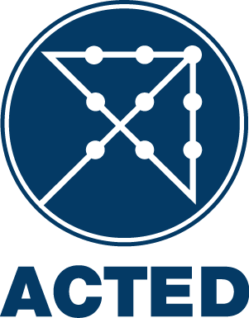

NATIONAL CALL FOR TENDER
T/10/BUW/45I/CON/ERB/19-06-2014/001

ACTED is inviting suppliers of Construction Works to submit offers for the provision of Works in Domiz II camp. The exact terms of this national call for tender can be collected at ACTED Erbil Office at the following address Ainkawa, 6th Street on Right after Checkpoint, House #240/1/71 or can be downloaded from the ACTED website at www.acted.org under the section “Tenders”.
All bids must be submitted at the same address or by e-mail at iraq.tender@acted.org no later than 12:00 (Erbil time) on July 3rd 2014.

