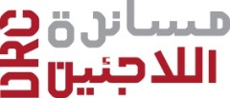

TENDER ANNOUNCEMENT: ITB No. 15/16,
SUPPLY OF CORE RELIEF ITEMS.
The Danish Refugee Council (DRC), with funding from our Donors ECHO and DANIDA, invites all suppliers to participate in tendering for supplying CRI in Baghdad.
Tender Issuing Date: 10th July 2016
Tender Closing Date: 15th July 2016 at 15:00 hours local Baghdad time.
THE ITB DOCUMENTS CAN BE OBTAINED BY ASKING, THROUGHT THE E MAILS:
procurement.off.baghdad@drciraq.dk
The tender documents will provide all relevant information in detail, including date, time, and place for the submission of the Tender.
Please quote ITB-BGT-15/16 in all communication.

