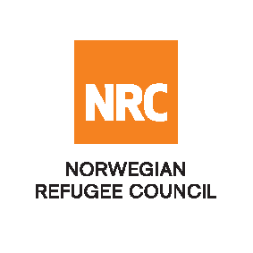

INVITATION TO BID

The Norwegian Refugee Council (NRC) is a non-governmental, humanitarian organization with 60 years of experience in helping to create a safer and more dignified life for refugees and internally displaced people. NRC advocates for the rights of displaced populations and offers assistance within the shelter, education, emergency food security, legal assistance, and water, sanitation and hygiene sectors.

NRC has been present in Iraq since 2010, with offices located in Anbar Province, Baghdad, Erbil, Dohuk and Kirkuk. We have scaled up our response across Iraq to meet the large-scale crisis facing the country, reaching Iraqis with emergency assistance and supporting Syrian refugees as they live in exile. Our goal is to always be prepared to work in new settings, so we are establishing more local partnerships in Iraq.

Tender: Rehabilitation of 7(seven) Water Treatment Plants in Central Iraq

The Norwegian Refugee Council (NRC) Office in Iraq invites eligible and interested service providers to participate on the tender and download the tender documents from the provided link:

https://www.nrc.no/tender/rehabilitation-of-7--water-treatment-plants-in-central-iraq/

Deadline : Tender closing is at 15:00 Hrs (Iraq time) on 1st October 2017
Submissions : All completed bids should be submitted in a sealed envelope (by hand delivery or
courier), addressed to;

Tender Committee
Ref: IQ/002/2017
Norwegian Refugee Council, Iraq
Ekhlas Empire Building
3rd Floor,
Korani Ainkawa Area,
100 Meter Street – Erbil, Kurdistan

NRC reserves the right to select/reject any bids, in part or full, as it may deem necessary without providing feedback on this regard. No liability or claim in that respect would be admissible or entertained whatsoever

