- TECHNICAL SPECIFICATIONS OF VEHICLES

No | Descriptions | Possible Producer, Equivalent brand and Reference Picture | Quantity
LOT1 | Heavy Duty SUV#1
1 | Model Year: 2016 or newer  Fuel Type: Diesel or Petrol  Engine Displacement: min 4150cm³  Drive: 4x4  Speed: 5  Number of cylinders: 6  Transmission: Manual  Fuel Tank Capacity: min. 90L  Number of Doors: 3  Number of Seats: 13  Seating type: Bench  Front Seating arrangement: 1+2  Rear Seating arrangement: 2x5 inward facing  Safety & Interior Features  - A/C & Central Heating  - Audio/CD/Radio  - Double Airbags (Driver + Passenger)  - ABS/EBD/Brake Assist  - Differential Lock  - Emergency Kit & Fire Extinguisher/Tool Kit  - Central door locking  Exterior Features  Bumper : Semi-sealed halogen headlamps  Exterior rear view mirrors: Side steps  Front and rear towing eyes: Sliding rear quarter windows x 4  High/Low 2-speed windshield wipers (inc. mist): Spare wheel mounted on back door, lockable  Lockable fuel lid: Stabiliser bars: front and rear  Mudguards: Front and rear: Swing-out type back door  Rear step bumper: Windshield - green laminated | Toyota Land Cruiser 78, Long Wheelbase Hard Top or Equivalent  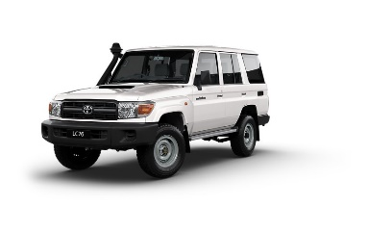  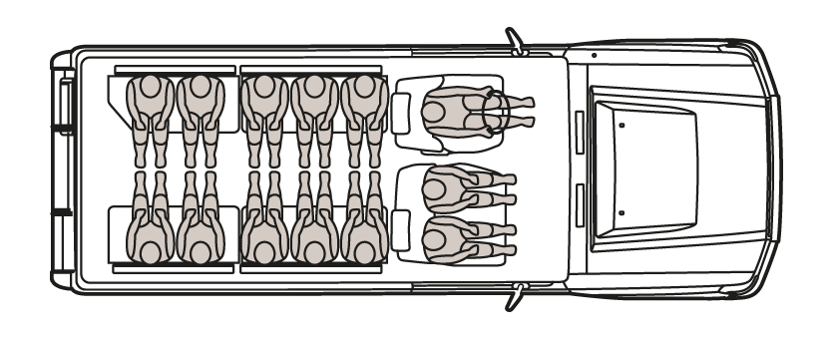 | 1
LOT2 | Heavy Duty SUV#2
1 | Model Year: 2016 or newer  Colour: White (without strips and/or decals)  Fuel Type: Petrol  Number of cylinders: 6  Engine Displacement: min 3900cm³  Traction: Four-wheel drive  Transmission: Automatic  Output: min. 250HP  Fuel Tank Capacity: min. 80L  Safety & Interior Features  - Dual Zone A/C & Central Heating  - Fabric or Leather Seats  - Audio/CD/Radio  - Min 2 Airbags (Driver + Passenger)  - ABS/EBD/Brake Assist  - Rear View Camera  - Emergency Kit & Fire Extinguisher/Tool Kit  Exterior Features  - Central Locking  - Power Windows  - Side Steps  - No side decals  - 4 Doors  - Full size spare tyre | Toyota Land Cruiser Prado 4,0L TX-L or Equivalent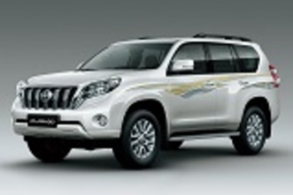 | 1
- WARRANTY & DOCUMENTS:

The supplier shall provide min. 2 years / 50.000Km warranty.

A warranty card signed and stamped shall be provided. All documents, manuals and handbooks shall be provided in English and/or Arabic/Kurdish

- GENERAL REMARKS AND SPECIAL CONDITION

- General
The supplier shall provide the vehicles with all standard technical features and specifications and in full working conditions.

- Technical after sales service
The contractor shall list in the offer the workshop network for warranty, after sales services and maintenance in Duhok Governorate.

- Commissionning and handover of the vehicles
By an authorized supplier representative.

