- TECHNICAL SPECIFICATIONS

No | Descriptions | Possible Producer, Equivalent brand and Reference Picture | Quantity
1 | SUV  Model Year: 2018  Colour: White  Fuel Type : Petrol  Engine Displacement: cc 2494cm³  Traction : Four wheel drive  Transmission: 6 speed Automatic  Output: min. 176HP  Fuel Tank Capacity : min. 60L  Safety & Interior Features  - A/C & Central Heating  - Audio/CD/Radio  - 2 Airbags (Driver + Passenger + Side + Curtain)  - ABS/EBD/Brake Assist  - Emergency Kit & Fire Extinguisher/Tool Kit  Exterior Features  - Central Locking  - Power Windows  - Power Mirrors  - Parking Sensors and/or Rear View Camera | Toyota RAV4 2,5L 4WD or equivalent KIA, Nissan, etc  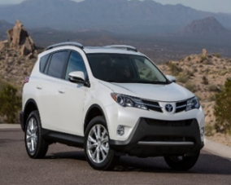 | 1

- WARRANTY & DOCUMENTS:

The supplier shall provide min. 2 years / 50.000Km warranty.

A warranty card signed and stamped shall be provided. All documents, manuals and handbooks shall be provided in English and/or Arabic/Kurdish

- GENERAL REMARKS AND SPECIAL CONDITION

- General
The supplier shall provide the vehicles with all standard technical features and specifications and in full working conditions.

- Technical after sales service
The contractor shall list in the offer the workshop network for warranty, after sales services and maintenance in Erbil Governorate.

- Commissionning and handover of the vehicles
By an authorized supplier representative.

