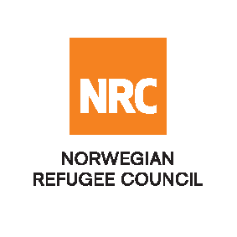

REQUEST FOR QUOTATION

The Norwegian Refugee Council (NRC) is a non-governmental, humanitarian organization with 60 years of experience in helping to create a safer and more dignified life for refugees and internally displaced people.

NRC advocates for the rights of displaced populations and offers assistance within the Shelter, Education, and Emergency food security, and Legal assistance and Water, sanitation and hygiene sectors.

NRC has been present in Iraq since 2010, with offices located in Anbar province, Baghdad, Erbil, Dohuk, Hamam Al Alil, Mosul and Kirkuk. We have scaled up our response across Iraq to meet the large-scale crisis facing the country, reaching Iraqis with emergency assistance and supporting Syrian refugees as they live in exile. Our goal is to always be prepared to work in new settings, so we are establishing more local partnerships in Iraq.

No | RFQ Reference | Description
1 | RFQ 8800326 | Fabrication of 16 m3 steel rubbish containers as per the attached drawings/designs, photos and specifications.
2 | RFQ 8800323 | Supply and rental of Tipers, Front Loaders, Garbage Compactors for Solid Waste Management project in Mosul as per the RFQ
3 | RFQ 8800335 | Supply 1100 L Steel Rubbish Bins. The bidders should provide catalogues as per the attached photo

Note: Each RFQ will be treated separately and bidders are advised to provide separate quotations for each. Companies are encouraged to apply for the RFQ in their specialization.

The Norwegian Refugee Council (NRC) Office in Iraq invites eligible and interested bidders to participate in the tender as per referenced RFQs:

Deadline : Tender closing is at 15:00 Hrs (Iraq time) on 26th March 2018
Submissions : All completed bids should be submitted in a sealed envelope (by hand delivery
Or courier), addressed to;

Tender Committee
Ref: Refer to RFQ reference
Norwegian Refugee Council, Iraq
- Or NRC Erbil office, Ekhlas Empire Building, 3rd Floor, Korani Ainkawa Area, 100 Meter Street.
- Or NRC Mosul office, Al-Majmua Takafiya Area, East Mosul.
Or By email to iq.procurement@nrc.no

NRC reserves the right to select/reject any bids, in part or full, as it may deem necessary without providing feedback on this regard. No liability or claim in that respect would be admissible or entertained whatsoever

