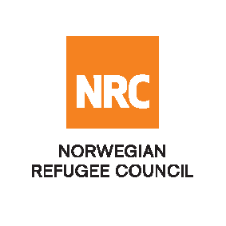

Tender Advert

The Norwegian Refugee Council (NRC) is a non-governmental, humanitarian organization with 60 years of experience in helping to create a safer and more dignified life for refugees and internally displaced people.

NRC advocates for the rights of displaced populations and offers assistance within the Shelter, Education, and Emergency food security, and Legal assistance and Water, sanitation and hygiene sectors.

NRC has been present in Iraq since 2010, with offices located in Anbar province, Baghdad, Erbil, Dohuk, Hamam Al Alil, Mosul and Kirkuk. We have scaled up our response across Iraq to meet the large-scale crisis facing the country, reaching Iraqis with emergency assistance and supporting Syrian refugees as they live in exile. Our goal is to always be prepared to work in new settings, so we are establishing more local partnerships in Iraq.
No | RFQ Reference | Description
1 | RFQ #181750 | - Supply and installation of 500 mm DIA gate valves with electrical actuator for the filtration unit in the new left bank station (Gubba station) in east Mosul  - Supply and installation of 250 mm DIA gate valves with electrical actuator for the filtration unit in the new left bank station (Gubba station) in east Mosul
Essential Criteria for the Bidders
- Company profile indicating key personnel and their contact details
- Previous experiences undertaking similar projects/construction.
- Valid trading license from KRI/Iraq and TAX clearance certificate.
- Financial capacity
- Sufficient number of machinery and construction equipment.

Remark: The bids that do not meet the essential criteria will not be considered for evaluation.
The bidders can submitted their bids online http://www.globalesourcing.eu/

All bids should be submitted within 14 days of this advertisement, before or by 8 April 2018 through the eSourcing system as mentioned above.

NRC technical department will be inviting interested bidders for site visit, project-briefing session and details of the project on 2nd April 2018 at 12:00 pm.

Meeting location:
NRC Mosul office, Al Zeraie neighbourhood - Sadam Mosque traffic light - AL Yaqoot building, East Mosul.

The pre bid meeting is mandatory. Bidder who don’t attend the meeting and site visit will not be considered for this tender and will automatically be disqualified.

NRC reserves the right to select/reject any bids, in part or full, as it may deem necessary. No liability or claim in that respect would be admissible or entertained whatsoever.

