- TECHNICAL SPECIFICATIONS OF VEHICLES

No | Descriptions | Possible Producer, Equivalent brand and Reference Picture | Quantity
1 | SUV 1  Model Year : 2018  Colour : White  Fuel Type : Petrol  Engine Displacement : min. cc 2494cm  ³  Traction : Four wheel drive  Transmission : 6 speed Automatic  Output : min. 176HP  Fuel Tank Capacity : min. 60L  Safety & Interior Features  - A/C & Central Heating  - Audio/CD/Radio  - 2 Airbags (Driver + Passenger + Side + Curtain)  - ABS/EBD/Brake Assist  - Emergency Kit & Fire Extinguisher/Tool Kit  Exterior Features  - Central Locking  - Power Windows  - Power Mirrors  Parking Sensors and/or Rear View Camera | Toyota RAV4 2,5L 4WD or equivalent KIA,Nissan,etc  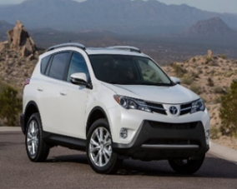 | 1
2 | Heavy Duty SUV 2  Model Year: 2018  Colour: White (without strips and/or decals)  Fuel Type: Petrol  Traction: Four-wheel drive  Transmission: Automatic  Output: min. 250HP  Fuel Tank Capacity: min. 80L  Safety & Interior Features  - Seats 7  - Dual Zone A/C & Central Heating  - Centre Console Cooler Box  - Push Start Button  - Fabric Seats  - Fabric or Leather Seats  - Audio/CD/Radio  - Min 2 Airbags (Driver + Passenger)  - ABS/EBD/Brake Assist  - Rear View Camera  - Emergency Kit & Fire Extinguisher/Tool Kit  Exterior Features  - Central Locking  - Power Windows  - Side Steps  - No side decals  - 5 Doors  - Full size spare tyre  - Radiator Grille With Chrome  - Front Bumper Coloured  - Rear Bumper Coloured  - Rear Sensors  - Rear View Camera  - Sun Roof  - Roof Rail  Audio and Entertainment System  - AUDIO/ USB/ AUX/ Bluetooth  - 6 Speakers  - Steering Wheel Control  Safety Features  - Vehicle Satiability Control (VSC)  - Active Traction Control (A-TRC)  - Hill Start Assist Control (HAC)  - Airbags: Driver + Passenger | Toyota Land Cruiser TXL 4.0L, V6, 24 VALVE, DOHC, DUAL VVT-I (1GR-FE)or Equivalent  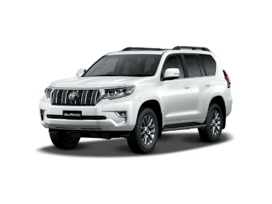 | 1
- WARRANTY & DOCUMENTS:

The supplier shall provide min. 2 years / 50.000Km warranty.

A warranty card signed and stamped shall be provided. All documents, manuals and handbooks shall be provided in English and/or Arabic/Kurdish

- GENERAL REMARKS AND SPECIAL CONDITION

- General
The supplier shall provide the vehicles with all standard technical features and specifications and in full working conditions.

- Technical after sales service
The contractor shall list in the offer the workshop network for warranty, after sales services and maintenance in Erbil, Duhok and Sulaimaniyah Governorates.

- Commissionning and handover of the vehicles
By an authorized supplier representative.

