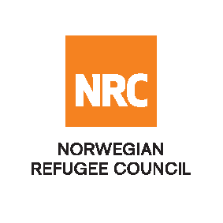

INVITATION TO BID

The Norwegian Refugee Council (NRC) is a non-governmental, humanitarian organization with 60 years of experience in helping to create a safer and more dignified life for refugees and internally displaced people. NRC advocates for the rights of displaced populations and offers assistance within the shelter, education, emergency food security, legal assistance, and water, sanitation and hygiene sectors.

NRC has been present in Iraq since 2010, with offices located in Anbar Province, Baghdad, Erbil, Dohuk and Kirkuk. We have scaled up our response across Iraq to meet the large-scale crisis facing the country, reaching Iraqis with emergency assistance and supporting Syrian refugees as they live in exile. Our goal is to always be prepared to work in new settings, so we are establishing more local partnerships in Iraq.

ITB: Supply, Installation and Maintenance of Electrical Equipment in IDPs Camps in BzBz and Amiryat Al-Faluja

The Norwegian Refugee Council (NRC) Office in Iraq invites eligible and interested contractors to collect the Invitation to Bid from NRC office in Baghdad:

Deadline : Tender closing is at 13:00 Hours (Iraq time) on 13th May 2018

Submissions : All completed bids should be submitted in a sealed envelope (by hand delivery or courier), according to the instruction mentioned in the invitation to bid documents.

- Please contact us on the following number for further details; 07735931854 .

