- Technical Specifications

Item No | Product Name | Product Specifications | Qt. | Unit
1. | MDF Wooden Sheets, for sitting part  (90cm x 22cm x 18mm) | Wooden sheets, moisture resistant (Medium Density Fiber MDF), Turkish standard or equivalent type, Density must be 780 Kg/M3 or more for sittings part of the Desk, final dimensions must be 90cm length x 22cm width x 18mm thickness, color off-white (بيجي), all 4-corners are rounded, the sheet must be smoothened, all edges are to be fillet, ready to be fixed. | 2.000 | Pcs
2. | MDF Wooden Sheets, for front part  (90cm x 19cm x 18mm) | Wooden sheets, moisture resistant (Medium Density Fiber MDF), Turkish standard or equivalent type, Density must be 780 Kg/M3 or more for front part of the Desk , final dimensions must be 90cm length x 19cm width x 18mm thickness ,color off-white (بيجي), all 4-corners are rounded , the sheet must be smoothened , three edges are fillet , ready to be fixed. | 2.000 | Pcs
3. | MDF Wooden Sheets, for Upper part  (90cm x 36cm x 18mm) | Wooden sheets, moisture resistant (Medium Density Fiber MDF), Turkish standard or equivalent type, Density must be 780 Kg/M3 or more for upper part of the Desk , final dimensions must be 90cm length x 36cm width x 18mm thickness ,color off-white (بيجي), only two of the 4-corners are rounded ( the two ends of the long edge) , three edges are fillet , the sheet must be grooved for pencil at a distance of 5cm from the outer edge and for 70cm length , also the sheet must be smoothened , ready to be fixed. | 2.000 | Pcs
4. | MDF Wooden Sheets, for lower part  (68cm x 30cm x 18mm) | Wooden sheets, moisture resistant (Medium Density Fiber MDF), Turkish standard or equivalent type, Density must be 780 Kg/M3 or more for lower part of booking place of the Desk , final dimensions must be 68cm length x 30cm width x 18mm thickness ,color off-white (بيجي), all the 4-corners are straight (NOT rounded with no fillet edges) , the sheet must be smoothened , ready to be fixed. | 2.000 | Pcs

- DELIVERY
- The delivery location is Bnaslawa, Darato, and Kasnazan Erbil, Iraq.

- REMARKS AND CONDITIONS
- Providing, Supplying, and Transportation costs (loading and unloading) are included in the price.
- The Supplier must specify the delivery time in the Bid Form.
- Samples will be requested by GIZ during technical evaluation process for the needed items.
- The Items does not include the steel frame of the Desk.

- Details of the Desk and sample image

MDF Wooden Sheet, Upper Part

MDF Wooden Sheet Sitting Part
MDF Wooden Sheet
Lower Part
MDF Wooden Sheet
Front Part

(Details of Portions)

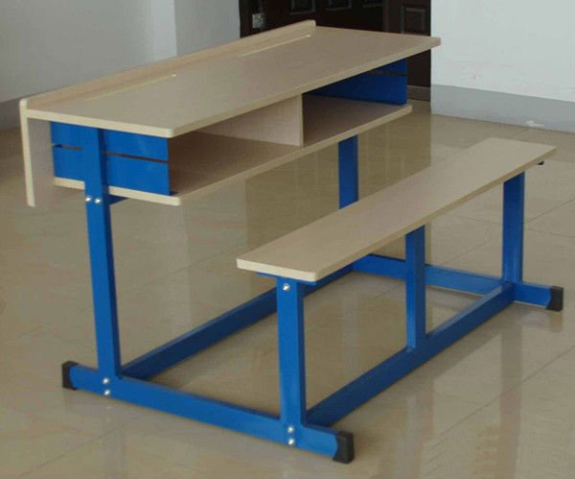
(Sample Desk as a reference picture)

