- Technical Specifications

Item No | Product Name | Product Specifications | Quantity | Unit
1. | Steel forms | Providing galvanized steel forms "with handles for vertical lifting after the chambers have been filled up with concrete" for producing interlock bricks, the thickness of the steel should not be less than 2.5mm. The Accepted difference (error) in Dimensions is -1.00mm and +1.00mm for the frames, and the accepted difference (error) in Dimensions is -0.00mm and +0.5mm for the thickness of the plates. The height of the form “bricks' thickness" should be 90mm.  The height of the handles is (400mm + 150mm), and the section dimensions are (25X25X2.00)mm. | 18 | Pcs
2. | Steel hand compactor | Providing steel hand compactor with handle, for compacting the concrete after the chambers have been filled up. The plate of the hammer should be 8mm thickness, the section of the handle is 25mmX25mmX2mm. | 18 | Pcs

- DELIVERY TIME AND DELIVERY LOCATION

- The delivery Location is giz's warehouse in Gavarke/Duhok.
- Supplier must specify delivery time in bid form.

- REMARKS AND CONDITIONS

- Providing, Supplying, and Transportation costs (loading and unloading) are included in the price.
- Samples or physical checking will be requested by GIZ during process for the needed items.
- After awarding; a sample will be provided by supplier and GIZ will physically check and approve and the rest quantity will be provided after that.
- In case any conflict between GIZ and supplier regarding the quality check of the product, Duhok construction laboratory will the reference to check the quality of the product.
- All the works shall be executed according to specifications in Annex 1, attached drawings (No. 1 and No. 2) and reference pictures, and other contract documents and the instructions of GIZ site Engineer.

- Details of the Desk and sample image

- Reference Picture

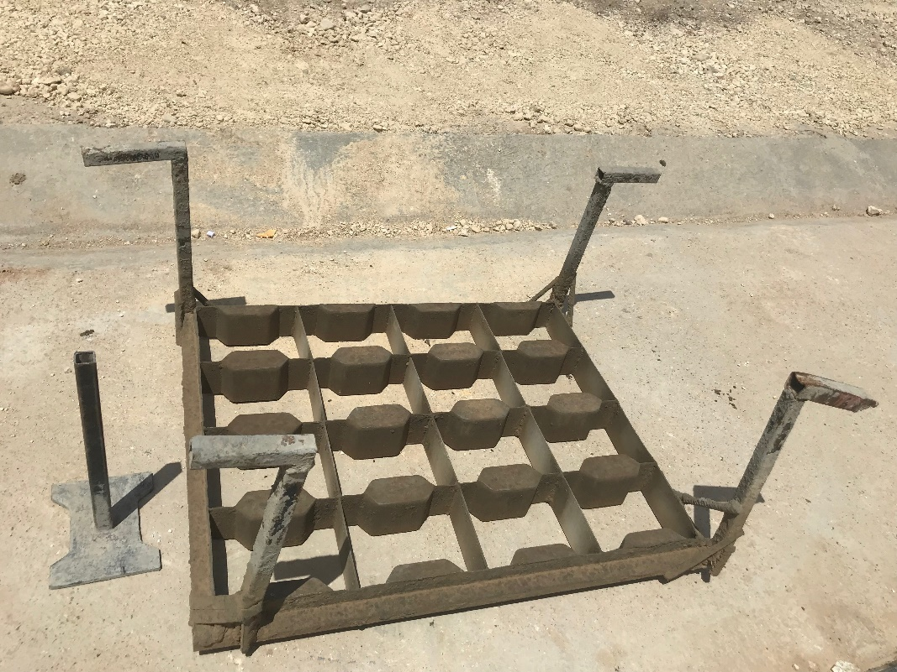
Steel hand compactor
Steel forms
(Sample Desk as a reference picture)

- Drawing No. 1

- Drawing No. 2

