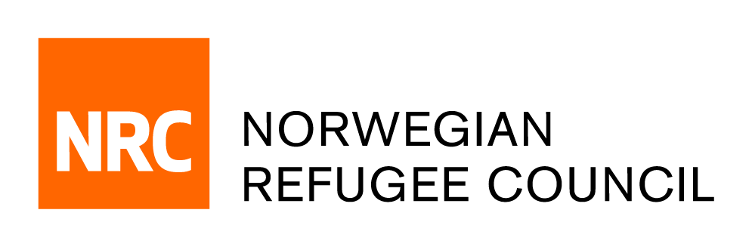

INVITATION TO TENDER

Norwegian Refugee Council (NRC) Iraq Office invites bids from competent Construction suppliers/Contractors in Iraq for the following works: Rehabilitation of seven schools in Duhok governorate area.

 | PR # 8300431 | Rehabilitation of 7 schools in Duhok

Essential Criteria for the Bidders

- Company profile indicating key personnel and their contact details.
- Evidence (certificates) of completing past similar projects.
- Volume of business done in last 3 years with evidence to confirm that.
- Valid current license from KRI governorate.
- Copy of bank statement of last 6 months.
If your company is interested in participating in the tender it requires to visit NRC Duhok Office.
Please note that the request to participate must be done before the deadline 16/08/2018. Otherwise, your application to participate in this tender will not be accepted by the buyer.

Offers to be submitted also to NRC Duhok Office (Norwegian Refugee Council Zirka, Bangawan street 52 house Z007/179/009/01 - Kurdistan Region/Duhok) near to 2nd gate of Duhok University ; submission of the offer should be before the deadline 16 /08/2018 15:00 Hrs

NRC reserves the right to select/reject any bids, in part or full, as it may deem necessary. No liability or claim in that respect would be admissible or entertained whatsoever.

For more information, contact ( procurement.dohuk@nrc.no ) .

