- Technical Specifications

Item No | Product Name | Product Specifications | Quantity | Unit | Possible Producer, Equivalent brand and Reference Picture
1. | Grass cutter machine vehicle | Engine: B & S Intek V-Twin cylinder 656cc European standards or Equivalent  Cutting Deck Size: Approx. 122cm/48in  Transmission: Hydrostatic  Blade Engagement Clutch: Electromagnetic  Discharge: Rear discharge with the option to mulch and  discharge (with optional accessories)  Cutting Positions: 7 positions, 30 – 90mm  Wheels: Approx. 15in x 18in  Grass box Capacity: 300 liters  Fuel Tank Volume: 7 liters  Net Weight: not less than 225 kg | 5 | pcs | 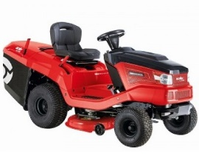
2. | Grass cutter machine manually | TYPE: GEAR TYPE, European standards or Equivalent  Power: Approx. 6.25 HP Engine: fuel, Briggs & Stratton 625 or equivalent Cutting width: Approx. 51cm workable surface: 2000 m2 | 10 | pcs | 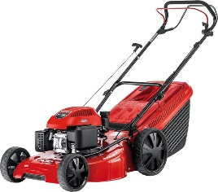
3. | Manual plug & rotitler | Engine: fuel type, Briggs & Stratton 625 European standards or Equivalent.  Displacement: Approx. 190 ccm 2.4 kW 2900 rpm,  Waorking width = 50 cm  Tiller blades: 4 units Φ 30 weight = Approx. 46 kg (forward & Reverse) drive | 3 | pcs | 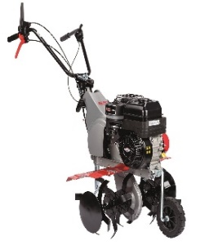
4 | Hedge Trimmer | Engine: fuel- 2 stroke, European standards or Equivalent displacement: Approx. 23 cm3 power: Approx. 0.58kW/0.78 hp weight: Approx. 4.6 kg blade length: 60 cm blade type: diamond cut | 9 | pcs | 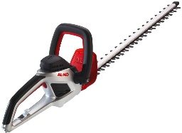
5 | Chainsaw | Engine: fuel, European standards or Equivalent displacement: Approx. 45.1 cm3 power: Approx. 2.2kW/3.0 hp power to weight ratio: Approx. 2.1kg/kW weight: Approx. 4.7 kg bar length: Approx. 38 cm | 3 | pcs | 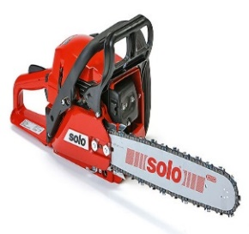

- DELIVERY TIME AND DELIVERY LOCATION

- The Delivery Location is GIZ's warehouse in Sulaymaniyah City.
- Supplier must specify delivery time in the bid form.

- REMARKS AND CONDITIONS

- Providing, Supplying, and Transportation costs (loading and unloading) are included in the price.
- Catalogues will be requested by GIZ during process for the needed items.
- After awarding; a sample will be provided by supplier and GIZ will physically check and approve and the rest quantity will be provided after that.
- In case any conflict between GIZ and supplier regarding the quality check of the product, Sulaymaniyah construction laboratory will be the reference to check the quality of the product.

