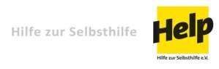

Acknowledgment Letter
Ref: IRQ37-17/RPWS
Dear Sir/Madam,

Subject: Tender Dossier
We, the undersigned, acknowledge receipt of your Invitation for tender of Rehabilitation the water pumping station in Bartallah town, Nineveh Governorate, and hereby confirm that.

To submit a tender to Help - Hilfe zur Selbsthilfe by the deadline date of 27 September 2018.

We acknowledge that this Invitation to tender is confidential and proprietary to Help - Hilfe zur Selbsthilfe, and contains privileged information. Upon request, we will return this or any part thereof, and all copies thereof to Help - Hilfe zur Selbsthilfe.

Name & Title of Authorized Representative: _____________________________________
Signature: _____________________________________
Company Name and Address: _____________________________________
Telephone number: ______________________________________
Email address: _______________________________________
Company Stamp: ______________________________________

