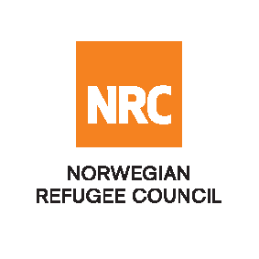

Advertisement - Tender

The Norwegian Refugee Council (NRC) is a non-governmental, humanitarian organization with 60 years of experience in helping to create a safer and more dignified life for refugees and internally displaced people.

NRC advocates for the rights of displaced populations and offers assistance within the Shelter, Education, and Emergency food security, and Legal assistance and Water, sanitation and hygiene sectors.

NRC has been present in Iraq since 2010, with offices located in Anbar province, Baghdad, Erbil, Dohuk, Hamam Al Alil, Mosul and Kirkuk. We have scaled up our response across Iraq to meet the large-scale crisis facing the country, reaching Iraqis with emergency assistance and supporting Syrian refugees as they live in exile. Our goal is to always be prepared to work in new settings, so we are establishing more local partnerships in Iraq.

No | RFQ Reference | Description
1 | ITB – 003 - 2018 – NRC - Iraq | INVITATION TO TENDER FOR Frame Work Agreement for Transport

The Norwegian Refugee Council (NRC) Office in Iraq invites eligible and interested bidders to participate in the tender as per referenced RFQs:

Deadline : Tender closing is at 15:00 Hrs (Iraq time) on 4th October 2018 (Receiving not sending)
Submissions : All completed bids should be submitted in a sealed envelope (by hand delivery
Or courier), addressed to;
Tender Committee
Ref: Refer to RFQ reference
Norwegian Refugee Council, Iraq

Norwegian Refugee Council
Ekhlas Empire Building, Beside Hogir Fuel Station
Korani Ankawa area, 100 m street
Erbil, Iraq

All clarifications, questions and correspondences should be directed to iq.procurement@nrc.no

NRC reserves the right to select/reject any bids, in part or full, as it may deem necessary without providing feedback on this regard. No liability or claim in that respect would be admissible or entertained whatsoever

