- TECHNICAL SPECIFICATIONS OF VEHICLES

No | Descriptions | Possible Producer, Equivalent brand and Reference Picture | Quantity
1 | Heavy Duty SUV  Model Year : 2015 or higher  Colour : White  Fuel Type : Diesel  Engine Displacement : min 4164cm³  Engine Model: 1HZ  Traction : Four wheel drive  Transmission : Manual  Output : min. 120HP  Fuel Tank Capacity : 130 L  Transmission: Manual  Number of cylinders: 6  Maximum power (kw/rpm): 96/3800  Maximum Torque (Nm/rpm): 285/2200  Battery: 80D26 (12 V) , 65 amp-hour  Power assisted steering  Engine oil cooler  Brake control valve  Transfer Box Protection  High Altitude Compensator  Air cleaner: Cyclone with snorkel  Fuel Sedimenter with fuel filter  Differential- rear 4.300 4P Stabilizer bar- front &rear  Safety & Interior Features  - A/C & Central Heating  - Audio/CD/Radio  - Double Airbags (Driver + Passenger)  - ABS/EBD/Brake Assist  - Differential Lock  - Emergency Kit & Fire Extinguisher/Tool Kit  Exterior Features  - Central Locking  - Power Windows  - Side Steps  - 4 Doors | Toyota Land Cruiser 70 4,2L 4WD or Equivalent  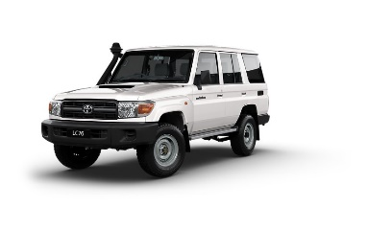 | 2
- WARRANTY & DOCUMENTS:

The supplier shall provide min. 2 years / 50.000Km warranty.

A warranty card signed and stamped shall be provided. All documents, manuals and handbooks shall be provided in English and/or Arabic/Kurdish

- GENERAL REMARKS AND SPECIAL CONDITION

- General
The supplier shall provide the vehicles with all standard technical features and specifications and in full working conditions.

- Technical after sales service
The contractor shall list in the offer the workshop network for warranty, after sales services and maintenance in Iraq

- Commissionning and handover of the vehicles
By an authorized supplier representative.

