- TECHNICAL SPECIFICATIONS
No | Descriptions | Possible Producer, Equivalent brand and Reference Picture | Quantity
1 | Heavy Duty SUV  Model Year: 2018  Colour: White (without strips and/or decals)  Fuel Type: Petrol  Number of cylinders: 6  Engine Displacement: min 3900cm³  Traction: Four-wheel drive  Transmission: Automatic  Output: min. 250HP  Fuel Tank Capacity: min. 80L  Safety & Interior Features  - Dual Zone A/C & Central Heating  - Fabric or Leather Seats  - Audio/CD/Radio  - Min 2 Airbags (Driver + Passenger)  - ABS/EBD/Brake Assist  - Rear View Camera  - Emergency Kit & Fire Extinguisher/Tool Kit  Exterior Features  - Central Locking  - Power Windows  - Side Steps  - No side decals  - 4 Doors  - Full size spare tyre | Toyota Land Cruiser Prado 4,0L TX-L or Equivalent KIA, Hyundai, Nissan, etc.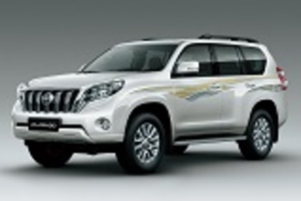 | 2
- WARRANTY & DOCUMENTS:

The supplier shall provide min. 2 years / 50.000Km warranty.

A warranty card signed and stamped shall be provided. All documents, manuals and handbooks shall be provided in English and/or Arabic/Kurdish

- GENERAL REMARKS AND SPECIAL CONDITION

- General
The supplier shall provide the vehicles with all standard technical features and specifications and in full working conditions.

- Technical after sales service
The contractor shall list in the offer the workshop network for warranty, after sales services and maintenance in Iraq.

- Commissionning and handover of the vehicles
By an authorized supplier representative.

