
Weekly Iraq .Xplored report
06 October 2018

Prepared by Risk Analysis Team, Iraq

garda.com

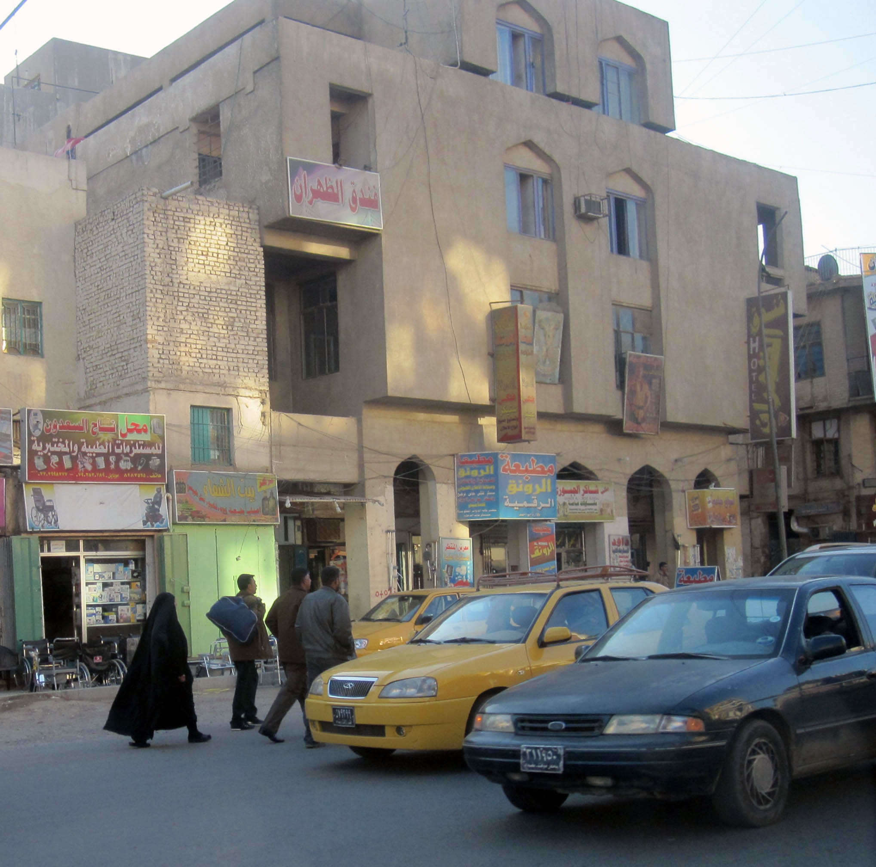

TABLE OF CONTENTS

TABLE OF CONTENTS 2
Activity Map 3
OUTLOOK 4

Short term outlook 4

Medium to long term outlook 4
EXECUTIVE SUMMARY 5

President Elected and Prime Minister Nominated during turbulent week 5

Ministry of Foreign Affairs responds to US Consulate departure 5

IRGC launched missiles across Iraq into Syria 5

UNAMI released casualty figures for September 5
THREAT MATRIX 5
OVERVIEW 6

President Elected and Prime Minister Nominated during turbulent week 6

Ministry of Foreign Affairs responds to US Consulate departure 7

IRGC launched missiles across Iraq into Syria 7

UNAMI released casualty figures for September 7
WEEKLY OPERATIONAL ASSESSMENT 8

Countrywide Military/Security Situation 8
ACRONYM LIST 13
GARDAWORLD INFORMATION SERVICES 14
GARDAWORLD 14

This report is an abridged version of GardaWorld Weekly Iraq .Xplored October 06, 2018. To subscribe to the full versions of the daily/weekly Iraq .Xplored reports, or for enquires relating to other GardaWorld services, please contact daniel.matthews@garda.com

Disclaimer: The information and opinions expressed in this Report are the views of GardaWorld and constitute a judgment as at the date of the Report and are subject to change without notice. The information and opinions expressed in this Report have been formed in good faith on the basis of the best information and intelligence available at the time of writing, but no representation or warranty, express or implied, is made as to its accuracy, completeness or correctness. GardaWorld accepts no liability arising out of or in connection with the comments made or the information set out in this Report and the reader is advised that any decision taken to act or not to act in reliance on this Report is taken solely at the reader’s own risk. In particular, the comments in this Report should not be construed as advice, legal or otherwise.

Activity Map

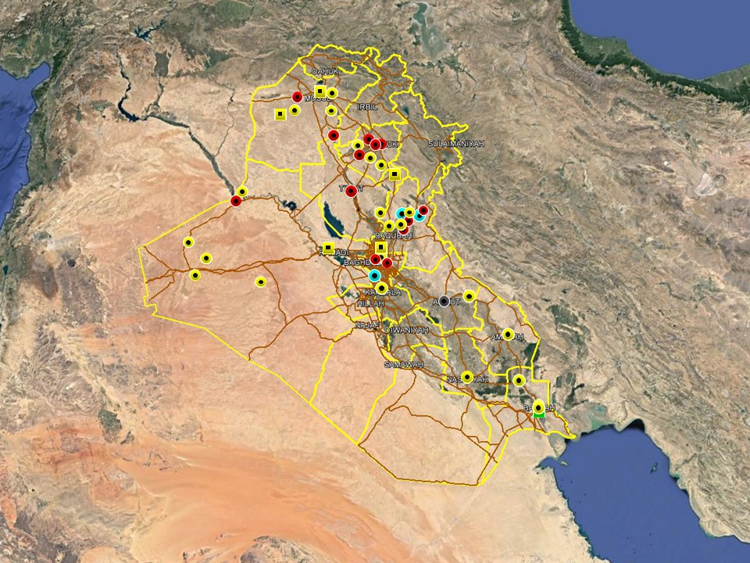

OUTLOOK

Short term outlook

- A heightened insurgent intent to stage signature attacks is assessed to remain throughout the remainder of Muharram. As underlined by the suicide VBIED attack between Baiji and Tikrit on 12 September, terrorist attacks are more likely in mixed areas of the north, including Salah al-Din, Diyala and Kirkuk which remain more permissive to IS operations. As always, there is a heightened sense of cultural and religious sensitivities during this period, with an associated risk of religiously motivated attacks.

- While the situation in Basra has calmed down since the violent unrest earlier in the month, political tensions are assessed to remain high with an associated risk of spontaneous gatherings. An increased security posture for preventive reasons can be expected to remain in the city with additional security deployments and increased checkpoint scrutiny.

- IDF attacks on the International Zone, Baghdad and the US consulate near Basra International Airport suggests heightened intent to target US interests in the country. While no group has claimed responsibility for the attacks, it is likely that Iranian-backed elements are behind these incidents in an effort to harass and intimidate for political purposes. As such, the outlook for further attacks targeting US interests is assessed as increased in the coming weeks.

- Political focus over the next week will revolve around the election of key positions including President and Prime Minister. Political negotiations to decide the composition of the new government can also be expected to dominate parliamentary sessions, with associated risks of demonstrations as tensions remain high.

Medium to long term outlook

- Sectarian violence can be expected to continue in areas of Northern Iraq which remain permissive to IS operations, including Nineveh, Salah al-Din, Diyala and southwestern Kirkuk. Attacks will continue to target security checkpoints and outpost, especially in Sunni dominated areas controlled by Shia dominated security forces.

- Islamic State activity will continue to dominate security reporting with focus on the potential resurgence of an insurgent campaign in northern and western Iraq. Despite ongoing ISF efforts to clear remaining IS pockets, the group retains a degree of freedom of movement in the desert regions of Anbar, near the Syrian border, and along the Hamrin Mountains.

- Low-level incidents related to criminality, personal disputes and tribal tensions are likely to continue in Basra and the southern region. Long-term tensions are also expected to be driven by the return of militia factions expecting material and social rewards for their contribution in the campaign against IS.

EXECUTIVE SUMMARY

President Elected and Prime Minister Nominated during turbulent week
Barham Salih was elected as the new President of the Republic, defeating KDP’s Fuad Hussein and five other candidates in a parliamentary vote on October 02. Salih then proceeded to nominate Abdul al-Mahdi as the Prime Minister-designate who now has 30 days to form a cabinet and permanently assume the position.

Ministry of Foreign Affairs responds to US Consulate departure
The Ministry of Foreign Affairs responded early in the week to the US decision to withdraw staff from its consulate in Basra, calling the decision unfortunate but ensuring that the government does all it can to protect diplomatic missions. Iran predictably dismissed the decision as political propaganda and political reactions in Iraq widely see the decision to withdraw as driven by geopolitical factors rather than the security situation in Basra.

IRGC launched missiles across Iraq into Syria
Iran launched several missiles across Iraqi airspace into Syria, targeting IS militants east of Euphrates River in response to an attack on a military parade in Ahwaz. Subsequent reports claimed the missile strikes were coordinated between Iraq, Syria, Iran and Russia while the international coalition denied knowledge of the strikes.

UNAMI released casualty figures for September
UNAMI released its monthly casualty figures for September which marked the lowest number of civilians killed and injured since the start of the count. As usual, Baghdad province was the province mostly affected followed by Anbar and Salah al-Din.

THREAT MATRIX

Region | Political | Terrorism | Militancy | Crime | K&R
KRG* | Moderate | Low | Moderate | Low | Low
North** | Moderate | High-Extreme | High | High | High
Baghdad | Moderate | Moderate | Moderate | Moderate | Moderate
Anbar | Moderate | High | High | High | High
South*** | Moderate | Low | Moderate | Moderate | Moderate
Threat Scale | Minimal | Low | Moderate | High | Extreme

* KRG – Dohuk, Erbil & Sulaymaniyah
** North – Nineveh, Salah ad-Din & Diyala
*** South – Babil, Wasit, Karbala, Najaf, Diwaniyah, Dhi Qar, Muthanna, Maysan & Basra

OVERVIEW

President Elected and Prime Minister Nominated during turbulent week
Following the suspension of the first parliamentary session dedicated to the election of the new President on October 01, PUK candidate Barham Salih was finally elected new President of the Republic of Iraq on October 02. Salih defeated main challenger, KDP’s Fuad Hussein, as well as five other minor candidates following a clear victory in the first round of voting. Salih then proceeded to nominate Abdul al-Mahdi as the new Prime Minister who now has 30 days to nominate a Cabinet. In the event of failure, Salih must select another PM nominee within 15 days of the expired 30-day period. The nomination of al-Mahdi as the designated PM was surprisingly quick and appears to have side-tracked article 76:1 of the Constitution, which stipulates that the President “shall charge the nominee” of the largest parliamentary bloc with the formation of the Cabinet. With the issue of ‘the largest bloc’ still unresolved, the nomination of Mahdi without protestations seemingly validates reports over the past week that both al-Bina and al-Islah (Sadr/Abadi led) unofficially agreed to put forward Mahdi as the new PM. Indeed, following the nomination Abadi, Sadr, Ameri and Maliki all made congratulatory statements to Mahdi who also met with PM Abadi later in the week to discuss the transition of power.

After congratulating Mahdi in his initial remarks, Muqtada al-Sadr released another statement via social media giving Mahdi a year to ‘prove his success and take serious steps to build Iraq’ and implement reforms or else ‘face an uprising by the whole Iraqi people.’ The statement also said the Sairun Alliance ‘succeeded in nominating an independent prime minister’ and is now encouraging him to form a new cabinet ‘without pressure from any parties or sects.’ Therefore, the alliance has decided ‘not to nominate any of its members to assume a ministerial post in the upcoming cabinet.’ Later in the week, Usama al-Nujafi, VP and leader of the Sunni Iraqi Decision Alliance, and Hikma leader Ammar al-Hakim issued separate statements of support for Abdul al-Mahdi as Prime Minister, refuting reports that they rejected his nomination. After meeting on October 04, the office of Nujafi said the two agreed to support Mahdi and overcome any political challenges that lay ahead. The next day, Hikma movement also issued a statement refuting claims in some media outlets that Hikma would not support al-Mahdi. The statement also listed ten political issues which should be prioritised by the new administration, including security, employment and decentralization of powers.

Ministry of Foreign Affairs responds to US Consulate departure
In the beginning of the week, the Ministry of Foreign Affairs (MoFA) expressed regret over the US’ decision to depart from its Consulate in Basra on September 29. According to MoFA spokesperson Ahmed Mahjoub, the Government of Iraq (GoI) remains committed to the protection of all diplomatic missions in the country and urged all missions to ‘neglect the propaganda which aims at endangering the security and stability of the country and undermining Iraq’s relations with other countries.’ Also responding to the closure, Iran’s Foreign Ministry Spokesperson Bahram Qassemi said the Islamic Republic “condemns any attack on diplomats or diplomatic missions” but dismissed the US’ justification for the departure as “ludicrous.” Qassemi added that the closure comes after weeks of “propaganda, speculation and baseless accusations” against Iran.

IRGC launched missiles across Iraq into Syria
The Islamic Revolutionary Guards Corps announced that several ballistic missiles launched from Iran targeted an IS stronghold in Syria in the early hours on October 01. The exact location of the target was not specified but the statement said it took place ‘east of the Euphrates River’, targeting “takfiri terrorists backed by America and regional powers” in retaliation for the attack in Ahwaz on September 22.

UNAMI released casualty figures for September
According to casualty figures recorded by the United Nations Assistance Mission for Iraq (UNAMI), a total of 75 civilians were killed and 179 injured in total in acts of ‘terrorism, violence and armed conflict’ during September. The figures include ‘ordinary citizens and others considered civilian’ including police in non-combat functions. As usual, Baghdad was the worst affected province (31 killed and 70 injured) followed by Anbar (15 killed/37 injured) and Salah al-Din (09 killed/38 injured).

WEEKLY OPERATIONAL ASSESSMENT

Countrywide Military/Security Situation

Northern Provinces
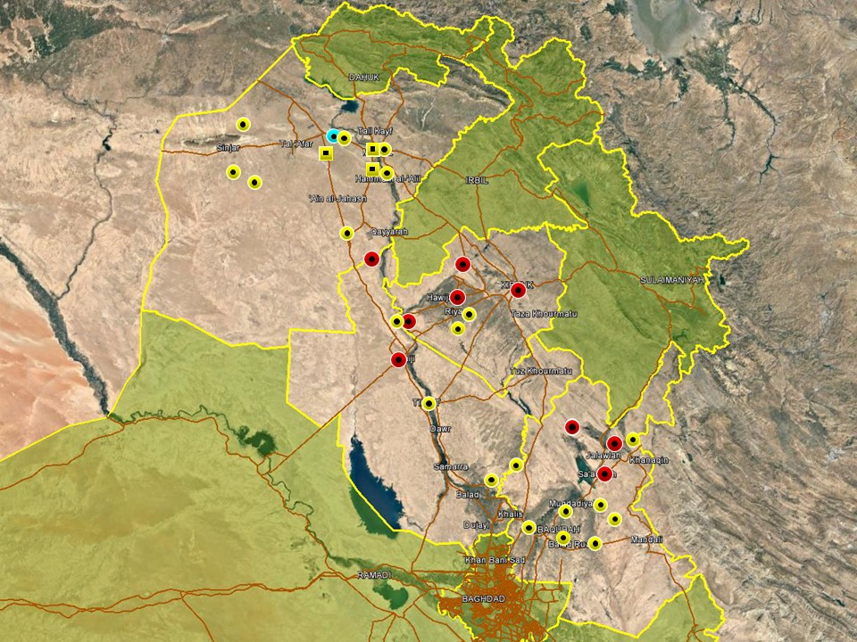

Overall security patterns in the northern region conformed to established trends with insurgent activity confined to rural areas of Nineveh, southwestern Kirkuk and northern Diyala. In Nineveh, targeted SAF attacks were reported in Mosul city following reports that IS cells remain active in the city. In response, ISF carried out several arrest operations of suspected IS militants during the week in the eastern districts of Mosul. In the provincial areas, IS militants are being blamed for continuous attacks against local tribal leaders and village elders as part of tactics seen in recent months. ISF security operations also continued in Tal Afar and southern Sinjar, reportedly arresting multiple insurgents during the week.

In Kirkuk city, two separate explosions were reported in the evening of October 04 in Durmiz and al-Essra respectively, injuring four in total. One of the devices, in Durmiz, was reportedly attached to a car, with some media outlets reporting the incident as a VBIED. The attacks are consistent with a recent pattern of low-yield attacks in city, possibly carried out by insurgent sympathisers to stoke tensions but with limited capability to carry out high-profile attacks. Activity in the province was otherwise characterised by low-level attacks in the southwestern areas around Hawijah, including low-level IEDs and SAF targeting civilians and security forces. A relatively calm reporting period was observed in Salah al-Din province with no significant attacks reported. On October 02, at least one mortar round impacted in central Tuz Khourmatu, causing no casualties or damage. The impact took place near the residence of a former Turkmen MP. No group claimed responsibility for the attack but it is worth noting that the area around Tuz Khourmatu is characterised by high levels of political tensions. ISF activity in the province was predominantly confined to the south with repeated operations carried out east of Balad near the Diyala provincial boundary. As usual, PMU forces linked with the AHH, have been involved in the operations aimed at limiting insurgent freedom of movement along the border areas.

Relatively high levels of hostilities were yet again recorded in Diyala province. Multiple attacks were recorded in the northern areas of Khanaqin, Jalawla and Qarrah Teppeh which underlines continued IS intent to exploit divisions in disputed areas. Low-level activity also continued in the Diyala River Valley including Muqdadiyah, Abu Saida and Baqubah. As usual, most incidents comprised low-level SAF, kidnappings and indirect fire attributable to an ongoing asymmetric campaign to destabilize the area by local insurgent cells.

In a separate development related to northern Iraq, the Turkish Parliament voted this week to ratify a motion extending the authority to launch cross-border operations into Iraq and Syria for another year. The decree, which has been extended annually since 2014, allows cross border intervention in response to ‘threat to Turkey’s national security’ and also stipulates that foreign forces may use Turkish military bases to counter the same threats. Referencing Iraq, the motion stressed Turkey’s respect for the territorial integrity of Iraq but says the continuing presence of PKK and ISIS in the country ‘poses a direct threat to regional peace, stability and the security” of Turkey.

Anbar Province
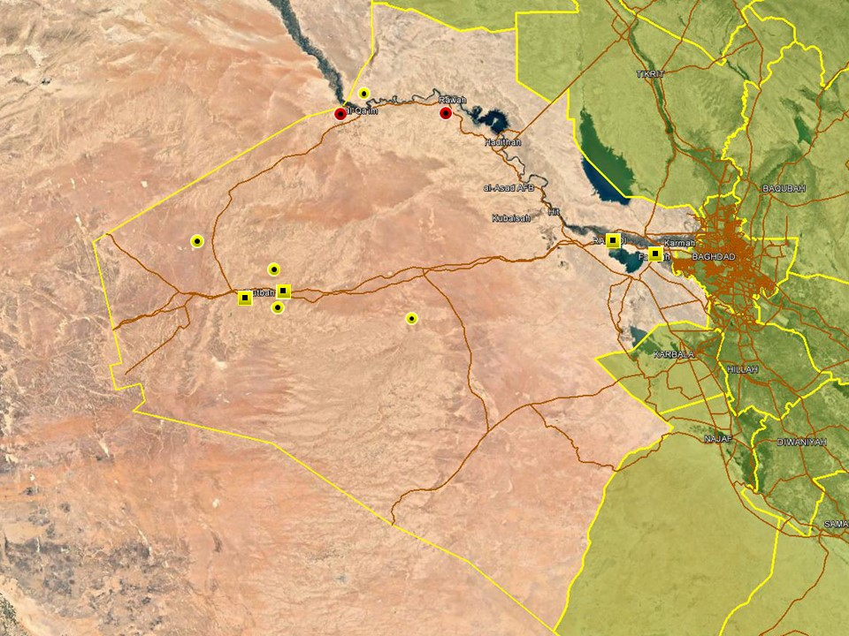

A relatively uneventful reporting period was noted in the west with few hostile incidents recorded. With the exception of isolated roadside IED attacks in Qaim and Rawa district, reporting was dominated by ISF operations targeting suspected IS militants in rural areas around Rutbah and al-Qaim. A large number of IEDs and weapons likely left by IS were also discovered over the course of these operations. Multiple arrest operations were also reported in Ramadi and Fallujah, targeting suspected terrorism and criminality. Separately, a large number of internally displaced people were reported to have returned to the province during the week as the resettlement process progresses.

Capital Region (Including Baghdad City)

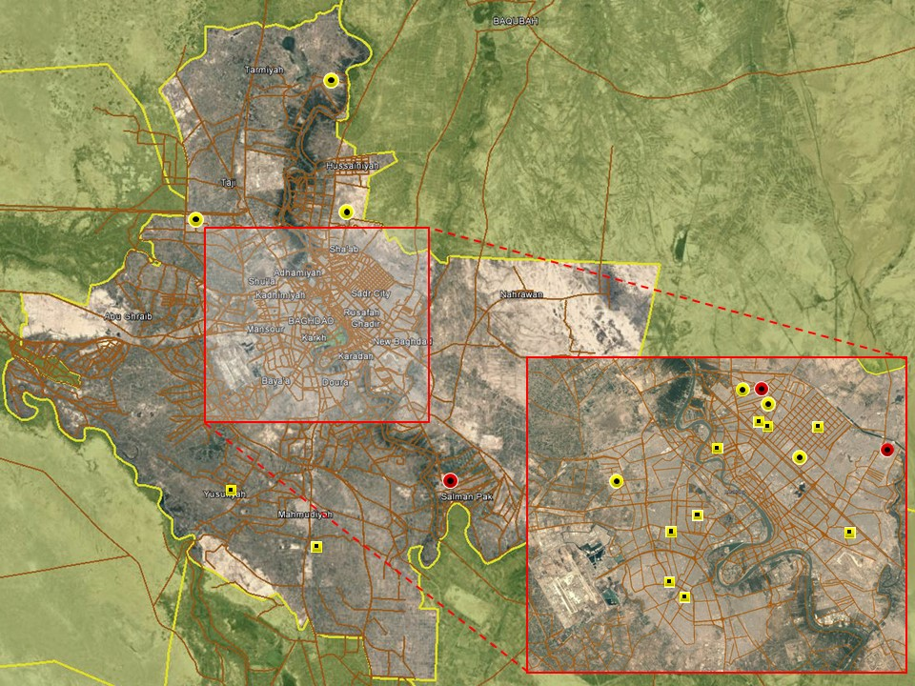

No large-scale attacks took place in the capital over the week however low-level IEDs likely attributable to IS sympathisers continued. The most significant incident took place on October 01 when two coordinated IEDs detonated in Shaab district, killing one and injuring four others. One civilian was killed and another injured when another IED detonated in New Baghdad district. With the exception of these attacks, most hostile incidents were as usual related to low-level disputes and criminality in the eastern areas of the city including Adhamiyah, Sadr City and New Baghdad. ISF also carried out multiple arrest operations throughout the week in different areas, also targeting criminality.

A relatively calm period was observed in the provincial areas with few incidents recorded. Minor SAF and IED was reported on separate occasions in Tarmiyah district and Mada’in, north and south of the city respectively, claiming low numbers of casualties. The body of a male with gunshot wounds was also found in Sabah al-Bour. There are currently no indications that the security situation in the provincial areas will change.

Southern Provinces
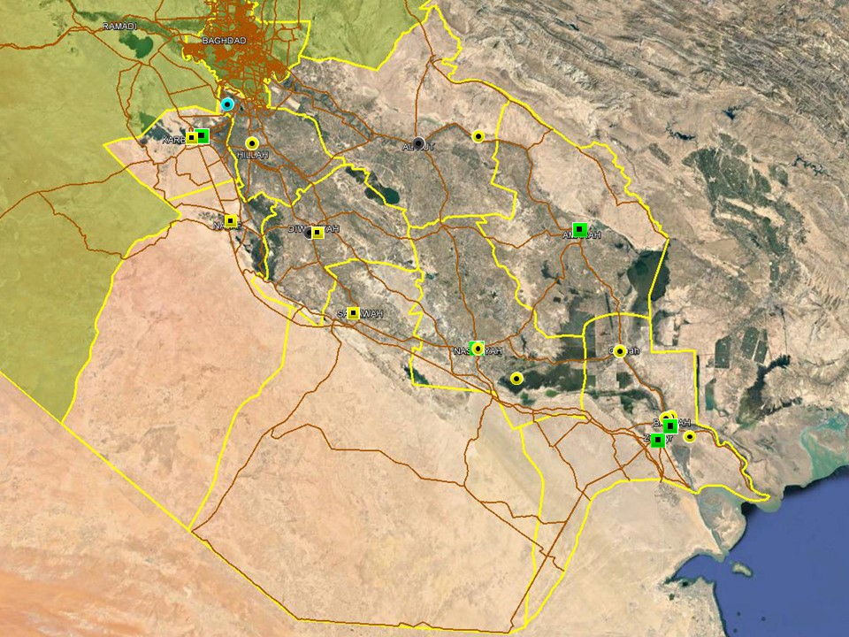

Low level activity continued in Babil province which continues to experience low-level insurgent activity given its proximity to southern Baghdad and Anbar province. On September 30, three PMU members were injured when a mortar shell landed near a security checkpoint in Jurf al-Sakhar. Unidentified gunmen also opened fire on the vehicle of a police officer in Mahawil district north of Hillah on October 02, wounding the victim. Hostilities in other southern provinces were largely consistent with long-standing trends including tribal disputes and criminality in Diwaniyah, Wasit, Maysan and Dhi Qar.

In Basra acts of tribal violence and SAF attacks targeting women have increased this week. The tribal activity, endemic throughout Iraq, but witnessed more frequently in Basra when security forces appear distracted. This may be related to news that the senior leadership was undergoing a re-shuffle with PM Abadi transferring the Basra Army Operations Commander (BaOC) to a training college in Baghdad and appointing Qassim al-Maliki as the new CG who assumed command this week. With exception of a protest march to commemorate the victims of recent protests, there were no major demonstrations this week in the province. However, the appointment of Abdul al-Mahdi as the new Iraqi PM may see some increase in protest action with some Basrawi’s viewing his tenure as Oil Minister as a cause to many of the province’s current problems. Incidents of female murder are another cause for concern with claims that the majority have been involved in ‘un-Islamic’ practices; this increase in activity is likely driven by the period of Muharram which commands greater religious observance.

ACRONYM LIST

AII - Area of Intelligence Interest
AKA - Also Known As
AO - Area of Operations
APC - Armored Personnel Carrier
APIED - Anti-Personnel IED
AQ - Al-Qaeda
AT - Anti-Tank
ATGW - Anti Tank Guided Weapon
AVIED - Anti-Vehicle IED
BBIED - Body Borne IED
Bde - Brigade
Bn - Battalion
BXP - Border Crossing Point
CET - Convoy Escort Team
CLC - Concerned Local Citizens
CoP - Chief of Police
CP - Check Point
C-PERS - Captured Personnel
CPX - Complex Attack (attack using multiple weapon systems)
CQA - Close Quarter Assassination/Attack
DBS - Drive by Shooting
Div - Division
DoD - Department of Defense
DoS - Department of State
DoS - US Department of State
ECP - Entry Control Point
EFP - Explosively Formed Projectile
EOD - Explosive Ordinance Disposal (Bomb Squad)
ERW - Explosive Remnants of War
FoM - Freedom of Movement
GoI - Government of Iraq
HCN - Host Country National
HG - Hand Grenade
HME - Home Made Explosive
HMG - Heavy Machine Gun
HVT - High Value Target
IC - International Community
IDF - Indirect Fire (i.e.: rockets, mortars)
IDP - Internally Displaced Persons
IEC - Independent Electoral Commission
IED - Improvised Explosive Device
IM - International Military
IOC - International Oil Company
IRAM - Improvised Rocket Assisted Mortar
IRL - Improvised Rocket Launcher
IS - Islamic State
IVCP - Illegal Vehicle Check Point
IVO - In Vicinity Of
IZ - International Zone
KIA - Killed in Action
LN - Local National/Iraqi Civilian
MAIED - Magnetically attached IED (aka UVIED)
MIA - Missing in Action
MoD - Ministry of Defense
MoF - Ministry of Finance
MoFA - Ministry of Foreign Affairs
MoHE - Ministry of Higher Education
MoI - Ministry of Interior
MoJ - Ministry of Justice

MoO - Ministry of Oil
MoT - Ministry of Transportation
MSR - Main Supply Route
NFDK - No Further Details Known
NGO - Non-Governmental Organization (aid/charity)
NSTR - Nothing Significant To Report
OCG - Organized Crime Group
OPF - Oil Protection Force
PAX - Person, Persons or Passenger
PBIED - Person-Borne Improvised Explosive Device (UN Term)
PMF – Popular Mobilisation Forces
PoI - Point of Impact (for IDF)
PoO - Point of Origin (for IDF)
PSAF - Precision Small Arms Fire
PSC - Private Security Company
PSD - Private Security Detail
RCIED - Remote-Controlled IED
RPG - Rocket Propelled Grenade
RTA - Road Traffic Accident
SAF - Small Arms Fire
SAFIRE - Surface to Air FIRE
SF - Special Forces
SVBIED - Suicide Vehicle Borne IED
SVEST - Suicide Explosive Worn Vest
TCN - Third Country National
TCP - Traffic Control Point
Technical - An improvised weapon-mounted pick-up truck
TTP - Tactics, Techniques and Practices
UVIED - Under Vehicle IED
UXO - Unexploded Ordnance
VBIED - Vehicle Borne IED
VCP - Vehicle Checkpoint
WIA - Wounded in Action

GARDAWORLD INFORMATION SERVICES

From our management offices and field offices in strategic locations our constant monitoring of the high-risk environments in which we work is conveyed through our range of .Xplored™ risk analysis reports. The reports contain detailed updates, delivering current and relevant ground-truth information to assist both our personnel and our clients in their decision-making.

Our wider risk management solutions provide members of the defense, diplomatic, development, oil & gas and infrastructure sectors operating in potentially high-risk and complex environments with a comprehensive range of risk analysis, intelligence, crisis response, and training services. These services are designed to provide clients with the proactive capability to remain aware in potentially hostile environments and identify risks while strengthening their reactive capacity in emergency situations.

Our current regular reporting geographies include: Nigeria, Mali, Libya, Iraq, Afghanistan and Yemen on a daily, weekly, fortnightly, and monthly basis.

Through our constant monitoring and predictive threat analysis our Information Services team help you plan for, manage, and respond to risks.

For more information on our .Xplored reports or for information about our special-to-task reports tailored to individual client requirements, please contact us: informationops@garda.com or contact our regional representative iraq.ram@garda.com (Mobile: +964 7823 783 972)

For more information on how our services can support your business in Iraq contact:
Daniel Matthews, Senior Director Iraq daniel.matthews@garda.com

GARDAWORLD

A global leader in comprehensive security and risk management

GardaWorld International Protective Services is the international security division of GardaWorld Security Corporation, the world's largest privately owned security company with over 62,000 global staff.

We support clients in emerging, complex and high-risk markets around the world with static security, security consulting, risk analysis and reporting, crisis management and business continuity, mobile security, close protection, training and kidnap for ransom and extortion response solutions.

We work across multiple business sectors to provide protection and security for clients in the extractives, aerospace and defense, critical infrastructure, government and diplomatic and development sectors to secure employees, assets, and reputation so clients can focus solely on running daily operations and growing their business.

Discover more about the markets we serve and to learn how our international security solutions can help you contact us today: gwinfo@garda.com

Middle East
International Protective Services Headquarters
Office 2502, Tower 2, Currency House
DIFC, PO Box 482069
Dubai, United Arab Emirates

United States
1101 Wilson Boulevard
Suite 1725
Arlington, VA, 22209
United States

UK
5th Floor
1, London Bridge
London
SE1 9BG

Europe
37-39 rue des Deux Eglises
1000 Brussels
Belgium

garda.com

