
Weekly Iraq .Xplored report
13 October 2018

Prepared by Risk Analysis Team, Iraq

garda.com

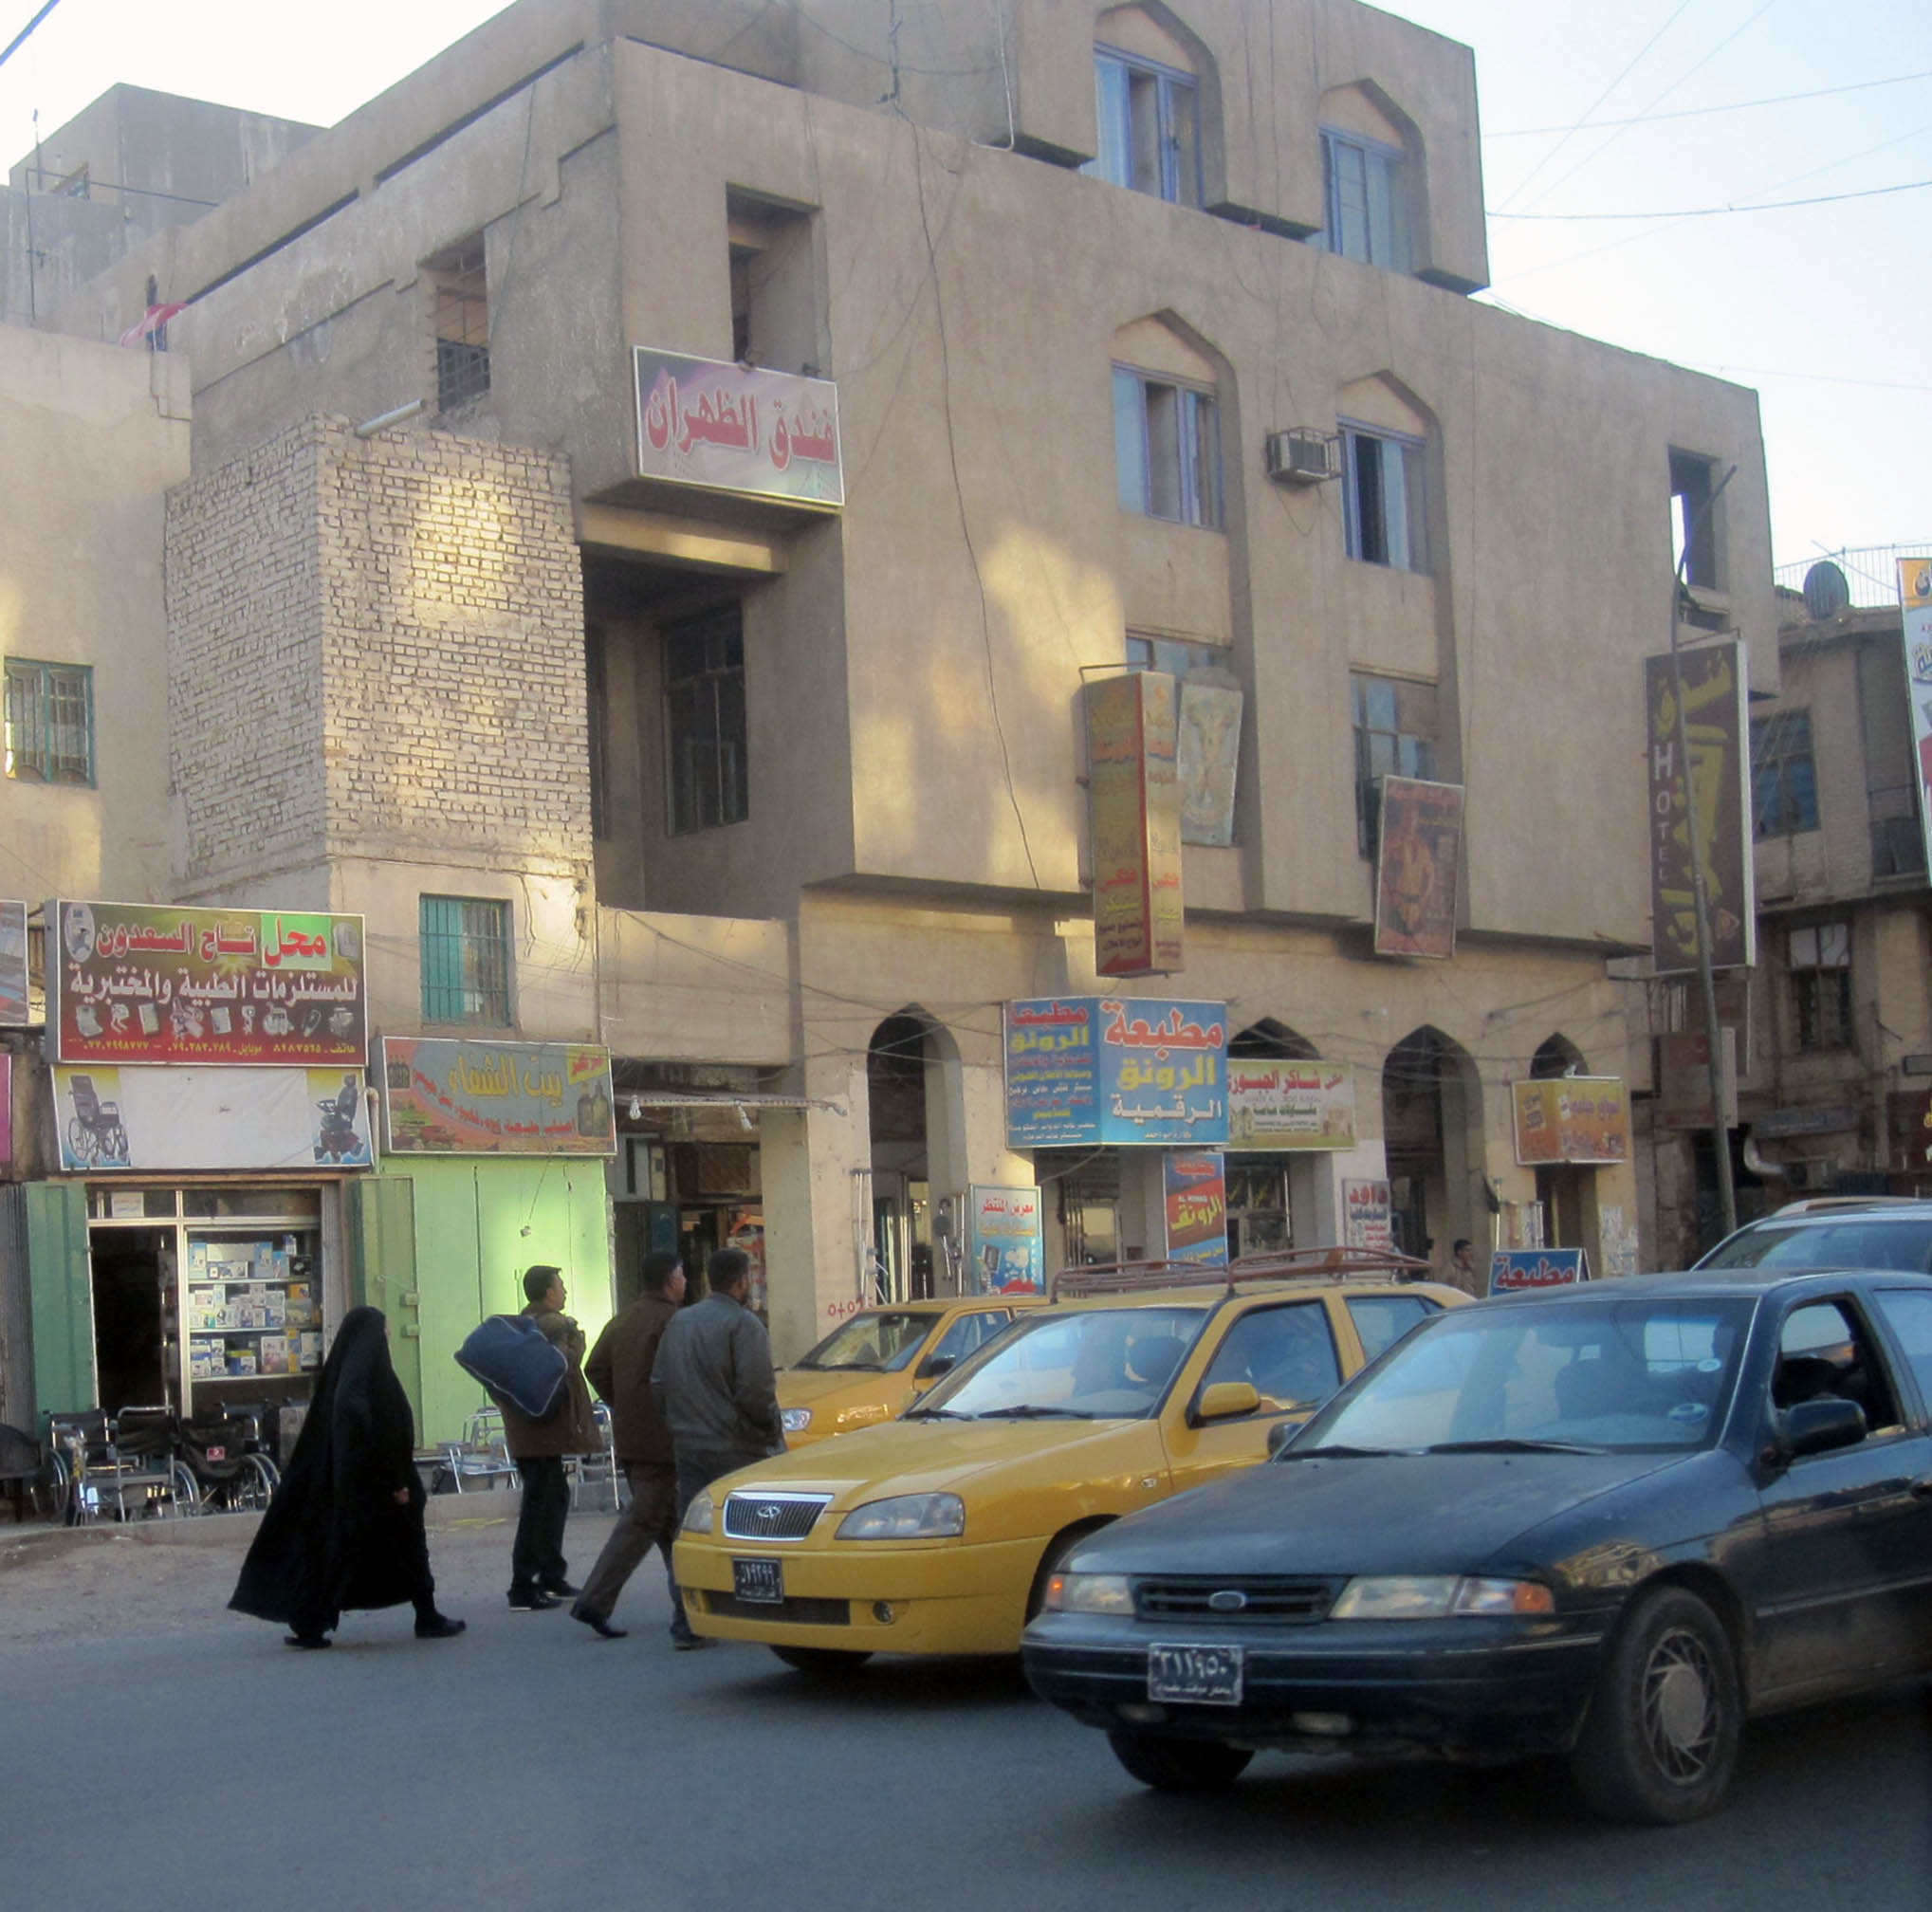

TABLE OF CONTENTS

TABLE OF CONTENTS 2
Activity Map 3
OUTLOOK 4

Short term outlook 4

Medium to long term outlook 4
EXECUTIVE SUMMARY 5

PM-designate Mahdi received applications for ‘technocratic’ cabinet 5

Interior Ministry says ‘extremist group’ behind recent high-profile killings 5

Turkey's Foreign Minister visited Baghdad 5

President Salih met with Syrian Ambassador 5
THREAT MATRIX 5
OVERVIEW 6

PM-designate Mahdi received applications for ‘technocratic’ cabinet 6

Interior Ministry says ‘extremist group’ behind recent high-profile killings 6

Turkey's Foreign Minister visited Baghdad 6

President Salih met with Syrian Ambassador 7
WEEKLY OPERATIONAL ASSESSMENT 8

Countrywide Military/Security Situation 8
ACRONYM LIST 13
GARDAWORLD INFORMATION SERVICES 14
GARDAWORLD 14

This report is an abridged version of GardaWorld Weekly Iraq .Xplored October 06, 2018. To subscribe to the full versions of the daily/weekly Iraq .Xplored reports, or for enquires relating to other GardaWorld services, please contact daniel.matthews@garda.com

Disclaimer: The information and opinions expressed in this Report are the views of GardaWorld and constitute a judgment as at the date of the Report and are subject to change without notice. The information and opinions expressed in this Report have been formed in good faith on the basis of the best information and intelligence available at the time of writing, but no representation or warranty, express or implied, is made as to its accuracy, completeness or correctness. GardaWorld accepts no liability arising out of or in connection with the comments made or the information set out in this Report and the reader is advised that any decision taken to act or not to act in reliance on this Report is taken solely at the reader’s own risk. In particular, the comments in this Report should not be construed as advice, legal or otherwise.

Activity Map

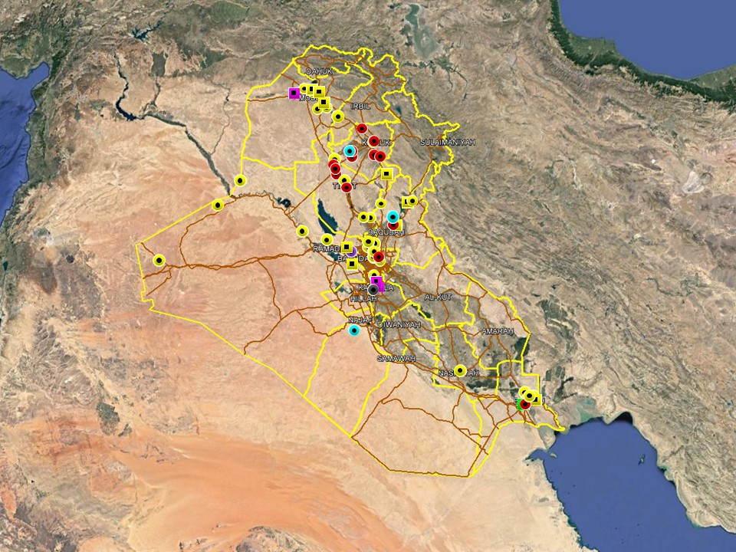

OUTLOOK

Short term outlook

- IDF attacks on the International Zone, Baghdad and the US consulate near Basra International Airport in early and mid-September suggests heightened intent to target US interests in the country. While no group has claimed responsibility for the attacks, it is likely that Iranian-backed elements are behind these incidents in an effort to harass and intimidate for political purposes. As such, the outlook for further attacks targeting US interests is assessed as increased. These developments are not unprecedented and Basra province remains permissive for commercial operations which is unlikely to change.

- While the situation in Basra has calmed down since the violent unrest in early September, political tensions are assessed to remain high with an associated risk of spontaneous gatherings. An increased security posture for preventive reasons can be expected to remain in the city with additional security deployments and increased checkpoint scrutiny over Arbaeen period.

- The Ashoura commemoration passed without major incidents in the southern region and Baghdad amidst extensive security measures. A heightened insurgent intent to stage signature attacks is assessed to remain throughout the remainder of Muharram. Terrorist attacks are more likely in mixed areas of the north, including Salah al-Din, Diyala and Kirkuk which remain more permissive to IS operations.

- Following the election of President and Prime Minister nominee, political focus over the coming weeks will revolve around political negotiations to decide the composition of the new government; there is an associated risk of demonstrations as tensions remain high, especially in Baghdad. Upcoming budget discussions can also be expected to drive protest activity in Baghdad and the southern provinces.

Medium to long term outlook

- Sectarian violence can be expected to continue in areas of Northern Iraq which remain permissive to IS operations, including Nineveh, Salah al-Din, Diyala and southwestern Kirkuk. Attacks will continue to target security checkpoints and outpost, especially in Sunni dominated areas controlled by Shia dominated security forces.

- Islamic State activity will continue to dominate security reporting with focus on the potential resurgence of an insurgent campaign in northern and western Iraq. Despite ongoing ISF efforts to clear remaining IS pockets, the group retains a degree of freedom of movement in the desert regions of Anbar, near the Syrian border, and along the Hamrin Mountains.

- Low-level incidents related to criminality, personal disputes and tribal tensions are likely to continue in Basra and the southern region. Long-term tensions are also expected to be driven by the return of militia factions expecting material and social rewards for their contribution in the campaign against IS.

EXECUTIVE SUMMARY

PM-designate Mahdi received applications for ‘technocratic’ cabinet
After meeting with several senior officials and party leaders early in the week, Prime Minister-designate Abdul Mahdi announced that anyone who considers himself fit for a ministerial position may submit an application through a dedicated website but stressed that candidates must have appropriate experience and qualifications. This followed reports earlier in the week that Mahdi had put forward four conditions for his government.

Interior Ministry says ‘extremist group’ behind recent high-profile killings
In an interview on October 09, Interior Ministry Qassim al-Araji said the investigation into the recent deaths of a number of high-profile women in Baghdad points to the involvement of an ‘extremist militant group’ in at least one of the cases. Araji said the group, which was not named, was most likely behind the killing of Tara Fares, the social media model killed in Karada in early September.

Turkey's Foreign Minister visited Baghdad
The visit by Mevlut Cavusoglu broadly focused on improving bilateral ties, including cooperation on terrorism, and reaffirming Turkey’s commitment to Iraq’s reconstruction effort despite a number of outstanding issues between the two sides. Despite pleasant rhetoric, there was no reported breakthrough on the issue of water levels or the Turkish troop presence in northern Iraq.

President Salih met with Syrian Ambassador
President Barham Salih received the Syrian Ambassador to Iraq Jadan al-Dandah in the Presidential Palace for the first time on October 12. The two reportedly discussed common issues facing the two countries and their ‘deep historical and cultural ties’. The Ambassador also submitted a letter of congratulations from President Assad, reaffirming his intent to forms stronger ties with Iraq.

THREAT MATRIX

Region | Political | Terrorism | Militancy | Crime | K&R
KRG* | Moderate | Low | Moderate | Low | Low
North** | Moderate | High-Extreme | High | High | High
Baghdad | Moderate | Moderate | Moderate | Moderate | Moderate
Anbar | Moderate | High | High | High | High
South*** | Moderate | Low | Moderate | Moderate | Moderate
Threat Scale | Minimal | Low | Moderate | High | Extreme

* KRG – Dohuk, Erbil & Sulaymaniyah
** North – Nineveh, Salah ad-Din & Diyala
*** South – Babil, Wasit, Karbala, Najaf, Diwaniyah, Dhi Qar, Muthanna, Maysan & Basra

OVERVIEW

PM-designate Mahdi received applications for ‘technocratic’ cabinet
After meeting with several senior officials and party leaders early in the week, Prime Minister-designate Abdul Mahdi announced that anyone who considers himself fit for a ministerial position may submit an application through a dedicated website but stressed that candidates must have appropriate experience and qualifications. This followed reports earlier in the week that Mahdi had put forward four conditions for his government, including 1) that he must be independent in picking his ministers; 2) that parties present five candidates for each post; 3) that he is given a free hand in running the government; and 4) that party and political interference in governmental work is eliminated. In a press statement on October 12, Mahdi subsequently announced that the government had received more than 15 thousand electronic applications for various ministerial posts over the week and that a preliminary analysis showed more than a thousand applicants had doctoral degrees. The statement added that a selection process would now start to pick the 601 most qualified candidates from the pot and then conduct interviews for the positions.

Interior Ministry says ‘extremist group’ behind recent high-profile killings
In an interview on October 09, Interior Ministry Qassim al-Araji said the investigation into the recent deaths of a number of high-profile women in Baghdad points to the involvement of an ‘extremist militant group’ in at least one of the cases. Araji said the group, which was not named, was most likely behind the killing of Tara Fares, the social media model killed in Karada in early September, as well as Karrar Nushi, an actor and male fashion model accused of homosexuality and killed in July 2017. Araji also said that the investigations into the deaths of surgeon Rafif al-Yasiri, well-known for performing plastic surgeries, and Rasha al-Hassan, the owner of a beauty parlour, have yet to be completed.

Turkey's Foreign Minister visited Baghdad
Outgoing Prime Minister Haider al-Abadi received Turkish Foreign Minister Mevlut Cavusoglu during the first day of his two-day visit to Iraq on October 11. The two reportedly discussed the importance of strengthening bilateral cooperation on security and terrorism and pledged to resolve any outstanding issues between the two countries, including water quotas. Cavusoglu also stressed Turkey’s commitment to support the reconstruction of liberated areas. After meeting with President Salih, Cavusoglu also said Turkey will reopen its consulates in Basra and Mosul, which he said were previously closed due to security reasons. Related, Turkish President Tayyip Erdogan again vowed this week to ‘finish’ PKK militants in Sinjar and Qandil regions of northern Iraq, reiterating that their presence constitutes a threat to Turkey’s national security. Erdogan made the comments during a speech commemorating eight Turkish soldiers killed in an attack claimed by the PKK in south eastern Turkey earlier in the week. Separately, PM-designate Mahdi met with Turkish Ambassador Fatih Yildiz to discuss bilateral relations, with both sides reportedly emphasising the need to enhance cooperation. In a subsequent tweet, the Turkish Embassy wrote that “a bright future awaits the relations between the two countries.”

President Salih met with Syrian Ambassador
President Barham Salih received the Syrian Ambassador to Iraq Jadan al-Dandah in the Presidential Palace for the first time on October 12. The two reportedly discussed common issues facing the two countries and their ‘deep historical and cultural ties.’ Al-Dandah also submitted a letter from President Assad congratulating him on assuming the Presidency position and stressing the need to strengthen bilateral ties between Iraq and Syria.

WEEKLY OPERATIONAL ASSESSMENT

Countrywide Military/Security Situation

Northern Provinces
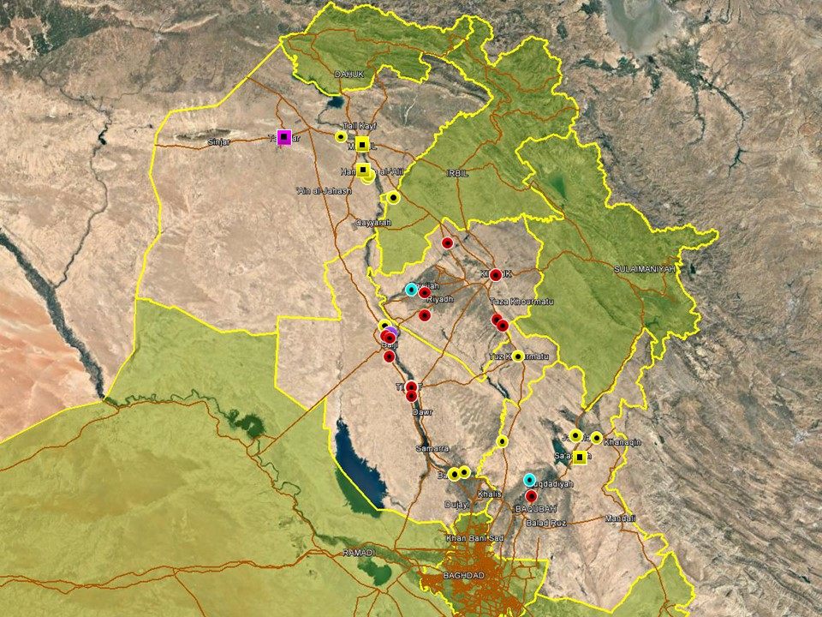

Overall, activity patterns in the northern region remain characterised by relatively high IS activity in rural areas of Nineveh, northern Salah al-Din, southwestern Kirkuk and northern Diyala, consistent with trends witnessed in recent months. In Nineveh province, IS hit and run attacks were reported on several occasions during the week in rural areas south of Mosul, including al-Hadhar, Hammam al-Alil and al-Kwair. The most notable incident took place on October 10, when IS militants attacked security posts manned by pro-government Sunni militias. The group also continued attacks against civilians, targeting villages in exposed, rural areas. According to local, unconfirmed reports clashes broke out between PMU members (affiliated with Asaib Ahl al-Haq and Kata’ib Sayyid al-Shuhada) and IP forces in eastern Mosul after the PMUs ‘stormed’ a Ministry of Interior compound. The cause of the dispute has not been confirmed. In a later statement, the PMUs denied that an altercation took place but said a small misunderstanding occurred with local police however the next day it was announced that a SWAT company of the Mosul Police had been ordered to withdraw from the district. In a statement, local police officials said the company will be tasked with a training mission elsewhere and denied that the decision had anything to do reports of a recent confrontation with PMUs in the district. Separately, PMU forces were reported to have abducted 14 civilians in Tal Afar district and threatened several others, demanding that they leave the district. The victims are reportedly formerly displaced people accused of having links with IS.

Relatively high levels of IS activity continued in the southwestern districts of Kirkuk with multiple IEDs, SAF and IDF attacks recorded during the week. Notably, IS militants were reported to have detonated multiple IEDs near a water treatment plant in al-Abbasi sub-district of Hawijah causing material damage. In a statement, a local council member said residents in the district are concerned over rumours that IS may attempt to poison water supplies and that federal police forces are ‘not carrying out their duties’ to protect the citizens. Low-level attacks targeting security checkpoints and civilians were also reported during the week in Kirkuk city, Dibis district and Daquq, continuing patterns of activity seen in recent weeks.

Typical attack patterns were also observed in Diyala province this week, with incidents confined to the northern, disputed districts and the Diyala River Valley. On October 11, ISF intercepted and arrested an IS suicide bomber in Khanaqin district who reportedly planned to detonate his device near civilians. Sporadic IDF, IED and SAF was also reported in the areas between Muqdadiyah and Baqubah, likely attributable to local insurgent cells. In Salah al-Din, the vast majority of recorded incidents took place in the northern areas around Baiji where multiple IED attacks were reported throughout the week. The most significant incident took place on October 06, when a roadside IED targeted a bus carrying workers of a refinery in Siniyah district, killing one and reportedly injuring over 30. The cause of the usually high injury toll from a road-side IED is not clear but may be attributable to the RTA which likely followed the detonation rather than the explosion itself. Some media reports also claimed that only one of those injured were “severely” wounded, indicating that most injuries were minor. Also in Baiji, PMU forces reportedly foiled an attempted VBIED attack, killing the driver as he approached a checkpoint in the district. Further south, ISF-operations continued in the southeastern areas around Balad and closer to the Diyala provincial boundary, targeting local IS cells in the area.

Anbar Province
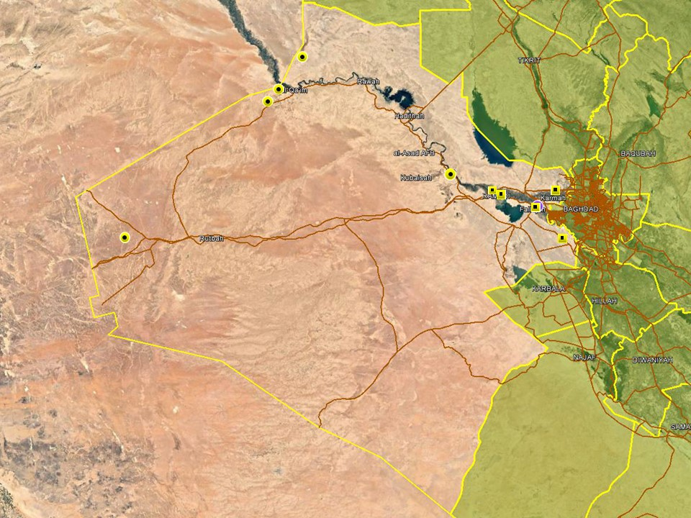

An increase in activity was noted in Anbar province relative to previous weeks however incident patterns remain largely consistent with those seen in previous weeks. Five individuals, including two ISF members, were injured when a VBIED detonated in Hay Nazzal district of Fallujah on October 06; the vehicle was reportedly parked near a currency exchange shop. IS claimed responsibility for the attack however local reports indicate that it was more likely related to a local dispute which would be consistent with recent attack patterns seen in the city. Reporting from Fallujah, Ramadi and the surrounding areas was otherwise dominated by security operations, targeting criminality and suspected terrorism during the week.

On October 11, IS launched an assault on al-Akkaz oilfield, south of al-Qaim, killing at least three ISF members and injuring several others. The assault was reportedly launched from across the Syrian border and took place amidst a sandstorm which facilitated the insurgent’s element of surprise. In response, ISF and PMU forces launched a security operation to secure the western border areas with additional troop deployments announced between al-Qaim and Tall Sufuk, an arrest covering more than 200 km.
Capital Region (Including Baghdad City)

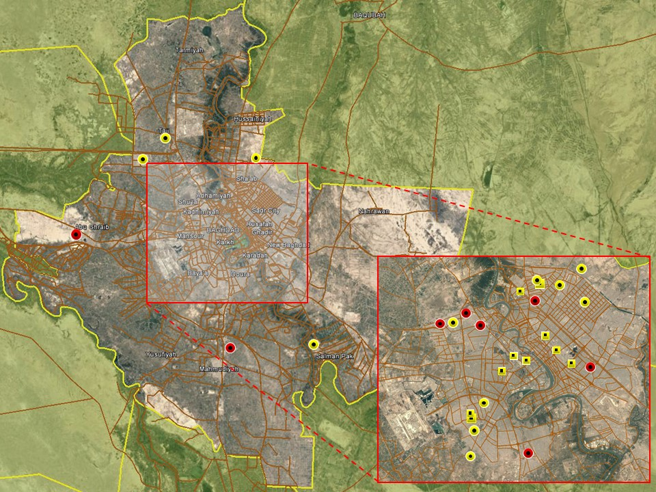

No significant changes were noted in the overall security situation in Baghdad city over the week. The vast majority of hostilities were confined to the poorer districts in eastern Baghdad, including Sadr City and Adhamiyah, and assessed to be related to local disputes. Reporting from central Baghdad was dominated by arrest operations and minor protests around Karadah and Mansour districts. In separate statements released via the messaging app telegram, IS claimed responsibility for a string of IED attacks in different areas of Baghdad on October 07. The statement said the attacks targeted ‘Shia civilians’ and claimed a casualty toll of more than 50 however most reports claimed a much lower casualty figure.

Southern Provinces
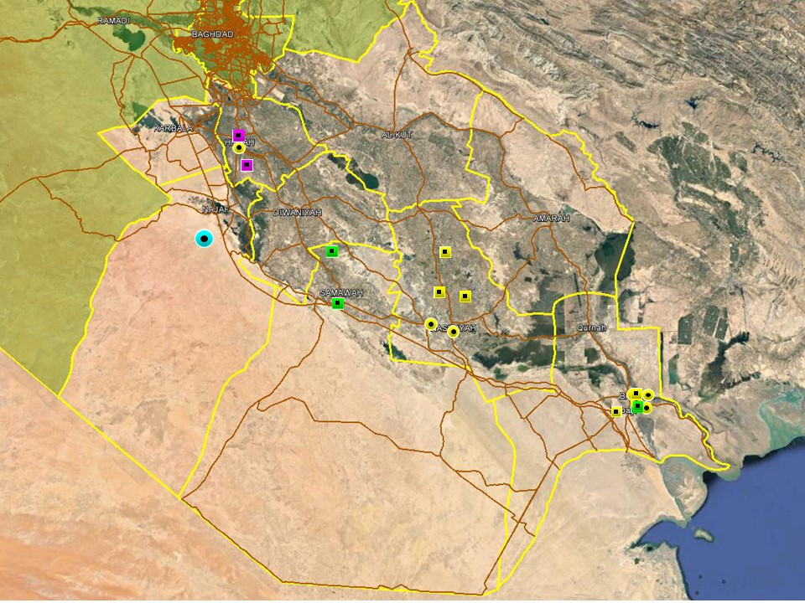

The overall security situation in the southern region remains unchanged with no large-scale developments noted this week. Notably, tribal clashes, reportedly involving RPGs and grenades, were reported in an unspecified rural area of Najaf province on October 11; casualty figures were not specified. In Babil province, a grenade was also tossed outside the residence of a Sadrist member of the Babil Provincial Council in Hillah, causing material damage but no casualties.

The overall situation in Basra remains relatively unchanged with the majority of hostile incidents confined to Basra City and the districts to the north, these related to a typical pattern of social violence and tribal dispute. Tribal disagreements are common in Basra and intra-Shi’a rivalry remains a constant undercurrent of life in the province, with a relatively high number of tribal disputes turning violent and often as in most cases recently proving fatal. Ahead of an increase in pilgrims moving through and around the province, the ISF and civil authorities have announced their plans to accommodate and protect those involved in this religious practice – some routes are to be closed completely, others partially and an increase in passengers arriving and departing Basra International Airport may mean increased check-in times, greater demand on taxis and more stringent security checks.

A low-yield IED find on Route Heart in Burgesiya on 11 October may have been planted as a warning to the OPF. The device had a few hundred grams of explosive content but was not armed to detonate - despite having a mobile phone and a detonator. The metal casing also contained ‘ship-yard confetti’ – nuts and bolts. This potentially constructed by individuals directly linked or aligned to the parties involved in an oil smuggling operation which was discovered and closed down on 5 October near Khor al-Zubayr

ACRONYM LIST

AII - Area of Intelligence Interest
AKA - Also Known As
AO - Area of Operations
APC - Armored Personnel Carrier
APIED - Anti-Personnel IED
AQ - Al-Qaeda
AT - Anti-Tank
ATGW - Anti Tank Guided Weapon
AVIED - Anti-Vehicle IED
BBIED - Body Borne IED
Bde - Brigade
Bn - Battalion
BXP - Border Crossing Point
CET - Convoy Escort Team
CLC - Concerned Local Citizens
CoP - Chief of Police
CP - Check Point
C-PERS - Captured Personnel
CPX - Complex Attack (attack using multiple weapon systems)
CQA - Close Quarter Assassination/Attack
DBS - Drive by Shooting
Div - Division
DoD - Department of Defense
DoS - Department of State
DoS - US Department of State
ECP - Entry Control Point
EFP - Explosively Formed Projectile
EOD - Explosive Ordinance Disposal (Bomb Squad)
ERW - Explosive Remnants of War
FoM - Freedom of Movement
GoI - Government of Iraq
HCN - Host Country National
HG - Hand Grenade
HME - Home Made Explosive
HMG - Heavy Machine Gun
HVT - High Value Target
IC - International Community
IDF - Indirect Fire (i.e.: rockets, mortars)
IDP - Internally Displaced Persons
IEC - Independent Electoral Commission
IED - Improvised Explosive Device
IM - International Military
IOC - International Oil Company
IRAM - Improvised Rocket Assisted Mortar
IRL - Improvised Rocket Launcher
IS - Islamic State
IVCP - Illegal Vehicle Check Point
IVO - In Vicinity Of
IZ - International Zone
KIA - Killed in Action
LN - Local National/Iraqi Civilian
MAIED - Magnetically attached IED (aka UVIED)
MIA - Missing in Action
MoD - Ministry of Defense
MoF - Ministry of Finance
MoFA - Ministry of Foreign Affairs
MoHE - Ministry of Higher Education
MoI - Ministry of Interior
MoJ - Ministry of Justice

MoO - Ministry of Oil
MoT - Ministry of Transportation
MSR - Main Supply Route
NFDK - No Further Details Known
NGO - Non-Governmental Organization (aid/charity)
NSTR - Nothing Significant To Report
OCG - Organized Crime Group
OPF - Oil Protection Force
PAX - Person, Persons or Passenger
PBIED - Person-Borne Improvised Explosive Device (UN Term)
PMF – Popular Mobilisation Forces
PoI - Point of Impact (for IDF)
PoO - Point of Origin (for IDF)
PSAF - Precision Small Arms Fire
PSC - Private Security Company
PSD - Private Security Detail
RCIED - Remote-Controlled IED
RPG - Rocket Propelled Grenade
RTA - Road Traffic Accident
SAF - Small Arms Fire
SAFIRE - Surface to Air FIRE
SF - Special Forces
SVBIED - Suicide Vehicle Borne IED
SVEST - Suicide Explosive Worn Vest
TCN - Third Country National
TCP - Traffic Control Point
Technical - An improvised weapon-mounted pick-up truck
TTP - Tactics, Techniques and Practices
UVIED - Under Vehicle IED
UXO - Unexploded Ordnance
VBIED - Vehicle Borne IED
VCP - Vehicle Checkpoint
WIA - Wounded in Action

GARDAWORLD INFORMATION SERVICES

From our management offices and field offices in strategic locations our constant monitoring of the high-risk environments in which we work is conveyed through our range of .Xplored™ risk analysis reports. The reports contain detailed updates, delivering current and relevant ground-truth information to assist both our personnel and our clients in their decision-making.

Our wider risk management solutions provide members of the defense, diplomatic, development, oil & gas and infrastructure sectors operating in potentially high-risk and complex environments with a comprehensive range of risk analysis, intelligence, crisis response, and training services. These services are designed to provide clients with the proactive capability to remain aware in potentially hostile environments and identify risks while strengthening their reactive capacity in emergency situations.

Our current regular reporting geographies include: Nigeria, Mali, Libya, Iraq, Afghanistan and Yemen on a daily, weekly, fortnightly, and monthly basis.

Through our constant monitoring and predictive threat analysis our Information Services team help you plan for, manage, and respond to risks.

For more information on our .Xplored reports or for information about our special-to-task reports tailored to individual client requirements, please contact us: informationops@garda.com or contact our regional representative iraq.ram@garda.com (Mobile: +964 7823 783 972)

For more information on how our services can support your business in Iraq contact:
Daniel Matthews, Senior Director Iraq daniel.matthews@garda.com

GARDAWORLD

A global leader in comprehensive security and risk management

GardaWorld International Protective Services is the international security division of GardaWorld Security Corporation, the world's largest privately owned security company with over 62,000 global staff.

We support clients in emerging, complex and high-risk markets around the world with static security, security consulting, risk analysis and reporting, crisis management and business continuity, mobile security, close protection, training and kidnap for ransom and extortion response solutions.

We work across multiple business sectors to provide protection and security for clients in the extractives, aerospace and defense, critical infrastructure, government and diplomatic and development sectors to secure employees, assets, and reputation so clients can focus solely on running daily operations and growing their business.

Discover more about the markets we serve and to learn how our international security solutions can help you contact us today: gwinfo@garda.com

Middle East
International Protective Services Headquarters
Office 2502, Tower 2, Currency House
DIFC, PO Box 482069
Dubai, United Arab Emirates

United States
1101 Wilson Boulevard
Suite 1725
Arlington, VA, 22209
United States

UK
5th Floor
1, London Bridge
London
SE1 9BG

Europe
37-39 rue des Deux Eglises
1000 Brussels
Belgium

garda.com

