
Weekly Iraq .Xplored report
20 October 2018

Prepared by Risk Analysis Team, Iraq

garda.com

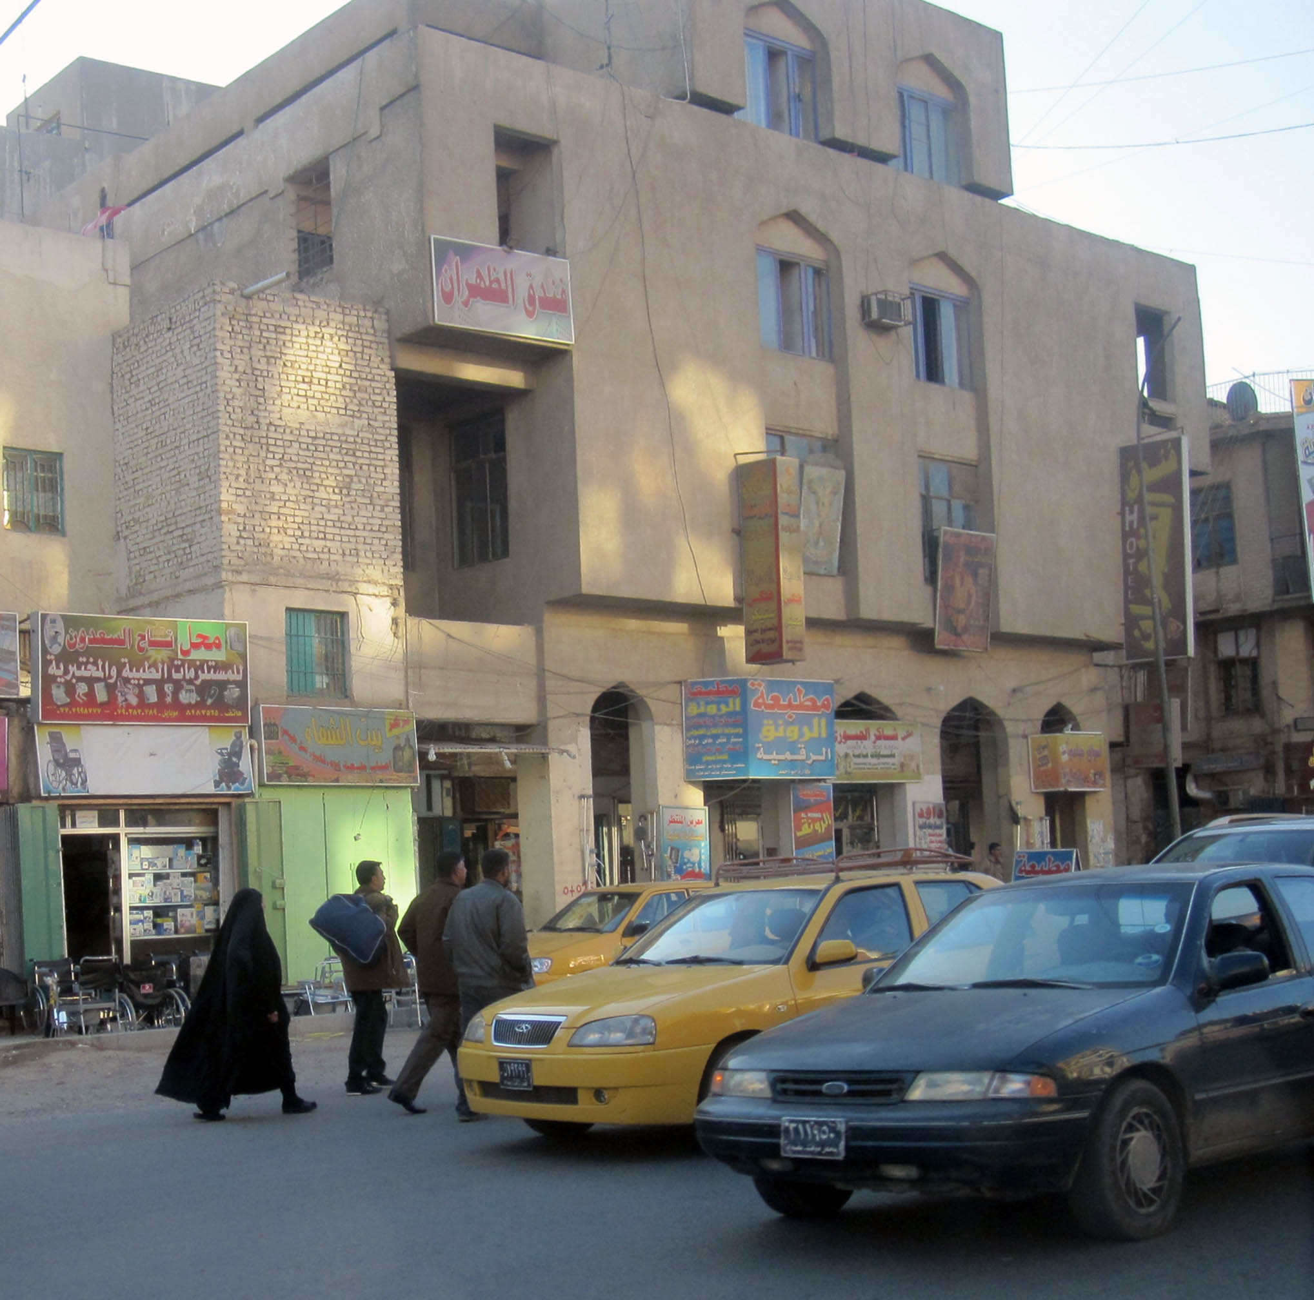

TABLE OF CONTENTS

TABLE OF CONTENTS 2
Activity Map 3
OUTLOOK 4

Short term outlook 4

Medium to long term outlook 4
EXECUTIVE SUMMARY 5

Mahdi’s effort to form technocratic government undermined by unofficial meddling 5

Sadr called on Sunnis to support technocratic government 5

Sairun and Fatah Alliance ‘working on legislation’ to eject foreign forces. 5

Foreign Minister Jafaari met said Syrian counter-part in Damascus 5

Investigation panel blames ‘infiltrating elements’ for Basra unrest 5
THREAT MATRIX 5
OVERVIEW 6

Mahdi’s effort to form technocratic government undermined by unofficial meddling 6

Sadr called on Sunnis to support technocratic government 6

Sairun and Fatah Alliance ‘working on legislation’ to eject foreign forces. 7

Foreign Minister Jafaari met said Syrian counter-part in Damascus 7

Investigation panel blames ‘infiltrating elements’ for Basra unrest 7
WEEKLY OPERATIONAL ASSESSMENT 8

Countrywide Military/Security Situation 8
ACRONYM LIST 13
GARDAWORLD INFORMATION SERVICES 14
GARDAWORLD 14

This report is an abridged version of GardaWorld Weekly Iraq .Xplored October 06, 2018. To subscribe to the full versions of the daily/weekly Iraq .Xplored reports, or for enquires relating to other GardaWorld services, please contact daniel.matthews@garda.com

Disclaimer: The information and opinions expressed in this Report are the views of GardaWorld and constitute a judgment as at the date of the Report and are subject to change without notice. The information and opinions expressed in this Report have been formed in good faith on the basis of the best information and intelligence available at the time of writing, but no representation or warranty, express or implied, is made as to its accuracy, completeness or correctness. GardaWorld accepts no liability arising out of or in connection with the comments made or the information set out in this Report and the reader is advised that any decision taken to act or not to act in reliance on this Report is taken solely at the reader’s own risk. In particular, the comments in this Report should not be construed as advice, legal or otherwise.

Activity Map

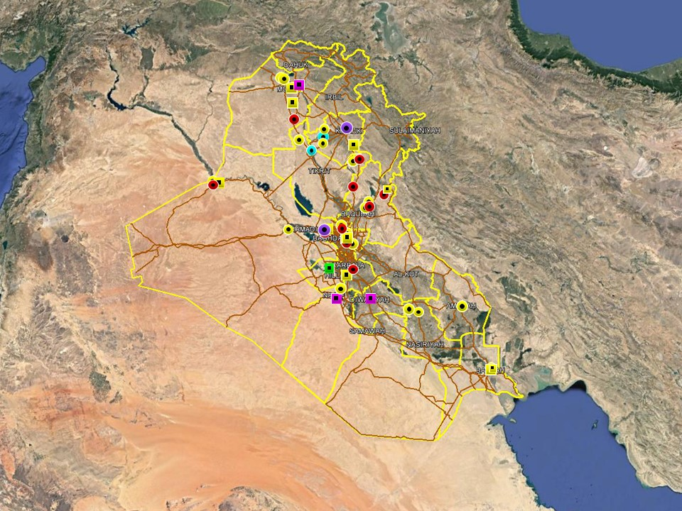

OUTLOOK

Short term outlook

- Preliminary security measures can be expected to be implemented in the next few days, especially in the southern region, ahead of the Arba’in commemoration which culminates October 29-31. Additional security forces will gradually be deployed across the southern region, Baghdad and Shia-dominated areas in northern Iraq, involving both police and army. Expect a heightened security posture and a rise in security alerts in the lead up to the commemoration.

- Insurgent intent to carry out high-profile attacks will be heightened in the lead up to and during the commemoration however their capability to carry out large-scale attacks in Baghdad and the south remains limited. Successful attacks are more likely to be carried out in mixed sectarian areas of northern Iraq, including southern Salah al-Din, Diyala and Kirkuk.

- IDF attacks on the International Zone, Baghdad and the US consulate near Basra International Airport in early and mid-September suggests heightened intent to target US interests in the country. While no group has claimed responsibility for the attacks, it is likely that Iranian-backed elements are behind these incidents in an effort to harass and intimidate for political purposes. As such, the outlook for further attacks targeting US interests is assessed as increased. These developments are not unprecedented and Basra province remains permissive for commercial operations which is unlikely to change.

- While the situation in Basra has calmed down since the violent unrest in early September, political tensions are assessed to remain high with an associated risk of spontaneous gatherings. An increased security posture for preventive reasons can be expected to remain in the city.

- Following the election of President and Prime Minister nominee, political focus over the coming weeks will revolve around political negotiations to decide the composition of the new government; there is an associated risk of demonstrations as tensions remain high, especially in Baghdad. Upcoming budget discussions can also be expected to drive protest activity in Baghdad and the southern provinces.

Medium to long term outlook

- Sectarian violence can be expected to continue in areas of Northern Iraq which remain permissive to IS operations, including Nineveh, Salah al-Din, Diyala and southwestern Kirkuk. Attacks will continue to target security checkpoints and outpost, especially in Sunni dominated areas controlled by Shia dominated security forces.

- Islamic State activity will continue to dominate security reporting with focus on the potential resurgence of an insurgent campaign in northern and western Iraq. Despite ongoing ISF efforts to clear remaining IS pockets, the group retains a degree of freedom of movement in the desert regions of Anbar, near the Syrian border, and along the Hamrin Mountains.

- Low-level incidents related to criminality, personal disputes and tribal tensions are likely to continue in Basra and the southern region. Long-term tensions are also expected to be driven by the return of militia factions expecting material and social rewards for their contribution in the campaign against IS.

EXECUTIVE SUMMARY

Mahdi’s effort to form technocratic government undermined by unofficial meddling
PM-designate Abdul Mahdi announced during the week that he intends to present the list of nominees for the new Cabinet in a Parliamentary session sometime next week amidst reports that political blocs on both sides of the political spectrum seeks to influence the outcome contrary to official statements.

Sadr called on Sunnis to support technocratic government
In a statement on social media during the week, Muqtada al-Sadr called on ‘his Sunni brothers’ to support technocratic, independent candidates for the new government. The statement also implicitly criticised some Sunni leaders and was met with a negative reaction from members of the Sunni establishment.

Sairun and Fatah Alliance ‘working on legislation’ to eject foreign forces.
A statement from members of Sairun alliance claim they are working alongside other political forces to draft legislation demanding the removal of foreign forces from Iraq. Separate reports claim Fatah Alliance is planning to draft similar legislation in Parliament. Contrary to some media reports, the drafts if approved would not be binding on the government and but likely made for political affect.

Foreign Minister Jafaari met said Syrian counter-part in Damascus
In another potential sign of closer Syria-Iraq relations, Foreign Minister Ibrahim al-Jafaari met with Syrian Foreign Minister Walid Muallem in Damascus during an official state visit on October 15. The meeting reportedly focused on the possibility of re-opening joint border crossings in western Anbar and in a subsequent press conference Jafaari said the opening of Albu Kamal border crossing is ‘imminent.

Investigation panel blames ‘infiltrating elements’ for Basra unrest
On October 16, a report released by an investigation panel tasked by outgoing PM Abadi to investigate the protests in Basra, concluded that ‘infiltrating elements’ were responsible for the casualties among protesters and security forces

THREAT MATRIX

Region | Political | Terrorism | Militancy | Crime | K&R
KRG* | Moderate | Low | Moderate | Low | Low
North** | Moderate | High-Extreme | High | High | High
Baghdad | Moderate | Moderate | Moderate | Moderate | Moderate
Anbar | Moderate | High | High | High | High
South*** | Moderate | Low | Moderate | Moderate | Moderate
Threat Scale | Minimal | Low | Moderate | High | Extreme

* KRG – Dohuk, Erbil & Sulaymaniyah
** North – Nineveh, Salah ad-Din & Diyala
*** South – Babil, Wasit, Karbala, Najaf, Diwaniyah, Dhi Qar, Muthanna, Maysan & Basra

OVERVIEW

Mahdi’s effort to form technocratic government undermined by unofficial meddling
PM-designate Abdul Mahdi announced during the week that he intends to present the list of nominees for the new Cabinet in a Parliamentary session sometime next week, with local reports indicating the vote will likely take place on October 22 or 24. This follows the announcement the previous week that Mahdi planned to install a ‘technocratic government’ along Sadrist’ principles, according to which anyone considered qualified for the position would be allowed to apply. There is widespread official agreement between the main political parties that Mahdi should be allowed to nominate candidates without partisan interference, a statement reiterated for example by Badr-leader Ameri early in the week. The statement also added that an agreement has been made between Fatah and the Sairun Alliance to reject partisan interference in the selection process. However multiple statements from MPs on both sides appear to suggest otherwise, with the Sadrist Sairun Alliance threatening during the week to withdraw confidence and not vote for the new cabinet if ministers are assigned based on sectarian quotas. Badr MPs have also been quoted during the week, criticising Abadi’s attempt to form a technocratic government as a ‘failure’ and thus implicitly criticising Mahdi’s attempt to replicate the experiment. Late reports in the week also suggests that the process may be delayed by continued attempts on both sides of the political spectrum to ‘veto’ the process if certain demands are not met. The same sources claim a preliminary cabinet proposal was scheduled to be presented on October 18 but was rejected by some political blocs who have threatened to withdraw confidence from Mahdi unless changes are made.

Sadr called on Sunnis to support technocratic government
In a statement on social media during the week, Muqtada al-Sadr called on ‘his Sunni brothers’ to support technocratic, independent candidates for the new government. In the statement Sadr called on them to ‘denounce the sectarian quota system, prioritise the public interest over the partisan one, care for your grassroots who have been shaken by the violence and extremism, and expel the corrupt and sectarianists.’ Sadr also said qualified, independent technocrats cannot ‘coexist together in peace and security away from the dagger of treachery and corrupt deals”.

Foreign Minister Jafaari met said Syrian counter-part in Damascus
In another potential sign of closer Syria-Iraq relations, Foreign Minister Ibrahim al-Jafaari met with Syrian Foreign Minister Walid Muallem in Damascus during an official state visit on October 15. The meeting reportedly focused on the possibility of re-opening joint border crossings in western Anbar and in a subsequent press conference Jafaari said the opening of Albu Kamal border crossing is ‘imminent.’ “For us, the border posts are not just geographical crossings, but also cultural, economic, political and even demographic,” Jaafari said. “This is why efforts have been made and will continue to be made to open these border posts”.

Investigation panel blames ‘infiltrating elements’ for Basra unrest
On October 16, a report released by an investigation panel tasked by outgoing PM Abadi to investigate the protests in Basra, concluded that ‘infiltrating elements’ were responsible for the casualties among protesters and security forces. The report said the security forces did not fire at the protesters but that the Basra Police Forces failed to react properly and did not fulfil their duty of protecting state facilities. The report further laid blame on ‘poor coordination’ between local authorities and the security forces, including the Basra Governor and local council members, for not acting in a timely and efficient way. The panel partially attributed this lack of efficiency to ‘partisan’ affiliations within the Basra Police, while adding that the ‘infiltrators’ belonged to various different parties.

WEEKLY OPERATIONAL ASSESSMENT

Countrywide Military/Security Situation

Northern Provinces
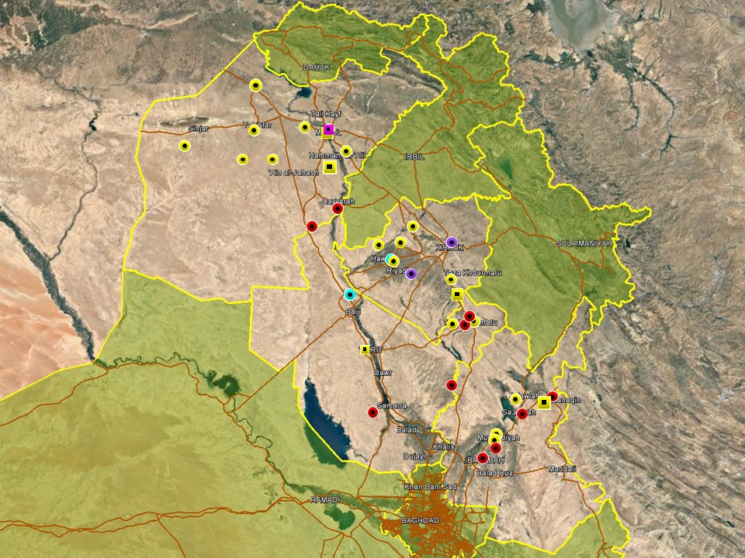

Relatively high levels continued in the northern areas this week, with activity again concentrated in rural areas of Nineveh, southwestern Kirkuk and Diyala province. In Nineveh, IS activity predominantly comprised targeted assassinations in rural areas north, west and south of Mosul city, targeting tribal leaders and civilians in areas characterised by relatively low levels of security. In typical incidents, two tribal members of the Sunni Shammari tribe were targeted and killed within 24hrs in Rabia and Sinjar districts. Gunmen also targeted a bus carrying civilians on Highway 1 (Tampa) near al-Hadhar junction, injuring at least two on October 17. These incidents underline continued IS activity in rural areas where the group has escalated activity in recent weeks through asymmetric attacks. Meanwhile, activity in Mosul city was primarily characterised by arrest operations targeting suspected terrorism in eastern Mosul.

In Salah al-Din province, a relatively subdued reporting was noted, with roadside IEDs again targeting civilians and ISF in Shirqat district. One mortar round also impacted near Baiji district, injuring three civilians. Low-level IED and SAF was also recorded in Tuz Khourmatu, consistent with IS activity and local ethno-sectarian tensions.

In Kirkuk, the most significant incident took place in Kirkuk city when on October 13 a VBIED detonated in al-Mamdouha neighbourhood, injuring six civilians. This further corresponds to continuing levels of hostilities in the southwestern areas of the province, including Hawijah district. IS activity this week continued to target PMU checkpoints and ISF patrols in the area, in line with long-standing trends. ISF also dismantled a VBIED on October 14 without incident.

Hostilities in Diyala province remain concentrated on the Diyala River Valley and characterised by low-level SAF and IED attributed to sectarian tensions, IS sympathisers and local disputes. A mix of ethno-sectarian tensions and Sunni insurgency is also assessed to drive hostilities in the northern areas of Khanaqin and Jalawla where incidents are recorded on a near daily basis in line with a general increase seen in recent months. ISF, backed by PMU forces, also announced the start of a large-scale security operation in various areas of Diyala province including Khanaqin, Jalawla, Abu Saida and Muqdadiyah district; the operation will reportedly last until early next week.

Anbar Province
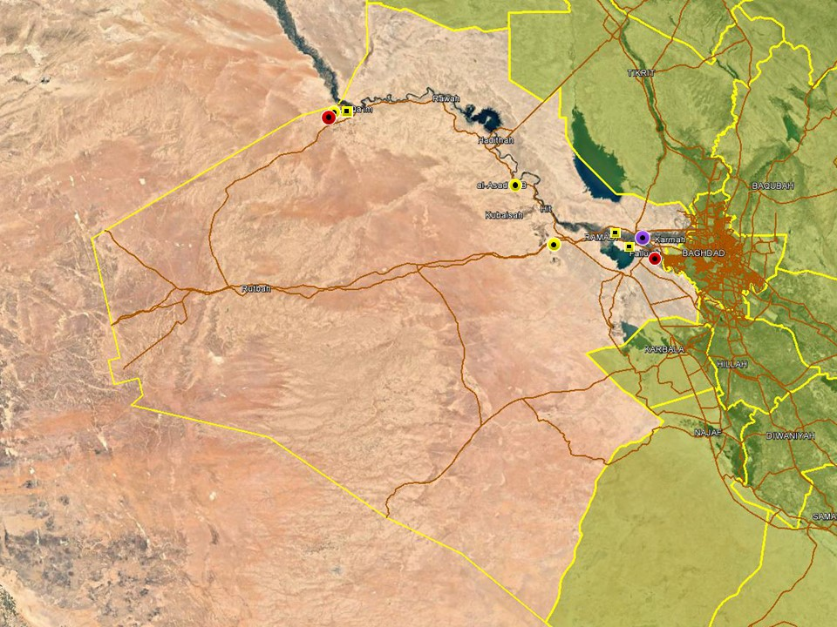

No significant changes in the overall security changes were observed in Anbar province this week with general incident trends conforming to long-standing patterns. In Fallujah, two low-yield IEDs detonated on October 11, causing no casualties in line with recent trends of intimidation style attacks likely driven by local disputes rather than terrorism. However, on October 17, ISF dismantled a VBIED in Saqlawiyah district, northwest of Fallujah without incident. Reporting from eastern Anbar was otherwise dominated by arrest operations targeting criminality and suspected terrorism.

Separately, ISF released a statement denying that a large-scale attack targeted an ISF HQ in the 35-kilo west of Ramadi on October 18, as widely reported. The statement claimed the attack merely comprised an IED detonating in front of a security patrol, injuring one ISF member and a ‘number of associates.’ The statement further called on media outlets to verify information before publication. According to the initial report, a number of assailants were involved in the attack which led to clashes with ISF and causing casualties on both sides. Separately, three IS militants were reportedly killed by ISF when they attempted to attack a checkpoint in the 18-kilo area, west of Ramadi.

Capital Region (Including Baghdad City)

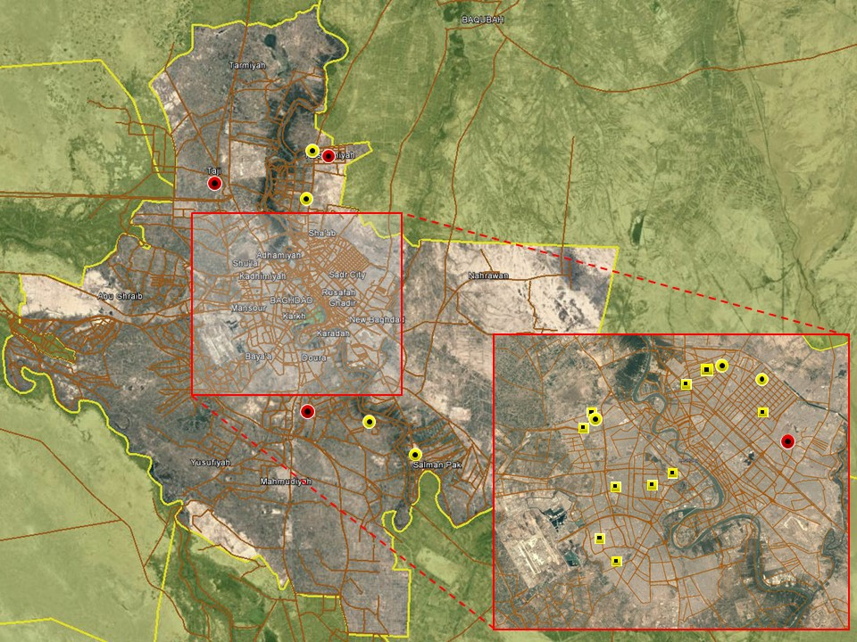

A relatively uneventful reporting period was observed in Baghdad city with no significant attacks taking place. Hostile activity was as usual confined to the northern and eastern districts of the capital, including New Baghdad and Adhamiyah districts. Incidents comprised low-level IED and SAF assessed to be related to local tensions rather than terrorism. Arguably the most significant incident took place in Sadr City, where the body of a senior member of the Sadrist Sairun Alliance was found dead with gunshot wounds. The death of cleric Sheikh Ali Saeedi was confirmed by a member of the alliance and an investigation has been launched into the incidentActivity in western Baghdad was characterised by arrest operations targeting criminality with low levels of hostilities noted during the week.

Hostilities in the provincial districts were confined to areas usually characterised by high levels of violence including Taji, Abu Ghraib, Arab Jibour and Mada’in, all involving either SAF or low-level IED attacks. As usual, this is assessed to be driven by local tensions, criminality and low-capability insurgents.

Southern Provinces
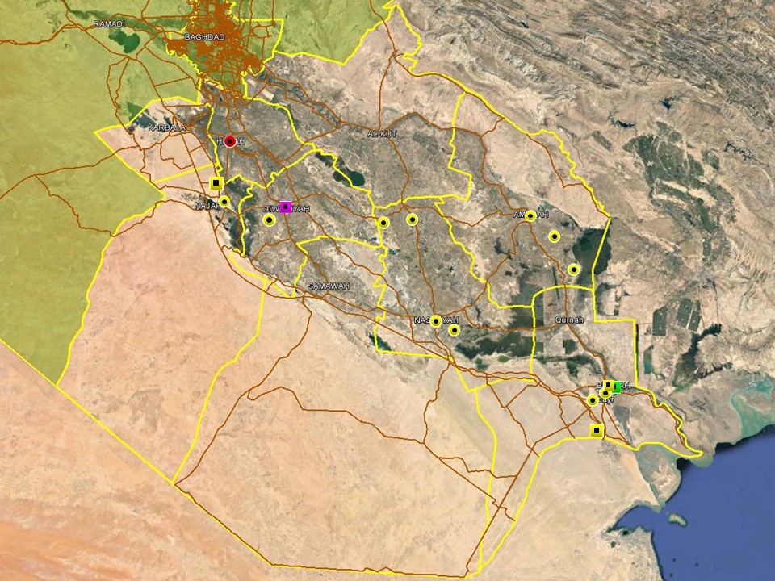

Overall trends in the southern region remain predictable with no significant changes observed during the week. Low-level Sunni insurgent activity remains confined to mixed areas in northern Babil where two PMU members were targeted and injured by a roadside IED during the week. A PMU-led security operation also commenced in the desert areas of western Karbala ahead of Arba’in commemoration to mitigate the threat of insurgent infiltration from Anbar. Tribal tensions persist in several provinces including Najaf, Maysan, Basra and Dhi Qar, with local disputes reported on separate occasions during the week in typically troubled rural areas.

he profile of violence for Basra continues to be low-level intimidatory and criminal in nature, security within the province is again now amongst the most stable in Iraq - this after the violent protest events of July, August and September have ceded for the religious period of Muharram – and also perhaps this week as thousands of security force members and PMU were deployed throughout and to the north of the province to protect Arba’in pilgrims heading to Karbala and Najaf (these large groups now out of Basra and in Muthanna and Dhi Qar). Politically, it has also been a relatively subdued period, with the only noticeable issues being discussed, linked to a replacement DG of Basra Health, the issues of further desalination and water related infrastructure and the financial success of the Governors visit to Baghdad last weekend. The monies allegedly secured should see 6,000 employed within a number of local ministries and a number of previously stalled projects linked to water infrastructure re-started and hopefully completed. Demonstrator activity has been witnessed this week, but all three events remained peaceful, recorded limited attendance and were all related to employment.

ACRONYM LIST

AII - Area of Intelligence Interest
AKA - Also Known As
AO - Area of Operations
APC - Armored Personnel Carrier
APIED - Anti-Personnel IED
AQ - Al-Qaeda
AT - Anti-Tank
ATGW - Anti Tank Guided Weapon
AVIED - Anti-Vehicle IED
BBIED - Body Borne IED
Bde - Brigade
Bn - Battalion
BXP - Border Crossing Point
CET - Convoy Escort Team
CLC - Concerned Local Citizens
CoP - Chief of Police
CP - Check Point
C-PERS - Captured Personnel
CPX - Complex Attack (attack using multiple weapon systems)
CQA - Close Quarter Assassination/Attack
DBS - Drive by Shooting
Div - Division
DoD - Department of Defense
DoS - Department of State
DoS - US Department of State
ECP - Entry Control Point
EFP - Explosively Formed Projectile
EOD - Explosive Ordinance Disposal (Bomb Squad)
ERW - Explosive Remnants of War
FoM - Freedom of Movement
GoI - Government of Iraq
HCN - Host Country National
HG - Hand Grenade
HME - Home Made Explosive
HMG - Heavy Machine Gun
HVT - High Value Target
IC - International Community
IDF - Indirect Fire (i.e.: rockets, mortars)
IDP - Internally Displaced Persons
IEC - Independent Electoral Commission
IED - Improvised Explosive Device
IM - International Military
IOC - International Oil Company
IRAM - Improvised Rocket Assisted Mortar
IRL - Improvised Rocket Launcher
IS - Islamic State
IVCP - Illegal Vehicle Check Point
IVO - In Vicinity Of
IZ - International Zone
KIA - Killed in Action
LN - Local National/Iraqi Civilian
MAIED - Magnetically attached IED (aka UVIED)
MIA - Missing in Action
MoD - Ministry of Defense
MoF - Ministry of Finance
MoFA - Ministry of Foreign Affairs
MoHE - Ministry of Higher Education
MoI - Ministry of Interior
MoJ - Ministry of Justice

MoO - Ministry of Oil
MoT - Ministry of Transportation
MSR - Main Supply Route
NFDK - No Further Details Known
NGO - Non-Governmental Organization (aid/charity)
NSTR - Nothing Significant To Report
OCG - Organized Crime Group
OPF - Oil Protection Force
PAX - Person, Persons or Passenger
PBIED - Person-Borne Improvised Explosive Device (UN Term)
PMF – Popular Mobilisation Forces
PoI - Point of Impact (for IDF)
PoO - Point of Origin (for IDF)
PSAF - Precision Small Arms Fire
PSC - Private Security Company
PSD - Private Security Detail
RCIED - Remote-Controlled IED
RPG - Rocket Propelled Grenade
RTA - Road Traffic Accident
SAF - Small Arms Fire
SAFIRE - Surface to Air FIRE
SF - Special Forces
SVBIED - Suicide Vehicle Borne IED
SVEST - Suicide Explosive Worn Vest
TCN - Third Country National
TCP - Traffic Control Point
Technical - An improvised weapon-mounted pick-up truck
TTP - Tactics, Techniques and Practices
UVIED - Under Vehicle IED
UXO - Unexploded Ordnance
VBIED - Vehicle Borne IED
VCP - Vehicle Checkpoint
WIA - Wounded in Action

GARDAWORLD INFORMATION SERVICES

From our management offices and field offices in strategic locations our constant monitoring of the high-risk environments in which we work is conveyed through our range of .Xplored™ risk analysis reports. The reports contain detailed updates, delivering current and relevant ground-truth information to assist both our personnel and our clients in their decision-making.

Our wider risk management solutions provide members of the defense, diplomatic, development, oil & gas and infrastructure sectors operating in potentially high-risk and complex environments with a comprehensive range of risk analysis, intelligence, crisis response, and training services. These services are designed to provide clients with the proactive capability to remain aware in potentially hostile environments and identify risks while strengthening their reactive capacity in emergency situations.

Our current regular reporting geographies include: Nigeria, Mali, Libya, Iraq, Afghanistan and Yemen on a daily, weekly, fortnightly, and monthly basis.

Through our constant monitoring and predictive threat analysis our Information Services team help you plan for, manage, and respond to risks.

For more information on our .Xplored reports or for information about our special-to-task reports tailored to individual client requirements, please contact us:or contact our regional representative iraq.ram@garda.com (Mobile: +964 7823 783 972)

For more information on how our services can support your business in Iraq contact:
Daniel Matthews, Senior Director Iraq daniel.matthews@garda.com

GARDAWORLD

A global leader in comprehensive security and risk management

GardaWorld International Protective Services is the international security division of GardaWorld Security Corporation, the world's largest privately owned security company with over 62,000 global staff.

We support clients in emerging, complex and high-risk markets around the world with static security, security consulting, risk analysis and reporting, crisis management and business continuity, mobile security, close protection, training and kidnap for ransom and extortion response solutions.

We work across multiple business sectors to provide protection and security for clients in the extractives, aerospace and defense, critical infrastructure, government and diplomatic and development sectors to secure employees, assets, and reputation so clients can focus solely on running daily operations and growing their business.

Discover more about the markets we serve and to learn how our international security solutions can help you contact us today: gwinfo@garda.com

Middle East
International Protective Services Headquarters
Office 2502, Tower 2, Currency House
DIFC, PO Box 482069
Dubai, United Arab Emirates

United States
1101 Wilson Boulevard
Suite 1725
Arlington, VA, 22209
United States

UK
5th Floor
1, London Bridge
London
SE1 9BG

Europe
37-39 rue des Deux Eglises
1000 Brussels
Belgium

garda.com

