Instructions:

Dear Bidder;
Please note that the last day in submitting your priced BOQ and all the other requirements will be on Wednesday the 31th of October 2018 by 5 PM.
Please note that you can drop your sealed packages every day from 9 AM to 5 PM except Fridays, Saturdays at the SP Qaraqosh office or the Erbil SP office.
Our address is:
SP Erbil office - Erbil, Atconz, R2/111.
SP Qaraqosh office – Qaraqosh *see map below.

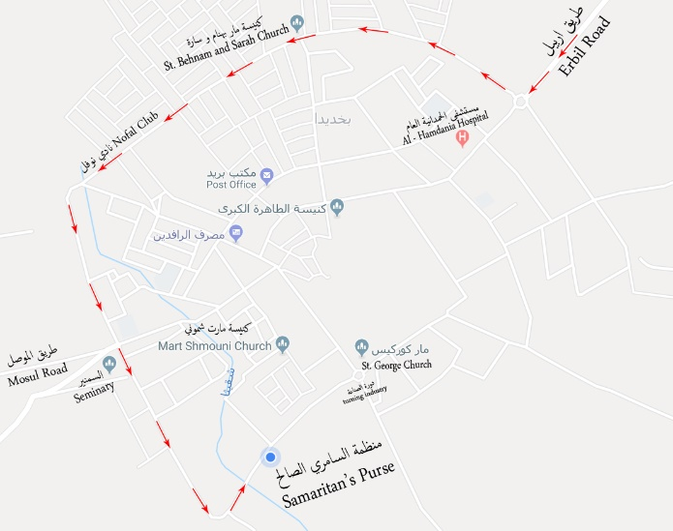

Note: No closed bids will be received after Wednesday October 31th, 2018, by 5 PM
Note: Please attach a copy of the following in your sealed package. Your company's registration, Chamber of commerce, Company's CV, References list, Tax registration, Bank information.

