- Technical Specifications

Item No | Product Name | Product Specifications | Quantity | Unit | Similar Reference Pictures
1 | Irrigation hose | Material: Plastic  Type: Thermoplastic pipe.  Size: 2”  Length: 25 meters.  Shape: As Shown round.  Color: Blue, Red and green.  Usage: water supply pipe. | 7 | pcs | 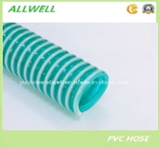
2 | Irrigation hose | Material: Plastic.  Type: Thermoplastic pipe.  Size: 1’’  Length: 25 meters.  Shape: As Shown Round.  Color: Blue, red and green.  Usage: water supply pipe. | 25 | Pcs
3 | Irrigation Tap | Material: polyethylene  Type: high density polyethylene tap.  Size: diameter 20 mm, normal and serrated.  Length: 95 mm  Shape: As Shown  Color: As Available.  Usage: Water Irrigation System tap. Each sack contains 100 Pieces . | 22 | Sack | 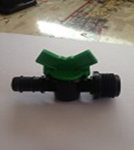
4 | Irrigation nozzle | Material: polyethylene  Type: high density polyethylene nozzle  Size: diameter 20 mm  Length: 20 mm  Shape: As Shown as shown  Usage: Water Irrigation System nozzle. Each sack contains 100 Pieces . | 95 | sack | 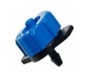
5 | Irrigation stopper | Material: polyethylene  Type: high density polyethylene stopper.  Size: diameter 20 mm.  Length: 40 mm  Shape: As Shown  Usage: Water Irrigation System. Each sack contains 100 pieces. | 32 | sack | 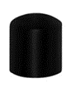
6 | Irrigation connecter | Material: polyethylene.  Type: high density polyethylene.  Size: diameter 20 mm.  Length: 65 mm  Shape: As Shown  Usage: Water Irrigation System. Each sack contains 100 pieces. | 16 | sack | 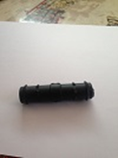
7 | Irrigation pipe | Material: polyethylene  Type: high density polyethylene pipe.  Size: 20 mm.  Length: 300 meters.  Shape: As Shown round.  Color: black.  Usage: Water Irrigation System. | 50 | pcs | 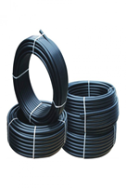
8 | Irrigation pipe | Material: polyethylene  Type: high density polyethylene pipe.  Size: 63 mm.  Length: 100 meters.  Shape: As Shown round.  Color: black.  Usage: Water Irrigation System. | 2 | pcs | 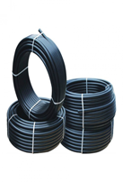
9 | Drip irrigation stand | Material: polyethylene  Type: high density polyethylene.  Size: diameter 1.5’’ by 3/4 “.  Length: 90 mm  Shape: As Shown as shown  Color: As Available.  Usage: Irrigation system | 170 | pcs | 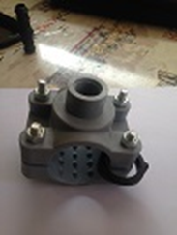
10 | Drip irrigation stand | Material: polyethylene  Type: high density polyethylene.  Size: diameter 2’’ by 3/4".  Length: 110 mm  Shape: As Shown  Color: As Available.  Usage: Water Irrigation System. | 10 | pcs | 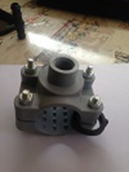
11 | Drip irrigation stand | Material: polyethylene  Type: high density polyethylene.  Size: diameter 2.5’’ to ¾.  Length: 130 mm  Color: As Available  Usage: Water Irrigation System. | 5 | pcs | 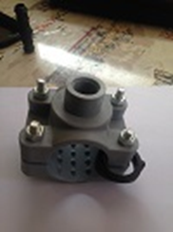
12 | Drip irrigation stand | Material: polyethylene  Type: high density polyethylene.  Size: diameter 2.5’’ to 1.5’’.  Length: 130 mm  Shape: As Shown  Color: any available  Usage: Water Irrigation System. | 30 | pcs
13 | Drip irrigation stand | Material: polyethylene  Type: high density polyethylene.  Size: diameter 3’’ by 1.5’’  Length: 150 mm  Shape: As Shown  Color: any available  Usage: Water Irrigation System | 12 | pcs | 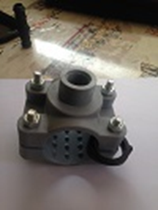
14 | Drip irrigation stand | Material: polyethylene  Type: high density polyethylene.  Size: diameter 2’’ by 1.5’’.  Length: 110 mm  Shape: As Shown  Color: available color.  Usage: Water Irrigation System | 10 | pcs | 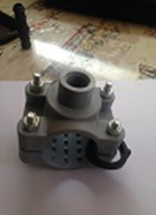
15 | Irrigation lock | Material: polyethylene.  Type: high density polyethylene.  Size: diameter 2.5 inch.  Length: 200 mm  Shape: As Shown  Color: As Available.  Usage: Water Irrigation System | 8 | pcs | 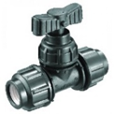
16 | Irrigation connector | Material: polyethylene.  Type: high density polyethylene.  Size: diameter 3”.  Length: 270 mm  Shape: As Shown  Color: As Available  Usage: Water Irrigation System | 8 | pcs | 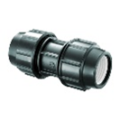
17 | Irrigation connector | Material: polyethylene  Type: high density polyethylene.  Size: diameter 2.5’’  Length: 240 mm  Shape: As Shown  Color: As Available  Usage: Water Irrigation System | 8 | pcs
18 | Irrigation hose Tetep | Material: Plastic.  Type: thermoplastic pipe.  Size: Diameter 17 mm.  Length: 1500 meters.  Shape: As Shown round.  Color: black.  Usage: Water Irrigation System. | 4 | pcs | 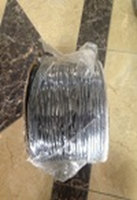
19 | Drip Irrigation | Material: polyethylene  Type: high density polyethylene.  Size: Diameter 75 mm .  Length: 100 meters.  Shape: As Shown round.  Color: black  Usage: water supply pipe. | 2 | pcs | 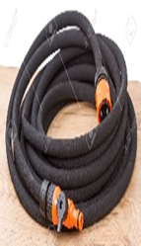
20 | Steel Irrigation lock | Material: steel stainless.  Type: steel.  Size: 2.5 inch.  Length: more than 130 mm, height: more than 125 mm.  Fluid temperature: -10 to 150 C.  Shape: As Shown  Color: As Available  Usage: Water Irrigation System | 8 | pcs | 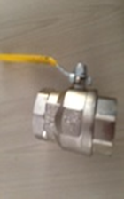
21 | Steel irrigation lock | Material: steel stainless.  Type: steel.  Size: 2 inches.  Length: more than 120 mm, height: more than 110 mm.  Fluid temperature: -10 to 150 C.  Shape: As Shown  Color: As Available  Usage: Water Irrigation System | 24 | pcs | 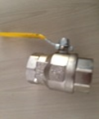
22 | Steel irrigation lock | Material: steel stainless.  Type: steel.  Size: 3 inches.  Length: more than 160 mm, height: more than 150 mm.  Fluid temperature: -10 to 150 C.  Shape: As Shown  Color: As Available  Usage: Water Irrigation System | 12 | pcs | 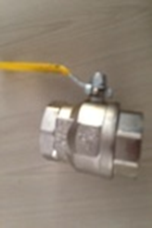
23 | Steel irrigation lock | Material: steel stainless.  Type: steel.  Size: 4 inches.  Length: more than 160 mm, height: more than 200 mm.  Fluid temperature: -10 to 150 C.  Shape: As Shown  Color: As Available  Usage: Water Irrigation System | 6 | pcs | 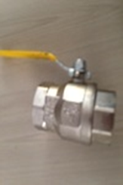
24 | irrigation connector | Material: steel stainless.  Type: steel.  Size: 2 inches.  Length: more than 80 mm, height: more than 55 mm.  Fluid temperature: -10 to 150 C.  Shape: As Shown  Color: As Available  Usage: Water Irrigation System | 8 | pcs | 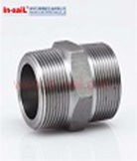
25 | irrigation connector | Material: steel stainless.  Type: steel.  Size: 3 inches.  Length: more than 90 mm, height: more than 80 mm.  Fluid temperature: -10 to 150 C.  Shape: As Shown Color: As Available  Usage: Water Irrigation System | 8 | pcs | 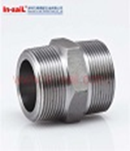
26 | irrigation Reverse | Material: steel stainless.  Type: reverse steel.  Size: 2 inches.  Length: more than 120 mm, height: more than 55 mm.  Fluid temperature: -10 to 150 C.  Shape: As Shown  Color: As Available  Usage: Water Irrigation System | 8 | pcs | 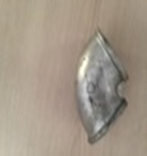
27 | irrigation Reverse | Material steel stainless.  Type: steel.  Size: 3 inches.  Length: more than 200 mm, height: more than 80 mm.  Fluid temperature: -10 to 150 C.  Shape: As Shown  Color: As Available  Usage: Water Irrigation System | 8 | pcs | 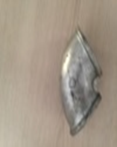
28 | irrigation division | Material: steel stainless.  Type: steel.  Size: 2 inches.  Length: more than 110 mm, height: more than 56 mm.  Fluid temperature: -10 to 150 C.  Shape: As Shown  Color: As Available  Usage: Water Irrigation System | 8 | pcs | 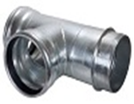
29 | irrigation division | Material: steel stainless.  Type: steel.  Size: 3 inches.  Length: more than 140 mm, height: more than 80 mm.  Fluid temperature: -10 to 150 C.  Shape: As Shown  Color: As Available  Usage: Water Irrigation System | 9 | pcs | 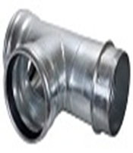
30 | irrigation stopper | Material: steel stainless.  Type: steel.  Size: 2 inches.  Length: more than 40 mm, height: more than 55 mm.  Fluid temperature: -10 to 150 C.  Shape: As Shown  Color: As Available  Usage: Water Irrigation System | 8 | pcs | 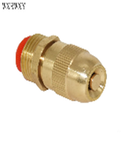
31 | irrigation stopper | Material: steel stainless.  Type: steel.  Size: 3 inches.  Length: more than 50 mm, height: more than 80 mm.  Fluid temperature: -10 to 150 C.  Shape: As Shown  Color: As Available  Usage: Water Irrigation System | 8 | pcs | 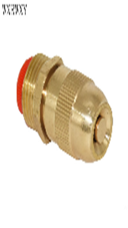
32 | irrigation lock | Material: steel stainless.  Type: steel.  Size: ¾ inch.  Length: more than 70 mm, height: more than 60 mm.  Fluid temperature: -10 to 150 C.  Shape: As Shown  Color: As Available  Usage: Water Irrigation System | 70 | pcs | 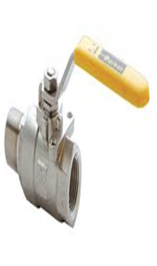
33 | Irrigation lock | Material: steel stainless.  Type: steel.  Size: 1 inch.  Length: more than 75 mm, height: more than 25 mm.  Fluid temperature: -10 to 150 C.  Shape: As Shown  Color: As Available  Usage: Water Irrigation System | 10 | pcs | 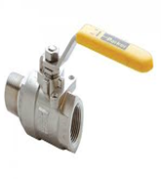
34 | Irrigation lock | Material: steel stainless.  Type: steel.  Size: ½ inch.  Length: more than 50 mm, height: more than 25 mm.  Fluid temperature: -10 to 150 C.  Shape: As Shown  Color: As Available  Usage: Water Irrigation System | 50 | pcs
35 | Irrigation miniature | Material: steel stainless.  Type: steel.  Size: 2 to 3 inches.  Length: more than 40 mm,  Fluid temperature: -10 to 150 C.  Shape: As Shown  Color: As Available  Usage: Water Irrigation System | 8 | pcs | 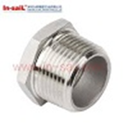
36 | Irrigation tap | Material: steel stainless.  Type: steel.  Size: ¾ inch.  Length: more than 100 mm, height: more than 65 mm.  Fluid temperature: -10 to 150 C.  Shape: As Shown  Color: As Available  Usage: Water Irrigation System | 102 | pcs | 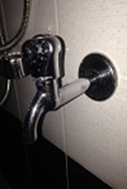
37 | Irrigation tap | Material: steel stainless.  Type: steel.  Size: ½ inch.  Length: more than 80 mm, height: more than 65 mm.  Fluid temperature: -10 to 150 C.  Shape: As Shown  Color: As Available  Usage: Water Irrigation System | 50 | pcs | 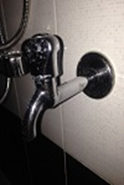
38 | Irrigation tap | Material: steel stainless.  Type: steel.  Size: 1 inch.  Length: more than 120 mm, height: more than 75 mm.  Fluid temperature: -10 to 150 C.  Shape: As Shown  Color: As Available  Usage: Water Irrigation System | 300 | pcs
39 | Irrigation lock | Material: polyethylene.  Type: high density polyethylene.  Size: diameter 2 inches.  Length: 200 mm  Shape: As Shown  Color: As Available  Usage: Water Irrigation System | 26 | pcs | 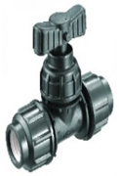
40 | irrigation lock | Material: polyethylene.  Type: high density polyethylene.  Size: diameter 3 inches.  Length:  Shape: As Shown  Color: As Available  Usage: Water Irrigation System | 11 | pcs | 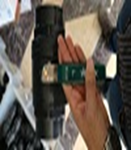
41 | Irrigation connector | Material: polyethylene.  Type: high density polyethylene.  Size: diameter 1 inch.  Length: 130 mm  Shape: As Shown  Color: As Available  Usage: Water Irrigation System | 40 | pcs | 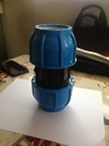
42 | Irrigation connector | Material: polyethylene.  Type: high density polyethylene.  Size: diameter 2 inches.  Length: 200 mm  Shape: As Shown  Color: As Available  Usage: Water Irrigation System | 12 | pcs | 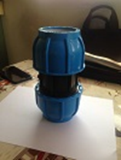
43 | Irrigation connector | Material: polyethylene.  Type: high density polyethylene.  Size: diameter 2.5 inches.  Length: 225 mm  Shape: As Shown  Color: As Available  Usage: Water Irrigation System | 5 | pcs | 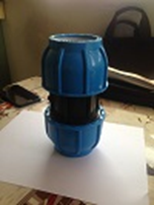
44 | Irrigation connector | Material: polyethylene.  Type: high density polyethylene.  Size: diameter 3 inches.  Length: 250 mm  Shape: As Shown  Color: As Available  Usage: Water Irrigation System | 4 | pcs | 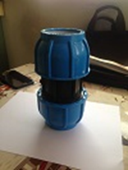
45 | irrigation Reverse | Material: polyethylene.  Type: high density polyethylene.  Size: diameter 1 inches.  Length: 180 mm  Shape: As Shown  Color: As Available  Usage: Water Irrigation System | 80 | pcs | 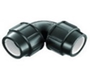
46 | irrigation Reverse | Material: polyethylene.  Type: high density polyethylene.  Size: diameter 2 inches.  Length: 230 mm  Shape: As Shown  Color: As Available  Usage: Water Irrigation System | 38 | pcs | 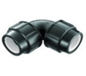
47 | Irrigation Reverse | Material: polyethylene.  Type: high density polyethylene.  Size: diameter 2.5 inches.  Length: 270 mm  Shape: As Shown  Color: As Available  Usage: Water Irrigation System | 6 | pcs | 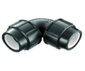
48 | Irrigation Reverse | Material: polyethylene.  Type: high density polyethylene.  Size: diameter 3 inches.  Length: 300 mm  Shape: As Shown  Color: As Available  Usage: Water Irrigation System | 6 | pcs
49 | irrigation stand | Material: polyethylene.  Type: high density polyethylene.  Size: diameter 2 inches.  Length: 110 mm  Shape: As Shown  Color: As Available  Usage: Water Irrigation System | 75 | pcs | 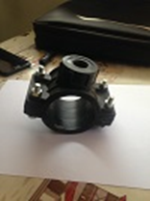
50 | Irrigation stand | Material: polyethylene.  Type: high density polyethylene.  Size: diameter 3 inches.  Length: 150 mm  Shape: As Shown  Color: As Available  Usage: Water Irrigation System | 6 | pcs
51 | Irrigation lock | Material: polyethylene.  Type: high density polyethylene.  Size: diameter 1 inches.  Length: 145 mm  Shape: As Shown  Color: As Available  Usage: Water Irrigation System | 125 | pcs | 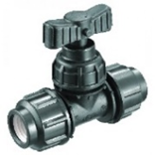
52 | Irrigation lock | Material: polyethylene.  Type: high density polyethylene.  Size: diameter ¾ inches.  Length: 110 mm  Shape: As Shown  Color: As Available  Usage: Water Irrigation System | 50 | pcs
53 | Irrigation lock | Material: polyethylene.  Type: high density polyethylene.  Size: diameter ½ inch.  Length: 80 mm  Shape: As Shown  Color: As Available  Usage: Water Irrigation System | 24 | pcs | 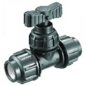
54 | Irrigation stopper | Material: polyethylene.  Type: high density polyethylene.  Size: diameter 2 inches.  Length: 120 mm  Shape: As Shown  Color: As Available  Usage: Water Irrigation System | 32 | pcs
55 | Irrigation stopper | Material: polyethylene  Type: high density polyethylene.  Size: diameter 1.5 inches.  Length: 90 mm  Shape: As Shown  Color: As Available  Usage: Water Irrigation System | 24 | pcs | 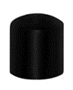
56 | Irrigation stopper | Material: polyethylene.  Type: high density polyethylene.  Size: diameter 2.5 inches.  Length: 140 mm  Shape: As Shown  Color: As Available  Usage: Water Irrigation System | 5 | pcs
57 | Irrigation stopper | Material: polyethylene.  Type: high density polyethylene.  Size: diameter 3 inches.  Length: 170 mm  Shape: As Shown  Color: As Available  Usage: Water Irrigation System | 6 | pcs
58 | Irrigation miniature | Material: polyethylene.  Type: high density polyethylene.  Size: diameter 3 to 2 inches.  Length: 240 mm  Shape: As Shown  Color: As Available  Usage: Water Irrigation System | 6 | pcs | 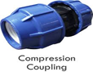
59 | Irrigation division | Material: polyethylene.  Type: high density polyethylene.  Size: diameter 2 inches.  Length: 270 mm  Shape: As Shown  Color: As Available  Usage: Water Irrigation System | 32 | pcs | 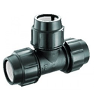
60 | Drip Irrigation | Material: polyethylene  Type: high density polyethylene.  Size: diameter 2 inches.  Length: 100 meters.  Shape: As Shown round.  Color: black  Usage: water supply pipe. | 14 | pcs | 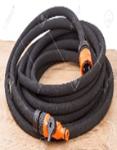
61 | Pipe | Material: polyethylene  Type: high density polyethylene.  Size: Diameter 16 mm.  Length: 400 meters.  Shape: As Shown round.  Color: black.  Usage: Water Irrigation System. | 25 | pcs | 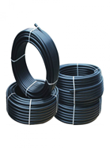
62 | Drip irrigation | Material: polyethylene  Type: high density polyethylene  Size: diameter 3 inches.  Length: 100 meters.  Shape: As Shown round.  Color: black.  Usage: water supply pipe. | 3 | pcs | 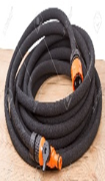
63 | Irrigation Lock | Material: polyethylene.  Type: high density polyethylene.  Size: diameter 4 inches.  Length:320 mm  Shape: As Shown  Color: As Available  Usage: Water Irrigation System  Italy or equivalent international standards | 4 | Pcs | 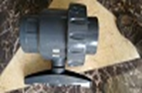
64 | Jack valve | Material: steel stainless.  Type: steel.  Size: 6 inches.  Length: more than 450 mm, height: more than 225 mm.  Fluid temperature: -10 to 150 C.  Shape: As Shown  Color: As Available  Usage: Water Irrigation System | 1 | pcs | 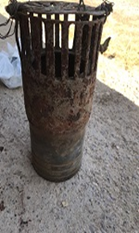
65 | Plastic hose | Material: Plastic  Type: Thermoplastic pipe.  Size: 6 inches.  Length: 12 meters.  Shape: As Shown round.  Color: Black, Red and green.  Usage: water supply pipe. | 12 | M.L  METRE LENGTH | 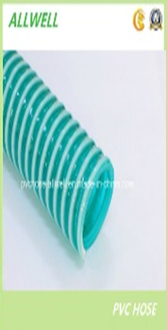
66 | Ring (Washer) | Material: Plastic.  Type: Thermoplastic ring.  Size: diameter 2.5 inches.  Shape: As Shown  Color: As Available  Usage: Water Irrigation System | 200 | pcs | 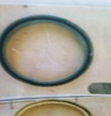
67 | Ring (Washer) | Material: Plastic.  Type: Thermoplastic ring  Size: diameter 5 inches.  Shape: As Shown  Color: As Available  Usage: Water Irrigation System | 100 | pcs | 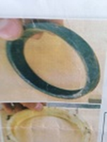
68 | irrigation connector | Material: polyethylene.  Type: high density polyethylene.  Size: diameter 1.5 inches.  Length: 150 mm  Shape: As Shown  Color: As Available  Usage: Water Irrigation System | 22 | pcs | 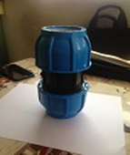
69 | Plastic irrigation hose 1.5" | Material: polyethylene  Type: thermoplastic pipe.  Size: diameter 1.5 inches.  Length: 100 meters.  Shape: As Shown round.  Color: As Available black.  Usage: water supply pipe. | 18 | pcs
70 | Irrigation division | Material: polyethylene.  Type: high density polyethylene.  Size: diameter 1.5 inches.  Length: 210 mm  Shape: As Shown  Color: As Available  Usage: Water Irrigation System | 68 | pcs | 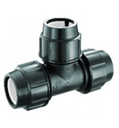
71 | Irrigation lock | Material: polyethylene.  Type: high density polyethylene.  Size: diameter 1.5 inches.  Length: 120 mm  Shape: As Shown  Color: As Available  Usage: Water Irrigation System | 12 | pcs | 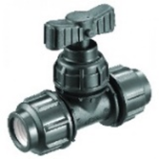
72 | Sprinkler spray | Material: polyethylene.  Type: Spray.  Size: diameter 5 mm.  Length: 140 mm  Shape: As Shown  Color: As Available  Usage: used in green houses as hanging sprinkler. | 125 | pcs | 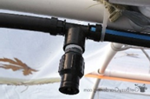
73 | Fittings | Material: polyethylene.  Type: high density polyethylene.  Size: diameter 90 mm.  Length: 150 -175 mm  Shape: As Shown  Color: As Available  Usage: Water Irrigation System | 40 | pcs | 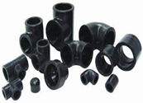
74 | clamp | Material: steel.  Type: stainless steel.  Size: 1 inch.  Length: 25 mm  Shape: As Shown  Color: As Available  Usage: Water Irrigation System | 150 | pcs | 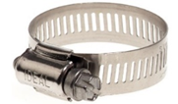
75 | Cap | Material: polyethylene.  Type:  Size: diameter ¾ inches.  Length: 60 mm  Shape: As Shown  Color: As Available  Usage: Water Irrigation System | 50 | pcs | 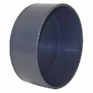
76 | Cap | Material: polyethylene.  Type:  Size: diameter 1 inch.  Length: 80 mm  Shape: As Shown  Color: As Available  Usage: Water Irrigation System | 50 | pcs | 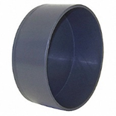
77 | Irrigation reverser | Material: polyethylene.  Type: high density polyethylene.  Size: diameter 1.5 inches.  Length: 210 mm  Shape: As Shown  Color: As Available  Usage: Water Irrigation System | 18 | pcs | 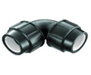

- DELIVERY TIME AND DELIVERY LOCATION

- The Delivery Location is GIZ/CFW warehouse in Duhok City.
- Supplier must specify delivery time in bid form.

- REMARKS AND CONDITIONS

- Providing, Supplying, and Transportation costs (loading and unloading) are included in the price.
- Catalogues or samples will be requested by GIZ during process for the needed items and GIZ will physically check and approve and the rest quantity will be provided after that.
- The laboratory test cost are included in price.
- In case any conflict between GIZ and supplier regarding the quality check of the product, Duhok construction laboratory will the reference to check the quality of the product.

