
ANNEX 1. Technical Specifications

PN 17.4047.1-002.00

Item No | Product Name | Product Specifications | Qt. | Unit
1. | Size A, wooden rulers 4m length x 10cm width x 2cm thickness. | size A, wooden rulers, Russian Origin or better, from Pine trees, each ruler of 4m length x 10cm width x 2cm thickness, the ruler must be straight , firm ,without any blemishes or imperfections, out of fractions or cracks , the price includes painting the rulers with two layers of oil paintings ( Iraqi Oil Paints or equivalent ) with dark green color ,the rulers will be used in renovating the existing green house in seed bank Nursery in Khabat town. | 40 | Pcs
2. | Size B, wooden rulers 1.6m length x 5cm width x 2cm thickness) | size B, wooden rulers, Russian Origin or better, from Pine trees, each ruler of 1.6m length x 5cm width x 2cm thickness , the ruler must be straight , firm ,without any blemishes or imperfections, out of fractions or cracks , the price includes painting the rulers with two layers of oil paintings ( Iraqi Oil Paints or equivalent ) with dark green color ,the rulers will be used in renovating the existing green house in seed bank Nursery in Khabat town. | 4.000 | Pcs

- DELIVERY
- The delivery location is Seed Bank Olive Nursery in Khabat District – Erbil Governorate , Iraq.

- REMARKS AND CONDITIONS
- Providing, Supplying, and Transportation costs (loading and unloading) are included in the price.
- The Supplier must specify the delivery time in the Bid Form.
- Painted Samples will be requested by GIZ during technical evaluation process for the needed items

- Details of the wooden rulers and sample image:

Size A :

MDF Wooden Sheet
Lower Part
Painted Wooden ruler 4m length x 10cm width x 2cm thickness

Size B :

Painted Wooden ruler 1.6m length x 5cm width x 2cm thickness

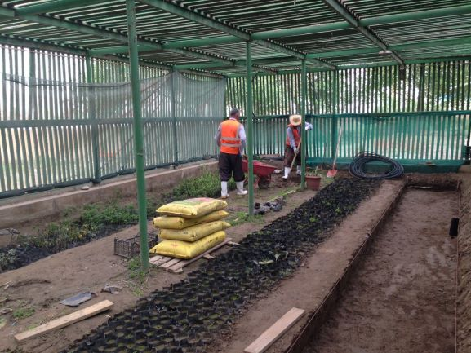

Image 1 : a greenhouse

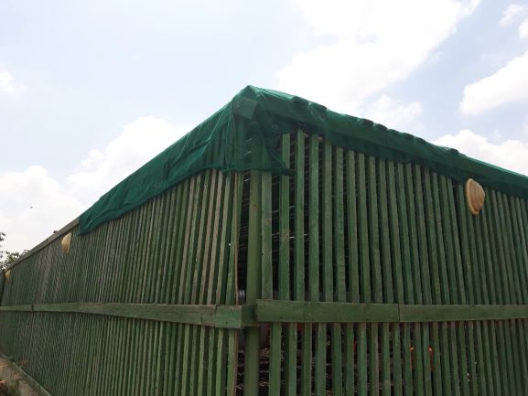

Image 2 : ( Both sizes A & B wooden rulers )

