- Technical Specifications of Items
Item No | Product Name | Product Specifications | Quantity | Unit | Reference Picture
1 | Pen | Trimate or equivalent model, each pack consists of 12 pens. | 120 | pack | 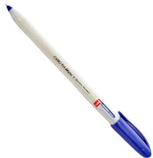
2 | Soft Pen | Uni-ball Eye Rollerball Pen or equivalent model, each pack consists of 12 soft pens. | 60 | Pack | 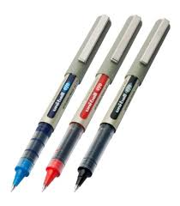
3 | Sticky Notes | sticky notes paper different colors, Approx. 7.5 cm* 7.5 cm, each pack consists of 4 colors and each pack consists of 400 sheets | 120 | Pack | 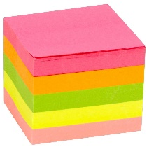
4 | Iron ruler | 30CM stainless straight edge steel ruler | 150 | Pcs | 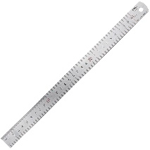
5 | A4 paper | Double A A4 copy paper 80 GCM or equivalent model. Each box consists of 5 reams | 60 | box | 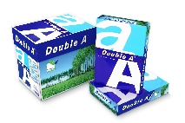
6 | Stapler | Stapler of mixed materials; steel and plastic, with size 22-26/6 | 60 | Pcs | 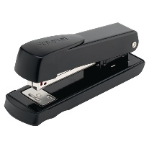
7 | Staples | Steel staples, yellow color 24/6 each box consists of 10 mini boxes which consists of 1000 staples. | 60 | box | 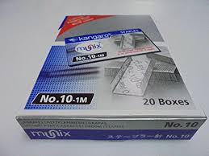
8 | Puncher | puncher of mixed materials; steel and plastic, with punch size 4.0mm | 60 | pcs | 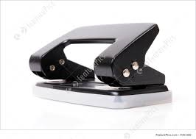
9 | Small Envelop | Paper envelop template size 500*297, each box consists of 10 packs, each pack consists of 20 pcs light brown or while color | 150 | box | 
10 | A3 size envelop | A3 Paper envelop template size 718*1092, each box consists of 10 packs, each pack consists of 20 pcs light brown or while color | 150 | box | 
11 | A4 Size Envelop | A4 paper envelop template e 210*297, each box consists of 10 packs, each pack consists of 20 pcs light brown or while color | 150 | box | 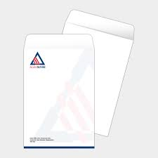
12 | Correction pen | UNI-Ball Correction Pen - CLP – 300 equivalent model, each pack consists of 12 soft pens. | 30 | Pack | 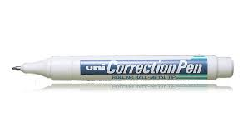
13 | A4 clear bag | White transparent file size A4 with three edges closed and one edge open. Closure Folders Files Bags 50 Pcs | 12 | Pack | 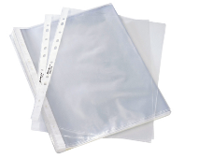
14 | Paper tray 3 layer | Metal Mess 3 Tier File Tray, Stackable Document Tray, 3 Layer Tray | 30 | Pcs | 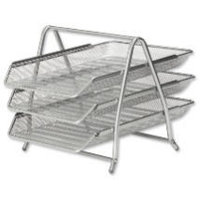
15 | White Board | Magnetic white board approx. 100*180 cm light aluminum frame with double faces | 6 | Pcs | 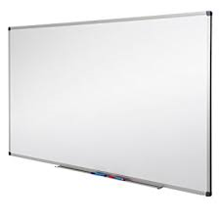
16 | Box file | Thick cartoon box file size A4 with approx. width 28cm* length 32 cm, each box consists of 50 | 12 | box | 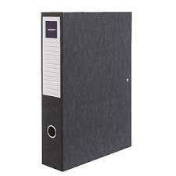
17 | Carbon paper to use under papers | Carbon paper ink used under the paper for easy copying, with the size of A4, each pack consists of 100 pcs | 12 | Packs | 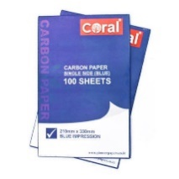
18 | Scissors | Scissors for paper and nylon medium size | 120 | PCS | 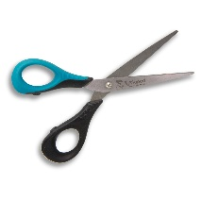
19 | Paper Cutter 180 gram | Precise Desktop Manual Paper Cutter | 12 | PCS | 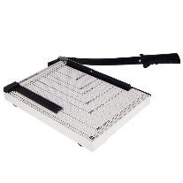

- DELIVERY
- The delivery locations are per below table:
# | Items | Location
# | Items | Duhok City | Zakho City | Erbil City | Soran City | Sulaimani City |  | Kalar City
1 | Pen | 20 | 20 | 20 | 20 |  | 20 | 20
2 | Soft Pen | 10 | 10 | 10 | 10 |  | 10 | 10
3 | Sticky Notes | 20 | 20 | 20 | 20 |  | 20 | 20
4 | Iron ruler | 25 | 25 | 25 | 25 |  | 25 | 25
5 | A4 paper | 10 | 10 | 10 | 10 |  | 10 | 10
6 | Stapler | 10 | 10 | 10 | 10 |  | 10 | 10
7 | Staples | 10 boxes | 10 boxes | 10 boxes | 10 boxes |  | 10 boxes | 10 boxes
8 | Puncher | 10 | 10 | 10 | 10 |  | 10 | 10
9 | Small Envelop | 25 | 25 | 25 | 25 |  | 25 | 25
10 | Large envelop | 25 | 25 | 25 | 25 |  | 25 | 25
11 | A4 Size Envelop | 25 | 25 | 25 | 25 |  | 25 | 25
12 | Correction pen | 5 | 5 | 5 | 5 |  | 5 | 5
13 | Nilon file | 2 pack | 2 pack | 2 pack | 2 pack |  | 2 pack | 2 pack
14 | Paper tray 3 layer | 5 | 5 | 5 | 5 |  | 5 | 5
15 | White Board | 1 | 1 | 1 | 1 |  | 1 | 1
16 | Box file | 2  Boxes | 2  Boxes | 2  Boxes | 2  Boxes |  | 2  Boxes | 2  Boxes
17 | Carbon paper to use under papers | 2 pack | 2 pack | 2 pack | 2 pack |  | 2 pack | 2 pack
18 | Scissors | 20 | 20 | 20 | 20 |  | 20 | 20
19 | Paper Cutter 180 gram | 2 | 2 | 2 | 2 |  | 2 | 2

- REMARKS AND CONDITIONS
- Good quality of all stationary items offered should be Assured.
- The price includes the delivery of all items to the designated locations.
- The supplier must provide the Warranty high quality for all items which must assured.

