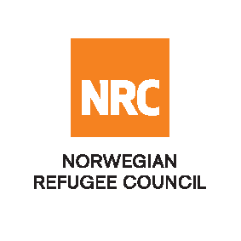

Advertisement - Tender

The Norwegian Refugee Council (NRC) is a non-governmental, humanitarian organization with 60 years of experience in helping to create a safer and more dignified life for refugees and internally displaced people.

NRC advocates for the rights of displaced populations and offers assistance within the Shelter, Education, and Emergency food security, and Legal assistance and Water, sanitation and hygiene sectors.

NRC has been present in Iraq since 2010, with offices located in Anbar province, Baghdad, Erbil, Dohuk, Hamam Al Alil, Mosul and Kirkuk. We have scaled up our response across Iraq to meet the large-scale crisis facing the country, reaching Iraqis with emergency assistance and supporting Syrian refugees as they live in exile. Our goal is to always be prepared to work in new settings, so we are establishing more local partnerships in Iraq.

No | RFQ Reference | Description
1 | IQ/BGD/027/2018 | Rehabilitation of Two Water Treatment Plants in Ramadi and Juwaiba in Anbar Governorate

The Norwegian Refugee Council (NRC) Office in Iraq invites eligible and interested bidders to participate in the tender as per referenced RFQs:

Sending bidding documents: Interested bidders can receive the invitation to bid at NRC office in Ramadi starting from 11th December 2018

Deadline : Tender closing is at 15:00 Hrs (Iraq time) on Thursday 27th December 2018 (Receiving not sending)

Submissions : All completed bids should be submitted in a sealed envelope (by hand delivery
Or courier), addressed to;
Tender Committee
Ref: Refer to RFQ reference
Norwegian Refugee Council, Anbar- Iraq

For more details about receiving the Invitation to Bid documents and about the submission, please call logistics team at 07834472687 or send an email to iq.baghdad.procurment@nrc.no.

NRC reserves the right to select/reject any bids, in part or full, as it may deem necessary without providing feedback on this regard. No liability or claim in that respect would be admissible or entertained whatsoever

