
Weekly Iraq .Xplored report
08 December 2018

Prepared by Risk Analysis Team, Iraq

garda.com

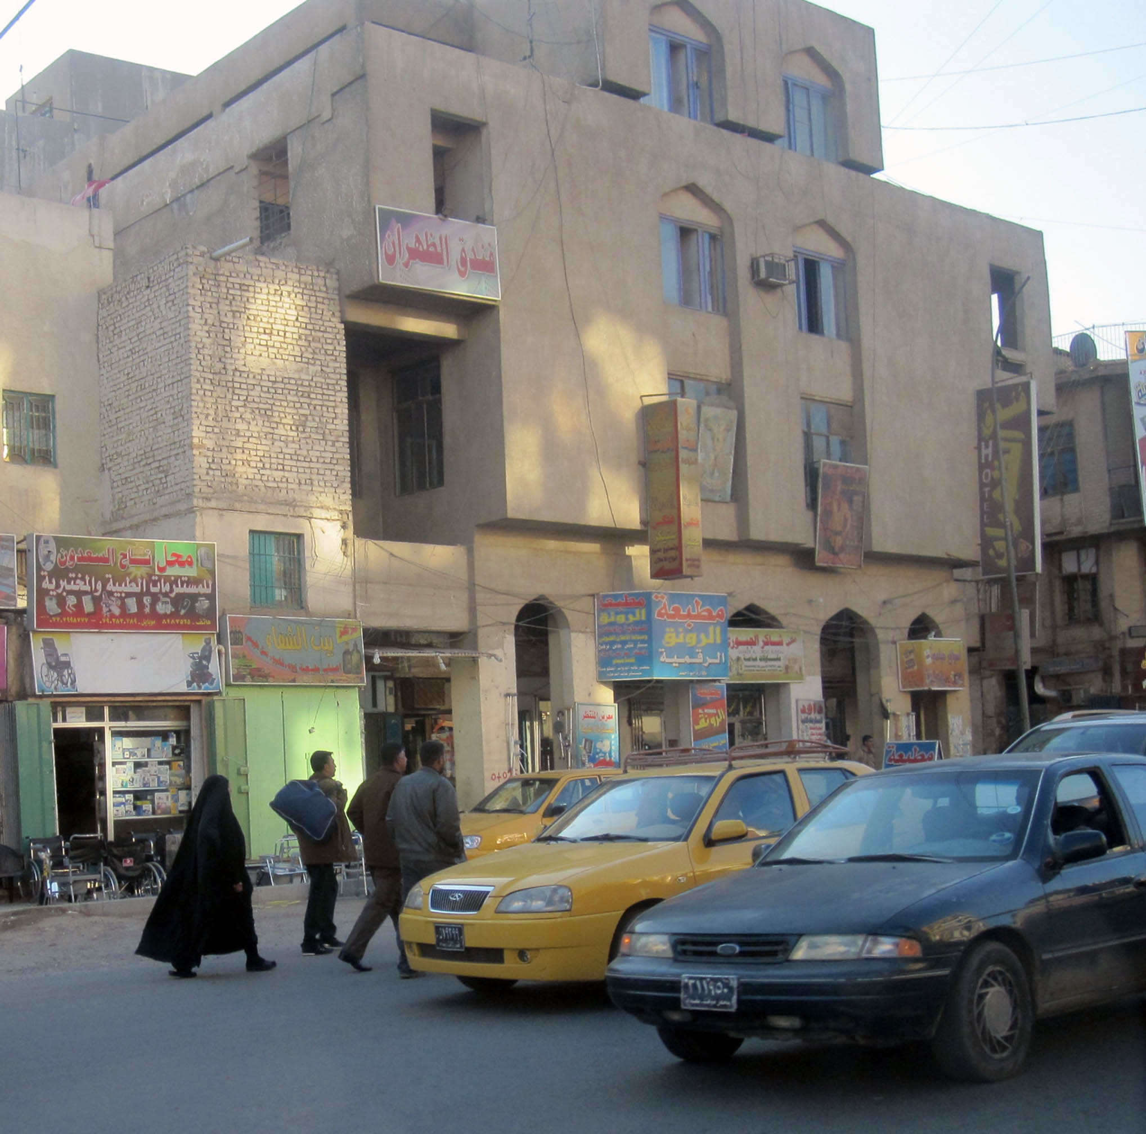

TABLE OF CONTENTS

TABLE OF CONTENTS 2
Activity Map 3
OUTLOOK 4

Short term outlook 4

Medium to long term outlook 4
Significant events 5

Parliament session to approve Cabinet ended in chaos 5

UNAMI’s monthly figures show further decline in civilian casualties 5

Heavy rains and floods continues to put pressure on Nineveh province 5
THREAT MATRIX 5
OVERVIEW 6

Political 6

Security 7

Humanitarian 9
WEEKLY OPERATIONAL ASSESSMENT 10

Countrywide Military/Security Situation 10
ACRONYM LIST 15
GARDAWORLD INFORMATION SERVICES 16
GARDAWORLD 16

Disclaimer: The information and opinions expressed in this Report are the views of GardaWorld and constitute a judgment as at the date of the Report and are subject to change without notice. The information and opinions expressed in this Report have been formed in good faith on the basis of the best information and intelligence available at the time of writing, but no representation or warranty, express or implied, is made as to its accuracy, completeness or correctness. GardaWorld accepts no liability arising out of or in connection with the comments made or the information set out in this Report and the reader is advised that any decision taken to act or not to act in reliance on this Report is taken solely at the reader’s own risk. In particular, the comments in this Report should not be construed as advice, legal or otherwise.

Activity Map

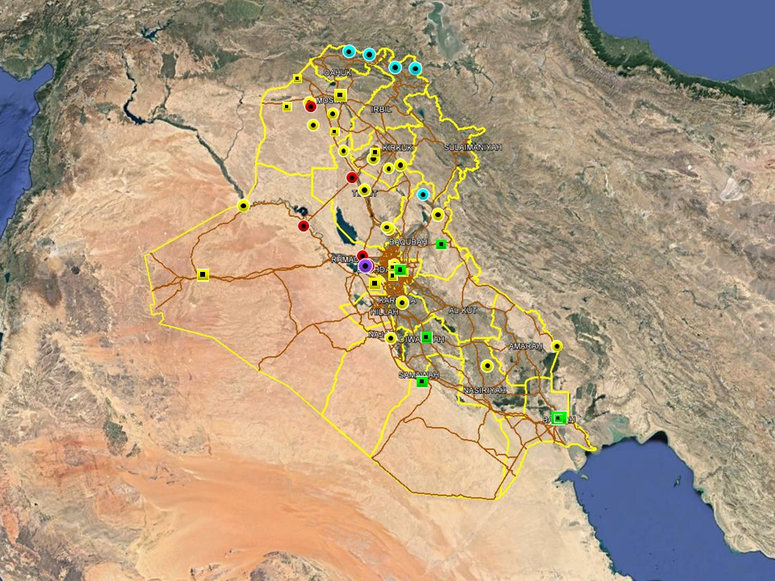

OUTLOOK

Short term outlook

- Islamic State claimed responsibility for a wave of IED attacks across Baghdad city on November 04. The five separate IED detonations claimed the lives of at least seven people and wounded 20 others and took place within two hours of each other suggesting a degree of coordination that only IS could achieve, utilising established networks within the city. However, these attacks utilised low-yield IEDs, and we have not seen large-scale, mass casualty attacks against civilian targets in Baghdad for many months. These latest attacks therefore do not necessarily mark a return to these forms of larger operations by the IS group, although they may represent a statement by IS to try and demonstrate its continued (but declining) relevance, as opposed to the start of a sustained uptick in violence.

- While the situation in Basra has calmed since the violent unrest earlier in the month, political tensions are assessed to remain high with an associated risk of spontaneous gatherings. An increased security posture for preventive reasons can be expected to remain in the city with additional security deployments and increased checkpoint scrutiny.

- IDF attacks on the International Zone, Baghdad and the US consulate near Basra International Airport suggests heightened intent to target US interests in the country. While no group has claimed responsibility for the attacks, it is likely that Iranian-backed elements are behind these incidents in an effort to harass and intimidate for political purposes. As such, the outlook for further attacks targeting US interests is assessed as increased in the coming weeks.

- Following the selection of the new President and Prime Minister focus now remains on the eight Cabinet of Minister positions that remain unresolved, including those of the Defence and Interior Ministers. Opposition from Moqtada Al-Sadr’s Sairoun alliance to the selection of non-partisan figures for the remaining posts means that there is an associated risk of demonstrations as tensions remain high, especially in Baghdad. Upcoming 2019 fiscal year budget discussions can also be expected to drive protest activity in Baghdad and the southern provinces.

Medium to long term outlook

- Sectarian violence can be expected to continue in areas of Northern Iraq which remain permissive to IS operations, including Nineveh, Salah al-Din, Diyala and southwestern Kirkuk. Attacks will continue to target security checkpoints and outpost, especially in Sunni dominated areas controlled by Shia dominated security forces.

- Islamic State activity will continue to dominate security reporting with focus on the potential resurgence of an insurgent campaign in northern and western Iraq. Despite ongoing ISF efforts to clear remaining IS pockets, the group retains a degree of freedom of movement in the desert regions of Anbar, near the Syrian border, and along the Hamrin Mountains.

- Low-level incidents related to criminality, personal disputes and tribal tensions are likely to continue in Basra and the southern region. Long-term tensions are also expected to be driven by the return of militia factions expecting material and social rewards for their contribution in the campaign against IS.

Significant events

Parliament session to approve Cabinet ended in chaos
Parliament failed to vote on the remaining positions in Prime Minister Mahdi’s cabinet during a session on December 04 which ended in chaos following controversy over the number of attendees. No new cabinet positions were filled, or even put up for a vote, and following several delays and meetings between the heads of the political blocs and PM Mahdi, Speaker Halbusi finally announced the suspension of the session. The failure to meet quorum was largely due to a boycott by several MPs from al-Islah coalition, which includes the Sadrist Sairun Alliance and Nasr, likely responding to Sadr’s recent criticism of Mahdi’s ‘partisan’ nominees

UNAMI’s monthly figures show further decline in civilian casualties
According to the UNAMI monthly casualty figures for November 2018, a total of 41 civilians were killed and another 73 injured as a result of terrorism, violence and armed conflict across the country during the month. As usual, Baghdad was the most affected province with 55 casualties in total (23 killed, 32 injured) followed by Nineveh (8 killed and 19 injured) and Anbar (4 killed and 15 injured).

Heavy rains and floods continue to put pressure on Nineveh province
Heavy rainfalls with resulting severe floods have continued in Nineveh province where federal authorities declared a state of emergency on Sunday, December 02. The statement urged residents to ‘stay away from the valley corridor as rescue teams are trying to take people out of the flooded areas’. Local observers and media outlets have since reported continuing struggles by rescue teams to alleviate civilians in exposed areas

THREAT MATRIX

Region | Political | Terrorism | Militancy | Crime | K&R
KRG* | Moderate | Low | Moderate | Low | Low
North** | Moderate | High-Extreme | High | High | High
Baghdad | Moderate | Moderate | Moderate | Moderate | Moderate
Anbar | Moderate | High | High | High | High
South*** | Moderate | Low | Moderate | Moderate | Moderate
Threat Scale | Minimal | Low | Moderate | High | Extreme

* KRG – Dohuk, Erbil & Sulaymaniyah
** North – Nineveh, Salah ad-Din, Kirkuk & Diyala
*** South – Babil, Wasit, Karbala, Najaf, Diwaniyah, Dhi Qar, Muthanna, Maysan & Basra

OVERVIEW

Political

Parliament session to approve Cabinet ended in chaos
Parliament failed to vote on the remaining positions in Prime Minister Mahdi’s cabinet during a session on December 04 which ended in chaos following controversy over the number of attendees. No new cabinet positions were filled, or even put up for a vote, and following several delays and meetings between the heads of the political blocs and PM Mahdi, Speaker Halbusi finally announced the suspension of the session. 168 MP were reported to have initially attended the session, three more than the 165 required to meet quorum, but several deputies reportedly called for a recount of the number of attendees after Halbusi proceeded with the session. The reason being that the count allegedly included people in attendance who were not MPs, including political advisors and former MPs. This reportedly led to verbal disputes and shouting amongst the MPs, including an altercation in the outside cafeteria. Despite several delays and attempts by PM Mahdi to resume the session, Halbusi eventually decided to postpone the meeting.

Islah coalition defends boycott of parliament session as pressure increases on Prime Minister Mahdi
Al-Islah coalition issued a statement defending the decision to boycott the Parliament session on December 04. Spokesperson Sabah al-Saadi said the coalition’s message was ‘clear’ with regards to rejecting attempts by other political forces to exercise external pressure on Mahdi in the nomination process and that it would continue to boycott future sessions if necessary. The statement followed a meeting attended by senior members of the coalition, including Haider al-Abadi, Iyad Allawi, Osama al-Nujafi and Khalid Obeidi. In a separate statement, Nasr MP Nada Jawdat said the session had also been boycotted because Mahdi failed to present CVs of the candidates less than 48hrs before the session. Jawdat added that the CVs had been presented on the same day with insufficient time for MPs to investigate their backgrounds.

Former PM Abadi reportedly offered VP position during meeting with Salih
Former PM Haider al-Abadi met with President Barham Salih in Baghdad on December 02 to discuss a number of ongoing political developments in the country. According to the official readout of the meeting, the two reportedly agreed on the need to find a new, joint mechanism for the appointment of ministers in order to speed up the process of electing the new cabinet. Separate, unconfirmed reports in Kurdish media outlets suggested Abadi had also been offered one of the Vice President positions by Salih. According to the reports, which quote ‘well-informed political sources close to the President’, Abadi accepted the offer however no further statements have been made.

Russian Ambassador invited Amiri and Fatah Alliance to visit Russia
In a meeting with Badr-leader Hadi al-Ameri, Russian Ambassador Maxim Maximov officially invited Ameri and senior members of al-Fatah Alliance to visit Moscow. In the readout of the meeting, Maximov praised Ameri’s role in the defeat of IS and in bringing political stability to the country. For his part, Ameri said Iraq is ‘looking forward to strengthening cooperation within the quadripartite security council involving Syria, Iran, Russia and Iraq. Ameri also welcomed Russian companies to invest in Iraq.

Nechirvan and Masrour Barzani nominated by KDP for President and Prime Minister in KRG
The KDP announced on December 03 its nomination of Masrour Barzani, head of the Kurdistan Region Security Council and son of former KRG President Massoud Barzani, for the Prime Minister position. Current KRG Prime Minister Nechirvan Barzani was also nominated for KRG President with a view to reactive the position following its suspension in 2017. The decision was made after a meeting in the KDP leadership council in Erbil.

Security

Iranian ‘hit squads’ reportedly deployed in Iraq
In an interview with a national media outlet on December 01, Ummah Party leader Mithal al-Alusi warned that Iranian ‘hit squads’ were operating in the country, threatening politicians and ordinary citizens who oppose Iranian interference in Iraqi politics. Al-Alusi was quoted saying these groups were deployed following the elections to “intimidate and silence people and threaten politicians who take stands against corruption and against the selling of Iraq to certain countries.” Al-Alusi also added that Muqtada al-Sadr and other prominent “patriots” are certainly on the top the “assassination lists”.

Ministry of Interior plays down security concerns in Nineveh
The Ministry of Interior released a statement addressing the situation in Nineveh province in light of recent concerns about the deteriorating security situation. According to spokesperson Maj. Gen Saad al-Maan, the general situation in the province and Mosul city is stable despite some ‘exaggerated reports’ about the province’s security problems. Al-Maan also denied the need for additional security reinforcements despite following calls by local MPs and officials in light of recent attacks, adding that the federal government maintains complete control over the province.

Humanitarian

UNAMI’s monthly figures show further decline in civilian casualties
According to the UNAMI monthly casualty figures for November 2018, a total of 41 civilians were killed and another 73 injured as a result of terrorism, violence and armed conflict across the country during the month. As usual, Baghdad was the most affected province with 55 casualties in total (23 killed, 32 injured) followed by Nineveh (8 killed and 19 injured) and Anbar (4 killed and 15 injured). Commenting on the figures, Special Representative Jan Kubis regretted the continuing loss of lives but noted that these figures are the lowest since the UNAMI started recording casualty statistics in 2012.

Heavy rains and floods continues to put pressure on Nineveh province
Heavy rainfalls with resulting severe floods have continued in Nineveh province where federal authorities declared a state of emergency on Sunday, December 02. The statement urged residents to ‘stay away from the valley corridor as rescue teams are trying to take people out of the flooded areas’. Local observers and media outlets have since reported continuing struggles by rescue teams to alleviate civilians in exposed areas, which include large areas of Mosul City and areas in the south along the Tigris River. Local officials and representatives have urged the federal government to urgently address the situation which has been exacerbated by incomplete sewage systems and poor infrastructure following damage during the IS-campaign.

WEEKLY OPERATIONAL ASSESSMENT

Countrywide Military/Security Situation

Northern Provinces
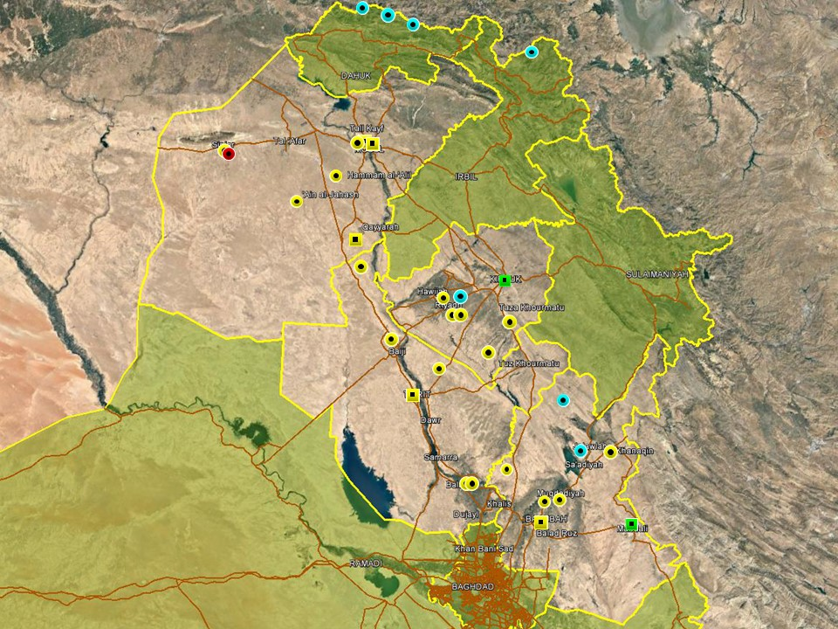

Relatively low levels of activity were noted in Nineveh province, possibly attributed to heavy rains and floods which remained the focus of reporting during the week. However, hit and run attacks and targeted assassinations continued to be reported in the rural areas of the province. Most notably, a tribal sheikh was killed during a failed kidnap attempt in al-Emrini village, south of Mosul, on December 06. The incident has been attributed to IS and forms part of a pattern of targeted attacks against tribal elders and civilians in the province witnessed in recent months. Activity in the province was otherwise dominated by ISF operations around Mosul city and nearby areas, arresting suspected IS members. Early in the week, in Sinjar, gunmen affiliated with the Kurdistan Workers Party (PKK) entered a PUK HQ and removed the PUK flag on top of the building; no clashes or casualties were reported however. Local officials indicated the incident may be related to a recent decision by the PUK to close down PKK affiliated offices in Sulaymaniyah. No further tensions have been reported since.

No significant security developments were noted in Kirkuk province which has also been affected by heavy rains and floods. Hostile activity has been predominantly confined to areas south of Kirkuk city, including Daquq and eastern Hawijah, with IS reportedly behind a number of hit and run attacks targeting ISF checkpoints during the week. These incidents are consistent with an established pattern of low-level asymmetric activity in these areas. Meanwhile, federal police-led security operations have continued around Hawijah, with multiple militants arrested and equipment seized during the week. In Kirkuk City, over 200 farmers staged a demonstration in front of Kirkuk Governate building on December 05 to protest a plan to relocate Arab families to an area northwest of the city. The plan was announced in November by acting Governor Rakan Saeed and involved allowing the families to set up farms in those areas.

A relatively uneventful period was noted in Salah al-Din province with no significant security developments observed. Low-level IS attacks continued in the eastern border areas with Diyala province, including two SAF attacks in eastern Balad targeting ISF checkpoints. PMU forces were also reported to have foiled two attempted IS operations to infiltrate population centres north of Tikrit. In a preventive security operation on December 06, the 88th PMU Brigade (a Sunni-dominated former tribal militia based in al-Alam) announced that one suicide bomber had been killed and two others wounded. Activity was otherwise characterised by ISF operations, including in Shirqat, Baiji and al-Alam, resulting in the arrest of several suspected IS militants during the week.

Activity in Diyala province remains characterised by low-level asymmetric activity, attributable to a mix of IS activity, sectarian tensions and local disputes. On December 05, ISF commenced a security operation around Lake Hamrin in response to heightened IS activity in the area. The day before, one civilian was killed and another wounded when IS gunmen opened fire near the lake and on the same day an infiltration attempt was reportedly foiled nearby by local PMU forces. Airstrikes and artillery strikes were also carried out early in the week in the Hamrin mountains area west of the lake, targeting IS gatherings and suspected camps.

Anbar Province

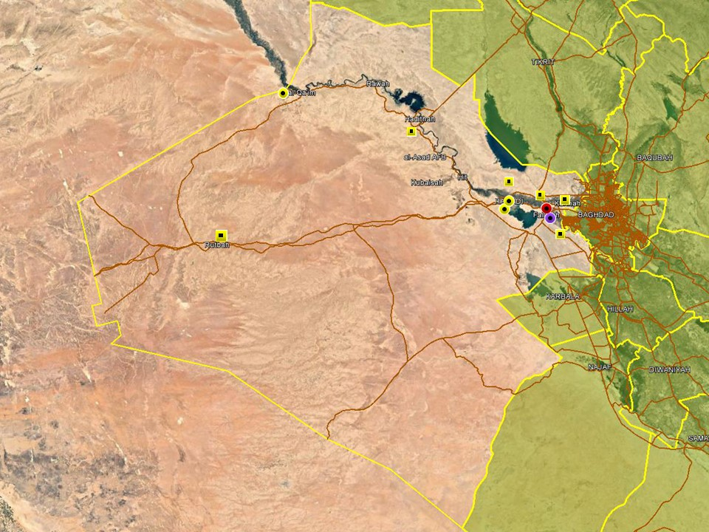

On December 05, IS reportedly launched several coordinated attacks in western Anbar in the past few days in an attempt to retake control over the Iraq-Syrian border. Qassem Musleh, who commands the western axis of the PMU forces in Qaim district, told national media outlets that the insurgents took advantage of bad weather and poor visibility to attack several ISF positions with mortar shells before attempting to advance on the ground. There were no reported changes in the territorial control of terrain. Further east, a VBIED was intercepted by PMU forces on December 06 at the Mowadafin entry checkpoint in eastern Fallujah; the driver, a teenager wearing an explosive vest, was arrested. Unconfirmed reports claimed a second device was intercepted near a security checkpoint in al-Nuaimiyah district of southern Fallujah. Overall, reporting patterns comprised ISF operations targeting suspected terrorism and seizing explosive remnants along the Ramadi-Fallujah corridor. Security operations were also reported in the districts of Rutbah and Ameriyat al-Fallujah, resulting in several terror-related arrests.

Capital Region (Including Baghdad City)

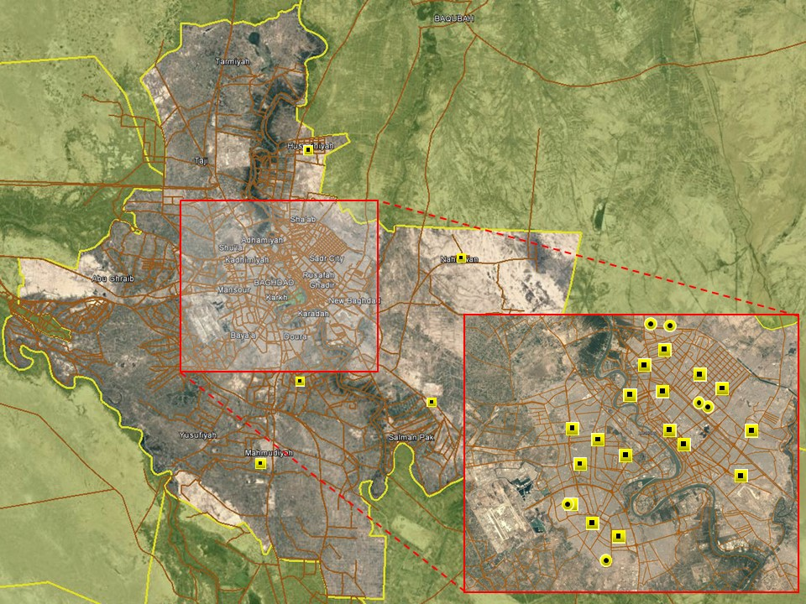

A relatively uneventful reporting period was noted in the capital with no large-scale security developments noted. The anticipated reopening of the International Zone has not yet materialised, likely reflecting concerns about existing political tensions associated with the cabinet formation process. Early in the week, work to reconfigure t-walls and checkpoints was increased with security sources claiming the reopening would be go ahead on December 03, however this did not happen and there were no official announcements on the matter. Given the political difficulties involved in electing the cabinet and the Sadrist threat to ‘go into opposition’ unless his demands are met, it is possible that the reopening is still several weeks away.

Meanwhile, the overall security situation in the city remains unchanged with low-level activity predominantly confined to the poorer districts associated with high levels of violence, including Sadr City, Adhamiyah and Shula. As is typical, these incidents were attributed to personal and local disputes rather than terrorism. The most notable incident occurred on December 06 when a senior member of the Sadrist peace companies was shot and killed in Shula district; the reasons for the attack have not been confirmed but several senior Sadrists claim the attack was politically motivated.

Southern Provinces
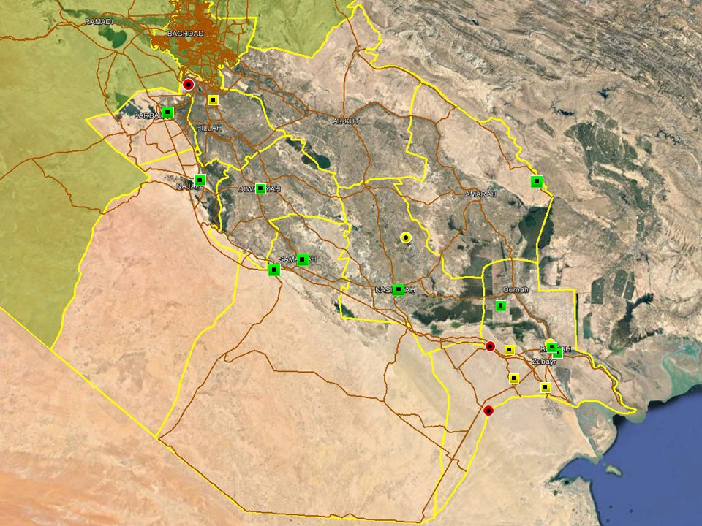

Hostile activity in the south followed long-standing trends with no large-scale security incidents reported. In Babil province, low-level attacks continued to target PMU checkpoints in Jurf al-Sakhar district, with a road-side IED wounding four PMU members on December 05. Isolated, low-level SAF incidents were also recorded in the provinces of Najaf and Dhi Qar, both related to tribal and personal disputes. Outside Basra, overall patterns of protest activity have been stable with small-scale gatherings motivated by local grievances recorded on a regular basis throughout the week.

Political tensions in Basra City remain relatively high, with demonstrations organised outside the Basra Governate building on a regular basis during the week. Protesters, some of which have commenced wearing yellow high visibility vests, have called for employment opportunities, the removal of Governor Idani and the release of protesters detained by the police. On December 04, some protesters attempted to storm the security perimeter of the building, prompting ISF intervention which reportedly resulted in live rounds being fired and stone throwing from the protesters. Several individuals were arrested as a result. The protest followed another demonstration reported in the evening of December 03 when protesters gathered and temporarily occupied the courtyard and exit of Basra International Hotel in Basra City. The protest took place while a meeting was being held between the Governor and the Minister of Finance inside the hotel. On December 02, ISF also dispersed a violent protest outside WQ2 concession area after protesters removed T-walls and stormed the perimeter fence at the southern entrance. The protesters comprised around 200 young men from Huwayr who had allegedly been promised employment. Some protesters were reportedly wounded in the subsequent clashes with the Oil Protection Force.

ACRONYM LIST

AII - Area of Intelligence Interest
AKA - Also Known As
AO - Area of Operations
APC - Armored Personnel Carrier
APIED - Anti-Personnel IED
AQ - Al-Qaeda
AT - Anti-Tank
ATGW - Anti Tank Guided Weapon
AVIED - Anti-Vehicle IED
BBIED - Body Borne IED
Bde - Brigade
Bn - Battalion
BXP - Border Crossing Point
CET - Convoy Escort Team
CLC - Concerned Local Citizens
CoP - Chief of Police
CP - Check Point
C-PERS - Captured Personnel
CPX - Complex Attack (attack using multiple weapon systems)
CQA - Close Quarter Assassination/Attack
DBS - Drive by Shooting
Div - Division
DoD - Department of Defense
DoS - Department of State
DoS - US Department of State
ECP - Entry Control Point
EFP - Explosively Formed Projectile
EOD - Explosive Ordinance Disposal (Bomb Squad)
ERW - Explosive Remnants of War
FoM - Freedom of Movement
GoI - Government of Iraq
HCN - Host Country National
HG - Hand Grenade
HME - Home Made Explosive
HMG - Heavy Machine Gun
HVT - High Value Target
IC - International Community
IDF - Indirect Fire (i.e.: rockets, mortars)
IDP - Internally Displaced Persons
IEC - Independent Electoral Commission
IED - Improvised Explosive Device
IM - International Military
IOC - International Oil Company
IRAM - Improvised Rocket Assisted Mortar
IRL - Improvised Rocket Launcher
IS - Islamic State
IVCP - Illegal Vehicle Check Point
IVO - In Vicinity Of
IZ - International Zone
KIA - Killed in Action
LN - Local National/Iraqi Civilian
MAIED - Magnetically attached IED (aka UVIED)
MIA - Missing in Action
MoD - Ministry of Defense
MoF - Ministry of Finance
MoFA - Ministry of Foreign Affairs
MoHE - Ministry of Higher Education
MoI - Ministry of Interior
MoJ - Ministry of Justice

MoO - Ministry of Oil
MoT - Ministry of Transportation
MSR - Main Supply Route
NFDK - No Further Details Known
NGO - Non-Governmental Organization (aid/charity)
NSTR - Nothing Significant To Report
OCG - Organized Crime Group
OPF - Oil Protection Force
PAX - Person, Persons or Passenger
PBIED - Person-Borne Improvised Explosive Device (UN Term)
PMF – Popular Mobilisation Forces
PoI - Point of Impact (for IDF)
PoO - Point of Origin (for IDF)
PSAF - Precision Small Arms Fire
PSC - Private Security Company
PSD - Private Security Detail
RCIED - Remote-Controlled IED
RPG - Rocket Propelled Grenade
RTA - Road Traffic Accident
SAF - Small Arms Fire
SAFIRE - Surface to Air FIRE
SF - Special Forces
SVBIED - Suicide Vehicle Borne IED
SVEST - Suicide Explosive Worn Vest
TCN - Third Country National
TCP - Traffic Control Point
Technical - An improvised weapon-mounted pick-up truck
TTP - Tactics, Techniques and Practices
UVIED - Under Vehicle IED
UXO - Unexploded Ordnance
VBIED - Vehicle Borne IED
VCP - Vehicle Checkpoint
WIA - Wounded in Action

GARDAWORLD INFORMATION SERVICES

From our management offices and field offices in strategic locations our constant monitoring of the high-risk environments in which we work is conveyed through our range of .Xplored™ risk analysis reports. The reports contain detailed updates, delivering current and relevant ground-truth information to assist both our personnel and our clients in their decision-making.

Our wider risk management solutions provide members of the defense, diplomatic, development, oil & gas and infrastructure sectors operating in potentially high-risk and complex environments with a comprehensive range of risk analysis, intelligence, crisis response, and training services. These services are designed to provide clients with the proactive capability to remain aware in potentially hostile environments and identify risks while strengthening their reactive capacity in emergency situations.

Our current regular reporting geographies include: Nigeria, Mali, Libya, Iraq, Afghanistan and Yemen on a daily, weekly, fortnightly, and monthly basis.

Through our constant monitoring and predictive threat analysis our Information Services team help you plan for, manage, and respond to risks.

For more information on our .Xplored reports or for information about our special-to-task reports tailored to individual client requirements, please contact us: informationops@garda.com or contact our regional representative iraq.ram@garda.com (Mobile: +964 7823 783 972)

For more information on how our services can support your business in Iraq contact:
Daniel Matthews, Senior Director Iraq daniel.matthews@garda.com

GARDAWORLD

A global leader in comprehensive security and risk management

GardaWorld International Protective Services is the international security division of GardaWorld Security Corporation, the world's largest privately owned security company with over 62,000 global staff.

We support clients in emerging, complex and high-risk markets around the world with static security, security consulting, risk analysis and reporting, crisis management and business continuity, mobile security, close protection, training and kidnap for ransom and extortion response solutions.

We work across multiple business sectors to provide protection and security for clients in the extractives, aerospace and defense, critical infrastructure, government and diplomatic and development sectors to secure employees, assets, and reputation so clients can focus solely on running daily operations and growing their business.

Discover more about the markets we serve and to learn how our international security solutions can help you contact us today: gwinfo@garda.com

Middle East
International Protective Services Headquarters
Office 2502, Tower 2, Currency House
DIFC, PO Box 482069
Dubai, United Arab Emirates

United States
1101 Wilson Boulevard
Suite 1725
Arlington, VA, 22209
United States

UK
5th Floor
1, London Bridge
London
SE1 9BG

Europe
37-39 rue des Deux Eglises
1000 Brussels
Belgium

garda.com

