
Weekly Iraq .Xplored report
15 December 2018

Prepared by Risk Analysis Team, Iraq

garda.com

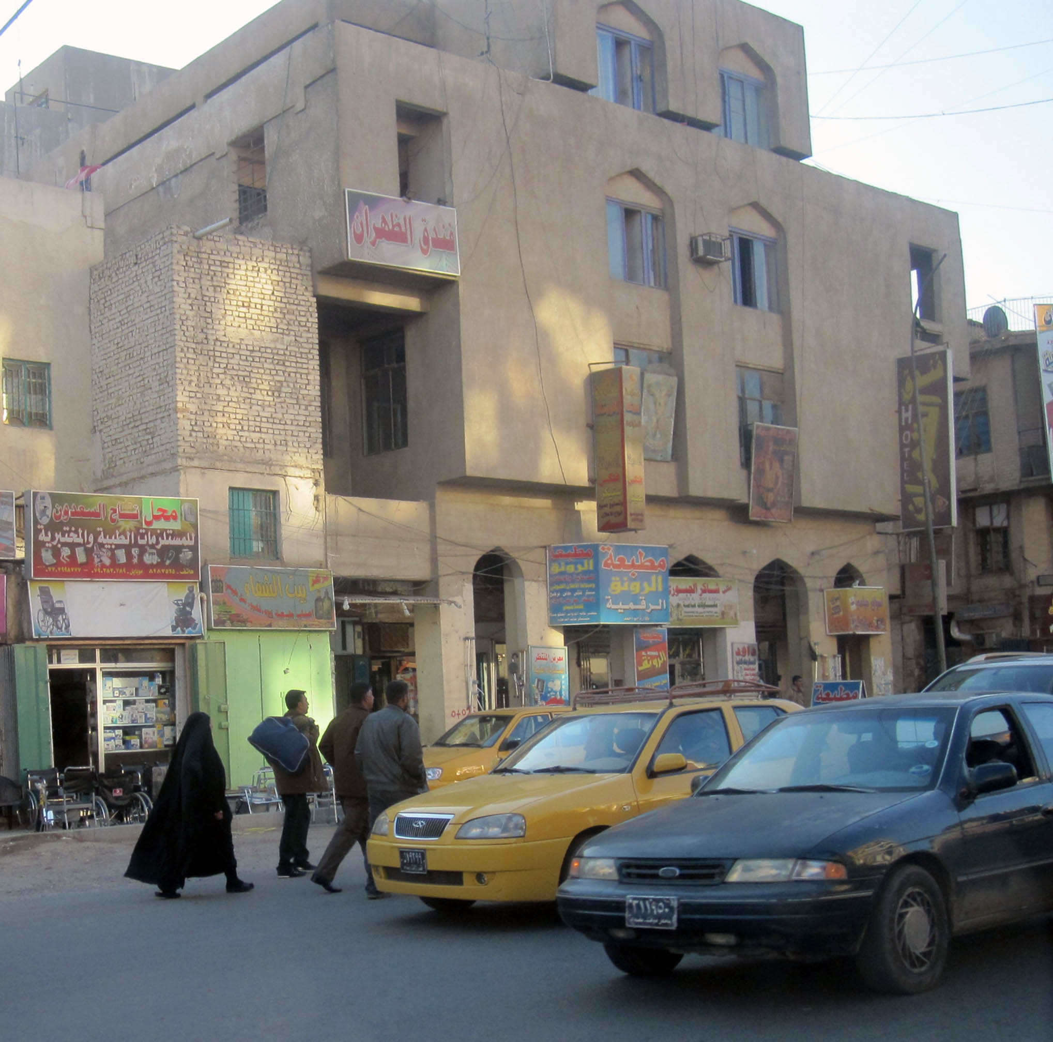

TABLE OF CONTENTS

TABLE OF CONTENTS 2
Activity Map 3
OUTLOOK 4

Short term outlook 4

Medium to long term outlook 4
Significant events 5

Political wrangling continues to delay cabinet formation 5

Prime Minister Mahdi commemorated victory over IS in speech 5

Largest US trade delegation since 2004 visited Baghdad 5
THREAT MATRIX 5
OVERVIEW 6

Political 6

Security 8
WEEKLY OPERATIONAL ASSESSMENT 10

Countrywide Military/Security Situation 10
ACRONYM LIST 15
GARDAWORLD INFORMATION SERVICES 16
GARDAWORLD 16

This report is an abridged version of GardaWorld Weekly Iraq .Xplored December 01, 2018. To subscribe to the full versions of the daily/weekly Iraq .Xplored reports, or for enquires relating to other GardaWorld services, please contact daniel.matthews@garda.com

Disclaimer: The information and opinions expressed in this Report are the views of GardaWorld and constitute a judgment as at the date of the Report and are subject to change without notice. The information and opinions expressed in this Report have been formed in good faith on the basis of the best information and intelligence available at the time of writing, but no representation or warranty, express or implied, is made as to its accuracy, completeness or correctness. GardaWorld accepts no liability arising out of or in connection with the comments made or the information set out in this Report and the reader is advised that any decision taken to act or not to act in reliance on this Report is taken solely at the reader’s own risk. In particular, the comments in this Report should not be construed as advice, legal or otherwise.

Activity Map

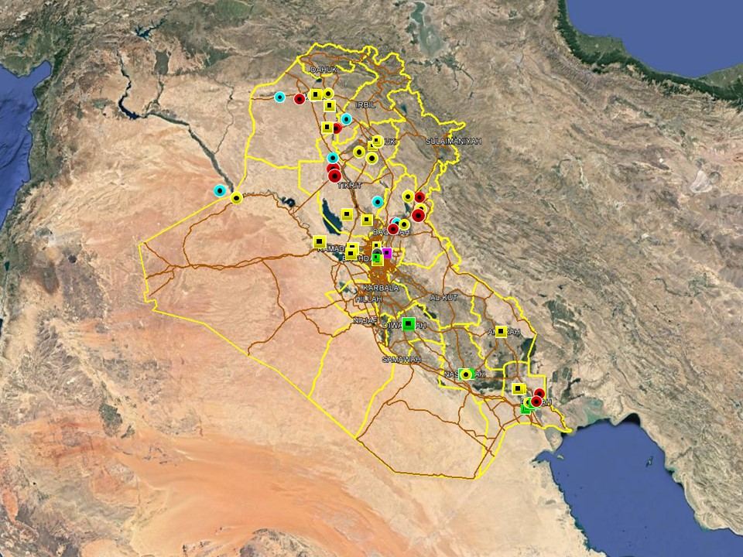

OUTLOOK

Short term outlook

- Prime Minister Mahdi announced that the timings for public access to the International Zone will be extended by three hours, until 01:00hrs, for the remainder of the test period. One through lane, allowing north-south access via the 14th July St, will be open between 17:00hrs and 01:00hrs until at least December 23. On December 11, Prime Minister Mahdi described the reopening as ‘irreversible’, indicating that the opening may last beyond the initial trial period depending on its success. So far, no security-related incidents have affected the reopening.

- IDF attacks on the International Zone, Baghdad and the US consulate near Basra International Airport in early and mid-September suggests heightened intent to target US interests in the country. While no group has claimed responsibility for the attacks, it is likely that Iranian-backed elements are behind these incidents in an effort to harass and intimidate for political purposes. As such, the outlook for further attacks targeting US interests is assessed as increased. These developments are not unprecedented and Basra province remains permissive for commercial operations which is unlikely to change.

- IS activity is expected to remain high in the northern provinces, including Nineveh, Kirkuk and Diyala province, especially in the rural areas. The group is likely to continue its asymmetric campaign through hit and run attacks, targeted assassination and terrorism to challenge ISF control in these areas. While the group is assessed to retain intent to stage attacks in Baghdad and the southern provinces, its capability in restricted as evidenced by a continuing decline in high-profile attacks in these areas.

- Political focus now remains on the eight Cabinet of Minister positions that remain unresolved, including those of the Defence and Interior Ministers. Opposition from Moqtada Al-Sadr’s Sairoun alliance to the selection of partisan figures for the remaining posts means that there is an associated risk of demonstrations as tensions remain high, especially in Baghdad. Upcoming 2019 fiscal year budget discussions can also be expected to drive protest activity in Baghdad and the southern provinces.

Medium to long term outlook

- Sectarian violence can be expected to continue in areas of Northern Iraq which remain permissive to IS operations, including Nineveh, Salah al-Din, Diyala and southwestern Kirkuk. Attacks will continue to target security checkpoints and outpost, especially in Sunni dominated areas controlled by Shia dominated security forces.

- Islamic State activity will continue to dominate security reporting with focus on the potential resurgence of an insurgent campaign in northern and western Iraq. Despite ongoing ISF efforts to clear remaining IS pockets, the group retains a degree of freedom of movement in the desert regions of Anbar, near the Syrian border, and along the Hamrin Mountains.

- Low-level incidents related to criminality, personal disputes and tribal tensions are likely to continue in Basra and the southern region. Long-term tensions are also expected to be driven by the return of militia factions expecting material and social rewards for their contribution in the campaign against IS.

Significant events

Political wrangling continues to delay cabinet formation
No significant progress was made this week on the effort to complete Mahdi’s cabinet where eight ministerial positions remain to be filled. This delay remains characterised by the standoff between the Sadrist Sairun Alliance and the Ameri/Maliki-led al-Bina which shows no signs of dissipating. The key conflict remains over the Interior Minister position where Faleh Fayyad’s nomination is rejected by Sadr but insisted on by Ameri, with support from Maliki. Attempts to find another suitable candidate have failed so far.

Prime Minister Mahdi commemorated victory over IS in speech
In a speech to commemorate the anniversary of the victory over IS, Prime Minister Abdel Mahdi hailed the effort made by the people of Iraq and the security forces to defeat ‘terror and evil forces’. Mahdi also highlighted corruption and unemployment as main challenges ahead, describing them as ‘the other faces of destruction and terrorism’ while blaming the Saddam regime for the current lack of stability.

Largest US trade delegation since 2004 visited Baghdad
In an apparent sign of intent from US to deepen energy ties with Iraq, a large trade delegation led by Energy Secretary Rick Perry visited Baghdad this week. After meeting with Oil Minister Thamer Ghadhban, Perry said in his address that the visit aimed to strengthen US support for Iraq’s energy sector and its effort to meet existing energy challenges. Perry also met with PM Mahdi and discussed Iraq’s role in Iranian sanctions.

THREAT MATRIX

Region | Political | Terrorism | Militancy | Crime | K&R
KRG* | Moderate | Low | Moderate | Low | Low
North** | Moderate | High-Extreme | High | High | High
Baghdad | Moderate | Moderate | Moderate | Moderate | Moderate
Anbar | Moderate | High | High | High | High
South*** | Moderate | Low | Moderate | Moderate | Moderate
Threat Scale | Minimal | Low | Moderate | High | Extreme

* KRG – Dohuk, Erbil & Sulaymaniyah
** North – Nineveh, Salah ad-Din, Kirkuk & Diyala
*** South – Babil, Wasit, Karbala, Najaf, Diwaniyah, Dhi Qar, Muthanna, Maysan & Basra

OVERVIEW

Political

Political wrangling continues to delay cabinet formation
No significant progress was made this week on the effort to complete Mahdi’s cabinet where eight ministerial positions remain to be filled. This delay remains characterised by the standoff between the Sadrist Sairun Alliance and the Ameri/Maliki-led al-Bina which show no signs of dissipating. The key conflict remains over the Interior Minister position where Faleh Fayyad’s nomination is rejected by Sadr but insisted on by Ameri, with support from Maliki. Mahdi’s role in this seems by all accounts marginal and in his press conference this week Mahdi said that he was not free to choose his cabinet and that the candidates, with the exception of eight or nine nominees, instead reflected the choices of political blocs. Regarding the Interior Ministry position, Mahdi added that he has no relation to Fayyad whose nomination was strictly the choice of Maliki and Ameri, contradicting the statements made by Fatah and State of Law MPs who earlier claimed is it ‘Mahdi who insisted on Faleh’s nomination.’ The remarkably candid statement from Mahdi may reflect the PMs frustration with the political pressure emanating from the Sadr-Ameri/Maliki rivalry which, despite repeated assertions from both sides that Mahdi should be free to choose candidates, is clearly impeding the completion of the cabinet. Some reports circulating this week suggested a series of meetings were taking place between key political stakeholders of both sides to engage in talks and to agree on another candidate following attempts to mediate by Wataniyah Bloc leader and former PM Iyad al-Allawi. Reports of a meeting between Ameri, Sadr and Deputy PMU Commander Abu Muhandis in Sadr’s house in Najaf were however dismissed by a senior Sadrist as a rumour with no basis in fact but multiple reports mentioned plans for a meeting between Halbusi, Ameri, and Hikma leader Ammar al-Hakim at Sadr’s residence in Najaf at some point in the near future.

Report claims US Ambassador asked Fayyad to withdraw candidacy for Interior Ministry
According to a report published by Lebanese newspaper al-Akhbar, US Ambassador Douglas Silliman met with former Security Advisor and Interior Ministry nominee Faleh Fayad last Saturday in an attempt to encourage Fayyad to withdraw his candidacy. Fayyad, who’s nomination was rejected by Parliament in late October but remains supported by the pro-Iranian, Ameri/Maliki-led al-Bina coalition, reportedly rejected Silliman’s request.

PM Mahdi commemorated victory over IS in speech
In a speech to commemorate the anniversary of the victory over IS, Prime Minister Abdel Mahdi hailed the effort made by the people of Iraq and the security forces to defeat ‘terror and evil forces’. Mahdi also highlighted corruption and unemployment as main challenges ahead, describing them as ‘the other faces of destruction and terrorism’ while blaming the Saddam regime for the current lack of stability. “Due to years of repression and dictatorship, together with marginalisation and discrimination policies, Iraq has lost its security and stability and missed chances of development, progress and economic prosperity”, he added in the speech which was broadcast live on the Iraqiya News channel during celebrations organised by the Ministry of Defence. The speech also called for enhanced cooperation with regional countries to achieve mutual prosperity and emphasised the need to restrict the spread of arms outside the state

Sadrist protesters reportedly threatened TV station in Karada
Sahar Abbas, a well-known host on Dijla TV channel, claimed she and the staff received death threats by Sadrist supporters after broadcasting content critical of Muqtada al-Sadr. Abbas claimed dozens of Sadrist supporters gathered outside and entered the office of the TV channel in Karada district last week, threatening its staff and management while demanding that the channel stops hosting guests and commentators critical of Sadr.

Largest US trade delegation since 2004 visited Baghdad
In an apparent sign of intent from US to deepen energy ties with Iraq, a large US trade delegation led by Energy Secretary Rick Perry visited Baghdad this week. After meeting with Oil Minister Thamer Ghadhban, Perry said in his address that the visit aimed to strengthen US support for Iraq’s energy sector and its effort to meet existing energy challenges. Perry also said the re-imposition of US sanctions on Iran, and its implications for Iraq, had been discussed while asserting that the US is ‘ready to assist in transitioning away from Iranian energy independence’. However, in his weekly press conference on December 11, Prime Minister Abdel Mahdi appeared to push back at apparent attempts by the US to encourage Iraq to cut energy ties with Iran and said Iraq ‘is not part of the US sanctions on Iran’ while reiterating Iraq’s opposition to the sanctions. Mahdi added that an Iraqi delegation will soon visit Washington DC to discuss the matter.

Protest outside Basra provincial council ended by ISF with tear gas
A gathering of roughly 150 protesters took place outside the Basra Provincial Council on December 14, coinciding with an extraordinary session in the council to elect a new Governor and appoint a permanent Chairman. Acting Chairman Walid Kitan postponed the session after it failed to meet quorum but protesters surrounding the building reportedly prevented the council members from exiting, prompting ISF to intervene. Some reports claim at least seven protesters were then injured after ISF used tear gas to break up the gathering with several protesters arrested. A member of the Council, Haider al-Saadi, also claimed to have been slightly wounded when at least one protester opened fire as they exited the building. In a press statement, Saadi blamed ‘terrorists’ and some political parties of being behind the demonstration.

Security

PM Mahdi issued a series of directives following high level security meeting
In his monthly meeting with senior members of the ISF, Prime Minister Abdel Mahdi issued a series of directives to address existing security challenges across the country. In the statement by Mahdi’s office, the PM emphasised the need to continue to pursue IS cells in the country to prevent a re-emergence of the group and said several measures had been taken to address specific security challenges. These include strengthening border security with surveillance cameras and take stronger efforts against corruption within some military units. The meeting also discussed the security situation in Nineveh, which was described as ‘reassuring’, and in Sinjar where several unspecified proposals were discussed to improve the situation.

Turkish airstrikes targeted PKK in Sinjar and Makhmour
In an apparent escalation of Turkish operations against the PKK in Iraq, President Erdogan and Defence Minister Khulosi Akbar announced that over 30 airstrikes had carried out in several areas of Nineveh province, targeting PKK presence in Sinjar and Qarah Jag Mountains of Makhmour. President Erdogan confirmed the airstrikes as part of expanded operations against the PKK and said further strikes are possible in the near future. Both claimed the airstrikes had successfully targeted PKK camps but that there were no civilian casualties. In response, the Iraq Foreign Ministry summoned the Turkish ambassador to protest the repeated violations of Iraq’s sovereignty. In a statement, the Ministry “condemned the violation of Iraqi airspace by Turkish aircraft and the targeting of several sites in Mount Sinjar and Makhmour in northern Iraq, which resulted in the loss of lives and property.” According to local and media reports, three civilians and a child were killed in the airstrikes, contradicting the statements made by Turkish leaders. Earlier in the week, a report released by the Turkish Anadolu Agency (AA), claimed Arab tribal leaders in Nineveh province are calling on Turkey to intervene against the PKK in the province. Speaking with AA, Muhasim al-Huwayt, cited as ‘spokesperson for the Arab tribes’, said more than a hundred children had been kidnapped and forcefully recruited by the PKK in Sinjar district where the group has entrenched itself and currently operates five camps with more than 1000 fighters each. Al-Huwayt further accused the PKK of ‘forcefully collecting money’ from the local population at checkpoints and said the ‘leaders of the Mosul tribes approve Turkey’s intervention to put an end to the PKK actions in the region’.

Iraqi court sentenced six IS militants to death over Khan Bani Saad attack
The Diyala criminal court announced this week that six individuals had been sentenced to death for their involvement in the car bomb attack in Khan Bani Saad in July 2015. The car bomb detonated near a busy local market, killing 120 civilians and injuring another 117, making it one of the deadliest terrorist attacks in the country since the 2003 invasion. The court statement added that the defendants had also been found guilty of several criminal acts in the province.

Baghdad Council approves new government despite objections from State of Law
Baghdad Provincial Council voted on December 12 to approve Fazil Shwaili, a member of the Sadrist Sairun Alliance, as the new Governor of Baghdad in an effort to replace current Governor Atwan Atwani of the State of Law Coalition (SoL). Atwani was elected into the Council of Representatives in the May elections which according to a majority of the council rendered the Governor position open for contention. In a subsequent press statement, Shwaili thanked the Council for its support and emphasised the need to invest in the infrastructure of the capital.

WEEKLY OPERATIONAL ASSESSMENT

Countrywide Military/Security Situation

Northern Provinces
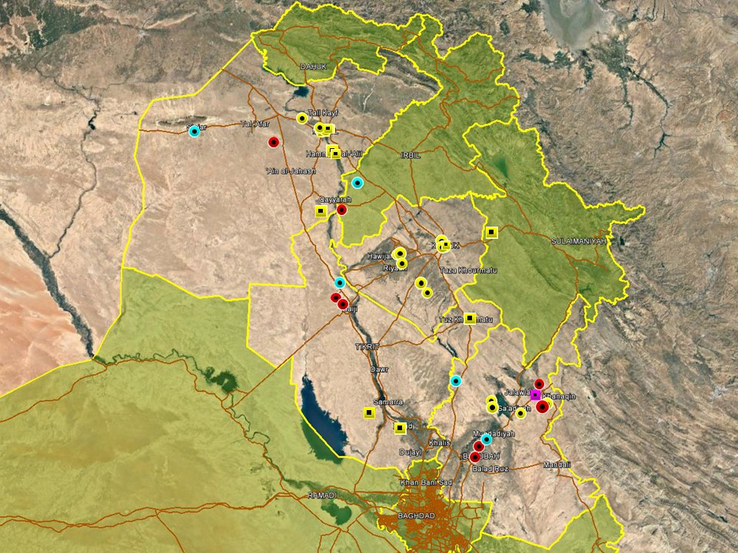

In the KRG, the Kurdish Assayish forces announced this week the arrest of members of an IS cell planning on carrying out suicide attacks in Sulaymaniyah province. The statement said the arrests followed a comprehensive investigation into a ‘terrorist network’ based in Kirkuk and Diyala province which planned to send militants into Sulaymaniyah province to carry out attacks. COMMENT: ‘The statement did not specify where the arrests took place or how far along the plot had advanced, but there are no indications that an attack was imminent. The arrests underline that insurgents retain intent, but are restrained in capability, to carry out attacks in the KRG. The last high-profile terrorist attack to target the region occurred in April 2015 in Erbil, when a suicide bomber detonated Ainkawa district of the city. In 2016, a suicide bomber targeted a checkpoint in the Chamchamal area of western Sulaymaniyah province, along the provincial boundary with Kirkuk, and a month later the security forces disrupted a plot to carry out terrorist attacks in Sulaymaniyah City and Halabja.’ COMMENT ENDS

Overall incident trends in the northern region of federal Iraq were otherwise consistent with those seen in recent weeks, with militant activity predominantly reported in rural areas of Nineveh, northern Salah al-Din and the Diyala river valley. In Nineveh province, no significant attacks were recorded however gunfights ensued on two occasions during ISF operations in the Badush region, northwest of Mosul, involving suspected IS militants. No large-scale attacks were recorded in Mosul City however, in a notable incident on December 11, the head of the Sunni Endowment, Abu Bakr Kanaan, said armed militia men, affiliated with the PMUs, seized control over the Arqam Mosque in Mosul and changed its name during the celebration of the victory over IS. In the response, the PMUs issued a statement offering a different interpretation to the events, saying that a group of local civilians first entered the Mosque and took control without authorization; the PMUs then intervened to restore the situation to normal. The statement added that an investigation has begun to determine whether the civilians had any connection to the PMUs but urged all media outlets to refrain from publishing inaccurate and unverified reports. COMMENT: ‘The details of the event have still not been confirmed however the incident underlines the presence of sectarian tensions emanating from continued PMU presence in the city which is resented my segments of the population and the local political establishment. These tensions tie in with resentment from provincial officials about a perceived neglect from federal authorities of existing challenges, ranging from the slow reconstruction effort to recent floods and continued civilian displacement.’ COMMENT ENDS

In Kirkuk province, relatively low incident levels were again noted in Hawijah district, following on from a similar lull in activity last week. Federal police units have continued to conduct operations in the district throughout the week at a high pace, which correlates with the decline in IS activity, with multiple arrests and cache finds reported. At least one operation in the district involved an anti-terror special force and coalition troops, suggesting a heightened ISF response to deal with the rise in violent activity observed in recent months. Absent a long-term engagement and concerted counter-insurgency efforts by the ISF however, a return in violent patterns is considered likely given the long-standing difficulties associated with controlling the hardline Sunni tribal areas in southwestern Kirkuk. Elsewhere, hostile trends in Kirkuk City remained consistent with long-standing patterns of local as well as seemingly politically motivated violence. Notably, a senior member of the Badr Organisation in the city survived an assassination attempt when gunmen opened fire near the Turkmen Front office in Musalla area; the motivation behind the incident has not been confirmed. ISF also carried out multiple arrests related to criminality and suspected terrorism in the city.

Overall activity in Salah al-Din was relatively subdued during the week and as usual confined to areas in the north and east. ISF found and cleared multiple IEDs in separate operations near Baiji district, including a suspected VBIED on December 11 near a local market area. Coalition airstrikes also targeted an IS underground tunnel system in the Makhoul Mountains on December 12. Airstrikes and SF ground operations were also reported in the eastern parts of the province, near the provincial boundary with Diyala, on separate occasions during the week. The use of airstrikes underlined the continuing instability of the border areas where IS is assessed to retain significant freedom of operation.

Anti-IS operations in Diyala province were again concentrated in the northern areas of the province, including Khanaqin and Lake Hamrin where Iraqi airstrikes and ground operations were conducted during the week. Ground operations were predominantly carried out by PMU forces affiliated with Badr and local tribal units. On December 12, clashes were also reported between Federal Police forces and IS militants following an ambush in Khanaqin district. An initial roadside IED explosion targeted the federal police convoy following an armed assault in which one member was killed and five others wounded; IS casualties were not specified. Further south, attacks against civilians were as usual confined to the Diyala River Valley, including the districts of Muqdadiyah, Abu Saida and northern Baqubah. A combination of IS activity, sectarian tensions and local disputes is assessed to be driven continued SAF, IED and occasional IDF in these areas.

Anbar Province

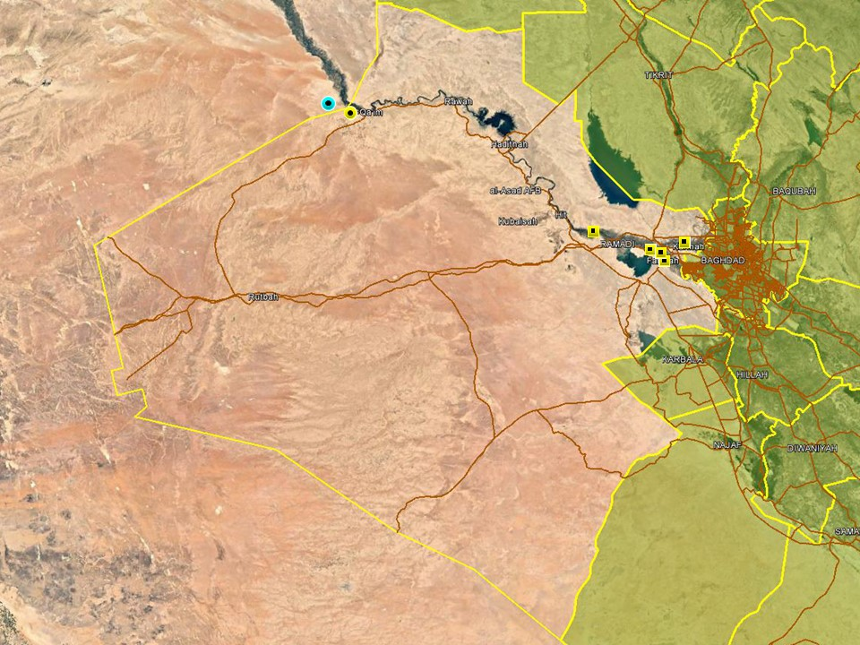

No large-scale developments were noted in Anbar province where overall activity was subdued in comparison to the previous weeks. The bulk of kinetic activity took place in the western areas near the Syrian border where ISF artillery was reported to have targeted IS militants across the border on more than one occasion during the week. On December 11, through joint coordination with the Syrian Government, Iraqi airstrikes were also carried out across the Syrian border in Sousse area, targeting two separate gatherings of IS militants. The Joint Operations Command said in a statement that the airstrikes had been carried out following intelligence suggesting the militant’s position and that they were successfully conducted. COMMENT: ‘This is not the first time that Iraqi airstrikes have been carried out on Syrian territory amidst pledges from both sides to enhance intelligence sharing and border cooperation to counter IS which retains pockets of control in eastern Syria.’ COMMENT ENDS

Reporting from the eastern areas of the province comprised arrest operations of suspected terrorists and criminality in Ramadi and Fallujah. ISF also conducted clearance operations and seized multiple explosive remnants in the outskirts of these cities on multiple occasions during the week.

Capital Region (Including Baghdad City)

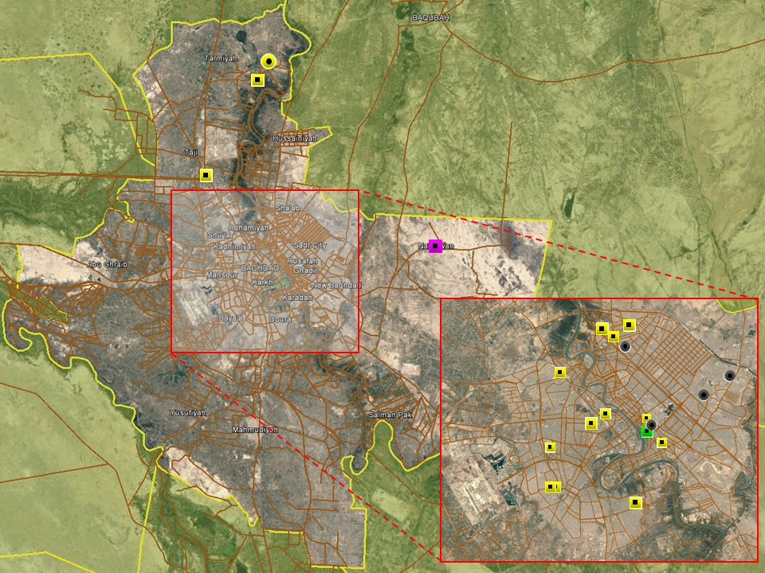

Overall violence in the capital was once again confined to low-level activity, related to local disputes and criminality. No incidents were recorded which are assessed to be related to IS or sectarian violence, underlining existing limitations in IS’ capability in the city. On December 12, two civilians were wounded when gunmen tossed a grenade outside a restaurant in Bataween area of Rusafa district before fleeing; the incident is indicative of a financial or local dispute rather than terrorism. In the same district, an off-duty ISF member was stabbed to death inside his home. The reasons for the incident is not clear and there are no indications that the two incidents are related. ISF found and dismantled a ‘smoke grenade’ outside a civilian house in Baladiyat area of New Baghdad; the incident is reportedly linked to a personal dispute. A gathering was reported on Tahrir Square on December 14 by Sadrists supporters in an attempt to affect the outcome of the cabinet formation process; hundreds were reportedly in attendance and the event unfolded peacefully amidst high security presence. A smaller gathering was also reported outside ECP2 by IHEC employees demanding permanent employment.

Relatively low incident levels were noted in the provincial areas. The most notable incident occurred in Tarmiyah district, north of Baghdad City, on December 12, where ISF surrounded and shot an IS militant armed with an explosive vest inside a house. The assailant was shot before he was able to detonate his device. Hostilities were otherwise subdued with low-level violence related to local tensions reported in Nahrawan and Mada’in but reporting otherwise dominated by arrest operations.

Southern Provinces
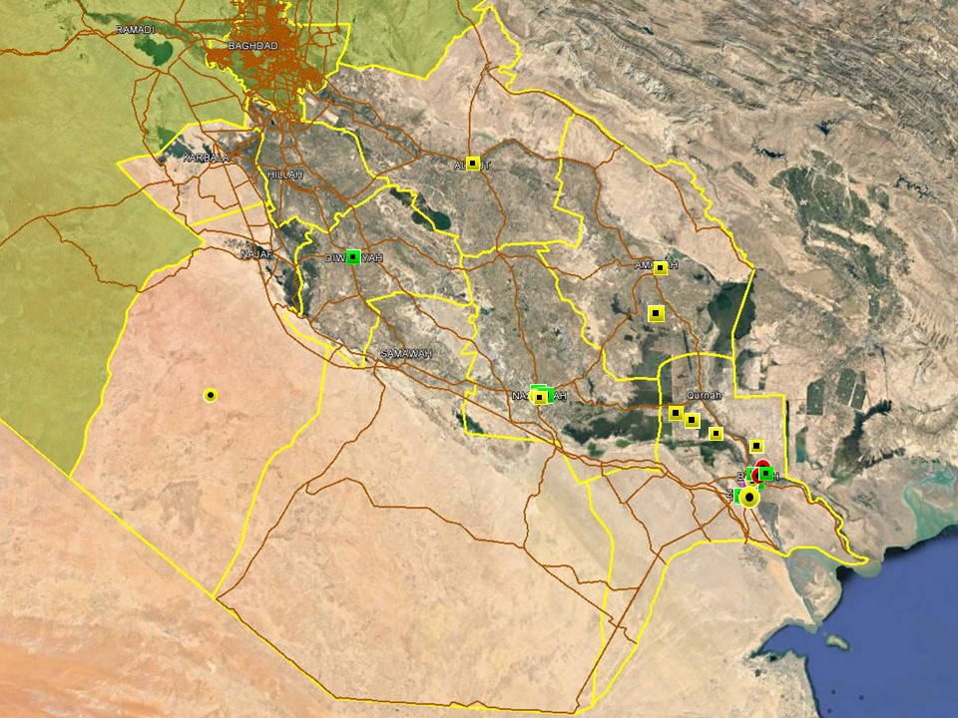

Incident numbers across southern Iraq showed a reduction in violent activity, however, protest action and tribal activity continued to follow established trends of criminal, low-level intimidatory and tribal violence. There were only three hostile events outside of Basra, all of those involving the use of SAF – one in Dhi Qar linked to a tribal feud and one each in Babil and Dhi Qar where members of the security forces were killed during the course of their duties. Demonstrations and ISF operations accounted for the remaining incidents with arrests reported across the region for various criminal offences, many related to drug trafficking. Two brigade-sized units of the Imam Ali Brigades also commenced a preventive security operation in the desert areas south of Najaf. This reportedly came in response to alleged security threats in the area, with no further details released.

In Basra only four incidents recorded were violent in nature, including two low-yield IEDs used to intimidate on December 09 and 12. A grenade was found and cleared on December 09 and a tribal SAF incident was reported on the December 11, which resulted in the death of a child. The remaining recorded activity related to protest action, ISF arrests, a kidnapping rescue (Iraqi National) and a mine strike on December 9 in the Shatt al-Arab area that resulted in three children being injured.

ACRONYM LIST

AII - Area of Intelligence Interest
AKA - Also Known As
AO - Area of Operations
APC - Armored Personnel Carrier
APIED - Anti-Personnel IED
AQ - Al-Qaeda
AT - Anti-Tank
ATGW - Anti Tank Guided Weapon
AVIED - Anti-Vehicle IED
BBIED - Body Borne IED
Bde - Brigade
Bn - Battalion
BXP - Border Crossing Point
CET - Convoy Escort Team
CLC - Concerned Local Citizens
CoP - Chief of Police
CP - Check Point
C-PERS - Captured Personnel
CPX - Complex Attack (attack using multiple weapon systems)
CQA - Close Quarter Assassination/Attack
DBS - Drive by Shooting
Div - Division
DoD - Department of Defense
DoS - Department of State
DoS - US Department of State
ECP - Entry Control Point
EFP - Explosively Formed Projectile
EOD - Explosive Ordinance Disposal (Bomb Squad)
ERW - Explosive Remnants of War
FoM - Freedom of Movement
GoI - Government of Iraq
HCN - Host Country National
HG - Hand Grenade
HME - Home Made Explosive
HMG - Heavy Machine Gun
HVT - High Value Target
IC - International Community
IDF - Indirect Fire (i.e.: rockets, mortars)
IDP - Internally Displaced Persons
IEC - Independent Electoral Commission
IED - Improvised Explosive Device
IM - International Military
IOC - International Oil Company
IRAM - Improvised Rocket Assisted Mortar
IRL - Improvised Rocket Launcher
IS - Islamic State
IVCP - Illegal Vehicle Check Point
IVO - In Vicinity Of
IZ - International Zone
KIA - Killed in Action
LN - Local National/Iraqi Civilian
MAIED - Magnetically attached IED (aka UVIED)
MIA - Missing in Action
MoD - Ministry of Defense
MoF - Ministry of Finance
MoFA - Ministry of Foreign Affairs
MoHE - Ministry of Higher Education
MoI - Ministry of Interior
MoJ - Ministry of Justice

MoO - Ministry of Oil
MoT - Ministry of Transportation
MSR - Main Supply Route
NFDK - No Further Details Known
NGO - Non-Governmental Organization (aid/charity)
NSTR - Nothing Significant To Report
OCG - Organized Crime Group
OPF - Oil Protection Force
PAX - Person, Persons or Passenger
PBIED - Person-Borne Improvised Explosive Device (UN Term)
PMF – Popular Mobilisation Forces
PoI - Point of Impact (for IDF)
PoO - Point of Origin (for IDF)
PSAF - Precision Small Arms Fire
PSC - Private Security Company
PSD - Private Security Detail
RCIED - Remote-Controlled IED
RPG - Rocket Propelled Grenade
RTA - Road Traffic Accident
SAF - Small Arms Fire
SAFIRE - Surface to Air FIRE
SF - Special Forces
SVBIED - Suicide Vehicle Borne IED
SVEST - Suicide Explosive Worn Vest
TCN - Third Country National
TCP - Traffic Control Point
Technical - An improvised weapon-mounted pick-up truck
TTP - Tactics, Techniques and Practices
UVIED - Under Vehicle IED
UXO - Unexploded Ordnance
VBIED - Vehicle Borne IED
VCP - Vehicle Checkpoint
WIA - Wounded in Action

GARDAWORLD INFORMATION SERVICES

From our management offices and field offices in strategic locations our constant monitoring of the high-risk environments in which we work is conveyed through our range of .Xplored™ risk analysis reports. The reports contain detailed updates, delivering current and relevant ground-truth information to assist both our personnel and our clients in their decision-making.

Our wider risk management solutions provide members of the defense, diplomatic, development, oil & gas and infrastructure sectors operating in potentially high-risk and complex environments with a comprehensive range of risk analysis, intelligence, crisis response, and training services. These services are designed to provide clients with the proactive capability to remain aware in potentially hostile environments and identify risks while strengthening their reactive capacity in emergency situations.

Our current regular reporting geographies include: Nigeria, Mali, Libya, Iraq, Afghanistan and Yemen on a daily, weekly, fortnightly, and monthly basis.

Through our constant monitoring and predictive threat analysis our Information Services team help you plan for, manage, and respond to risks.

For more information on our .Xplored reports or for information about our special-to-task reports tailored to individual client requirements, please contact us: informationops@garda.com or contact our regional representative iraq.ram@garda.com (Mobile: +964 7823 783 972)

For more information on how our services can support your business in Iraq contact:
Daniel Matthews, Senior Director Iraq daniel.matthews@garda.com

GARDAWORLD

A global leader in comprehensive security and risk management

GardaWorld International Protective Services is the international security division of GardaWorld Security Corporation, the world's largest privately owned security company with over 62,000 global staff.

We support clients in emerging, complex and high-risk markets around the world with static security, security consulting, risk analysis and reporting, crisis management and business continuity, mobile security, close protection, training and kidnap for ransom and extortion response solutions.

We work across multiple business sectors to provide protection and security for clients in the extractives, aerospace and defense, critical infrastructure, government and diplomatic and development sectors to secure employees, assets, and reputation so clients can focus solely on running daily operations and growing their business.

Discover more about the markets we serve and to learn how our international security solutions can help you contact us today: gwinfo@garda.com

Middle East
International Protective Services Headquarters
Office 2502, Tower 2, Currency House
DIFC, PO Box 482069
Dubai, United Arab Emirates

United States
1101 Wilson Boulevard
Suite 1725
Arlington, VA, 22209
United States

UK
5th Floor
1, London Bridge
London
SE1 9BG

Europe
37-39 rue des Deux Eglises
1000 Brussels
Belgium

garda.com

