
Weekly Iraq .Xplored report
22 December 2018

Prepared by Risk Analysis Team, Iraq

garda.com

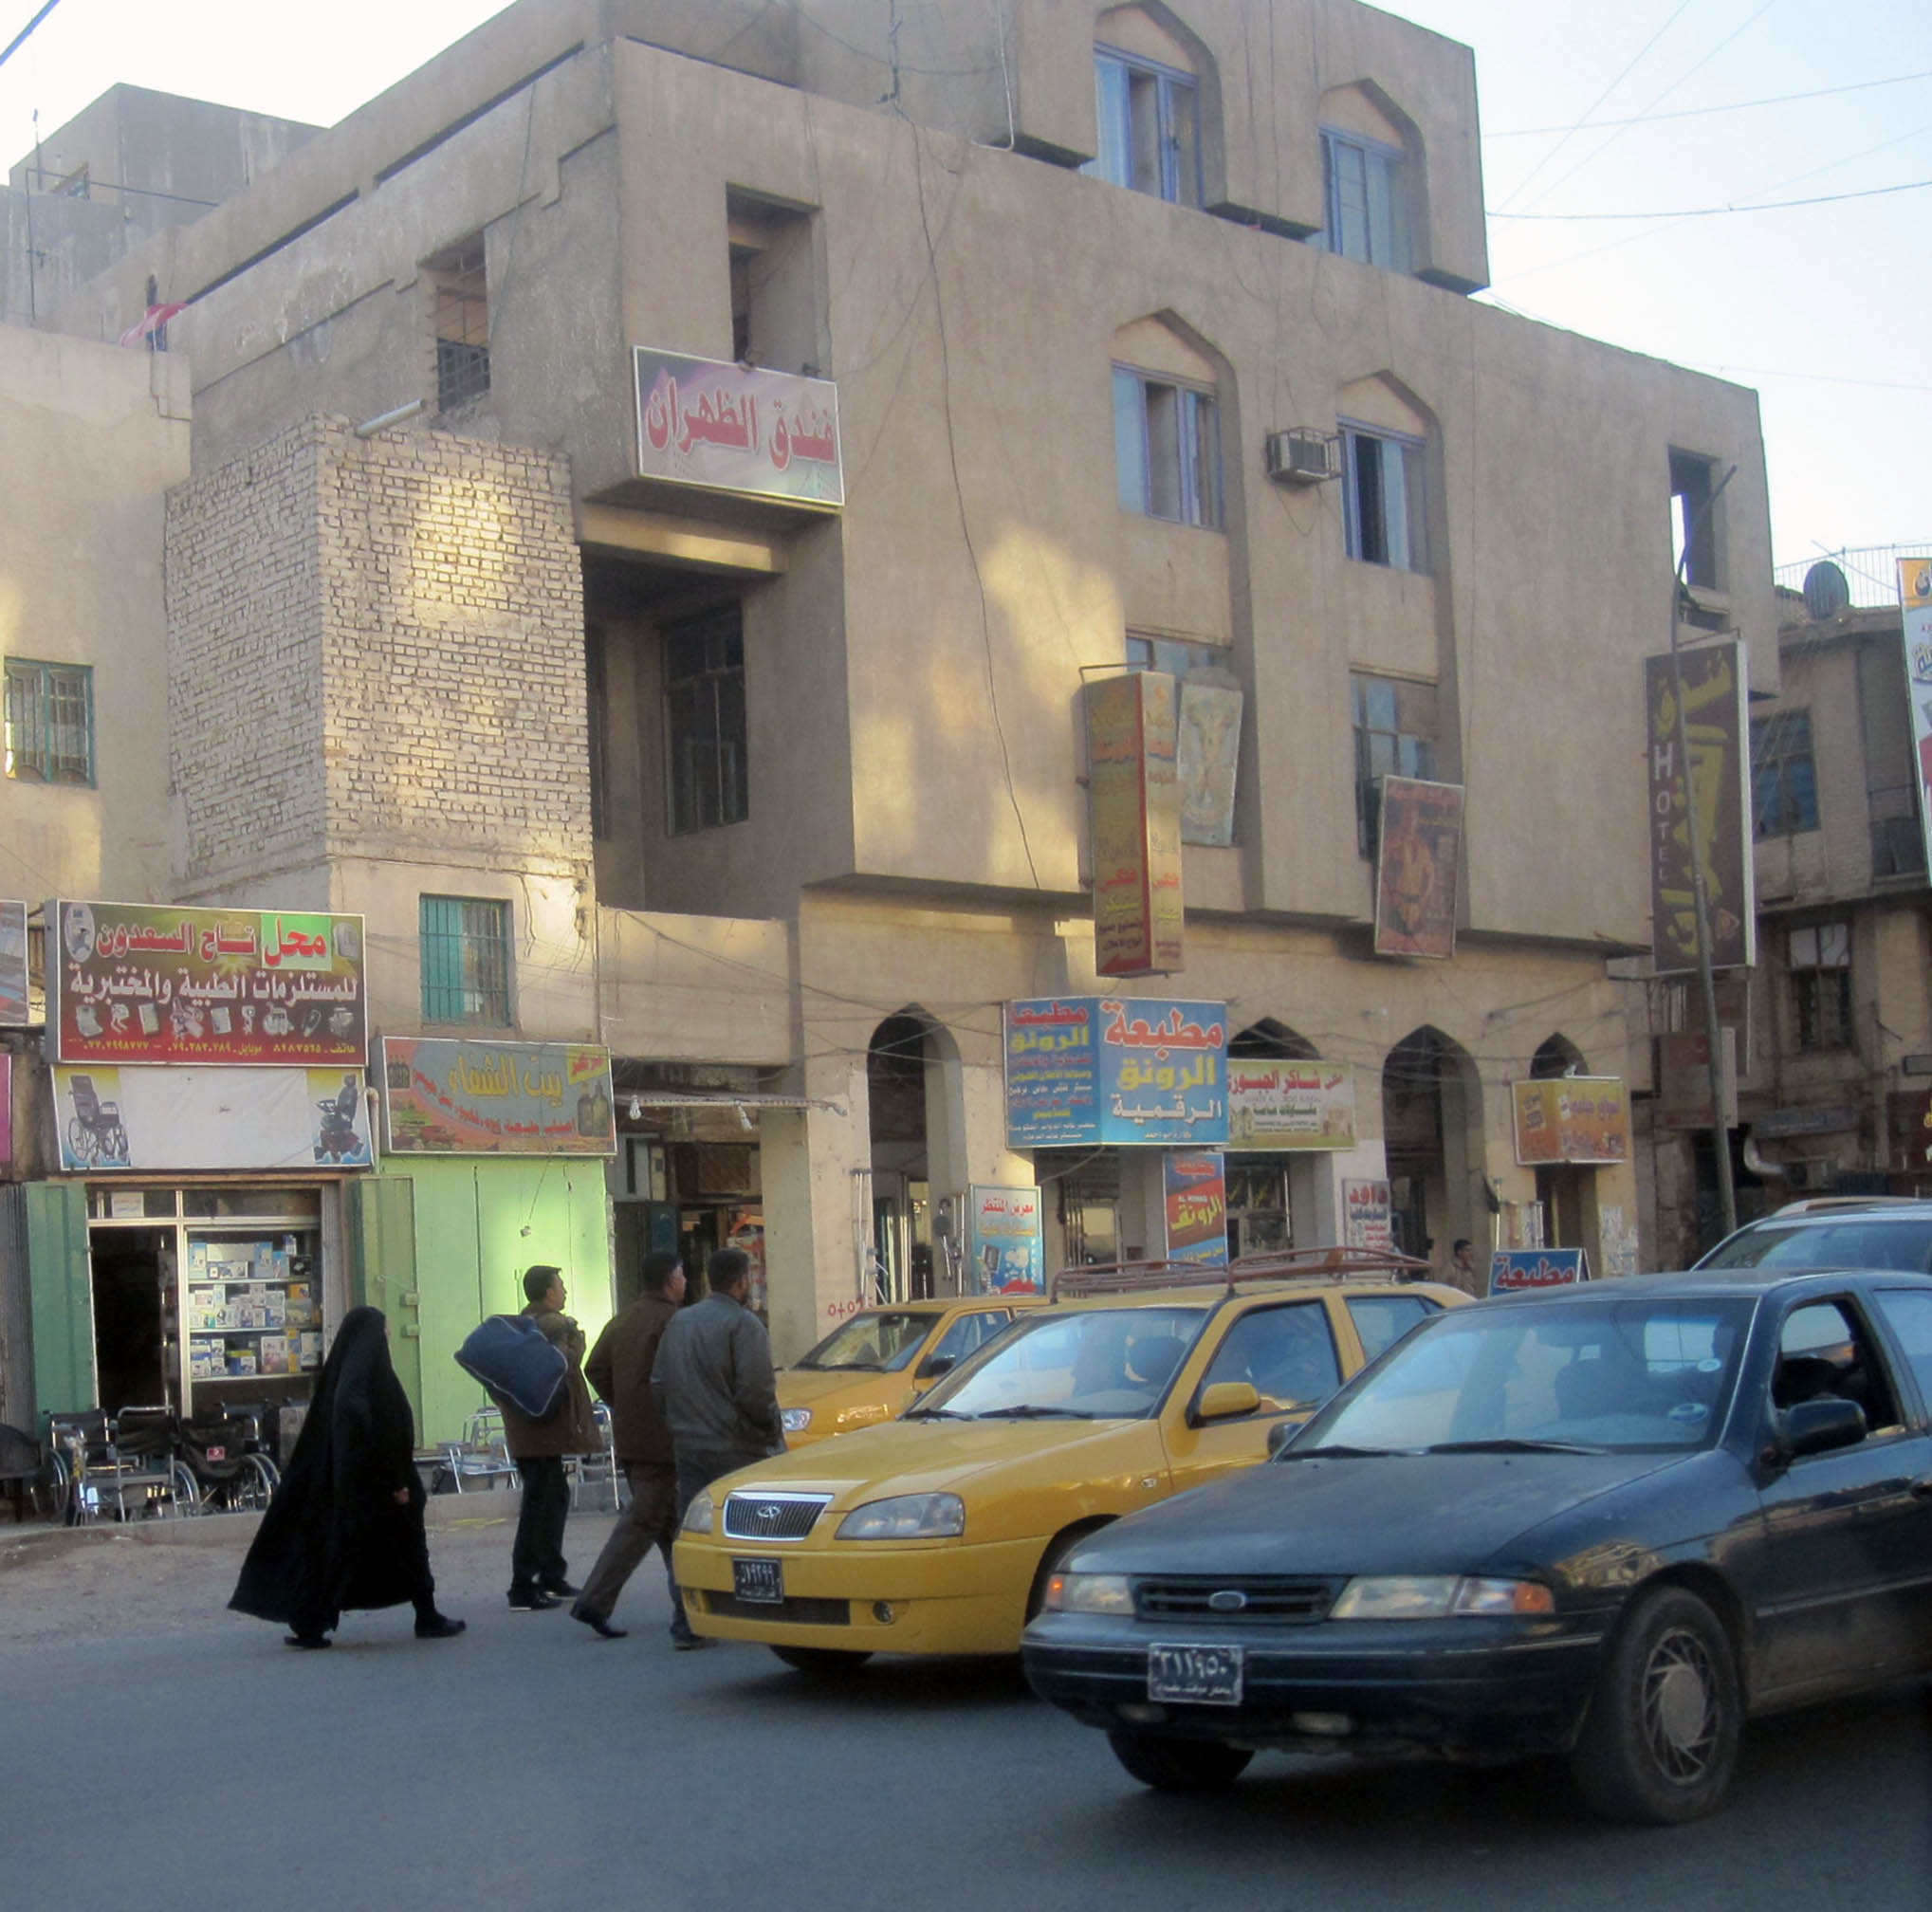

TABLE OF CONTENTS

TABLE OF CONTENTS 2
Activity Map 3
OUTLOOK 4

Short term outlook 4

Medium to long term outlook 4
Significant events 5

SecDef Mattis resigns following White House move to withdraw troops from Syria and Afghanistan 5

Iraq granted extension to Iranian sanctions waiver 5

Three new ministers approved by Parliament, but political impasse remains 5
THREAT MATRIX 5
OVERVIEW 6

National/Regional 6

Security 8
WEEKLY OPERATIONAL ASSESSMENT 9

Countrywide Military/Security Situation 9
ACRONYM LIST 14
GARDAWORLD INFORMATION SERVICES 15
GARDAWORLD 15

Disclaimer: The information and opinions expressed in this Report are the views of GardaWorld and constitute a judgment as at the date of the Report and are subject to change without notice. The information and opinions expressed in this Report have been formed in good faith on the basis of the best information and intelligence available at the time of writing, but no representation or warranty, express or implied, is made as to its accuracy, completeness or correctness. GardaWorld accepts no liability arising out of or in connection with the comments made or the information set out in this Report and the reader is advised that any decision taken to act or not to act in reliance on this Report is taken solely at the reader’s own risk. In particular, the comments in this Report should not be construed as advice, legal or otherwise.

Activity Map

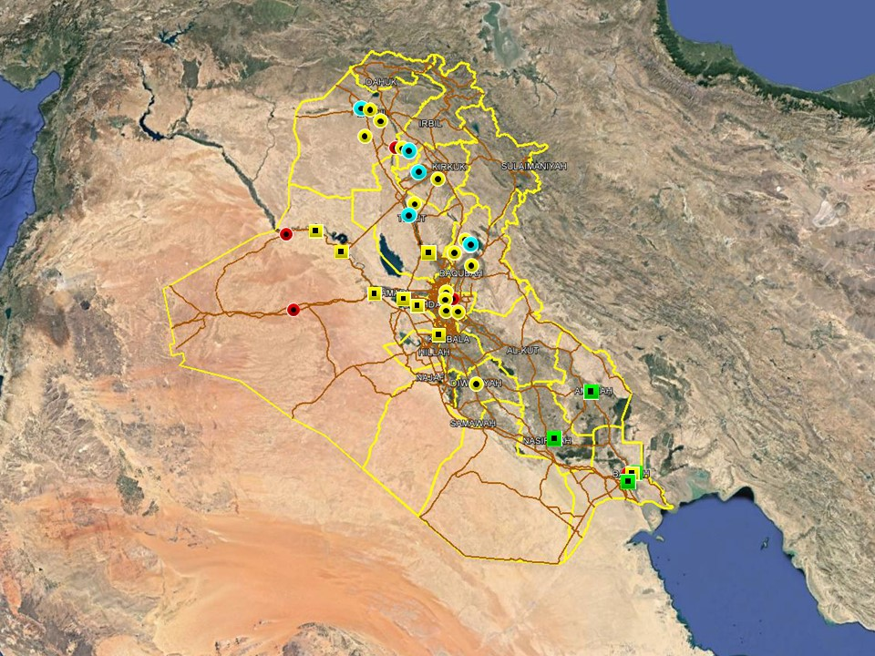

OUTLOOK

Short term outlook

- On December 16, PM Mahdi announced another extension of the opening hours of the International Zone. One through lane, allowing north-south access via the 14th July St, will be open between 17:00hrs and 05:00hrs until at least December 23. On December 11, Prime Minister Mahdi described the reopening as ‘irreversible’, indicating that the opening may last beyond the initial trial period depending on its success. On December 16, the US Embassy issued another security alert stating it has initiated “security protocols similar to those used throughout Baghdad during the IZ’s open hours.” Actions to take listed in the alert included to “keep a low profile, be aware of surroundings and use caution while transiting the IZ”.

- Political tensions remain high in Basra following a number of protests in Basra City this week. On December 21 a demonstration calling for the dismissal of the Governor was dispersed by ISF using tear gas and live ammunition, with several protesters injured according to media reports. Further protest activity, with an associated risk of violence, can be expected in Basra City in the short term as long as political tensions remain high.

- IS activity is expected to remain high in the northern provinces, including Nineveh, Kirkuk and Diyala province, especially in the rural areas. The group is likely to continue its asymmetric campaign through hit and run attacks, targeted assassination and terrorism to challenge ISF control in these areas. While the group is assessed to retain intent to stage attacks in Baghdad and the southern provinces, its capability in restricted as evidenced by a continuing decline in high-profile attacks in these areas.

- Political focus now remains on the five Cabinet of Minister positions that remain unresolved, including those of the Defence and Interior Ministers. Opposition from Moqtada Al-Sadr’s Sairoun alliance to the selection of partisan figures for the remaining posts means that there is an associated risk of demonstrations as tensions remain high, especially in Baghdad. Upcoming 2019 fiscal year budget discussions can also be expected to drive protest activity in Baghdad and the southern provinces.

Medium to long term outlook

- Sectarian violence can be expected to continue in areas of Northern Iraq which remain permissive to IS operations, including Nineveh, Salah al-Din, Diyala and southwestern Kirkuk. Attacks will continue to target security checkpoints and outpost, especially in Sunni dominated areas controlled by Shia dominated security forces.

- Islamic State activity will continue to dominate security reporting with focus on the potential resurgence of an insurgent campaign in northern and western Iraq. Despite ongoing ISF efforts to clear remaining IS pockets, the group retains a degree of freedom of movement in the desert regions of Anbar, near the Syrian border, and along the Hamrin Mountains.

- Low-level incidents related to criminality, personal disputes and tribal tensions are likely to continue in Basra and the southern region. Long-term tensions are also expected to be driven by the return of militia factions expecting material and social rewards for their contribution in the campaign against IS.

Significant events

SecDef Mattis resigns following White House move to withdraw troops from Syria and Afghanistan
US’ Foreign Policy in the Middle East underwent some drastic changes this week, commencing with President Trump’s announcement to withdraw ‘all troops’ from Syria and later a substantial number of forces from Afghanistan. The decision took allies and US officials by surprise, prompting criticism and concerns about the implications for the anti-IS campaign which despite Trumps’ apparent declaration of victory continues in Syria.

Iraq granted extension to Iranian sanctions waiver
The US granted Iraq a 90-day extension to an exemption to the Iranian sanctions regime which will allow Baghdad to continue importing Iranian gas and electricity. According to US officials, the extension has been granted to allow Iraq time to develop a plan to extricate itself from dependency on Iranian exports and become compliant with the sanctions.

Three new ministers approved by Parliament, but political impasse remains
In a partial victory for PM Mahdi, Parliament voted this week to approve three more ministers in his cabinet, including Nuri al-Dulaimi as Minister of Planning; Qusay al-Suhail as Minister of Higher Education; and Abdulamir al-Hamdani as the Minister of Culture. The nominees for the Minister of Education and Minister of Migration and Displacement were reportedly rejected while the remaining three positions were not put up for a vote.

THREAT MATRIX

Region | Political | Terrorism | Militancy | Crime | K&R
KRG* | Moderate | Low | Moderate | Low | Low
North** | Moderate | High-Extreme | High | High | High
Baghdad | Moderate | Moderate | Moderate | Moderate | Moderate
Anbar | Moderate | High | High | High | High
South*** | Moderate | Low | Moderate | Moderate | Moderate
Threat Scale | Minimal | Low | Moderate | High | Extreme

* KRG – Dohuk, Erbil & Sulaymaniyah
** North – Nineveh, Salah ad-Din, Kirkuk & Diyala
*** South – Babil, Wasit, Karbala, Najaf, Diwaniyah, Dhi Qar, Muthanna, Maysan & Basra

OVERVIEW

National/Regional

SecDef Mattis resigns following White House move to withdraw troops from Syria and Afghanistan
US’ Foreign Policy in the Middle East underwent some drastic changes this week, commencing with President Trump’s announcement to withdraw ‘all troops’ from Syria and later a substantial number of forces from Afghanistan. The decision took allies and US officials by surprise, prompting criticism and concerns about the implications for the anti-IS campaign which despite Trumps’ apparent declaration of victory continues in Syria. In a video message posted on Twitter, the President said “Our boys, our young women, our men, they’re all coming back and they’re coming back now. We won.” A Department of Defence spokesperson later confirmed that the US ‘have started the process of returning US troops from Syria as we transition to the next phase of the campaign’ and that the US would ‘continue working with allies to defeat IS wherever it operates’. Further to this US officials told international media outlets that the decision would likely lead to an end to air operations in the country as well. The Trump administration has been divided on the issue, most notably evident in Secretary of Defence James Mattis subsequent decision to resign in response to Trump’s decision after reportedly failing to convince the President to reconsider. In his resignation letter to the President, Mattis wrote that the US’ ‘strength as a nation is inextricable linked to the strength of our system of alliances and partnerships’, while emphasizing the importance of treating allies with respect to achieve national security objectives.

Iraq granted extension to Iranian sanctions waiver
The US granted Iraq a 90-day extension to an exemption to the Iranian sanctions regime which will allow Baghdad to continue importing Iranian gas and electricity. According to US officials, the extension has been granted to allow Iraq time to develop a plan to extricate itself from dependency on Iranian exports and become compliant with the sanctions without risking further complications in electricity distribution.

Three new ministers approved by Parliament, but political impasse remains
In a partial victory for PM Mahdi, Parliament voted this week to approve three more ministers in his cabinet, including Nuri al-Dulaimi as Minister of Planning; Qusay al-Suhail as Minister of Higher Education; and Abdulamir al-Hamdani as the Minister of Culture. The nominees for the Minister of Education and Minister of Migration and Displacement were reportedly rejected while the remaining three positions were not put up for a vote. PM Mahdi expressed confidence that the remaining positions would have been filled in the subsequent session held on December 20, however the session proceeded without a vote even included on the agenda.

Speaker Halbusi on official visit to Riyadh
Parliament Speaker Muhammed al-Halbusi made an official visit to Riyadh this week, heading a Parliamentary delegation following an invitation from the head of the Shura Council. A statement released by his office said Halbusi was received by Sheikh Abdullah bin Mohammed al-Sheikh, the Chairman of the Shura Council, and several members of the council, and both sides pledged to enhance bilateral relations and deepen economic ties. Saudi officials also pledged to continue support the reconstruction effort in Iraq.

Parliament agrees to send fact-finding mission to Nineveh
Parliament has agreed to conduct an investigation into the situation in Nineveh province and to send a fact-finding committee to the province in the near future to explore and identify existing challenges. According to the Parliament statement, the committee has been tasked to investigate ‘facts about the security, economical, service and humanitarian events’ in the province and will be led by former VP Osama al-Nujafi. Kurdish MP Bashar al-Kiki, the former chairman of the provincial council in Nineveh, has been appointed as the deputy leader of the committee.

New law for contractors drafted by Cabinet
In his weekly press conference, PM Mahdi said a new legislative bill is being drafted to improve the terms and conditions of temporary workers and contractors. This reportedly includes rights to pensions and guarantees of career progression similar to full time employment rights. In the speech, Mahdi spoke generally about the need to bring about real economic reforms and diversify the economy to avoid overreliance on oil prices.

Security

Turkish authorities urge Iraq to take responsibility over PKK presence
The Turkish Government said it will continue to target PKK in Iraq, despite formal protests from the GoI about territorial violations, while urging Baghdad to take responsibility over the PKK. A spokesperson for the Turkish Foreign Ministry reiterated this week that the PKK’s presence in Iraq and Syria poses a national security threat to Turkey, and said the Iraqi Government has a ‘duty’ to prevent its country from being used as a staging ground for attacks on neighbouring countries. The spokesperson added that ‘these operations in the fight against terrorism will continue as long as terror organisations nest on Iraqi soil and as long as Turkey’s security needs require operations to continue.’

Legislation to expel US forces drafted in Parliament
An MP of al-Fatah Alliance, Muhammad al-Baldawi, said that a draft resolution is being prepared in Parliament which calls for a complete withdrawal of US forces from Iraq. Al-Baldawi said ‘Parliament’s intention is to expel all US forces which harm Iraqi interests and threatens its national security’ and that this view “is also a view held by the government.” He added that the draft is now being reviewed by the legal committee and will soon be put up for a general vote.

WEEKLY OPERATIONAL ASSESSMENT

Countrywide Military/Security Situation

Northern Provinces
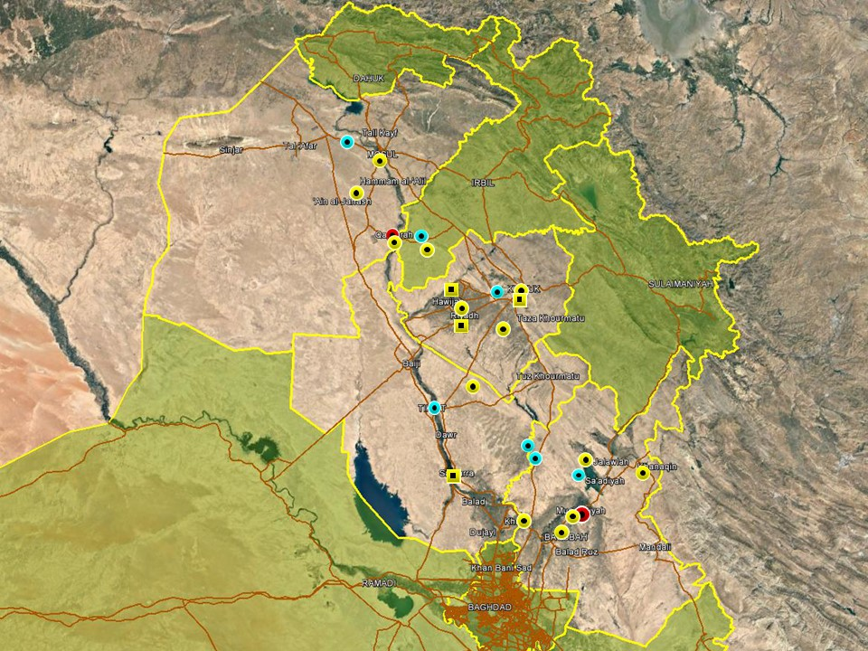

The overall activity patterns in Nineveh Province were consistent with recent trends. Hostile activity comprised low-level incidents and attacks targeting the local population in areas west and south of Mosul, some of which were attributed to IS militants as part of long-standing asymmetric trends in the province. ISF arrest operations dominated day to day activity in Mosul where the security forces continue to round up suspected terrorists. Airstrikes were also recorded around Mount Ashtana, northwest of Mosul, where an increase in IS activity has been noted recently. Activity in the southern areas of the province were as usual concentrated around Qayyarah district where local insurgent cells remain active, staging roadside IED and SAF attacks against ISF. On December 21, a Peshmerga commander told local media that coalition forces targeted a gathering of IS members in the mountainous areas north of Makhmour with artillery strikes. This followed a similar report earlier in the week of coalition ground forces being involved in anti-IS operations, suggesting a heighted response to increased IS activity in the Makhmour area.

Activity in Kirkuk province remains characterised by ISF security operations around Hawijah district, where a further decline in overall insurgent activity has been noted. With the exception of a foiled infiltration attempt in al-Khurddat district, IS activity was overall subdued, continuing a pattern of decreased hostilities seen in recent weeks. Correspondingly high levels of IS activity in northern Diyala province however may indicate a strategic shift away from the district in response to an increase in ISF operations. Hostile trends in Kirkuk City were also consistent with recent patterns, with local violence characterised by low-level incidents assessed to be related to local and criminal disputes. A number of minor incidents were also reported in connection with the Kurdish flag day which underline the continuation of Arab/Kurdish tensions in the city. The CTS forces reportedly removed the Kurdish flag after it was raised repeatedly by the Kurdish Communist Party HQ in Kirkuk City; Kurdish media also reported that two students had been arrested for attempting to raise the Kurdish flag in the city.

The most significant attack in Salah al-Din Province occurred on December 17 when six IS militants, armed with submachine guns and rocket-propelled grenade launchers, launched an attack on Alas oilfield in an apparent effort to sabotage a crude oil pipeline. The attack was repulsed, with three militants killed and the rest fleeing the area, but one OPF member was reportedly killed and the pipeline sabotaged, causing a fire. The attack was reportedly staged from the Hamrin Mountains north of the field, where IS is assessed to retain some degree of operational freedom, and from where repeated attacks have been staged against the oilfield in the past. Elsewhere, violence in the province was characterised by sporadic attacks, including a rocket attack targeting central Tikrit on December 19, causing no casualties or damage. Iraqi airstrikes also continued in the eastern border areas with Diyala, targeting IS cells around Mutajbiyah district.

Diyala province remains unstable, with relatively high levels of asymmetric violence targeting the local population. As usual, the vast majority of these incidents were concentrated in the Diyala Rivery Valley, comprising low-level SAF and IED, and driven by a mix of low-level insurgency, tribal disputes and criminality. Multiple assassinations this week also targeted government officials in Muqdadiyah and Khalis on separate occasions. In response, dozens of civilians demonstrated outside the Muqdadiyah local council building, denouncing recent attacks, allegedly involving PMU elements, on the residences of local council members in the district. The protesters also reportedly called on federal authorities to prevent PMU forces from intervening in local politics.

Anbar Province

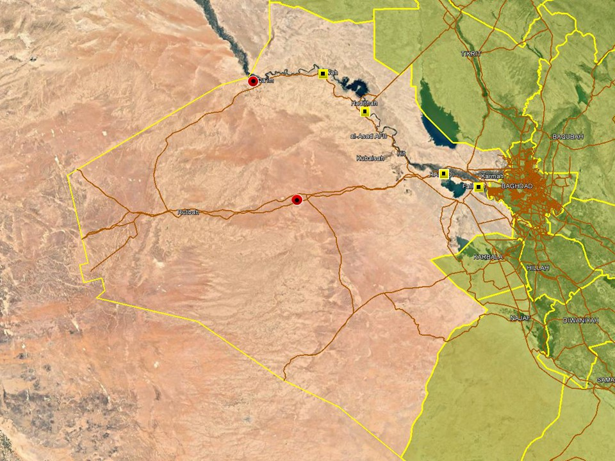

An overall uneventful week was observed in Anbar province with no significant security developments observed. ISF clearance operations continued in the western parts of the province, seizing and removing multiple IEDs and weapons in and around the districts of Qaim, Rawa and Hadithah. Several suspected IS militants were also arrested over the course of these operations. ISF operations also dominated activity in the east, around Fallujah and Ramadi, with multiple explosive remnants discovered and removed throughout the week. ISF also announced multiple arrests of suspected IS militants and criminality around the main population centres.

Capital Region (Including Baghdad City)

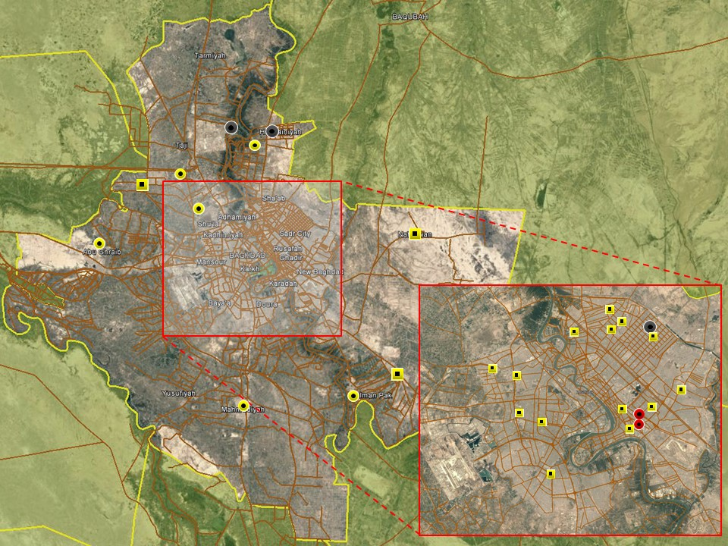

No large-scale incidents took place in Baghdad City, where activity trends again conformed to long-standing patterns. Hostilities were accordingly driven by local disputes and criminality predominantly concentrated in the less affluent districts of the city, including Sadr City, Adhamiyah and New Baghdad. With the exception of arrests under article IV terrorism, no terror-related activity was noted across the city. The overall situation in central Baghdad remains unchanged in terms of attacks, with two minor incidents reported this week, both targeting liquor stores in Karada district. The first comprised a low-yield IED and the other an incendiary device tossed outside; both caused material damage but no casualties. Small-scale demonstrations were also reported in the central districts, including on Tahrir Square and outside ECP2 of the IZ; both were peaceful and caused no movement disruptions.

Hostilities in the provincial areas were confined to population centres characterised by high levels of violence, including Hussainiyah in the north, Abu Ghraib in the west and Mada’in in the southeast. Incidents involved low-level SAF attacks, grenades and kidnappings, affecting the local population and driven by local issues. A demonstration to demand service improvements was also recorded in Bob al-Sham on December 17, with local citizens blocking traffic.

Southern Provinces
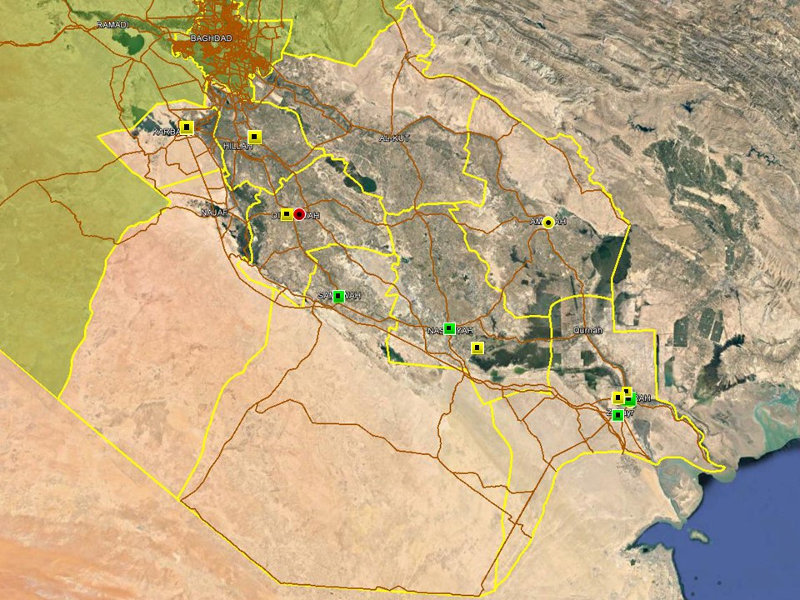

The overall security situation in the southern region remains stable, with no significant changes not this week in terms of incident trends. Reporting was as usual dominated by local protests in the provincial capital, driven by a mix of local grievances and political issues. Hostile activity mainly comprised local disputes and criminality, also centering on the provincial capitals.

In Basra, protest action has been the mainstay of this weeks recorded incidents. Civil disobedience movements have not lost momentum and the recent demonstrations in Basra city – most led by locals without the involvement of political figures - have consistently demanded increased representation in the new administration and have begun escalating as their issues remain unsolved. Basrawis demand an increase in Federal spending on their city and province, citing numerous infrastructure problems, unemployment and a continuing energy crisis as the main drivers for their actions. Parliamentary representatives from Basra, meanwhile, have jointly promised to abstain from voting on the 2019 Federal Budget – a draft of which should have been passed in November for any chance of timely implementation - should their demands for an increased share of Federal spending for the province be ignored. Three fatal UXO/ERW incidents this week should also act as a timely reminder to the deadly consequences of these munitions and the fact that the heavy rains associated with this time of year, can, and do unearth these unstable munitions

ACRONYM LIST

AII - Area of Intelligence Interest
AKA - Also Known As
AO - Area of Operations
APC - Armored Personnel Carrier
APIED - Anti-Personnel IED
AQ - Al-Qaeda
AT - Anti-Tank
ATGW - Anti Tank Guided Weapon
AVIED - Anti-Vehicle IED
BBIED - Body Borne IED
Bde - Brigade
Bn - Battalion
BXP - Border Crossing Point
CET - Convoy Escort Team
CLC - Concerned Local Citizens
CoP - Chief of Police
CP - Check Point
C-PERS - Captured Personnel
CPX - Complex Attack (attack using multiple weapon systems)
CQA - Close Quarter Assassination/Attack
DBS - Drive by Shooting
Div - Division
DoD - Department of Defense
DoS - Department of State
DoS - US Department of State
ECP - Entry Control Point
EFP - Explosively Formed Projectile
EOD - Explosive Ordinance Disposal (Bomb Squad)
ERW - Explosive Remnants of War
FoM - Freedom of Movement
GoI - Government of Iraq
HCN - Host Country National
HG - Hand Grenade
HME - Home Made Explosive
HMG - Heavy Machine Gun
HVT - High Value Target
IC - International Community
IDF - Indirect Fire (i.e.: rockets, mortars)
IDP - Internally Displaced Persons
IEC - Independent Electoral Commission
IED - Improvised Explosive Device
IM - International Military
IOC - International Oil Company
IRAM - Improvised Rocket Assisted Mortar
IRL - Improvised Rocket Launcher
IS - Islamic State
IVCP - Illegal Vehicle Check Point
IVO - In Vicinity Of
IZ - International Zone
KIA - Killed in Action
LN - Local National/Iraqi Civilian
MAIED - Magnetically attached IED (aka UVIED)
MIA - Missing in Action
MoD - Ministry of Defense
MoF - Ministry of Finance
MoFA - Ministry of Foreign Affairs
MoHE - Ministry of Higher Education
MoI - Ministry of Interior
MoJ - Ministry of Justice

MoO - Ministry of Oil
MoT - Ministry of Transportation
MSR - Main Supply Route
NFDK - No Further Details Known
NGO - Non-Governmental Organization (aid/charity)
NSTR - Nothing Significant To Report
OCG - Organized Crime Group
OPF - Oil Protection Force
PAX - Person, Persons or Passenger
PBIED - Person-Borne Improvised Explosive Device (UN Term)
PMF – Popular Mobilisation Forces
PoI - Point of Impact (for IDF)
PoO - Point of Origin (for IDF)
PSAF - Precision Small Arms Fire
PSC - Private Security Company
PSD - Private Security Detail
RCIED - Remote-Controlled IED
RPG - Rocket Propelled Grenade
RTA - Road Traffic Accident
SAF - Small Arms Fire
SAFIRE - Surface to Air FIRE
SF - Special Forces
SVBIED - Suicide Vehicle Borne IED
SVEST - Suicide Explosive Worn Vest
TCN - Third Country National
TCP - Traffic Control Point
Technical - An improvised weapon-mounted pick-up truck
TTP - Tactics, Techniques and Practices
UVIED - Under Vehicle IED
UXO - Unexploded Ordnance
VBIED - Vehicle Borne IED
VCP - Vehicle Checkpoint
WIA - Wounded in Action

GARDAWORLD INFORMATION SERVICES

From our management offices and field offices in strategic locations our constant monitoring of the high-risk environments in which we work is conveyed through our range of .Xplored™ risk analysis reports. The reports contain detailed updates, delivering current and relevant ground-truth information to assist both our personnel and our clients in their decision-making.

Our wider risk management solutions provide members of the defense, diplomatic, development, oil & gas and infrastructure sectors operating in potentially high-risk and complex environments with a comprehensive range of risk analysis, intelligence, crisis response, and training services. These services are designed to provide clients with the proactive capability to remain aware in potentially hostile environments and identify risks while strengthening their reactive capacity in emergency situations.

Our current regular reporting geographies include: Nigeria, Mali, Libya, Iraq, Afghanistan and Yemen on a daily, weekly, fortnightly, and monthly basis.

Through our constant monitoring and predictive threat analysis our Information Services team help you plan for, manage, and respond to risks.

For more information on our .Xplored reports or for information about our special-to-task reports tailored to individual client requirements, please contact us: informationops@garda.com or contact our regional representative iraq.ram@garda.com (Mobile: +964 7823 783 972)

For more information on how our services can support your business in Iraq contact:
Daniel Matthews, Senior Director Iraq daniel.matthews@garda.com

GARDAWORLD

A global leader in comprehensive security and risk management

GardaWorld International Protective Services is the international security division of GardaWorld Security Corporation, the world's largest privately owned security company with over 62,000 global staff.

We support clients in emerging, complex and high-risk markets around the world with static security, security consulting, risk analysis and reporting, crisis management and business continuity, mobile security, close protection, training and kidnap for ransom and extortion response solutions.

We work across multiple business sectors to provide protection and security for clients in the extractives, aerospace and defense, critical infrastructure, government and diplomatic and development sectors to secure employees, assets, and reputation so clients can focus solely on running daily operations and growing their business.

Discover more about the markets we serve and to learn how our international security solutions can help you contact us today: gwinfo@garda.com

Middle East
International Protective Services Headquarters
Office 2502, Tower 2, Currency House
DIFC, PO Box 482069
Dubai, United Arab Emirates

United States
1101 Wilson Boulevard
Suite 1725
Arlington, VA, 22209
United States

UK
5th Floor
1, London Bridge
London
SE1 9BG

Europe
37-39 rue des Deux Eglises
1000 Brussels
Belgium

garda.com

