
Weekly Iraq .Xplored report
29 December 2018

Prepared by Risk Analysis Team, Iraq

garda.com

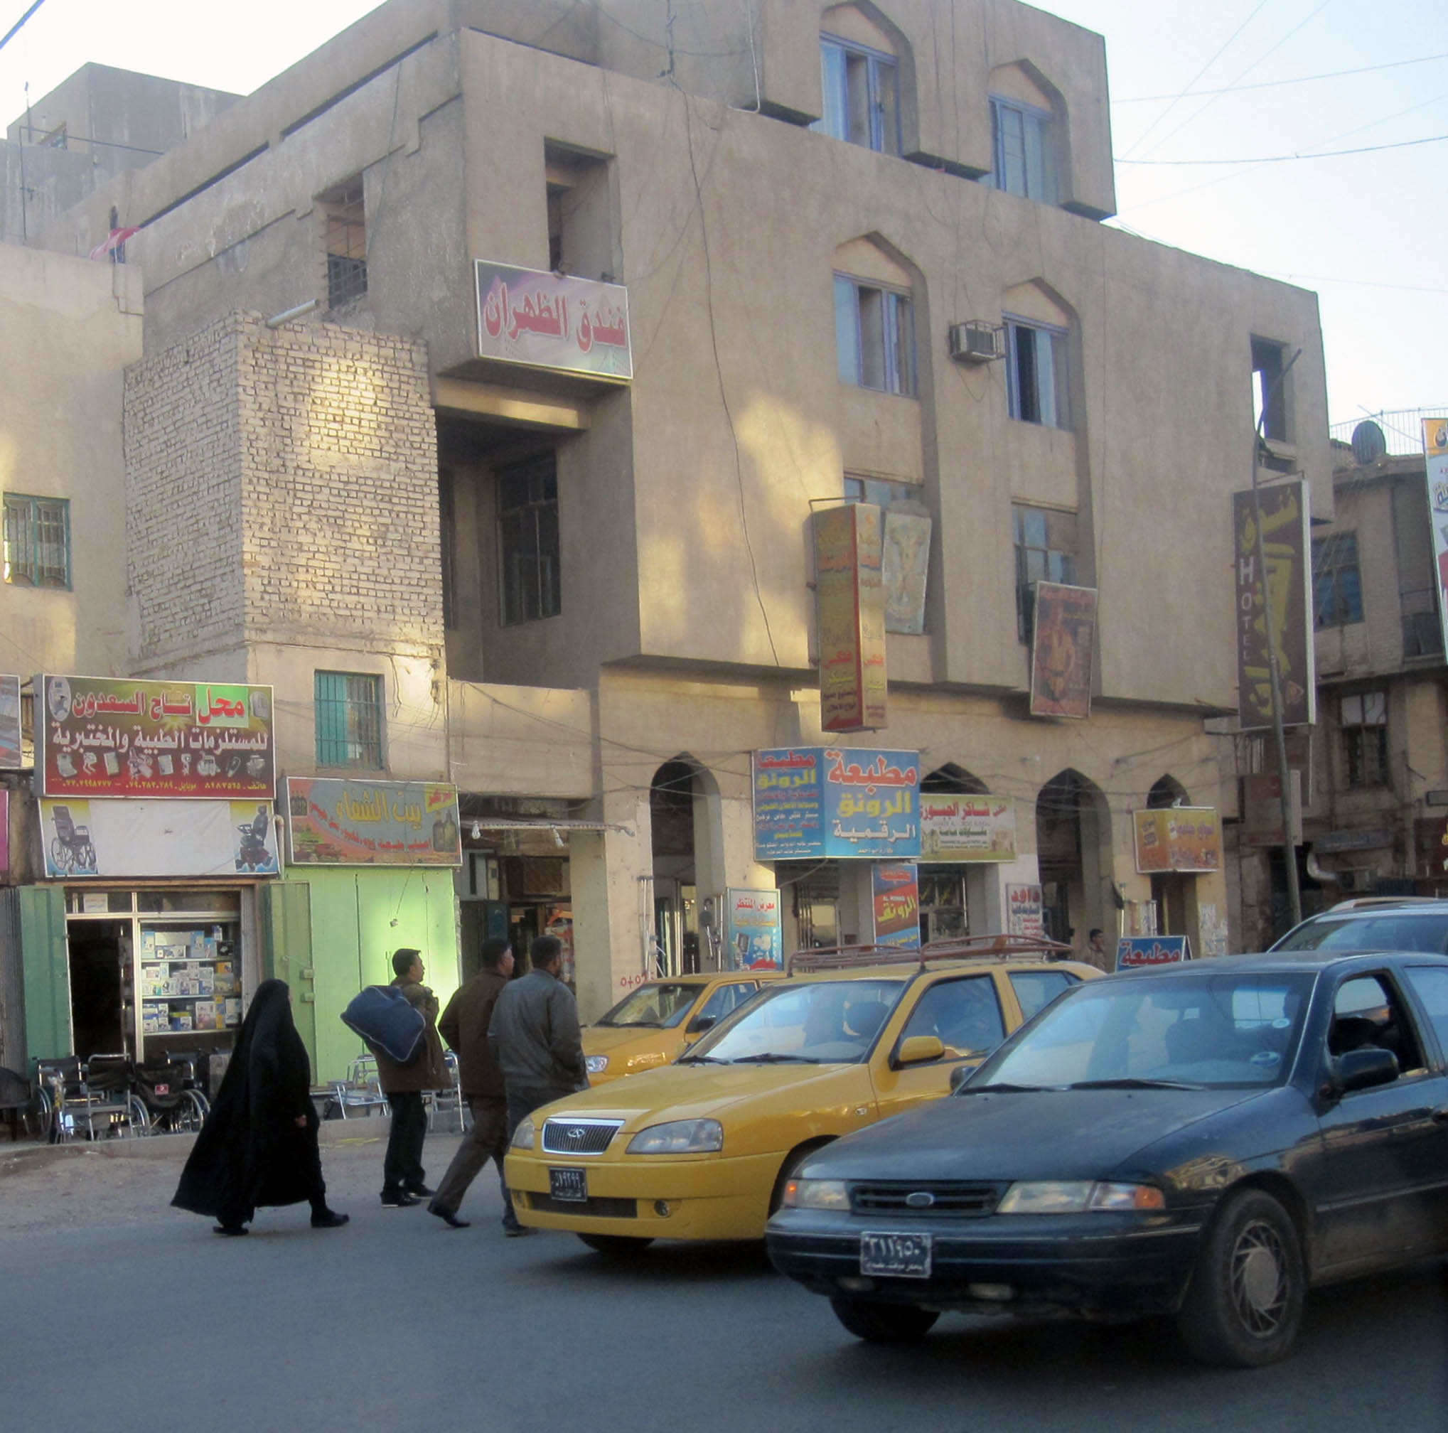

TABLE OF CONTENTS

TABLE OF CONTENTS 2
Activity Map 3
OUTLOOK 4

Short term outlook 4

Medium to long term outlook 4
Significant events 5

IDF targeted International Zone in response to unannounced visit by Trump 5

US withdrawal from Syria prompts envoy resignation and signs of shifting allegiances 5

Two new ministers approved by Parliament; three remaining 5
THREAT MATRIX 5
OVERVIEW 6

National/Regional 6
WEEKLY OPERATIONAL ASSESSMENT 9

Countrywide Military/Security Situation 9
ACRONYM LIST 14
GARDAWORLD INFORMATION SERVICES 15
GARDAWORLD 15

This report is an abridged version of GardaWorld Weekly Iraq .Xplored December 01, 2018. To subscribe to the full versions of the daily/weekly Iraq .Xplored reports, or for enquires relating to other GardaWorld services, please contact daniel.matthews@garda.com

Disclaimer: The information and opinions expressed in this Report are the views of GardaWorld and constitute a judgment as at the date of the Report and are subject to change without notice. The information and opinions expressed in this Report have been formed in good faith on the basis of the best information and intelligence available at the time of writing, but no representation or warranty, express or implied, is made as to its accuracy, completeness or correctness. GardaWorld accepts no liability arising out of or in connection with the comments made or the information set out in this Report and the reader is advised that any decision taken to act or not to act in reliance on this Report is taken solely at the reader’s own risk. In particular, the comments in this Report should not be construed as advice, legal or otherwise.

Activity Map

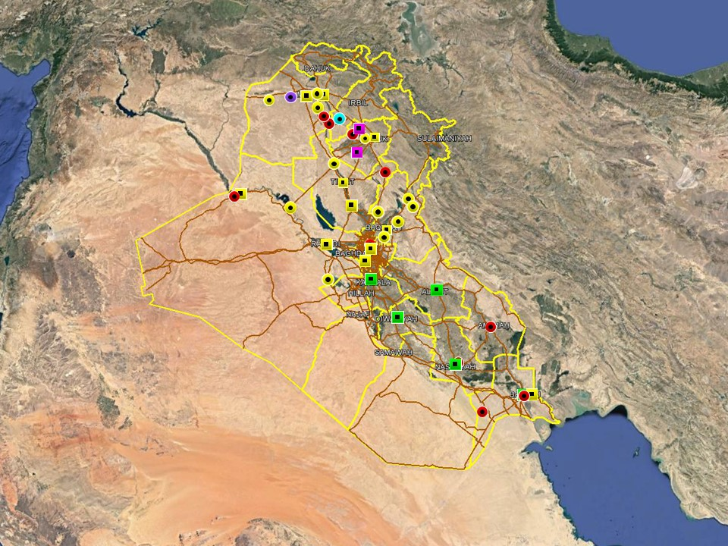

OUTLOOK

Short term outlook

- Rocket attacks directed at the International Zone and assessed to target the US Embassy in response to President Trump’s visit, highlight elevated anti-US sentiments and willingness from pro-Iranian factions to target US interests in the country. This is not unprecedented or unexpected, and absent a significant escalation in anti-US hostilities it is unlikely to affect commercial operations on the ground. The GoI’s response also highlight that US-Iraqi relations remain driven by pragmatic recognition of the necessity of continued western military and commercial support, and this is unlikely to change.

- The initial trial period for the International Zone opening expired on December 23 with no clarification from the Iraqi Government whether the IZ will remain open for public access. On December 11, Prime Minister Mahdi described the reopening as ‘irreversible’ and absent further announcement it can be assumed that the IZ will remain accessible to the public according to the current opening timings (17:00hrs – 05:00hrs). On December 16, the US Embassy issued a security alert stating it has initiated “security protocols similar to those used throughout Baghdad during the IZ’s open hours.” Actions to take listed in the alert included to “keep a low profile, be aware of surroundings and use caution while transiting the IZ”.

- Political tensions remain high in Basra following a number of protests in Basra City this week. On December 21 a demonstration calling for the dismissal of the Governor was dispersed by ISF using tear gas and live ammunition, with several protesters injured according to media reports. Further protest activity, with an associated risk of violence, can be expected in Basra City in the short term as long as political tensions remain high.

- IS activity is expected to remain high in the northern provinces, including Nineveh, Kirkuk and Diyala province, especially in the rural areas. The group is likely to continue its asymmetric campaign through hit and run attacks, targeted assassination and terrorism to challenge ISF control in these areas. While the group is assessed to retain intent to stage attacks in Baghdad and the southern provinces, its capability in restricted as evidenced by a continuing decline in high-profile attacks in these areas.

- Political focus now remains on the five Cabinet of Minister positions that remain unresolved, including those of the Defence and Interior Ministers. Opposition from Moqtada Al-Sadr’s Sairoun alliance to the selection of partisan figures for the remaining posts means that there is an associated risk of demonstrations as tensions remain high, especially in Baghdad. Upcoming 2019 fiscal year budget discussions can also be expected to drive protest activity in Baghdad and the southern provinces.

Medium to long term outlook

- Sectarian violence can be expected to continue in areas of Northern Iraq which remain permissive to IS operations, including Nineveh, Salah al-Din, Diyala and southwestern Kirkuk. Attacks will continue to target security checkpoints and outpost, especially in Sunni dominated areas controlled by Shia dominated security forces.

- Islamic State activity will continue to dominate security reporting with focus on the potential resurgence of an insurgent campaign in northern and western Iraq. Despite ongoing ISF efforts to clear remaining IS pockets, the group retains a degree of freedom of movement in the desert regions of Anbar, near the Syrian border, and along the Hamrin Mountains.

Significant events

IDF targeted International Zone in response to unannounced visit by Trump
Four rockets were fired towards the International Zone on December 27, with three impacting inside the zone without causing any casualties or damage. The attacks were almost certainly carried out by Shia militia factions in response to President Trump’s brief visit to Iraq which was met with strong reactions from pro-Iranian factions.

US withdrawal from Syria prompts envoy resignation and signs of shifting allegiances
Brett McGurk, the US Presidential Envoy to the Global Coalition against ISIS, tendered his resignation this week citing fundamental differences with Trump over his decision to withdraw troops from Syria while claiming senior officials had not been briefed on the decision. Later in the week, in an apparent response to the US withdrawal, a US-backed Kurdish ally in northern Syria invited Syrian government forces to enter areas controlled by the group to provide protection against Turkey.

Two new ministers approved by Parliament; three remaining
On December 24, Parliament voted to approve two more candidates for the remaining cabinet positions. Nawfal Bahaa Moussa was elected as Minister of Migration and Displacement while Shaima Khalil al-Hayali was approved as Minister of Education; Defence Minister nominee Faysal al-Jarba was again rejected in a vote. Sairun MPs walked out of the session before a vote on the Ministry of Interior could be held, thereby breaking quorum and postponing the vote.

THREAT MATRIX

Region | Political | Terrorism | Militancy | Crime | K&R
KRG* | Moderate | Low | Moderate | Low | Low
North** | Moderate | High-Extreme | High | High | High
Baghdad | Moderate | Moderate | Moderate | Moderate | Moderate
Anbar | Moderate | High | High | High | High
South*** | Moderate | Low | Moderate | Moderate | Moderate
Threat Scale | Minimal | Low | Moderate | High | Extreme

* KRG – Dohuk, Erbil & Sulaymaniyah
** North – Nineveh, Salah ad-Din, Kirkuk & Diyala
*** South – Babil, Wasit, Karbala, Najaf, Diwaniyah, Dhi Qar, Muthanna, Maysan & Basra

OVERVIEW

National/Regional

IDF targeted International Zone in response to unannounced visit by Trump
At approximately 05:20hrs on December 27, four rockets were fired towards the International Zone (IZ), likely targeting the US Embassy, with three impacting within the IZ and one outside; the exact points of impact and origin remain subject to conflicting reports. Credible reports however claim the rockets were fired from two separate locations in Baghdad City, including the districts of Karkh and New Baghdad (west and east of IZ), and that 107mm rockets were used, with no casualties or damage reported. The attacks are a likely response to US President Trump’s unannounced visit to Ain al-Asad airbase, Anbar province, late on December 26 where he told reporters that US troops would remain in the country and may use its presence along the border with Syria to “strike our enemies in the region”. This was met with condemnation from some militia leaders and PMU-affiliated representatives, with Kata’ib Hezbollah and Asaib ahl al-Haq both issuing statements saying they will ‘force the US to withdraw’ by force if necessary. It is therefore highly likely that the rockets were fired by militia factions aligned with pro-Iranian elements to back up the hostile rhetoric and make a political statement.

In response, the office of Prime Minister Abdul Mahdi issued a statement clarifying that the GoI had prior knowledge of Trump’s visit which it said came to congratulate the new Iraqi government and the international coalition on its success in fighting IS. The statement added that the request for a visit had been approved by the GoI and that a meeting had been scheduled between the two but cancelled in the last minute due to a disagreement over where to meet, with Trump reportedly declining a request to meet in Baghdad. The two leaders instead spoke on the phone, pledging to strengthen relations and to continue cooperating on mutual security issues. Trump, who reportedly left without meeting any Iraqi officials, also received an invitation to come to Baghdad while extending a similar invitation to Mahdi to come to Washington.

In the days after the visit, senior party members and influential leaders continued to criticise the US’ role in Iraq. A statement issued by al-Fatah Alliance described the visit as a ‘flagrant and clear violation of diplomatic norms’ and said it ‘raised questions about the nature of the US military presence and its real objectives’, which poses a threat to the security of Iraq. These sentiments were echoed by the State of Law coalition, which in a separate statement reaffirmed its rejection of ‘any foreign presence’ on Iraqi soil and said Trump’s visit ‘violated Iraqi sovereignty’. In a separate statement, Asaib Ahl al-Haq leader Qais Khazali reiterated his previous assertion that US forces should be expelled from the country by the Army and PMUs, and that the purpose of the US’ presence is to de-stabilise Iraq.

US withdrawal from Syria prompts envoy resignation and signs of shifting allegiances
Brett McGurk, the US Presidential Envoy to the Global Coalition against ISIS, tendered his resignation on December 21, thereby accelerating his departure from the position which was originally scheduled for February 2019. McGurk reportedly cited fundamental disagreements with President Trump over the decision to withdraw US troops from Syria as the key reason for his resignation and echoed former SecDef James Mattis’ in expressing concerns about not honoring alliances and local partners. Trump’s decision has also had repercussions on the ground in Syria. In a sign of switching alliances, the People’s Protection Units (YPG), a US-backed Kurdish group in northern Syria, issued a statement on December 28 inviting Syrian Government Forces to enter areas under YPG control, including Manbij, to ‘protect these areas against a Turkish invasion’. Syrian Government Forces later entered the district and raised the Syrian flag while a Syrian government spokesperson said they will now ensure the safety of all residents in the city and the surrounding districts.

Two new ministers approved by Parliament; three remaining
On December 24, Parliament voted to approve two more candidates for the remaining cabinet positions. Nawfal Bahaa Moussa was elected as Minister of Migration and Displacement while Shaima Khalil al-Hayali was approved as Minister of Education; Defence Minister nominee Faysal al-Jarba was again rejected in a vote. Sairun MPs walked out of the session before a vote on the Ministry of Interior could be held, thereby breaking quorum and postponing the vote.

Iran and Iraq signs MoU to continue energy cooperation
In an apparent rebuke to US efforts to cut Iraqi ties with Iran on energy issues, the two countries signed a memorandum of understanding (MoU), pledging commitment to a ‘long-term framework’ for cooperation within various energy sectors, including electricity and gas imports. The MoU was signed during a two-day visit by Iran’s Energy Minister Reza Ardakanian to Baghdad this week where he met with Electricity Minister Luay al-Khatteeb and Oil Minister Thamer al-Ghadhban. According to media reports, the MoU was confirmed by the Electricity Ministry and reportedly includes a series of pledges to develop and expand cooperation in various fields, including the exchange of expertise in production, transportation and distribution. Crucially, the MoU stipulates a continued import of power and gas through next year.

Iran unveils plans to build railway connecting Tehran with Damascus
Iranian officials unveiled a plan to build a moveable bridge across the Shat al-Arab River as part of a railway project linking the railway networks of Iran with Iraq and Syria. Mohammed Mousavi, Director General of the Iranian Department of Railway and Technical Structures, was quoted by Iranian state media saying Tehran is currently evaluating the costs of the project but said work would likely commence shortly. Mousawi reportedly added that this would be a step in a wider regional project linking Tehran with Damascus via southern Iraq.

WEEKLY OPERATIONAL ASSESSMENT

Countrywide Military/Security Situation

Northern Provinces
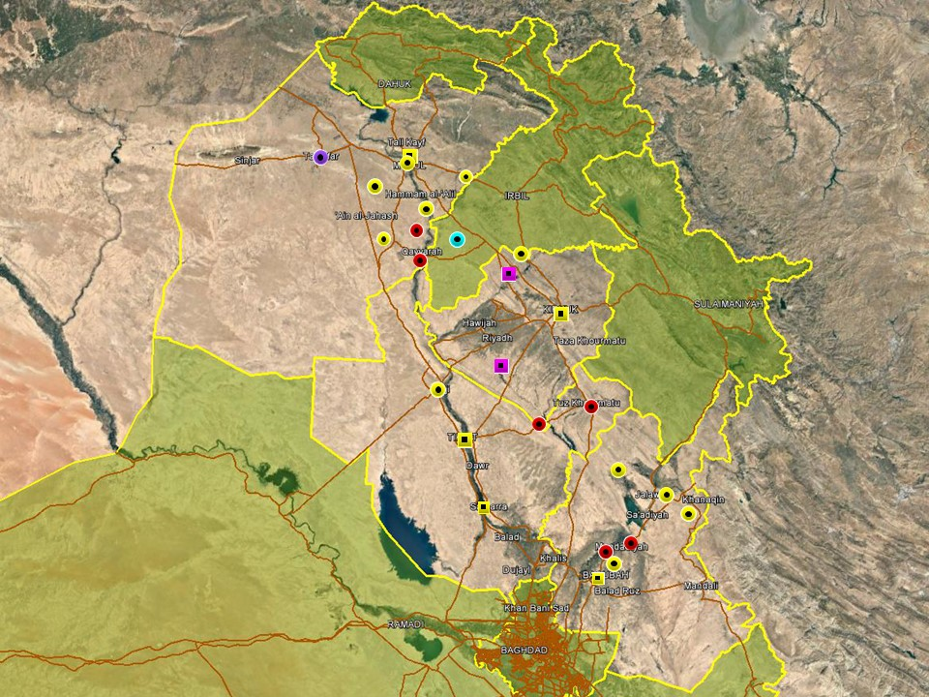

The most notable incident in Nineveh province took place on December 25 when a VBIED detonated in central Tal Afar, killing two civilians and injuring 11 others. The car was reportedly parked outside a busy café and ISIS claimed responsibility for the attack in a subsequent statement. Tal Afar is home of a significant Christian minority and it is possible that the attack, which took place on Christmas eve, targeted a café frequently visited by Christians. Separately, tensions in Sinjar district were elected this week following an incident involving Shia PMUs and Yazidi factions in the district. On December 23, Kurdish media reports claimed Badr affiliated PMU members ‘stormed’ the offices of the Ezidxan Protection Force (HPE) in Sinjar, disarming and arresting more than 20 HPE fighters. The detainees were later released after HPE leaders threatened to respond with force if necessary.

A relatively uneventful reporting period was noted in Kirkuk province, again characterised by federal police operations targeting IS activity in Hawijah district. As a result, multiple militants were reportedly arrested and large numbers of explosives and weapons seized in the district during the week. IS activity in the district remains relatively subdued in comparison to previous months. The most notable incident occurred in al-Rashad sub-district on December 25 when, in a series of apparently coordinated kidnappings, 14 civilians in total were abducted according to media reports. Separately, a UVIED detonated in Dibis district on December 28, injuring one civilian, however it is not clear whether the attack was carried out by IS or related to a local dispute, as is often the case in the district. Meanwhile, a report circulating by some media outlets that local residents repulsed an IS attack on December 26 in the district was subsequently discredited. A generally uneventful period was noted in Salah al-Din province, with most of the activity reported in the northern areas close to Kirkuk province and seemingly attributed to IS cells active in these areas. Attacks included kidnappings, assassinations and roadside IED targeting civilians in line with typical incident trends in areas north of Baiji, Hamrin Mountains and Tuz Khourmatu. ISF and PMU members affiliated with the Sadrist peace brigades also carried out security operations in the desert areas west of Samarra.

As usual, high activity levels were recorded in Diyala province, most of which continue to centre on the Diyala River Valley between Baqubah and Muqdadiyah, and Khanaqin district. Incidents in the river valley were recorded on a near daily basis and comprise SAF, kidnappings and occasional IDF targeting civilians and residential areas. Multiple attacks were also reported in Khanaqin district, where violence remains driven by a combination of ethnic tensions and IS activity. Most notable, two ISF members were wounded when IS militants assaulted a security checkpoint in Bawa Majmud region on December 22, an incident consistent with IS hit and run attacks in the areas. In response, ISF conducted security operations and carried out airstrikes in different areas of the province, including the Hamrin Basin area and southern Khanaqin. Multiple artillery strikes carried out by ISF were also reported during the week while a security operation targeted IS presence in the Waqin basin of northern Diyala, following reports that an IS banner had been raised in the village of Had al-Akhder. One IS hideout was reportedly destroyed.

Anbar Province

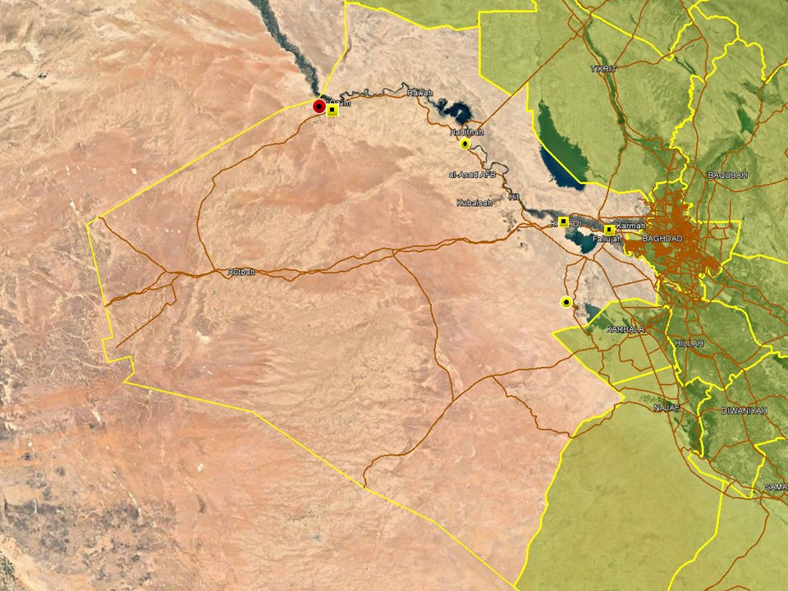

Another relatively subdued reporting period was observed in Anbar province, with no significant attacks and few hostile incidents recorded overall. On December 23, a VBIED was found and dismantled by ISF in Suhaila village, north of Hit, in the mid-Euphrates region. Three civilians were also killed over the course of a tribal dispute in Haditha district on December 25. Activity in western Anbar was otherwise characterised by ISF operations, including arrests and clearance operations around Qaim district near the Syria border. Further east, reporting around Ramadi and Fallujah districts comprised arrest operations targeting suspected criminality and terrorism, with no significant hostilities recorded. Further south, ISF foiled an infiltration attempt in Rahaliyah district near Lake Razzaza, where militants attempted to plant roadside IEDs on the main road between Majjar and Rahaliyah.

Capital Region (Including Baghdad City)

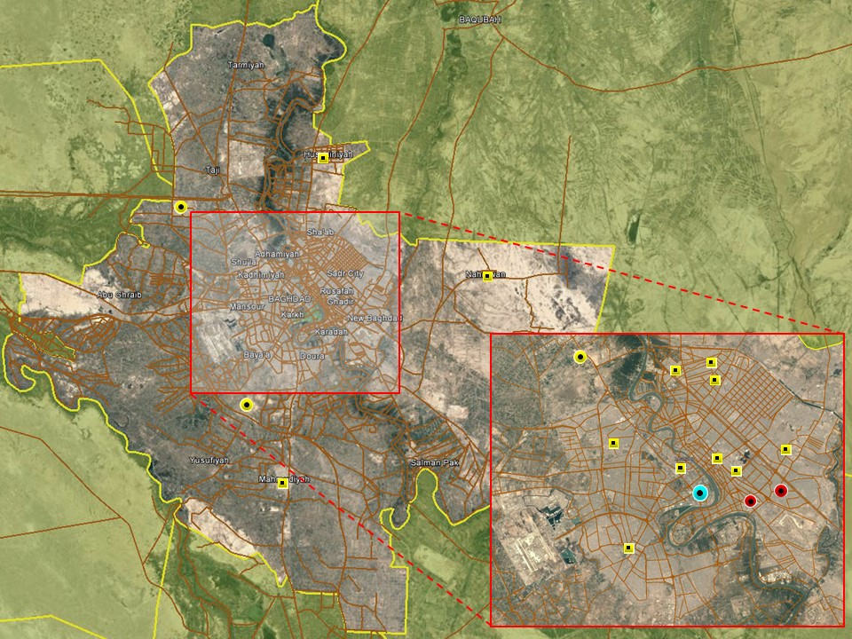

With the exception of the IDF attacks targeting the International Zone on December 27 (see National Reporting section above), activity patterns around Baghdad City were largely consistent with long-standing trends. On December 22, two IEDs detonated outside a liquor store in New Bagdhad district, causing material damage but no casualties. This is the fourth incident targeting liquor stores in Baghdad City over the past week, following two previous attacks in Karada district. Hostile activity across the capital was otherwise subdued and related to local disputes rather than terrorism.

No major security developments were noted in the provincial areas with low-level violence reported in population centres characterised by high levels of local violence. SAF attacks targeting civilians were accordingly reported in Sabah al-Bour, Taji and Radwaniyah while the victim of a kidnap was released in Mahmudiyah. ISF activity concentrated on criminality and suspected terrorism, with several arrest operations recorded in Nahrawan, Mahmudiyah, Hussainiyah and Abu Ghraib. The overall security situation in Baghdad province remains stable.

Southern Provinces
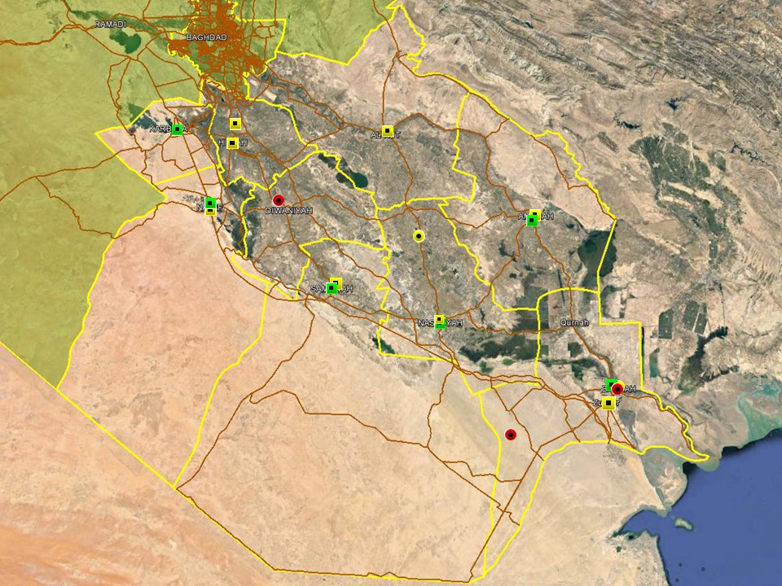

No significant security developments were noted overall in the southern region with daily activity patterns consistent with long-standing trends and accordingly domininated by criminality, local disputes and tribal tensions. Low-scale demonstrations driven by local and political grievances continue, with regular protests recorded in the provincial capitals during the week.

In Basra, protest action continued at a rate similar to that witnessed in previous weeks, in response to typical grievances including lack of federal spending, infrastructure problems, unemployment, a continuing energy crisis and a growing uncertainty as to the agenda of the Governor Idani. The period for him to announce his decision to remain in the post of Governor or take up his position in parliament is coming to an end and the council is keen to have someone earmarked as his successor as soon as an announcement is made. In relation to the stalled 2019 national budget, political activity intended to emphasise the economic significance of Basra will continue in a bid to increase the province’s share. There were no notable incidents in the city over the reporting period, with those recorded remaining low-level and related to local issues. On 24 December, the provincial council raised a recommendation for the dismissal of the current Basra Chief of Police. Of the 25 members present, it is believed almost all backed the motion for his dismissal. They cited the failure of the security forces to adequately protect them on the afternoon/evening of 15 December when large numbers of protesters prevented council members from escaping an ongoing session. Another potentially contenscious issue concerns the ‘Chairman’ of the Basra Provincial Council, Sabah al-Bazouni, who was released from prison on December 27 after having been incarcerated for 18 months; Bazouni stated he would begin his work as the BPC Chairman from next week.

ACRONYM LIST

AII - Area of Intelligence Interest
AKA - Also Known As
AO - Area of Operations
APC - Armored Personnel Carrier
APIED - Anti-Personnel IED
AQ - Al-Qaeda
AT - Anti-Tank
ATGW - Anti Tank Guided Weapon
AVIED - Anti-Vehicle IED
BBIED - Body Borne IED
Bde - Brigade
Bn - Battalion
BXP - Border Crossing Point
CET - Convoy Escort Team
CLC - Concerned Local Citizens
CoP - Chief of Police
CP - Check Point
C-PERS - Captured Personnel
CPX - Complex Attack (attack using multiple weapon systems)
CQA - Close Quarter Assassination/Attack
DBS - Drive by Shooting
Div - Division
DoD - Department of Defense
DoS - Department of State
DoS - US Department of State
ECP - Entry Control Point
EFP - Explosively Formed Projectile
EOD - Explosive Ordinance Disposal (Bomb Squad)
ERW - Explosive Remnants of War
FoM - Freedom of Movement
GoI - Government of Iraq
HCN - Host Country National
HG - Hand Grenade
HME - Home Made Explosive
HMG - Heavy Machine Gun
HVT - High Value Target
IC - International Community
IDF - Indirect Fire (i.e.: rockets, mortars)
IDP - Internally Displaced Persons
IEC - Independent Electoral Commission
IED - Improvised Explosive Device
IM - International Military
IOC - International Oil Company
IRAM - Improvised Rocket Assisted Mortar
IRL - Improvised Rocket Launcher
IS - Islamic State
IVCP - Illegal Vehicle Check Point
IVO - In Vicinity Of
IZ - International Zone
KIA - Killed in Action
LN - Local National/Iraqi Civilian
MAIED - Magnetically attached IED (aka UVIED)
MIA - Missing in Action
MoD - Ministry of Defense
MoF - Ministry of Finance
MoFA - Ministry of Foreign Affairs
MoHE - Ministry of Higher Education
MoI - Ministry of Interior
MoJ - Ministry of Justice

MoO - Ministry of Oil
MoT - Ministry of Transportation
MSR - Main Supply Route
NFDK - No Further Details Known
NGO - Non-Governmental Organization (aid/charity)
NSTR - Nothing Significant To Report
OCG - Organized Crime Group
OPF - Oil Protection Force
PAX - Person, Persons or Passenger
PBIED - Person-Borne Improvised Explosive Device (UN Term)
PMF – Popular Mobilisation Forces
PoI - Point of Impact (for IDF)
PoO - Point of Origin (for IDF)
PSAF - Precision Small Arms Fire
PSC - Private Security Company
PSD - Private Security Detail
RCIED - Remote-Controlled IED
RPG - Rocket Propelled Grenade
RTA - Road Traffic Accident
SAF - Small Arms Fire
SAFIRE - Surface to Air FIRE
SF - Special Forces
SVBIED - Suicide Vehicle Borne IED
SVEST - Suicide Explosive Worn Vest
TCN - Third Country National
TCP - Traffic Control Point
Technical - An improvised weapon-mounted pick-up truck
TTP - Tactics, Techniques and Practices
UVIED - Under Vehicle IED
UXO - Unexploded Ordnance
VBIED - Vehicle Borne IED
VCP - Vehicle Checkpoint
WIA - Wounded in Action

GARDAWORLD INFORMATION SERVICES

From our management offices and field offices in strategic locations our constant monitoring of the high-risk environments in which we work is conveyed through our range of .Xplored™ risk analysis reports. The reports contain detailed updates, delivering current and relevant ground-truth information to assist both our personnel and our clients in their decision-making.

Our wider risk management solutions provide members of the defense, diplomatic, development, oil & gas and infrastructure sectors operating in potentially high-risk and complex environments with a comprehensive range of risk analysis, intelligence, crisis response, and training services. These services are designed to provide clients with the proactive capability to remain aware in potentially hostile environments and identify risks while strengthening their reactive capacity in emergency situations.

Our current regular reporting geographies include: Nigeria, Mali, Libya, Iraq, Afghanistan and Yemen on a daily, weekly, fortnightly, and monthly basis.

Through our constant monitoring and predictive threat analysis our Information Services team help you plan for, manage, and respond to risks.

For more information on our .Xplored reports or for information about our special-to-task reports tailored to individual client requirements, please contact us: informationops@garda.com or contact our regional representative iraq.ram@garda.com (Mobile: +964 7823 783 972)

For more information on how our services can support your business in Iraq contact:
Daniel Matthews, Senior Director Iraq daniel.matthews@garda.com

GARDAWORLD

A global leader in comprehensive security and risk management

GardaWorld International Protective Services is the international security division of GardaWorld Security Corporation, the world's largest privately owned security company with over 62,000 global staff.

We support clients in emerging, complex and high-risk markets around the world with static security, security consulting, risk analysis and reporting, crisis management and business continuity, mobile security, close protection, training and kidnap for ransom and extortion response solutions.

We work across multiple business sectors to provide protection and security for clients in the extractives, aerospace and defense, critical infrastructure, government and diplomatic and development sectors to secure employees, assets, and reputation so clients can focus solely on running daily operations and growing their business.

Discover more about the markets we serve and to learn how our international security solutions can help you contact us today: gwinfo@garda.com

Middle East
International Protective Services Headquarters
Office 2502, Tower 2, Currency House
DIFC, PO Box 482069
Dubai, United Arab Emirates

United States
1101 Wilson Boulevard
Suite 1725
Arlington, VA, 22209
United States

UK
5th Floor
1, London Bridge
London
SE1 9BG

Europe
37-39 rue des Deux Eglises
1000 Brussels
Belgium

garda.com

