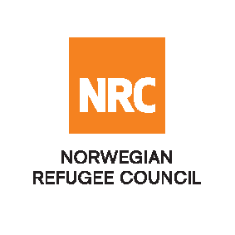

Tender Advert FWA 2019

Provision of Hotel and Conference Services for NRC Iraq

The Norwegian Refugee Council (NRC) is a non-governmental, humanitarian organization with 60 years of experience in helping to create a safer and more dignified life for refugees and internally displaced people.

NRC advocates for the rights of displaced populations and offers assistance within the Shelter, Education, Emergency food security, Legal assistance and Water, sanitation and hygiene sectors.

NRC has been present in Iraq since 2010, with offices located in Anbar province, Baghdad, Erbil, Dohuk, Hamam Al Alil, Mosul and Kirkuk. We have scaled up our response across Iraq to meet the large-scale crisis facing the country, reaching Iraqis with emergency assistance and supporting Syrian refugees as they live in exile. Our goal is to always be prepared to work in new settings, so we are establishing more local partnerships in Iraq.

The Norwegian Refugee Council (NRC) Office in Iraq invites eligible and interested suppliers to participate in the tender as per attached documents that will lead into Framework Agreements for at least 1 year: Refer to the table below;

Code# | Description | Contract Number
 | Contract Name: Provision of Hotel and Conference Services for NRC Iraq | ITB-HOS-03-2019-NRC-Iraq

Deadline : Tender closing is at 15:00 Hrs (Iraq time) on 07th February 2019

NOTE! NOTE! NOTE! NOTE! NOTE! NOTE!

- Submissions : For all completed bids for tender should be submitted in a sealed envelope (by hand delivery OR courier), addressed to;
Tender Committee
Norwegian Refugee Council, Iraq
Ekhlas Empire Building 3rd Floor, Korani Ainkawa Area, 100 Meter Street – Erbil, Kurdistan

NRC reserves the right to select/reject any bids, in part or full, as it may deem necessary without providing feedback on this regard. No liability or claim in that respect would be admissible or entertained whatsoever

