
Weekly Iraq .Xplored report
05 January 2019

Prepared by Risk Analysis Team, Iraq

garda.com

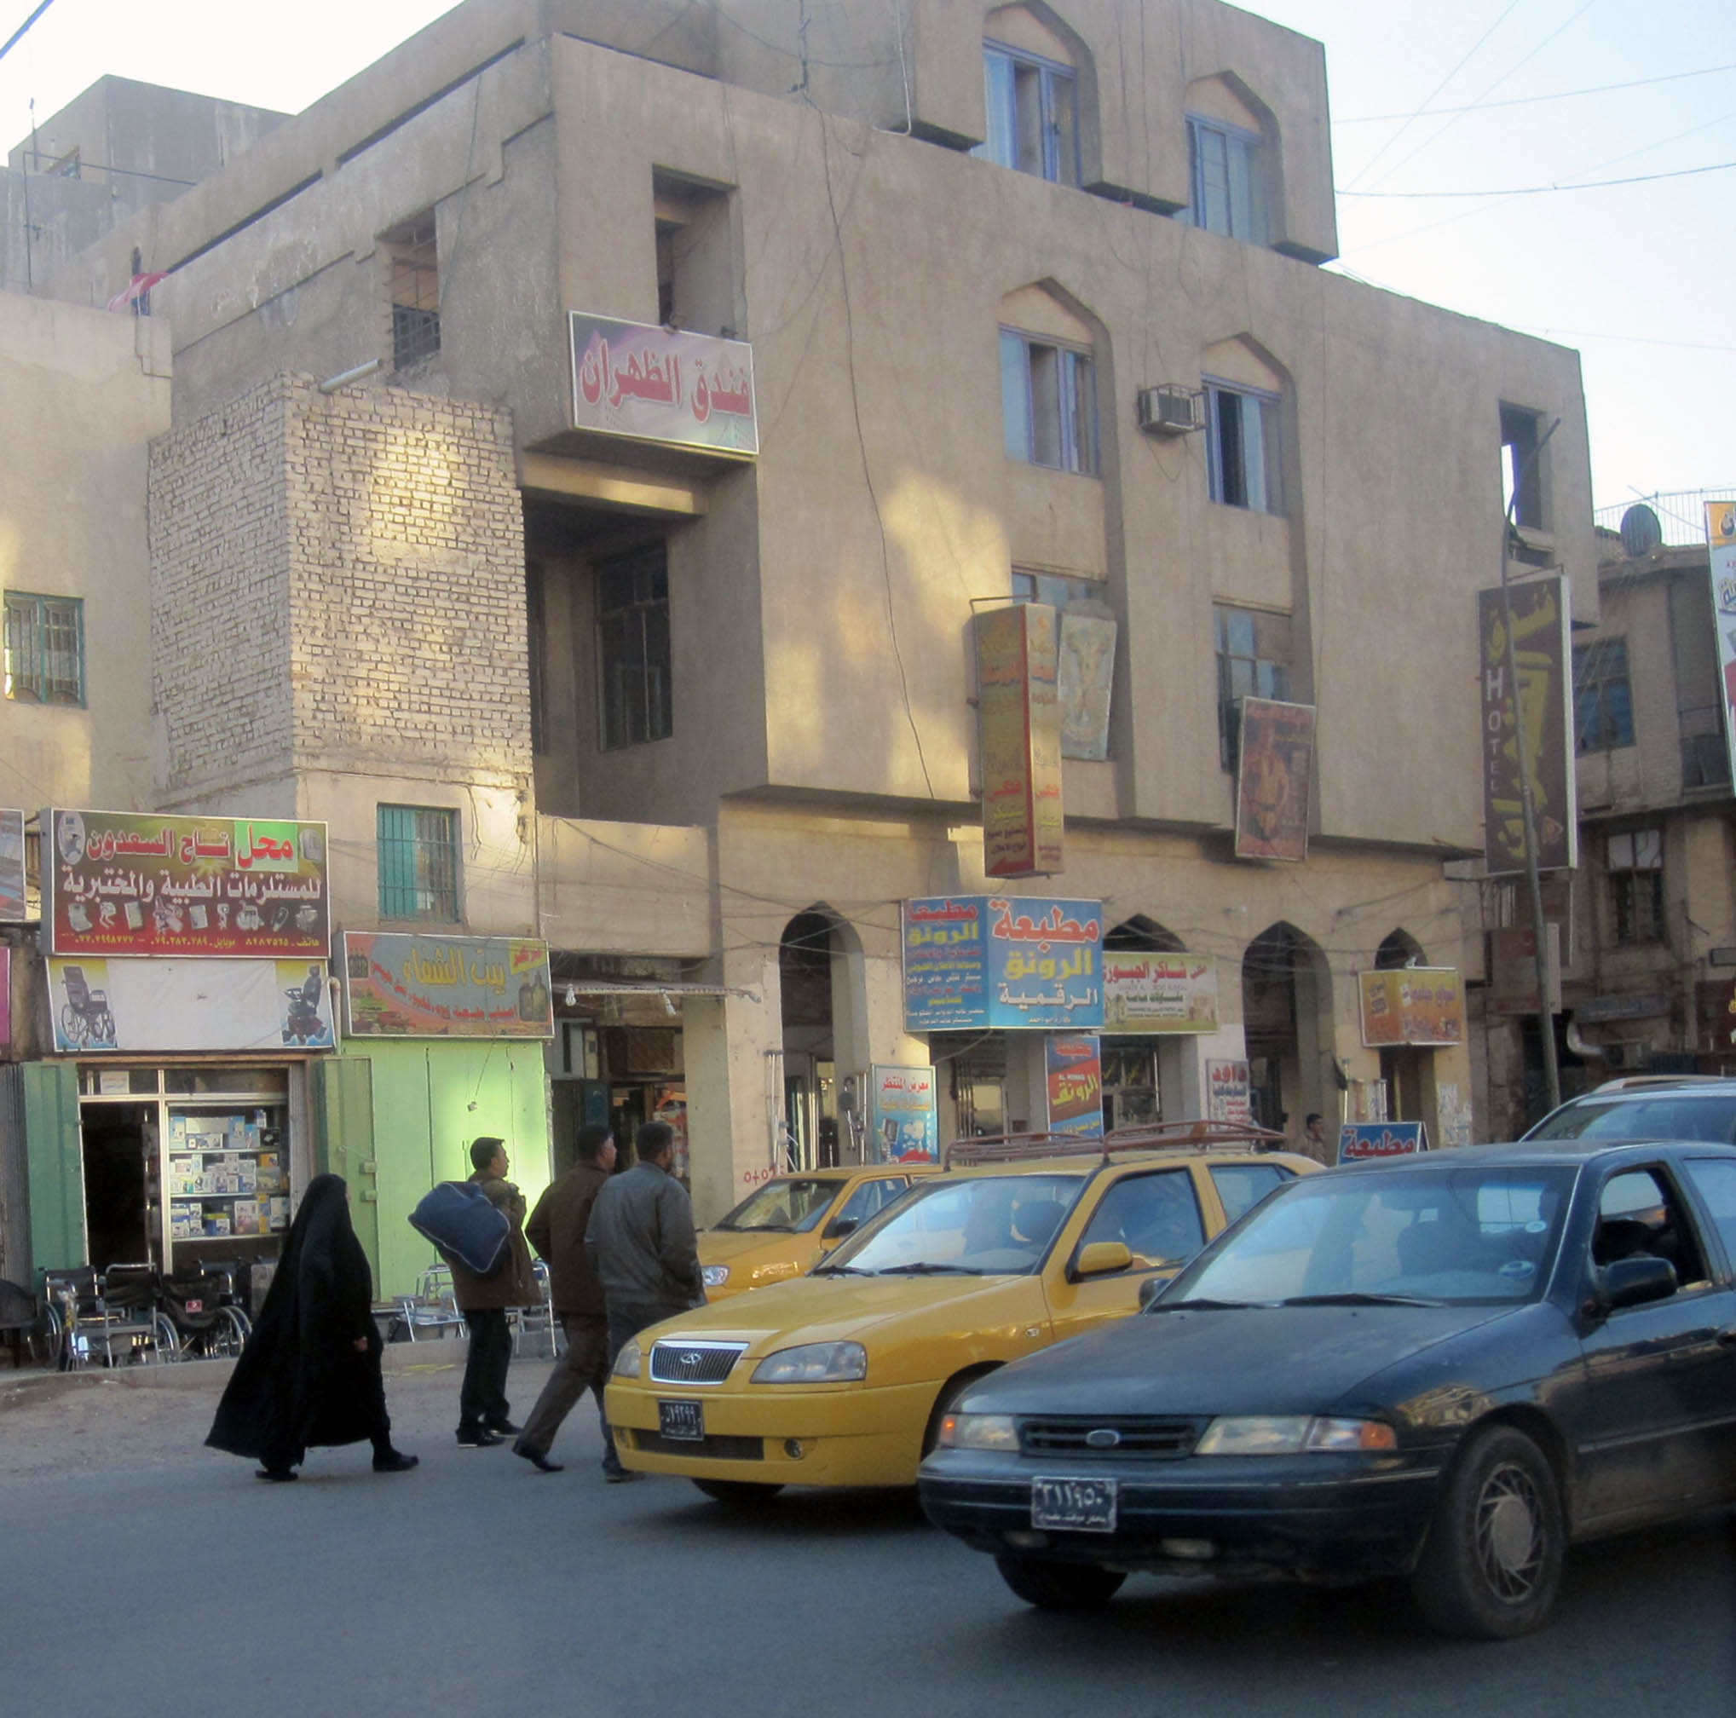

TABLE OF CONTENTS

TABLE OF CONTENTS 2
Activity Map 3
OUTLOOK 4

Short term outlook 4

Medium to long term outlook 4
Significant events 5

New US Presidential Envoy to anti-ISIS coalition appointed 5

Abdul Mahdi defends foreign troop presence and Iraqi sovereignty in press conference 5

Ministry of Health claims more than 100 people injured during celebrations 5
THREAT MATRIX 5
OVERVIEW 6

National/Regional 6
WEEKLY OPERATIONAL ASSESSMENT 9

Countrywide Military/Security Situation 9
ACRONYM LIST 14
GARDAWORLD INFORMATION SERVICES 15
GARDAWORLD 15

This report is an abridged version of GardaWorld Weekly Iraq .Xplored December 01, 2018. To subscribe to the full versions of the daily/weekly Iraq .Xplored reports, or for enquires relating to other GardaWorld services, please contact daniel.matthews@garda.com

Disclaimer: The information and opinions expressed in this Report are the views of GardaWorld and constitute a judgment as at the date of the Report and are subject to change without notice. The information and opinions expressed in this Report have been formed in good faith on the basis of the best information and intelligence available at the time of writing, but no representation or warranty, express or implied, is made as to its accuracy, completeness or correctness. GardaWorld accepts no liability arising out of or in connection with the comments made or the information set out in this Report and the reader is advised that any decision taken to act or not to act in reliance on this Report is taken solely at the reader’s own risk. In particular, the comments in this Report should not be construed as advice, legal or otherwise.

Activity Map

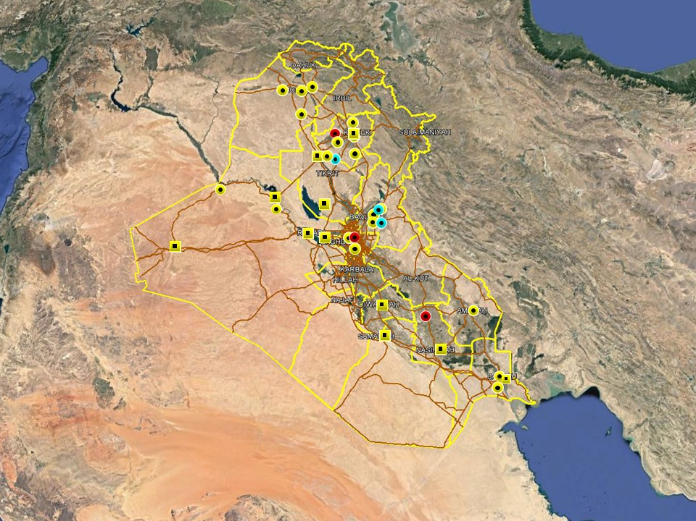

OUTLOOK

Short term outlook

- Rocket attacks directed at the International Zone and assessed to target the US Embassy in response to President Trump’s visit, highlight elevated anti-US sentiments and willingness from pro-Iranian factions to target US interests in the country. This is not unprecedented or unexpected, and absent a significant escalation in anti-US hostilities it is unlikely to affect commercial operations on the ground. The GoI’s response also highlight that US-Iraqi relations remain driven by pragmatic recognition of the necessity of continued western military and commercial support which is unlikely to change.

- The International zone remains open for public access during limited hours until further notice. On January 03 Prime Minister Mahdi announced another extension to the International Zone opening hours from 17:00hrs to 09:00hrs. On December 16, the US Embassy issued a security alert stating it has initiated “security protocols similar to those used throughout Baghdad during the IZ’s open hours.” Actions to take listed in the alert included to “keep a low profile, be aware of surroundings and use caution while transiting the IZ”.

- Political tensions remain high in Basra following a number of protests in Basra City this week. On December 21 a demonstration calling for the dismissal of the Governor was dispersed by ISF using tear gas and live ammunition, with several protesters injured according to media reports. Further protest activity, with an associated risk of violence, can be expected in Basra City in the short term as long as political tensions remain high.

- IS activity is expected to remain high in the northern provinces, including Nineveh, Kirkuk and Diyala province, especially in the rural areas. The group is likely to continue its asymmetric campaign through hit and run attacks, targeted assassination and terrorism to challenge ISF control in these areas. While the group is assessed to retain intent to stage attacks in Baghdad and the southern provinces, its capability in restricted as evidenced by a continuing decline in high-profile attacks in these areas.

- Political focus now remains on the five Cabinet of Minister positions that remain unresolved, including those of the Defence and Interior Ministers. Opposition from Moqtada Al-Sadr’s Sairoun alliance to the selection of partisan figures for the remaining posts means that there is an associated risk of demonstrations as tensions remain high, especially in Baghdad. Upcoming 2019 fiscal year budget discussions can also be expected to drive protest activity in Baghdad and the southern provinces.

Medium to long term outlook

- Sectarian violence can be expected to continue in areas of Northern Iraq which remain permissive to IS operations, including Nineveh, Salah al-Din, Diyala and southwestern Kirkuk. Attacks will continue to target security checkpoints and outpost, especially in Sunni dominated areas controlled by Shia dominated security forces.

- Islamic State activity will continue to dominate security reporting with focus on the potential resurgence of an insurgent campaign in northern and western Iraq. Despite ongoing ISF efforts to clear remaining IS pockets, the group retains a degree of freedom of movement in the desert regions of Anbar, near the Syrian border, and along the Hamrin Mountains.

Significant events

New US Presidential Envoy to anti-ISIS coalition appointed
James Jeffrey has been appointed as the new US Presidential Envoy to the Global Coalition against IS, replacing Brett McGurk who resigned earlier in December over his disagreement with the US troop withdrawal. A State Department spokesperson said Jeffrey will lead the implementation of President Trump’s announcement of a ‘responsible and orderly withdrawal’, and to coordinate the effort between the US and the International Coalition.

Abdul Mahdi defends foreign troop presence and Iraqi sovereignty in press conference
In his weekly press conference on December 30, Prime Minister Adel Abdul Mahdi said the presence of foreign troops on Iraqi soil does not constitute a violation of its sovereignty while emphasizing that there are ‘no US only Iraqi bases’ in the country. Mahdi added that while he respects the statements and viewpoints of some political blocs on the matter, the presence of foreign troops should not be confused with the issue of sovereignty

Ministry of Health claims more than 100 people injured during celebrations
An overall calm reporting period was noted over the New Year’s celebrations in terms of hostile incidents and political developments, however the Ministry of Health announced that more than 100 people were injured across the country as a result of celebratory SAF and fireworks.

THREAT MATRIX

Region | Political | Terrorism | Militancy | Crime | K&R
KRG* | Moderate | Low | Moderate | Low | Low
North** | Moderate | High-Extreme | High | High | High
Baghdad | Moderate | Moderate | Moderate | Moderate | Moderate
Anbar | Moderate | High | High | High | High
South*** | Moderate | Low | Moderate | Moderate | Moderate
Threat Scale | Minimal | Low | Moderate | High | Extreme

* KRG – Dohuk, Erbil & Sulaymaniyah
** North – Nineveh, Salah ad-Din, Kirkuk & Diyala
*** South – Babil, Wasit, Karbala, Najaf, Diwaniyah, Dhi Qar, Muthanna, Maysan & Basra

OVERVIEW

National/Regional

New US Presidential Envoy to anti-ISIS coalition appointed
James Jeffrey has been appointed as the new US Presidential Envoy to the Global Coalition against IS, replacing Brett McGurk who resigned earlier in December over his disagreement with the US troop withdrawal. A State Department spokesperson said Jeffrey will lead the implementation of President Trump’s announcement of a ‘responsible and orderly withdrawal’, and to coordinate the effort between the US and the International Coalition.

Iranian commander says warships will be deployed in ‘western Atlantic’
In a further sign of US-Iranian tensions, a senior Iranian naval commander told Iranian news outlets said Tehran will deploy naval forces to ‘the western Atlantic Ocean’, starting March. Rear-Admiral Touroj Hassani indicated that this is a response to the recent deployment of an aircraft carrier striker group by the US to the Persian Gulf, stating that ‘the US has a right to sail in international waters near Iran, the same way Iran has a right to sail near US waters.’ Hassani added that Iran has sufficient capabilities to ‘stand up against US actions’ and that the deployment to the Atlantic would include the ‘Sahand’, a newly launched, domestic made destroyer armed with surface to air missiles and a helicopter landing pad.

Abdul Mahdi defends foreign troop presence and Iraqi sovereignty in press conference
In his weekly press conference on December 30, Prime Minister Adel Abdul Mahdi said the presence of foreign troops on Iraqi soil does not constitute a violation of its sovereignty while emphasizing that there are ‘no US only Iraqi bases’ in the country. Mahdi added that while he respects the statements and viewpoints of some political blocs on the matter, the presence of foreign troops should not be confused with the issue of sovereignty. Mahdi also reiterated that the Government of Iraq had prior knowledge of Trump’s visit and that notification of the visit was submitted according to appropriate diplomatic procedures.

Ministry of Health claims more than 100 people injured during celebrations
An overall calm reporting period was noted over the New Year’s celebrations in terms of hostile incidents and political developments, however the Ministry of Health announced that more than 100 people were injured across the country as a result of celebratory SAF and fireworks. According to a Ministry spokesperson, 47 casualties, including 10 deaths, were recorded in Rusafa district alone according to preliminary figures, adding that the number may very well increase. Several arrests were also reported in Baghdad City and the south over celebratory SAF. Controversial footage also emerged on social media showing a Parliamentary deputy firing in the air while allegedly celebrating in Baghdad. The MP subsequently issued an apology and said the footage was old and from a wedding in Anbar province.

Salih and Erdogan pledge to deepen cooperation during meeting in Ankara
Addressing reporters after their meeting in Ankara this week, President Salih and President Erdogan pledged to deepen cooperation and develop relations between the two countries. Erdogan stressed the need to enhance cooperation on ‘terrorism’ to ensure regional security and stability while acknowledging the need to work on a number of other issues including electricity, energy and reconstruction. For his part, Salih said Iraq welcomes deeper cooperation with Turkey and called for a comprehensive agreement to address a range of issues, including water shortages.

UNAMI released civilian casualty figures for December
According to the monthly casualty figures released by UNAMI, only 32 civilians were killed across the country and another 32 injured in acts of terrorism and conflict-related violence in December 2018. Nineveh was the most affected province (27 killed and injured) followed by Baghdad (20) and Salah al-Din (6). The statement adds that “the figures include ordinary citizens and others considered civilian at the time of death or injury, such as police on non-combat functions, civil defence, personal security teams, facilities protection police and fire department personnel.” UNAMI also announced that since the numbers have steadily declined, it will cease publishing the figures on a monthly basis.

Basra Council Chairman resumes duties after prison sentence
Basra Provincial Council Chairman Sabah al-Bazuni officially resumed duties following his release from prison last week, having been sentenced to two years in August 2017 on two accounts of corruption. According to media reports quoting sources close to the provincial council, al-Bazuni was released on December 27 and resumed his duties as normal on December 30, attending meetings and signing documents at the Provincial Council.

Separately, Basra Governor Assad al-Idani announced that he will renounce his membership as a Parliamentary Deputy in Baghdad in order to continue his duties as Governor. In a statement issued by Idani’s office, he further pledged to cooperate with the provincial council during the coming year to ensure improvement in the delivery of services to the people of Basra.

WEEKLY OPERATIONAL ASSESSMENT

Countrywide Military/Security Situation

Northern Provinces
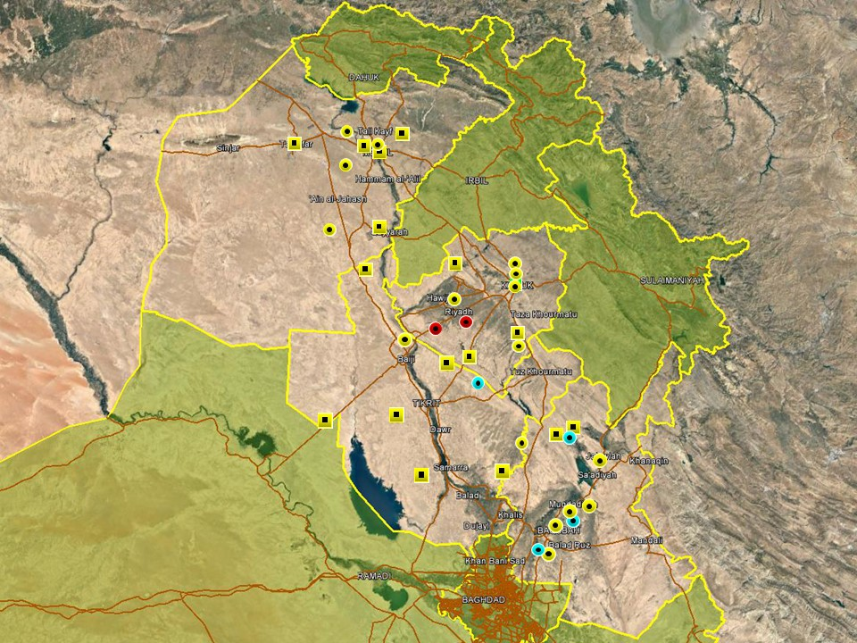

Overall incident patters in the northern region remained consistent with established trends and as such no significant changes were noted this week in the overall situation. In Nineveh province, IS cells and sympathisers continue to carry out low-level attacks, targeting ISF and civilians in rural areas of the province. According to Kurdish media reports quoting a security official, the bodies of three recently kidnapped IP officers were found near Ghazlani military base, south of Mosul. The same report claimed two IP officers were killed and five wounded when a roadside IED detonated near a police convoy in al-Hadhar district on December 27. On January 01, gunmen also shot and killed the wife of a bodyguard of former Nineveh governor Nawfal al-Aakoul, west of Mosul. It is assumed that the incident is politically motivated, but no further details have been released. PMU and ISF continued anti-IS operations across the province, including Badush, Hadhar, Bashiqah and Hammam al-Alil. ISF also carried out multiple anti-terror raids, at one point disrupting an IS plot to target senior government officials. Members of al-Abbas combat brigade were also reported to have deployed to Tal Afar district to ensure stability following a reported increase in IS activity in the aftermath of the VBIED attack on January 25.

A slight increase in activity was observed in Kirkuk province following a relatively lull observed in recent weeks. However, activity continues to be low-level and predominantly recorded in the southwestern areas of the province around Hawijah district. Incidents included roadside IED, UVIED and targeted SAF attacks, likely attributable to a mix of low-level insurgency and tribal activity characteristic of the area. Federal police forces also continued to conduct security operations in the district, seizing multiple IEDs and weapons during the week. Local media also reported that coalition forces carried out an air assault operation in al-Rashad sub-district of January 04, without disclosing further details. Low-level activity was also recorded north of Kirkuk City, including targeted assassinations involving SAF in Shoraw and Shwan; both are likely related to local disputes rather than terrorism. Two civilians were also injured when gunmen opened fire in Kirkuk City on December 30 for unspecified reasons. In a separate development, KDP and PUK officials were quoted by Kurdish media saying KDP Peshmerga would return to Kirkuk and ‘replace the PMU’ deployed in some areas. This was not confirmed by either ISF or the PMU, and the unlikely report remains uncorroborated.

Diyala province remains unstable with high levels of activity recorded again this week. Following patterns seen in previous weeks, attacks attributable to low-level insurgency, tribal tensions and local disputes, were again recorded on a near daily basis in the Diyala River Valley, including SAF and occasional IDF targeting civilians and residential areas. Local officials have reiterated calls for ISF to escalate operations in response to the reported entrenchment of IS cells in the outskirts of Muqdadiyah where hostilities remain elevated. ISF and PMU operations were concentrated in the northern areas of the province, including the Hamrin basin and areas bordering Salah al-Din. A slight increase has also been noted in the southern areas of the province, including Buhrez south of Baqubah where at least one mortar round impacted and killed one ISF member on December 31. An increase in IS activity has been recorded in the district over the past weeks, and local security officials have warned that IS is escalating activity by targeting local tribal leaders and ISF, replicating attack patterns seen elsewhere.

In Salah al-Din, relatively low levels of hostile activity were observed and reporting overall dominated by ISF operations concentrated north of Baiji and along the eastern border areas near Diyala province. ISF, backed by the peace companies were also reported to have carried out multiple clearance operations in the desert areas west of Samarra.

Anbar Province

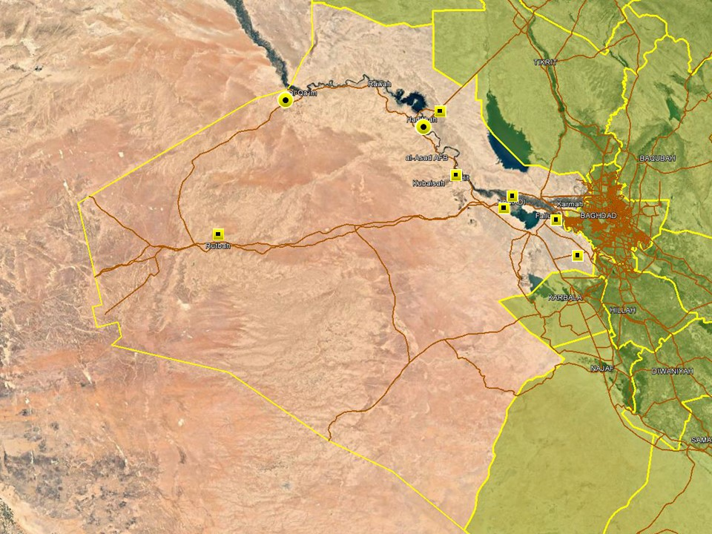

An overall calm reporting period was observed in Anbar province with few attacks recorded overall. That said, it is assumed that the real incident levels are higher, at least in rural areas of the province where reporting lines are disrupted. As such, hostile activity was confined to the western areas, including Hadithah and Qaim where local tribal factions were reportedly involved in clashes with IS on different occasions this week. ISF operations, backed by airstrikes, were also carried out in western Anbar, including Qaim and Rutbah, where IS is still assessed to retain an operational presence. ISF also foiled an infiltration attempt in Hadithah, along the border with Salah al-Din, where IS members from Mount Makhoul attempted to establish a logistical corridor between the two provinces. The purpose was likely to facilitate the movement of supplies between Syria and northern Salah al-Din, where IS retains a presence in the mountain areas of Hamrin and Makhoul. A subsequent deployment of additional ISF to western Anbar may have come in response to these developments and uncertainty emanating from the US troop withdrawal which may afford IS greater operational freedom in eastern Syria.

In east Anbar, activity was dominated by arrest operations targeting criminality and suspected terrorism. Arrest operations were consequently recorded on a near-daily basis in Ramadi, Fallujah and the surrounding districts, underlining that ISF retains a high level of control in these areas.

Capital Region (Including Baghdad City)

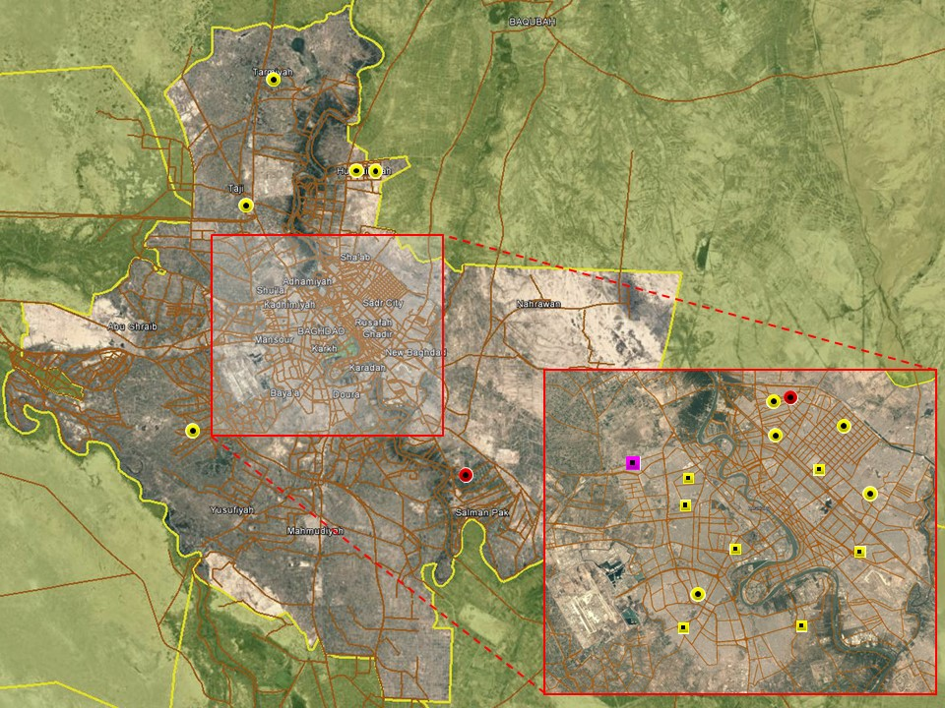

A typical reporting period was noted in Baghdad City, again characterised by low-level violence confined to less affluent areas characterised by high levels of violence and tensions. SAF and small-scale IED were recorded during the week in Adhamiyah, New Baghdad, Sadr City and West Rashid, likely motivated by local disputes rather than terrorism. The victim of a recent kidnapping was also released in Shulah district in the northwest. No significant development were noted in central Baghdad where hostilities remain subdued. Gunshots were heard in Karada district on January 03 and later confirmed related to an arrest operation. Minor protest activity was recorded as usual on Tahrir Square and outside various government ministries but all were small-scale and uneventful. ISF operations also continued on a regular basis, targeting criminality in different areas of the capital throughout the week.

A relatively uneventful period was also noted in the provincial areas, with low-level attacks confined to typically violent population centres. Accordingly, isolated instances of SAF, body finds and IED were recorded in Taji, Tarmiyah and Hussainiyah, north of Baghdad, all assessed to be related to local disputes. An IED also detonated near a high voltage power line in Mada’in district, southeast of Baghdad, causing local power outages on December 31. The cause of the incident is not clear.

Southern Provinces
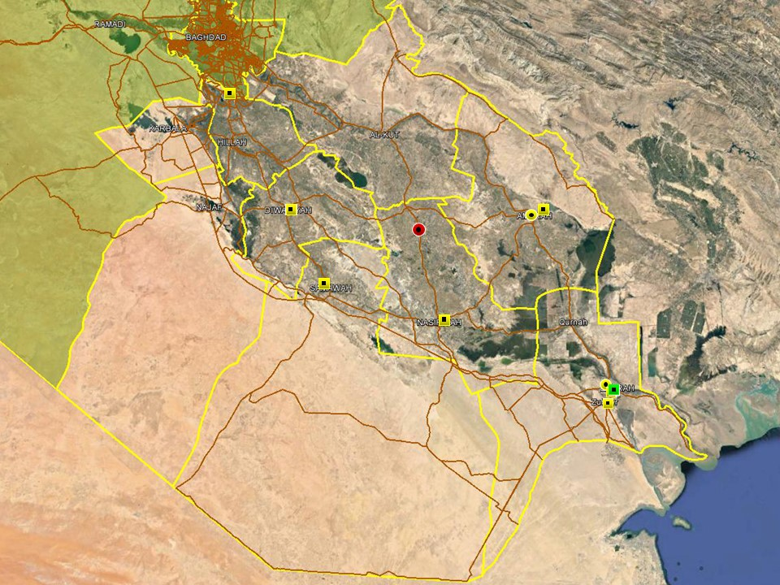

The overall situation in the southern region remains stable with no significant changes noted during the week. Daily reporting trends remain dominated by arrest operations targeting criminality and local disputes, while hostile activity remains similarily characterised by low-level incidents. Accordingly, an IED detonated in Rifa’I district outside a contruction company on January 03, causing damage to a truck parked outside. The incident is characteristic of a financial dispute. Low-level SAF was also recorded in Maysan province where a primary school building was targeted by SAF on January 02. A legacy SVEST was also discovered in Warka sub-district north of Samawah and removed without incident.

In Basra, the announcement of the allocation of 370 employment opportunities within the O&G sector resulted in limited protest action at the Zubayr employment office and on Contractors Row in North Rumaila. 27 000 applicates for the jobs were later confirmed, with the majority of the work offered centring on static security, drivers and admin posts. Protest action in relation to employment, better services and an end to council/political corruption continued but at a much reduced rate and less violent than of late. No notable incidents were recorded during the reporting period, with those recorded remaining low-level. One incident revolved around oil smuggling in which a police officer was shot and killed on January 02. The event highlights once again that this action is morphing from a small scale tribal endeavour to a widespread phenomenon that is supported by political parties, gangs and powerful militia figures.

ACRONYM LIST

AII - Area of Intelligence Interest
AKA - Also Known As
AO - Area of Operations
APC - Armored Personnel Carrier
APIED - Anti-Personnel IED
AQ - Al-Qaeda
AT - Anti-Tank
ATGW - Anti Tank Guided Weapon
AVIED - Anti-Vehicle IED
BBIED - Body Borne IED
Bde - Brigade
Bn - Battalion
BXP - Border Crossing Point
CET - Convoy Escort Team
CLC - Concerned Local Citizens
CoP - Chief of Police
CP - Check Point
C-PERS - Captured Personnel
CPX - Complex Attack (attack using multiple weapon systems)
CQA - Close Quarter Assassination/Attack
DBS - Drive by Shooting
Div - Division
DoD - Department of Defense
DoS - Department of State
DoS - US Department of State
ECP - Entry Control Point
EFP - Explosively Formed Projectile
EOD - Explosive Ordinance Disposal (Bomb Squad)
ERW - Explosive Remnants of War
FoM - Freedom of Movement
GoI - Government of Iraq
HCN - Host Country National
HG - Hand Grenade
HME - Home Made Explosive
HMG - Heavy Machine Gun
HVT - High Value Target
IC - International Community
IDF - Indirect Fire (i.e.: rockets, mortars)
IDP - Internally Displaced Persons
IEC - Independent Electoral Commission
IED - Improvised Explosive Device
IM - International Military
IOC - International Oil Company
IRAM - Improvised Rocket Assisted Mortar
IRL - Improvised Rocket Launcher
IS - Islamic State
IVCP - Illegal Vehicle Check Point
IVO - In Vicinity Of
IZ - International Zone
KIA - Killed in Action
LN - Local National/Iraqi Civilian
MAIED - Magnetically attached IED (aka UVIED)
MIA - Missing in Action
MoD - Ministry of Defense
MoF - Ministry of Finance
MoFA - Ministry of Foreign Affairs
MoHE - Ministry of Higher Education
MoI - Ministry of Interior
MoJ - Ministry of Justice

MoO - Ministry of Oil
MoT - Ministry of Transportation
MSR - Main Supply Route
NFDK - No Further Details Known
NGO - Non-Governmental Organization (aid/charity)
NSTR - Nothing Significant To Report
OCG - Organized Crime Group
OPF - Oil Protection Force
PAX - Person, Persons or Passenger
PBIED - Person-Borne Improvised Explosive Device (UN Term)
PMF – Popular Mobilisation Forces
PoI - Point of Impact (for IDF)
PoO - Point of Origin (for IDF)
PSAF - Precision Small Arms Fire
PSC - Private Security Company
PSD - Private Security Detail
RCIED - Remote-Controlled IED
RPG - Rocket Propelled Grenade
RTA - Road Traffic Accident
SAF - Small Arms Fire
SAFIRE - Surface to Air FIRE
SF - Special Forces
SVBIED - Suicide Vehicle Borne IED
SVEST - Suicide Explosive Worn Vest
TCN - Third Country National
TCP - Traffic Control Point
Technical - An improvised weapon-mounted pick-up truck
TTP - Tactics, Techniques and Practices
UVIED - Under Vehicle IED
UXO - Unexploded Ordnance
VBIED - Vehicle Borne IED
VCP - Vehicle Checkpoint
WIA - Wounded in Action

GARDAWORLD INFORMATION SERVICES

From our management offices and field offices in strategic locations our constant monitoring of the high-risk environments in which we work is conveyed through our range of .Xplored™ risk analysis reports. The reports contain detailed updates, delivering current and relevant ground-truth information to assist both our personnel and our clients in their decision-making.

Our wider risk management solutions provide members of the defense, diplomatic, development, oil & gas and infrastructure sectors operating in potentially high-risk and complex environments with a comprehensive range of risk analysis, intelligence, crisis response, and training services. These services are designed to provide clients with the proactive capability to remain aware in potentially hostile environments and identify risks while strengthening their reactive capacity in emergency situations.

Our current regular reporting geographies include: Nigeria, Mali, Libya, Iraq, Afghanistan and Yemen on a daily, weekly, fortnightly, and monthly basis.

Through our constant monitoring and predictive threat analysis our Information Services team help you plan for, manage, and respond to risks.

For more information on our .Xplored reports or for information about our special-to-task reports tailored to individual client requirements, please contact us: informationops@garda.com or contact our regional representative iraq.ram@garda.com (Mobile: +964 7823 783 972)

For more information on how our services can support your business in Iraq contact:
Daniel Matthews, Senior Director Iraq daniel.matthews@garda.com

GARDAWORLD

A global leader in comprehensive security and risk management

GardaWorld International Protective Services is the international security division of GardaWorld Security Corporation, the world's largest privately owned security company with over 62,000 global staff.

We support clients in emerging, complex and high-risk markets around the world with static security, security consulting, risk analysis and reporting, crisis management and business continuity, mobile security, close protection, training and kidnap for ransom and extortion response solutions.

We work across multiple business sectors to provide protection and security for clients in the extractives, aerospace and defense, critical infrastructure, government and diplomatic and development sectors to secure employees, assets, and reputation so clients can focus solely on running daily operations and growing their business.

Discover more about the markets we serve and to learn how our international security solutions can help you contact us today: gwinfo@garda.com

Middle East
International Protective Services Headquarters
Office 2502, Tower 2, Currency House
DIFC, PO Box 482069
Dubai, United Arab Emirates

United States
1101 Wilson Boulevard
Suite 1725
Arlington, VA, 22209
United States

UK
5th Floor
1, London Bridge
London
SE1 9BG

Europe
37-39 rue des Deux Eglises
1000 Brussels
Belgium

garda.com

