Norwegian Refugee Council (NRC) Iraq
Supply and Delivery Furniture for Erbil, Mosul, Sinjar, HAA and Baaj
ITB-FUR-02-2019-NRC-Iraq

17th Of January 2019

Our reference: ITB-FUR-02-2019-NRC-Iraq
SUBJECT: INVITATION TO TENDER FOR Supply and Delivery Furniture for Erbil, Mosul, Sinjar, HAA and Baaj

Dear Mr/Ms

Following your enquiry regarding the publication of the above-mentioned invitation to tender, please find enclosed the following documents, which constitute the tender dossier.

Any request for clarification must be received by NRC in writing at least 5 working days before the deadline for submission of tenders. NRC will reply to bidders' questions at least 2 working days before the deadline for submission of tenders.

Costs incurred by the bidder in preparing and submitting the tender proposals will not be reimbursed.

We look forward to receiving your tender at the address specified in the Instructions to Bidders before 07th of February 2019, as stated in the procurement notice.

If you decide not to submit a tender, we would be grateful if you could inform us in writing, stating the reasons for your decision.

Yours sincerely,
NRC Procurement Team

This ITB document contains the following:
- This cover Letter
- Section 2: Bid Data sheet
- Section 3: NRC Invitation to bid general terms & condition
- Section 4: Technical description of the Bid
- Section 5: Bidding form
- Section 6: Pricing Proposal
- Section 7: Company Profile and Previous Experience
- Section 8: Additional Information on Specifications of Goods
- Section 9: Suppliers Ethical Standards Declaration

Sections highlighted in green must be completed by the bidder.

SECTION 2
BID DATA SHEET
- BACKGROUND DATA

Contract Name: Supply and Delivery Furniture for Erbil, Mosul, Sinjar, HAA, and Baaj | Contract Number: ITB-FUR-02-2019-NRC-Iraq

This bid is issued by Norwegian Refugee Council (NRC office in Iraq) Any correspondence can be addressed the following email address: iq.procurement@nrc.no

- SCOPE OF SUPPLY

The Contracts eligible for bidding are:
Description of the supply contract

Supply and Delivery Furniture for Erbil, Mosul, Sinjar, HAA, and Baaj

- SCHEDULE & DEADLINE FOR SUBMISSION

The deadline for submission of bids is 1500 Hrs. on the 07th February 2019. Late bids will not be accepted.
 | DATE | TIME*
Invitation to Bid release | 17th Jan. 2019
Deadline for request for any clarifications from NRC | 31st Jan. 2019 | 1500
Deadline for submission of tenders (receiving date, not sending date) | 07th Feb. 2019 | 1500
* All times are in the local time of Iraq
Please note all dates are provisional dates and NRC reserves the right to modify this schedule.

- MANNER OF SUBMISSION:

Please submit your bids in accordance with the requirements detailed below:

Complete sealed bid documents shall be hand delivered at Ekhlas Empire Building, Beside Hogir Fuel Station Korani Ankawa area, 100 m street- Erbil

not later than 1500Hrs, on the due date indicated above. Tenders will be opened thereafter in the presence of the tenderers or their representatives who choose to attend.
- ASSESSMENT CRITERIA

Award of the contract(s) will be based on the following:

Step 1: Administrative compliance check

Bidders must provide evidence of the following for their bid to be considered compliant:
- Sections 5-9 completed, signed and stamped
- Bidder has included a copy of their valid business licence

Step 2: Technical Evaluation

A Technical Evaluation of all bids received will be conducted to shortlisted bidders. Criteria that will be used to evaluate and score the bids are outlined in Section 3, Clause 25

Step 3: Financial Evaluation

Price in comparison to NRC established expectation and in comparison to other bidders of comparable technical quality
- BIDDER’S CHECKLIST
Description | To be filled by bidder |  | To be filled by NRC bid committee
 | Included? |  | Present & complete? |  | Comments
Step/ document to be submitted with tender | Yes | No | Yes | No
Complete tender package delivered before the deadline specified in Section 2 - Bid Data Sheet - Compulsory
Section 4 –Supplies Provision – completed, signed & stamped – Compulsory
Section 5 – Bidding Form – completed, signed & stamped – Compulsory
Section 6 – Pricing Proposal - signed & stamped – Compulsory
Section 7 – Company profile & experience – completed, signed & stamped – Compulsory
Section 8 – Additional Information on Specifications of Goods – completed, signed & stamped – Compulsory
Section 9 – Supplier ethical standards declaration – signed & stamped – Compulsory
Supporting documents
Copy of company registration – Compulsory
Copy of tax registration – Compulsory
Copies of past contracts/ POs as proof of experience
Copies of company direct IDs – Compulsory

To be filled in by NRC bid committee only | Eligible | Ineligible
Outcome of administrative eligibility check.

SECTION 3
NRC Invitation to bid - General terms & conditions

- SCOPE OF BID
  - The bid is based on the scope of the assignment as determined in the Bid Data Sheet (Section 2). The instruction to bidders should be read in conjunction with the Bid Data Sheet.
  - The successful Bidder will be expected to complete the assignment by the Intended Completion Date specified in the contract to be signed

- CORRUPT PRACTICES
  - Norwegian Refugee Council requires Employees, Bidders and Contractors, to observe standards of ethics during procurement and the execution of contracts. In pursuit of this, Norwegian refugee Council defines, for the purposes of this provision, the terms set forth below as follows:
  - “Corrupt practice” includes the offering, giving, receiving, or soliciting of anything of value to influence the action of a public official in the procurement process or in contract execution; and
  - “Fraudulent practice” includes a misrepresentation of facts in order to influence a procurement process or the execution of a contract to the detriment of the Norwegian Refugee Council, and includes collusive practices among Bidders prior to or after bid submission designed to establish bid prices at artificial, non-competitive levels and to deprive the Norwegian Refugee Council of the benefits of free and open competition;
  - In any case where fraud or corruption is identified, NRC will:
- reject any bids where the Bidder has engaged in corrupt or fraudulent practices in competing for the Contract;
- remove bidding contractors who engage in fraudulent or corrupt practices, from our prequalified list
- liaise with District Officials to report if fraudulent or corrupt practices are identified
- terminate works
  - Any communications between a Bidder and the Norwegian Refugee Council related to matters of alleged fraud or corruption must be made in writing and addressed to the Country Director in Iraq

- ELIGIBLE BIDDERS
  - A Bidder shall meet the following criteria to be eligible to participate in NRC procurement:
- the bidder, at the time of bid, is not:
    - insolvent;
    - in receivership;
    - bankrupt; or
    - being wound up
- the bidder’s business activities have not been suspended;
- the bidder is not the subject of legal proceedings for any of the circumstances in (b); and
- The bidder has fulfilled his or her obligations to pay taxes and social security contributions. In a case where VAT is included in a bid, a copy of the VAT certificate must accompany the bid. A Bidder, and all parties constituting the Bidder including sub-contractors, shall not have a conflict of interest. All Bidders found to have a conflict of interest shall be disqualified. A Bidder may be considered to have a conflict of interest with one or more parties in this bidding process, if they have a relationship with each other, directly or through common third parties, that puts them in a position to have access to information about or influence on the bid of another Bidder, or influence the decisions of the Norwegian Refugee Council regarding this bidding process
  - A Bidder whose circumstances in relation to eligibility change during a procurement process or during the execution of a contract shall immediately inform the Norwegian Refugee Council.
  - NRC reserves the right to refuse a bid at any time if the bidder or one of its sub-contractors provided material support or resources to any individual or entity that commits, attempts to commit, advocates, facilitates, or participates or is found guilty of fraud, active corruption, collusion, coercive practice, bribery, involvement in a criminal organization or illegal activity, or immoral human resources practices, including but not limited to: child labour, non-discrimination, freedom of association, payment of the legal national minimum wage, and forced labour.

- JOINT VENTURES, CONSORTIA AND ASSOCIATIONS
Bids submitted by a joint venture, consortium or association of two or more firms as partners will only be accepted in exceptional circumstances.

- ONE BID PER BIDDER PER WORK
Each Bidder shall submit only one Bid per contract. A Bidder who submits or participates in more than one bid per contract will cause all the bids with the Bidder’s participation to be rejected.

- COST OF BIDDING
The Bidder shall bear all costs associated with the preparation and submission of his Bid, and the Norwegian Refugee Council shall not be responsible or liable for those costs, regardless of the conduct or outcome of the bidding process.

- INSPECTION
NRC is obliged to ensure that its procurement decisions are clearly justified and documented and keeping within the Donors mandatory principles. In that regard, full and on-the-spot access must be granted to representatives of NRC, the Donor or any organization or person mandated by it, to premises belonging to NRC or its contractors. The right to access shall include all documents and information necessary to assess, or audit the implementation of the contract

- OBTAINING AND COMPLETING BIDDING DOCUMENTS
  - Bidders who did not obtain the Bidding Document directly from the Norwegian Refugee Council will be rejected during evaluation. Where a Bidding Document is obtained from the Norwegian Refugee Council on a Bidder’s behalf, the Bidder’s name must be registered with the Norwegian Refugee Council at the time of issue.
  - The Bidder is expected to examine all instructions, forms, terms, and specifications in the Bidding Document. Failure to furnish all information or documentation required by the Bidding Document may result in the rejection of the bid.

- CLARIFICATION OF BIDDING DOCUMENT
A prospective Bidder requiring any clarification of the Bidding Document shall contact the Norwegian Refugee Council in writing. The Norwegian Refugee Council will respond in writing to any request for clarification before the deadline for clarification of bids. The Norwegian Refugee Council shall forward copies of its response to all Bidders who have acquired the Bidding Document, including a description of the inquiry but without identifying its source.

- AMENDMENT OF BIDDING DOCUMENT
  - At any time prior and until 48 hours prior to the deadline for submission of bids, the Norwegian Refugee Council may amend or cancel the Bidding Document by informing the bidders in writing.
  - To give prospective Bidders reasonable time in which to take an amendment or cancellation into account in preparing their bids, the Norwegian Refugee Council can, at his discretion, extend the deadline for the submission of bids.

- LANGUAGE OF BID
  - The bid, as well as all correspondence and documents relating to the bid shall be written in English.
  - Supporting documents and printed literature that are part of the bid may be in another language provided they are accompanied by an accurate translation of the relevant passages in English, in which case, for purposes of interpretation of the Bid, such translation shall govern.

- DOCUMENTS COMPRISING THE BID
  - The bid submitted by the Bidder shall comprise the following:
- Signed and stamped Contractor’s bid in Section 5
- Any other information and documents requested in Section 5.
- Pricing proposal (as in Section 6)
- Company Profile and Previous experience (as in Section 7)
- Additional information on specification of Goods (as in Section 8)
- Signed and stamped Supplier Ethical Standards Declaration in Section 9
  - All forms must be completed without any alterations to the format, and no substitutes shall be accepted. All blank spaces shall be filled in with the information requested.

- BID PRICE FOR SUPPLY CONTRACT
  - Bid prices are for the complete quantity of items required; quantity in each category of items cannot be reduced.
  - Items for which no rate or price is entered by the Bidder will be as not quoted.
  - Unless otherwise specified in Section 2 - the Bid Data Sheet, all duties, taxes and other levies payable by the contractor under the contract, shall be included in the total bid price submitted by the bidder.
  - For bidder subject to VTA, VTA should be mentioned in the offers
  - The Bidder is reminded that it is entirely his responsibility to ensure the accuracy of his bid. No alteration will be made to the bid after its submission on the grounds of any arithmetical errors subsequently discovered.

- CURRENCIES OF BID AND PAYMENT
All prices shall be quoted by the Bidder in IQD, unless otherwise stated. Similarly, all payments will be made in IQD.

- BID VALIDITY
  - Bids shall remain valid for a period of 1 Year after the date of the bid submission deadline as prescribed by Norwegian Refugee Council. A bid valid for a shorter period shall be rejected as non-compliant.
  - In exceptional circumstances, prior to the expiration of the bid validity period, the Norwegian Refugee Council may request Bidders in writing to extend the period of validity of their bids. A Bidder must confirm in writing his acceptance of the extension. In case of extension, modification of the bid is not permitted.

- ALTERNATIVE BIDS
Bidders shall submit offers that comply with the requirements of the bidding documents, including the basic technical design as indicated in the drawings and specifications. Alternative bids shall not be considered unless otherwise indicated in Section 2 – the Bid Data Sheet.

- FORMAT AND SIGNING OF BID
The Bidder shall prepare one set of bid documents per contract that he wishes to bid for. The bidder should hold a copy of the documents with himself, for reference purposes.

- SEALING AND MARKING OF THE BID
  - The Bidder shall enclose the bid for each contract in a plain envelope securely sealed
  - The envelopes shall:
  - be addressed to the Logistics Office, Norwegian Refugee Council, in the location specified in Section 2 – the Bid Data Sheet
  - bear the Contract number
  - no other markings should be on the envelope
  - If all envelopes are not sealed and marked as required, the Norwegian Refugee Council will reject the bid

- DEADLINE FOR SUBMISSION OF BIDS
Bids must be received by the Norwegian Refugee Council at the address given and no later than the date and time indicated in Section 2 - the Bid Data Sheet.

- LATE BIDS
The Norwegian Refugee Council shall not consider any bid that arrives after the deadline for submission as stipulated in Section 2 – the Bid Data Sheet. Any bid received by the Norwegian Refugee Council after the deadline for submission of bids shall be declared late and rejected.
- WITHDRAWAL AND REPLACEMENT OF BIDS
  - A Bidder may withdraw or replace its bid after it has been submitted at any time before the deadline for submission of bids by sending a written notice, signed by an authorized representative. Any corresponding replacement of the bid must accompany the respective written notice. All notices must be:
- submitted as with Clauses 20 and 21, and in addition, the envelopes shall be clearly marked “WITHDRAWAL” or “REPLACEMENT” and
- received by the Norwegian Refugee Council prior to the deadline for submission of bids, in accordance with Section 2 – the Bid Data Sheet
  - After the opening of bids, modifications to bids must be documented and any discussions reported in writing. A bid may be withdrawn at any stage, with written notice.

- CONFIDENTIALITY
  - Information relating to the examination, evaluation, comparison, and post-qualification of bids, and recommendation of contract award, shall not be disclosed to bidders or any other persons not officially concerned with such process until information detailing the best evaluated Bidder is communicated to all Bidders.
  - Any effort by a Bidder to influence the Norwegian Refugee Council in the examination, evaluation, comparison, and post-qualification of the bids or contract award decisions may result in the rejection of its bid.
  - From the time of bid opening to the time of Contract award, if any Bidder wishes to contact the Norwegian Refugee Council on any matter related to the bidding process, it should do so in writing.
- CLARIFICATION OF BIDS
Norwegian Refugee Council may, at its discretion, ask any Bidder for a clarification of its Bid. The Norwegian Refugee Council’s request for clarification and the response shall be in writing. Any clarification submitted by a Bidder that is not in response to a request by the Norwegian Refugee Council shall not be considered. All requests for clarifications shall be copied to all bidders for information purposes. No change in the price or substance of the bid shall be permitted, except to confirm the correction of errors.
- BIDS VALIDATION
  - The Norwegian Refugee Council’s determination of a Bid’s validity is to be based on the contents of the bid itself, which cannot be corrected if determined to be invalid
  - A valid bid is one that complies with all the terms, conditions, and specifications of the Bidding Document, without deviation or omission, which affects, or could affect;
- the scope, quality, or performance of the Works specified in the Contract; or
- limits in any substantial way, the Norwegian Refugee Council’s rights or the Bidder’s obligations under the Contract

- EVALUATION OF BID
  - The Norwegian Refugee Council shall examine the legal documentation and other information submitted by Bidders to verify eligibility, and then will review and score bids according to the following criteria;
- Quality of the product according required specifications. NRC evaluates samples for testing
- Price in comparison to NRC established rate
- Overall timeframe for the delivery of the requested goods
- Demonstrated excellence in service, support and warranties
- Thoroughness of quotation preparation
- Quality, reputation and performance of supplier
- Adherence to Ethic, environmental, anti-corruption NRC policies
- Earlier experiences and documentation proven in the tender documents, related to the service required under this contract
  - NRC reserves the right to make an award based solely on the quotations received, to modify the requirements prior to awarding, or to negotiate further with one or more suppliers. NRC reserves the right to award a contract to the supplier who, in their sole opinion, provides the best combination of cost and quality benefits.
  - Anti-money laundering, anti-bribery, anti-corruption and anti-terrorism legislation applicable in some jurisdictions may require NRC to verify the identity of the bidder prior to financial transactions. NRC reserves the right to use online screening tools to check the bidder’s record with regards to their possible involvement in illegal or unethical practices.
  - The Norwegian Refugee Council reserves the right to reject all bids, and re-tender if no satisfactory bids are submitted

- AWARD PROCEDURE
  - The Norwegian Refugee Council shall award the Contract in writing, with an award letter, to the Bidder whose offer has been determined to be the best, before the end of the bid validity period
  - Any bidder who has not been awarded a contract, will be notified in writing
  - Until a formal contract is prepared and executed, the Award Letter shall constitute a binding agreement between the bidder and NRC.
  - The Award Letter will state the sum that the Norwegian Refugee Council will pay the Contractor in consideration of the Works as prescribed in the Contract, and in accordance with the Bid.
  - The Bidder is thereafter required to submit a Letter of Acceptance, confirming their wish to proceed with a contract.

- SIGNING OF CONTRACT
  - Upon receipt of the Letter of Acceptance, the Norwegian Refugee Council shall call the successful Bidder to sign the Contract.
  - Within an agreed timeframe, the successful Bidder shall sign, date, and return the Contract to the Norwegian Refugee Council.
SECTION 4
TECHNICAL DESCRIPTION OF THE GOODS

No | Description  الوصف | الوصف | Image  الصورة | Unit  الوحدة
1 | Refrigerator 18 Feet | ثلاجه 18 قدم | 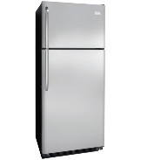 | PCS
2 | Freezer, Capacity: 318 Liter product size in cm (L X W X H) (120 X 70 X 90) | فريزر سعه 318 لتر | 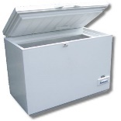 | PCS
3 | Office desk - 3 drawer lockable size: (120X80) cm | مكتب مع 3 ادراج مقاس 120*80 سم | 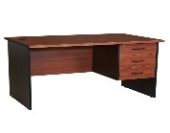 | PCS
4 | Office chair, Swivel chair | كرسي مع عجلات ( جلد) | 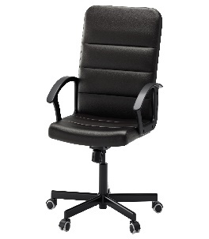 | PCS
5 | A leather Waiting Chair | كرسي ثابت | 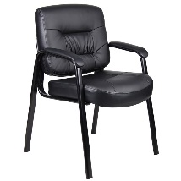 | PCS
6 | 3Small drawers | 3 ادراج خشب | 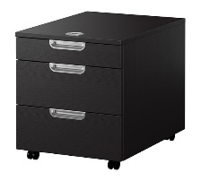 | PCS
7 | Filling cabinet, Durable Welded Metal | أدراج ملفات حديد | 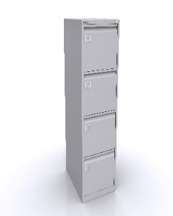 | PCS
8 | Conference table with 6 chairs and without chairs | طاوله إجتماعات دائريه مع 6 كراسي |  | Set
8 | Meeting table with 6 chairs and without chairs | طاوله إجتماعات مستطيله مع 6 كراسي |  | Set
9 | Storage cabinet, Durable welded metal construction (180 *90*40) cm | دولاب ملفات حديد | 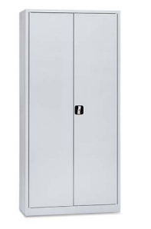 | PCS
10 | Kitchen  Wooden table (180cm*80) cm | طاوله خشب مقاس 180*80 سم | 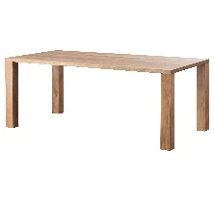 | PCS
11 | Storage cabinet, With upper glass | دولاب ملفات، الجزء الاعلي زجاج | 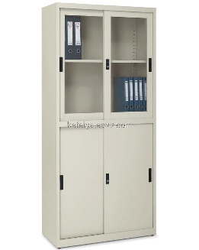 | PCS
12 | Cloth Rack, 180cm high | حامل ملابس ارتفاع 180 سم | 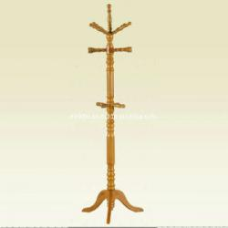 | PCS
13 | Wardrobe, Wooden 180cm high | دولاب ملابس خشب 180 سم | 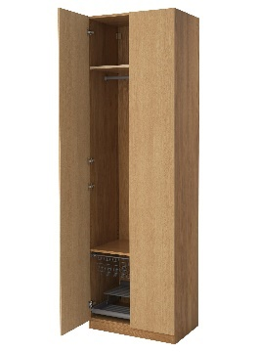 | PCS
14 | Double Bed With Mattress, size: double (160*200) cm | سرير نفرين مع الفرش( دوشك)  160* 200 سم |  | PCS
 | Single Bed With Mattress, | سرير نفر مع الفرش( دوشك) |  | PCS
15 | Standing Mirror, Size: 44cm x 165cm | مرآه حسب الصورة |  | PCS
16 | Air Conditioner, 1.5 tons | مكيف هواء طن ونص | 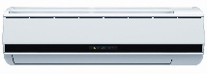 | PCS
 | Air Conditioner, 2tons | مكيف هواء طن ونص |  | PCS
 | Air Conditioner, 1ton | مكيف هواء طن ونص |  | PCS
 | Air Conditioner, 2.6 tons | مكيف هواء طن ونص |  | PCS
17 | Water Dispenser, Tank capacity 3.4 liter, cooling capacity 2 liter/12C^{ᵒ} | براد ماء | 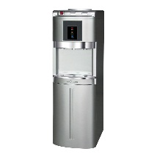 | PCS
18 | Iron | مكاويه | 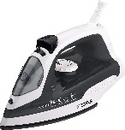 | PCS
19 | Iron Board | منضدة مكواية |  | Pcs
20 | Drying Clothes Rack | مجفف ملابس | 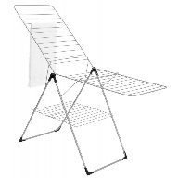 | Pcs
21 | Electric Oven, 28litre | فرن كهربائي, 28 لتر | 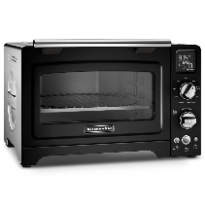 | Pcs
22 | Dining table with 6 chairs, Glass cover, steel frame | منضدة طعام مع 6 كراسي, غطاء زجاجي مع اطار معدني | 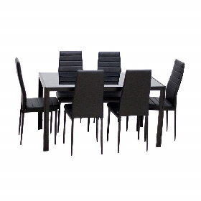 | Pcs
23 | Microwave 1100W, 25litre | مايكرويف 1100 واط , سعة 25 لتر | 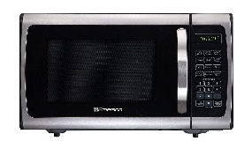 | Pcs
24 | Chest of drawers with mirror | جرارت مع مرآة | 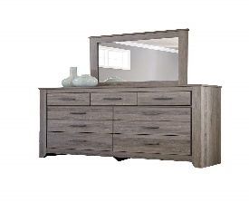 | Pcs
25 | Plastic chair | كرسي بلاستك | 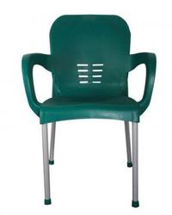 | Pcs
26 | Plastic table | منضدة بلاستك |  | Pcs
27 | Standing fan | مروحة عامودية |  | Pcs
28 | Electric Heater, 1500W, steel | مدفأة كهربائية, 1500 واط , معدنية | 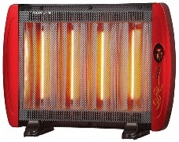 | Pcs
29 | Wooden Coffee table | منضدة قهوة خشبية | 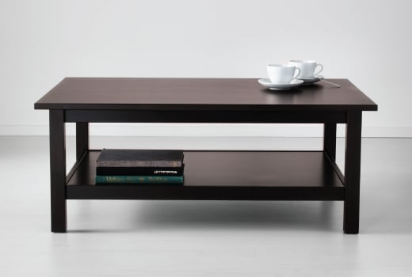 | Pcs
30 | Gas Stove with Oven, 5 burners | طباخ غازي مع فرن, 5 شعلات | 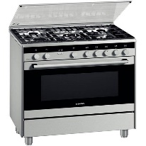 | Pcs

Bidders can submit an offer for one, several or all lots. Offers must clearly show what lots are included.
Offers must be submitted for the total quantity of each lot: offers submitted for a partial quantity of one lot will not be taken into consideration by NRC.

List of Goods and Price Schedule Your quotation should clearly indicate the following:
- Detailed specifications (if different from stipulated specifications):
- Place of manufacture and country of origin.

The selected supplier will be responsible for the cost and risks for supply and deliver furniture to the assigned locations.

SECTION 5:
BIDDING FORM

Please provide information against each requirement.
Additional rows can be inserted for all questions as necessary. If there is insufficient space to complete your answer in the space provided, please include on a separate attachment with a reference to the question.

- Bidder’s general business details
- General information

Company name:
Any other trading names of company:
Registered name of company (if different):
Nature of primary business/trade:
Primary contact name:
Job title:
Phone:
Email:
Registered Address:

Business licence number:
Country of registration
Registration date:
Expiry date:
Legal status of company (eg. partnership, private limited company, etc.)

- Owners/Managers
Please fill in the below table with the full names and the year of birth of the company’s owner(s) and manager(s)*:

Full name | Year of birth

* Please note this information is necessary in order to conduct the vetting procedure referred to in clause 25 of the Invitation to Bid-General Terms and Conditions.

- Employees
Please list the employees who would be involved with NRC in the event of contract award:

Employee name | Job title | Role on NRC project | Phone | Email
1.
2.
3.
…

- Company bank account details:

Beneficiary name:
Beneficiary account no.:
Beneficiary Bank:
Bank branch:
SWIFT:
IBAN:
Bank address:

- References
Please provide details of at least 3 client references whom NRC may contact, preferably from NGOs and UN agencies, for similar related works:

Client/company name | Contact person | Phone | Email | Contract details (works, location, size, value, etc)
1.
2.
3.
…

- Defects Liability/Guarantee Period
Framework Agreement
NRC are seeking suppliers who are interested in entering into a fixed price Framework Agreement (Framework Contract) that would allow fixed prices and fluctuating order frequency during the course of the contract.
- In the event of contract award, please confirm you are willing to enter into a fixed price agreement with NRC.
- Yes
- No

- Bid Validity-Will be fixed for atleast 1 year
Please confirm the validity of your bid below (in calendar days):

- Confirmation of Bidder’s compliance

We, the Bidder, hereby certify that our tender is a genuine offer and intended to be competitive and we confirm we are eligible to participate in public procurement and meet the eligibility criteria specified in the Invitation to Bid. We confirm that the prices quoted are fixed and firm for the duration of the validity period and will not be subject to revision or variation.

The following documents are included in our Bid: (please indicate which documents are included by ticking the boxes below).

Documents | Included
Section 5: Bidding form; completed, signed and stamped | ☐
Section 6: Pricing Proposal; completed, signed and stamped | ☐
Section 7: Company Profile and Previous Experience; completed, signed and stamped | ☐
Section 8: Additional Information on Specifications of Goods; completed, signed and stamped | ☐
Section 9: Supplier’s ethical standards declaration; completed, signed and stamped | ☐
Copy of valid business licence | ☐

We understand that NRC is not bound to accept the lowest, or indeed any bid, received.
We agree that NRC may verify the information provided in this form itself or through a third party as it may deem necessary.

We confirm that NRC may in its consideration of our offer, and subsequently, rely on the statements made herein.
Name of Signatory: | Tel N°:
Title of Signatory: | Name of Company:
Signature & stamp: | Date of Signing:
Signature & stamp: | Address:

SECTION 6:
PRICING PROPOSAL

No | Description  الوصف | الوصف | Image  الصورة | Unit  الوحدة | Qty | Unit Price (USD) | Specifications | Brand  الماركة
1 | Refrigerator 18 Feet | ثلاجه 18 قدم |  | PCS | 1
2 | Freezer, Capacity: 318 Liter product size in cm (L X W X H) (120 X 70 X 90) | فريزر سعه 318 لتر |  | PCS | 1
3 | Office desk - 3 drawer lockable size: (120X80) cm | مكتب مع 3 ادراج مقاس 120*80 سم |  | PCS | 1
4 | Office chair, Swivel chair | كرسي مع عجلات ( جلد) |  | PCS | 1
5 | A leather Waiting Chair | كرسي ثابت |  | PCS | 1
6 | 3Small drawers | 3 ادراج خشب |  | PCS | 1
7 | Filling cabinet, Durable Welded Metal | أدراج ملفات حديد |  | PCS | 1
8 | Conference table with 6 chairs and without chairs | طاوله إجتماعات دائريه مع 6 كراسي |  | Set | 1
8 | Meeting table with 6 chairs and without chairs | طاوله إجتماعات مستطيله مع 6 كراسي |  | Set | 1
9 | Storage cabinet, Durable welded metal construction (180 *90*40) cm | دولاب ملفات حديد |  | PCS | 1
10 | Kitchen  Wooden table (180cm*80) cm | طاوله خشب مقاس 180*80 سم |  | PCS | 1
11 | Storage cabinet, With upper glass | دولاب ملفات، الجزء الاعلي زجاج |  | PCS | 1
12 | Cloth Rack, 180cm high | حامل ملابس ارتفاع 180 سم |  | PCS | 1
13 | Wardrobe, Wooden 180cm high | دولاب ملابس خشب 180 سم |  | PCS | 1
14 | Double Bed With Mattress, size: double (160*200) cm | سرير نفرين مع الفرش( دوشك)  160* 200 سم |  | PCS | 1
 | Single Bed With Mattress, | سرير نفر مع الفرش( دوشك) |  | PCS | 1
15 | Standing Mirror, Size: 44cm x 165cm | مرآه حسب الصورة |  | PCS | 1
16 | Air Conditioner, 1.5 tons | مكيف هواء طن ونص |  | PCS | 1
 | Air Conditioner, 2tons | مكيف هواء طن ونص |  | PCS | 1
 | Air Conditioner, 1ton | مكيف هواء طن ونص |  | PCS | 1
 | Air Conditioner, 2.6 tons | مكيف هواء طن ونص |  | PCS | 1
17 | Water Dispenser, Tank capacity 3.4 liter, cooling capacity 2 liter/12C^{ᵒ} | براد ماء |  | PCS | 1
18 | Iron | مكاويه |  | PCS | 1
19 | Iron Board | منضدة مكواية |  | Pcs | 1
20 | Drying Clothes Rack | مجفف ملابس |  | Pcs | 1
21 | Electric Oven, 28litre | فرن كهربائي, 28 لتر |  | Pcs | 1
22 | Dining table with 6 chairs, Glass cover, steel frame | منضدة طعام مع 6 كراسي, غطاء زجاجي مع اطار معدني |  | Pcs | 1
23 | Microwave 1100W, 25litre | مايكرويف 1100 واط , سعة 25 لتر |  | Pcs | 1
24 | Chest of drawers with mirror | جرارت مع مرآة |  | Pcs | 1
25 | Plastic chair | كرسي بلاستك |  | Pcs | 1
26 | Plastic table | منضدة بلاستك |  | Pcs | 1
27 | Standing fan | مروحة عامودية |  | Pcs | 1
28 | Electric Heater, 1500W, steel | مدفأة كهربائية, 1500 واط , معدنية |  | Pcs | 1
29 | Wooden Coffee table | منضدة قهوة خشبية |  | Pcs | 1
30 | Gas Stove with Oven, 5 burners | طباخ غازي مع فرن, 5 شعلات |  | Pcs | 1
31 | Automatic Washing Machine 8 Kg, with dryer | غسالة ملابس مع مجففة, 8 كيلو | 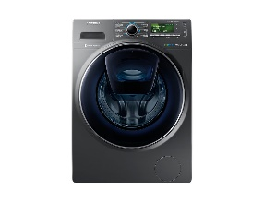 | Pcs | 1
32 | TV Table, wooden | طاولة تلفاز خشبية | 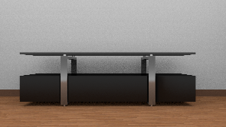 | Pcs | 1

We understand that you are not bound to accept the lowest or any bid received.

Name of Signatory: | Tel N°:
Title of Signatory: | Name of Company:
Signature & stamp: | Date of Signing:
Signature & stamp: | Address:

SECTION 7
COMPANY PROFILE AND PREVIOUS EXPERIENCE
The Bidder is requested to:
- Submit the Company Profile
- Complete the following Previous Experience Table listing the contracts undertaken in the past 5 years for supply of similar commodities as required under this contract
- Submit evidences of previous experience in form of Contracts, Completion Certificates, etc.

# | Name of Project / Type of work | Total value of the performed works (....) | Duration of the works contract | Starting date | Ending date | Contracting Authority and Place
1
2
3
4
5
…
NOTE: The list shouldn’t be limited to this Form in regards to the number of works reported. A comprehensive list of the last 5 years’ experience has to be submitted adapting the Form to the necessary rows.
NRC may conduct reference checks for previous contracts completed

SECTION 8:
Additional Information on Specifications of Goods
(Bidders can add pictures, certification, certificate of origin, result of analysis etc.)

SECTION 9
SUPPLIER’S ETHICAL STANDARDS DECLARATION

NRC as a humanitarian organization expects its suppliers and contractors to have high ethical standards. Any organization supplying goods to NRC valued at over 10,000 USD (or equivalent) in one year must sign this declaration. This declaration will be kept on file for a period of 10 years and should be updated every year or more often as appropriate.

NRC staff may perform spot checks to verify that these standards are adhered to. Should NRC deem that the supplier fails to meet, or is not taking appropriate steps to meet, these standards, any and all contracts and agreements with NRC may be terminated.

Anyone doing business with Norwegian Refugee Council shall as a minimum;
- Comply with all laws and regulations in effect in the country or countries of business;
- Meet the ethical standards as listed below; or
- Positively agree to the standards and be willing to implement changes in their organization.

- Anti-corruption and suppliers compliance with laws and regulations:
  - The supplier confirms that it is not involved in any form of corruption.
  - Where any potential conflict of interest exists between the supplier or any of the suppliers staff members with any NRC staff member, the supplier shall notify NRC in writing of the potential conflict. NRC shall then determine whether action is required. A conflict of interest can be due to a relationship with a staff member such as close family etc.
  - The supplier will immediately notify senior NRC management if exposed for alleged corruption by representatives of NRC.
  - The supplier shall be registered with the relevant government authority with regard to taxation.
  - The supplier shall pay taxes according to all applicable national laws and regulations.
  - The supplier warrants that it is not involved in the production or sale of any weapons including anti-personnel mines.

- Conditions related to the employees:
  - No workers in our company will be forced, bonded or involuntary prison workers.
  - Workers shall not be required to lodge “deposits” or identity papers with their employer and shall be free to leave their employer after reasonable notice.
  - Workers, without distinction, shall have the right to join or form trade unions of their own choosing and to bargain collectively.
  - Persons under the age of 18 shall not be engaged in work which is hazardous to their health or safety, including night work.
  - Employers of persons under the age of 18 must ensure that the working hours and nature of the work does not interfere with the child’s opportunity to complete his/ her education.
  - There shall be no discrimination at the work place based on ethnic background, religion, age, disability, gender, marital status, sexual orientation, union membership or political affiliation.
  - Measures shall be established to protect workers from sexually intrusive, threatening, insulting or exploitative behavior, and from discrimination or termination of employment on unjustifiable grounds, e.g. marriage, pregnancy, parenthood or HIV status.
  - Physical abuse or punishment, or threats of physical abuse, sexual or other harassment and verbal abuse, as well as other forms of intimidation, shall be prohibited.
  - Steps shall be taken to prevent accidents and injury to health arising out of, associated with, or occurring in, the course of work, by minimizing, so far as is reasonably practicable, the causes of hazards inherent in the working environment.
  - Wages and benefits paid for a standard working week shall meet, at a minimum, national legal standards or industry benchmark standards, whichever is higher. Wages should always be enough to meet basic needs.
  - Working hours shall comply with national laws and benchmark industry standards, whichever affords greater protection. It is recommended that working hours do not exceed 48 hours per week (8 hours per day).
  - Workers shall be provided with at least one day off for every 7 day period.
  - All workers are entitled to a contract of employment that shall be written in a language they understand.
  - Workers shall receive regular and documented health and safety training, and such training shall be repeated for new workers.
  - Access to clean toilet facilities and to potable water, and, if appropriate, sanitary facilities for food storage shall be provided.
  - Accommodation, where provided, shall be clean, safe and adequately ventilated, and shall have access to clean toilet facilities and potable water.
  - No Deductions from wages shall be made as a disciplinary measure.

- Environmental conditions:
  - Production and extraction of raw materials for production shall not contribute to the destruction of the resources and income base for marginalized populations, such as in claiming large land areas or other natural resources on which these populations are dependent.
  - Environmental measures shall be taken into consideration throughout the production and distribution chain ranging from the production of raw material to the consumer sale. Local, regional and global environmental aspects shall be considered. The local environment at the production site shall not be exploited or degraded by pollution.
  - National and international environmental legislation and regulations shall be respected.
  - Hazardous chemicals and other substances shall be carefully managed in accordance with documented safety procedures.

We, the undersigned verify that we are in compliance with all applicable laws and regulations and meet the ethical standards as listed above, or positively agree to these ethical standards and are willing to implement necessary changes in the organization.

DATE: _________________

NAME OF SUPPLIER/COMPANY: ­ _____________________________________________

NAME OF REPRESENTATIVE: _____________________________________________

SIGNATURE: _____________________________________________

COMPANY STAMP: _____________________________________________

