Tender for the construction of the sanitation unit in five schools in Snuni area (Barhangar School, Al Iraq School, Al Yarmouk School, Dahula School and Barzan School).
NGO Samaritan’s Purse invites all suppliers to participate in a tender meeting with our project manager and site engineer for the construction of the sanitation unit in five schools in Snuni area (Barhangar School, Al Iraq School, Al Yarmouk School, Dahula School and Barzan School).
The meeting will be held at 10:00 AM on Sunday, January 20, 2019.
The meeting address is:
Sinjar- Snuni SP office (36.471305, 41.709423) *see map below:
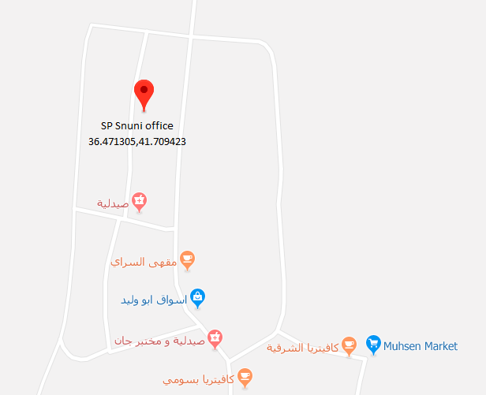
Please contact this phone number (0750 135 1723) if you have any questions about meeting location.
Note: Only participants in the meeting can apply for this tender.

