
Weekly Iraq .Xplored report
16 February 2019

Prepared by Risk Analysis Team, Iraq

garda.com

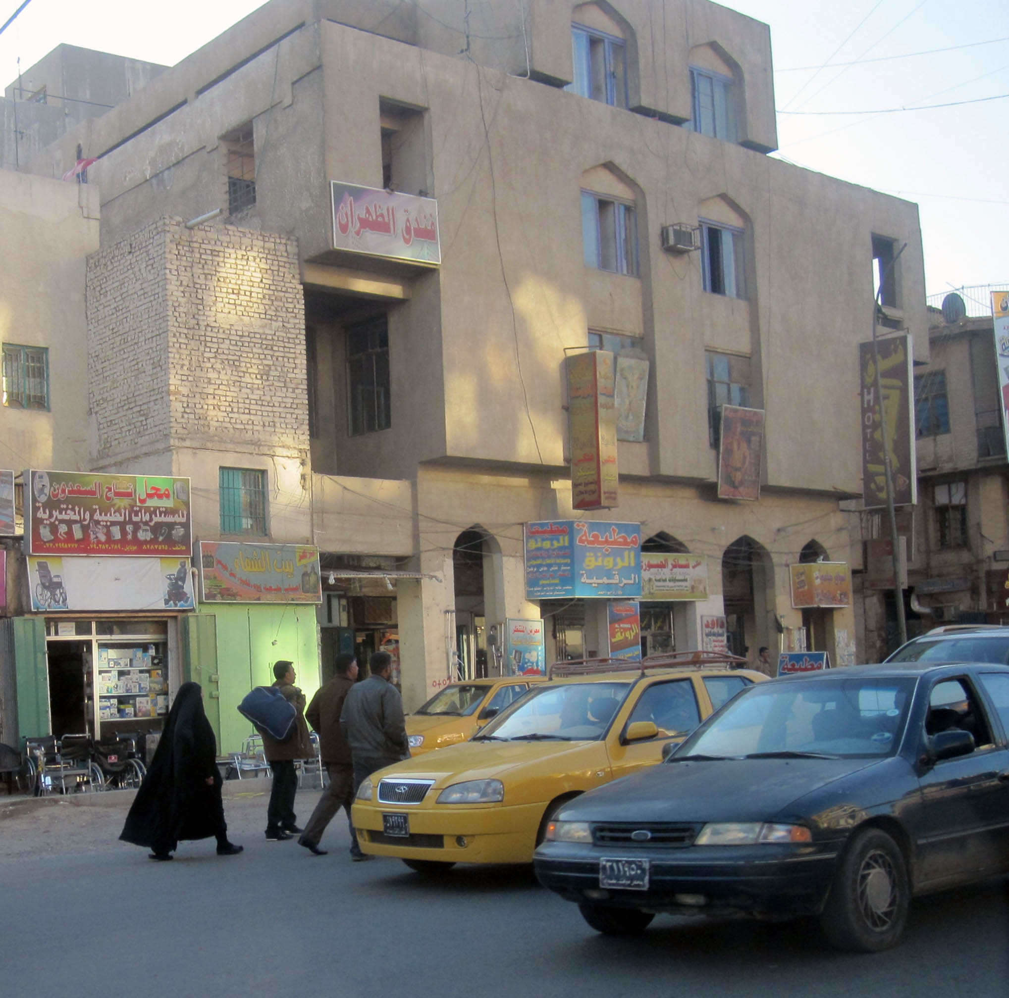

TABLE OF CONTENTS

TABLE OF CONTENTS 2
Activity Map 3
OUTLOOK 4

Short term outlook 4

Medium to long term outlook 4
Significant events 5

Trump’s comments prompt renewed calls to reject US troop presence 5

No timeline for US withdrawal as SDF commence ‘final’ operation in east Syria 5

US-led security summit commenced in Warsaw 5
THREAT MATRIX 5
OVERVIEW 6

Political & Security 6
WEEKLY OPERATIONAL ASSESSMENT 9

Countrywide Military/Security Situation 9
ACRONYM LIST 14
GARDAWORLD INFORMATION SERVICES 15
GARDAWORLD 15

This report is an abridged version of GardaWorld Weekly Iraq .Xplored February 09, 2019. To subscribe to the full versions of the daily/weekly Iraq .Xplored reports, or for enquires relating to other GardaWorld services, please contact daniel.matthews@garda.com

Disclaimer: The information and opinions expressed in this Report are the views of GardaWorld and constitute a judgment as at the date of the Report and are subject to change without notice. The information and opinions expressed in this Report have been formed in good faith on the basis of the best information and intelligence available at the time of writing, but no representation or warranty, express or implied, is made as to its accuracy, completeness or correctness. GardaWorld accepts no liability arising out of or in connection with the comments made or the information set out in this Report and the reader is advised that any decision taken to act or not to act in reliance on this Report is taken solely at the reader’s own risk. In particular, the comments in this Report should not be construed as advice, legal or otherwise.

Activity Map

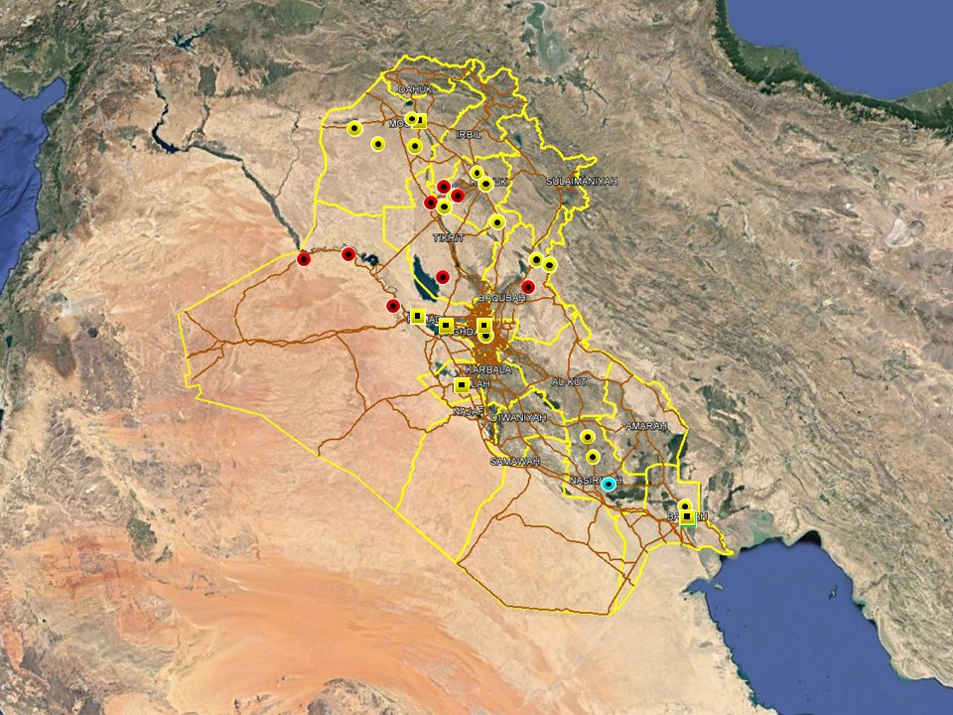

OUTLOOK

Short term outlook

- Rocket attacks directed at the International Zone and assessed to target the US Embassy in response to President Trump’s visit, highlight elevated anti-US sentiments and willingness from pro-Iranian factions to target US interests in the country. This is not unprecedented or unexpected, and absent a significant escalation in anti-US hostilities it is unlikely to affect commercial operations on the ground. The GoI’s response also highlight that US-Iraqi relations remain driven by pragmatic recognition of the necessity of continued western military and commercial support which is unlikely to change.

- The International zone remains open for public access during limited hours until further notice. On January 03 Prime Minister Mahdi announced another extension to the International Zone opening hours from 17:00hrs to 09:00hrs. The protest by families of ISF ‘martyrs’ on January 23, saw the crowd pass through ECP 5 to the south of the International Zone (IZ) but were halted before entering the IZ proper. Although the IZ was not breached, this event serves as a reminder that the drawing down of some physical security measures around the IZ may embolden demonstrators to attempt to march into the IZ during future protests.

- Political tensions remain high in Basra following a number of protests in Basra City. On January 18, 2019, the latest in a series of demonstrations calling for the dismissal of the Governor was dispersed by ISF using tear gas. Further protest activity, with an associated risk of violence, can be expected in Basra City in the short term as long as political tensions remain high.

- IS activity is expected to remain high in the northern provinces, including Nineveh, Kirkuk and Diyala province, especially in the rural areas. The group is likely to continue its asymmetric campaign through hit and run attacks, targeted assassination and terrorism to challenge ISF control in these areas. While the group is assessed to retain intent to stage attacks in Baghdad and the southern provinces, its capability in restricted as evidenced by a continuing decline in high-profile attacks in these areas.

- Political focus now remains on the four Cabinet of Minister positions that remain unresolved, including those of the Defence and Interior Ministers. Opposition from Moqtada Al-Sadr’s Sairoun alliance to the selection of partisan figures for the remaining posts means that there is an associated risk of demonstrations as tensions remain high, especially in Baghdad.

Medium to long term outlook

- Sectarian violence can be expected to continue in areas of Northern Iraq which remain permissive to IS operations, including Nineveh, Salah al-Din, Diyala and southwestern Kirkuk. Attacks will continue to target security checkpoints and outpost, especially in Sunni dominated areas controlled by Shia dominated security forces.

- Islamic State activity will continue to dominate security reporting with focus on the potential resurgence of an insurgent campaign in northern and western Iraq. Despite ongoing ISF efforts to clear remaining IS pockets, the group retains a degree of freedom of movement in the desert regions of Anbar, near the Syrian border, and along the Hamrin Mountains.

- Low-level incidents related to criminality, personal disputes and tribal tensions are likely to continue in Basra and the southern region. Long-term tensions are also expected to be driven by the return of militia factions expecting material and social rewards for their contribution in the campaign against IS.

Significant events

Trump’s comments prompt renewed calls to reject US troop presence
President Trump’s assertion in early February that US troops in Iraq would be used to ‘watch Iran’ continued to spark strong reactions and anti-American sentiments this week. In perhaps the politically most significant development, the pro-Iranian al-Fatah Alliance and Sadrist Sairun Alliance announced their joint rejection of the US presence. Meanwhile, PM Mahdi and some of the more moderate factions in parliament have attempted to tone down the rhetoric. In a meeting with acting US Defense Secretary Patrick Shanahan, PM Mahdi affirmed Iraq’s willingness to continue cooperating with the United States in the fight against terrorism while stressing that current agreements must be respected.

No timeline for US withdrawal as SDF commence ‘final’ operation in east Syria
Outgoing US CENTCOM Commander Joseph Votel said this that the US would likely commence the withdrawal of forces from Syria ‘within weeks’ but cautioned that no definitive timeline for the withdrawal has been agreed. Speaking with the press during a two-week ‘farewell’ tour before stepping down as Commander of CENTCOM, Votel said the speed of the withdrawal will depend on events on the ground and that the US will seek to maintain pressure on IS in Syria and Iraq where ‘tens of thousands’ of fighters remain.

US-led security summit commenced in Warsaw
A two-day conference hosted in Warsaw but led by the United States to discuss peace and security related issues in the Middle East commenced on February 13 with speeches by Vice President Pence, Secretary of State Mike Pompeo and Israeli Prime Minister Benjamin Netanyahu. The conference was first announced by the US following Pompeo’s speech in Cairo in January which strongly criticised Iran and according to US officials the meeting was originally aimed to build international support for the Trump administration’s policies on Iran.

THREAT MATRIX

Region | Political | Terrorism | Militancy | Crime | K&R
KRG* | Moderate | Low | Moderate | Low | Low
North** | Moderate | High-Extreme | High | High | High
Baghdad | Moderate | Moderate | Moderate | Moderate | Moderate
Anbar | Moderate | High | High | High | High
South*** | Moderate | Low | Moderate | Moderate | Moderate
Threat Scale | Minimal | Low | Moderate | High | Extreme

* KRG – Dohuk, Erbil & Sulaymaniyah
** North – Nineveh, Salah ad-Din, Kirkuk & Diyala
*** South – Babil, Wasit, Karbala, Najaf, Diwaniyah, Dhi Qar, Muthanna, Maysan & Basra

OVERVIEW

Political & Security

Trump’s comments prompt renewed calls to reject US troop presence
President Trump’s assertion in early February that US troops in Iraq would be used to ‘watch Iran’ continued to spark strong reactions and anti-American sentiments this week. In perhaps the politically most significant development, the pro-Iranian al-Fatah Alliance and Sadrist Sairun Alliance announced their joint rejection of the US presence. In a joint press conference headed by Fatah leader Hadi al-Ameri and Sairun representative Nassar al-Rubaie, the two leaders called on the GoI to revise its current agreements regarding foreign military assistance while iterating that the continued presence of US troops is no longer justified by the previous agreement. Separately, MP Hassan al-Yassari of al-Fatah alliance said 77 MPs have signed a request calling for the US to reveal the exact number of troops currently stationed in the country. Al-Yassari added that the request will be submitted to the GoI and also demands that the US disclose the exact nature of their duties.

Meanwhile, PM Mahdi and some of the more moderate factions in parliament have attempted to tone down the rhetoric. In a meeting with acting US Defense Secretary Patrick Shanahan, PM Mahdi affirmed Iraq’s willingness to continue cooperating with the United States in the fight against terrorism while stressing that current agreements must be respected. According to the official readout provided by the PM’s office, Mahdi stressed that the US role is limited to fighting terrorism, training Iraqi forces and nothing more, and that Iraq will not accept the presence of ‘foreign military bases’ on its soil. Mahdi also emphasised that his government makes decisions independently of what some political parties think and that it will continue to cooperate with regional allies who serve the interests of the Iraqi people. For his part, Shanahan reportedly reaffirmed the US commitment to an independent, sovereign Iraq capable of defending itself, and said the US welcomes the opportunity to continue provide assistance in training and counter-terrorism. After the meeting, Shanahan also told reporters he made it “very clear that we recognise their sovereignty, their focus on independence and that we are there at the invitation of the government.”

Separately, speaking with a Kurdish media outlet, Adnan al-Zarfi, the head of Nasr Alliance’s faction in Parliament, also warned against attempts by some factions expel US forces given existing security challenges and the need for continued international support. Al-Zarfi added that such legislation would be ‘difficult’ to pass but that there is growing support in parliament from both pro-Iranian and nationalist factions to end the US presence in the country. Al-Zarfi further echoed Foreign Minister Mohammed al-Hakim in clarifying that the troop presence involves ‘only military advisors and trainers who assist the Iraqi Army’ and that it comes within an established framework of cooperation between Iraq and the International Coalition.

No definitive timeline for US withdrawal as SDF commence ‘final’ operation in east Syria
Outgoing US CENTCOM Commander Joseph Votel said this that the US would likely commence the withdrawal of forces from Syria ‘within weeks’ but cautioned that no definitive timeline for the withdrawal has been agreed. Speaking with the press during a two-week ‘farewell’ tour before stepping down as Commander of CENTCOM, Votel said the speed of the withdrawal will depend on events on the ground and that the US will seek to maintain pressure on IS in Syria and Iraq where ‘tens of thousands’ of fighters remain: “they are dispersed and disaggregated, but there is leadership”, Votel added. Meanwhile, the US-backed Syrian Democratic Forces (SDF) commenced on February 09 what they described as ‘the final push’ against IS in eastern Syria, targeting the last remaining IS stronghold in Deir Ez Zour province. Since launching the operation, SDF claims to have surrounded the town from all sides and that a final push into the town centre is imminent. One SDF commander added that the town is empty apart from the remaining IS fighters after most civilians left ahead of the operation. Col. Sean Ryan of the International Coalition added that most of the 200 or so fighters who remain are foreign fighters with nowhere to go and that resistance remains high.

US-led security summit commenced in Warsaw
A two-day conference hosted in Warsaw but led by the United States to discuss peace and security related issues in the Middle East commenced on February 13 with speeches by Vice President Pence, Secretary of State Mike Pompeo and Israeli Prime Minister Benjamin Netanyahu. In his opening speech, Pence hailed the conference as ‘the beginning of a new era’, while praising that Israeli PM Netanyahu and the leaders of Bahrain, Saudi Arabia and the UAE are ‘all breaking bread together’ and sharing ‘honest perspectives on the challenges facing the area.’ The summit is reported to be the first time an Israeli leader and senior Arab officials are attending an international conference cantered on the Middle East since the Madrid peace conference in 1991, which set the stage for the Oslo Accords between Israel and the Palestinians. In a symbolic gesture, Netanyahu and Arab officials also shared a stage during a group photo scheduled for meeting participants.

Iran pledges to ‘take revenge’ after suicide attack against IRGC convoy
The spokesperson for the Iranian Foreign Ministry, Bahram Qassemi, said Tehran would ‘take revenge for the blood of the martyrs’ after a suicide car bomb targeted and killed 27 members of the Islamic Revolutionary Guards Corps (IRGC) in south-eastern Iran on February 13. The attack was subsequently claimed by Jaish al-Adl (Army of Justice), a Salafi Jihadist groups based in the Baluchistan province of Iran with links to Al Qaeda and IS. Senior commanders of the IRGC were also quoted saying that Iran would launch a ‘relentless battle’ against terrorism in response and that the fight would not be confined to within the borders of Iran.

ISF establishes new military communications cell
ISF spokesperson Yahia Razool announced the establishment of the new ‘Security Media Cell’ which will be tasked with communicating security and military related information to the general public. In a statement, Razool added that the cell will be part of the existing ‘Military Media Cell’ and linked to the office of Prime Minister and Commander in Chief Abdul Mahdi. The statement added that the new centre will seek to “establish new practices” in dealing with security statements and reports, including responding to “reckless” and ‘inaccurate’ reports. It will also work to dispel rumours and raise awareness of the work and operations of security forces across the country.

UNAMI Representative addressed Security Council
In her first address to the UN Security Council in New York, the Special Representative to Iraq Jeanine Hennis-Plasschaert stressed the importance of completing the remaining cabinet positions and said the political stalemate in the country is a ‘great concern’ that is harming the Iraqi people. Hennis-Plasschaert also expressed concern about the continuing activities of IS and the humanitarian situation. Separately, Iraq’s Ambassador to the UN Bahr al-Uloom reportedly submitted a formal complaint regarding the continuation of Turkish airstrikes on Iraqi soil. “No matter what the rationale is, these air strikes are condemned and a violation of Iraqi sovereignty,” al-Uloom added.

WEEKLY OPERATIONAL ASSESSMENT

Countrywide Military/Security Situation

Northern Provinces
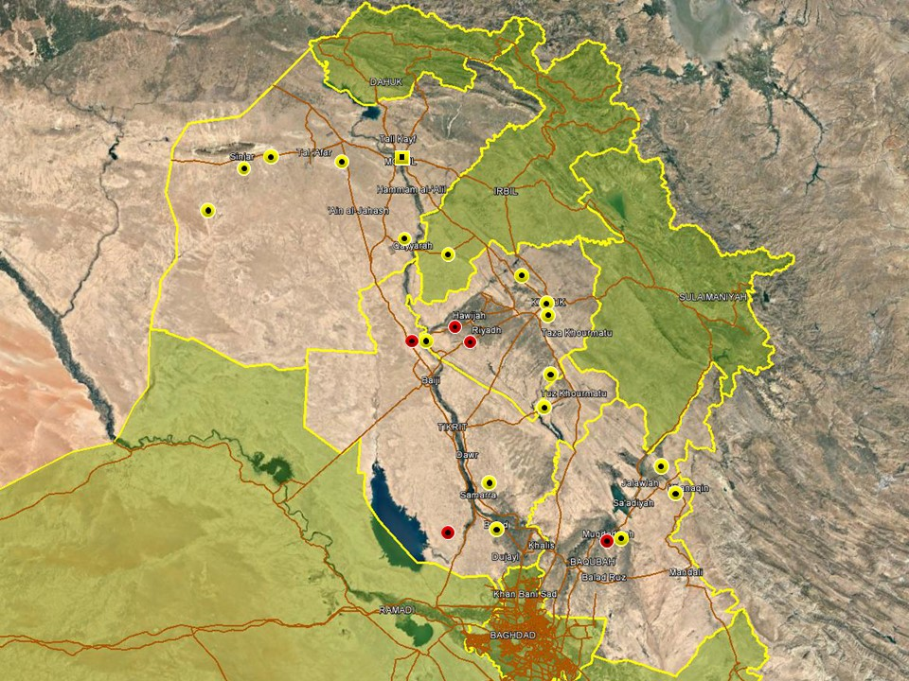

Activity patterns in the northern region remains consistent with established trends and accordingly characterised by relatively high levels of IS activity in rural areas of Nineveh, southwestern Kirkuk, northern Salah al-Din and northern Diyala. While not assessed to pose a serious, territorial threat, insurgent cells continue to wage an asymmetric campaign of violence characterised by hit and run attacks, kidnappings and IED targeting the civilian population and ISF. In Nineveh province, most of this activity was confined to areas west of Mosul including Sinjar district and the desert areas south of Tal Afar. In a typical incident on February 12, two ISF members were shot and killed near a checkpoint in Muhallabiyah area and on the same day two suicide bombers were arrested outside Sinjar town. The intended target was not specified but the incident underlines IS’ continued intent to carry out signature attacks in the province. In Mosul City, reporting was dominated by arrest operations targeting criminality and suspected IS activity, with multiple individuals detained in both west and east Mosul during the week. The overall security situation in the city was not changed.

An increase in incidents was noted in Kirkuk province this week, with violence centred on Kirkuk City and Hawijah district where IS cells and hardline Sunni tribes remain active. In Hawijah, three roadside IED attacks targeted and killed ISF members on February 10 and 11 respectively along Highway 19; both targeted members of the Federal Police which remain deployed in the area. In a sign of the prevailing lack of ISF control of the terrain, coalition airstrikes were also reported in Hawijah on two occasions during the week, targeting and killing multiple insurgents. PMU forces were also reported to have foiled an IS infiltration attempt in the village of Qarrah Teppeh in Dibis district, killing one militant and injuring another. Activity in Kirkuk City was characterised by low-level attacks, involving SAF and grenade attacks, causing minor casualties. It is assessed that these incidents are most likely related to local and personal disputes rather than political tensions or terrorism.

In Salah al-Din, eight members of the Sadrist Peace Companies were killed and two others wounded when a large-scale roadside IED detonated in Jazira region, southwest of Samarra. The incident, and the high casualty figure, is unusual in that the Peace Companies, which has been tasked with securing the areas around Samarra, is rarely directly targeted in the region where insurgent activity has declined in recent years. The incident underlines however that IS cells remain active in the border areas with Anbar and where they are assessed to retain relatively high levels of freedom. Further north, ISF carried out security operations in the Makhoul Mountains and Mutaibiyah area, near the Diyala provincial boundary. In an interview with local media this week, Iraqi security expert Hisham al-Hashemi warned about the resurgence of IS in rural areas of Salah al-Din and said the population in these areas are urging the security forces to step up efforts to mitigate the threat. Hashemi singled out the ‘TharThar’ area, near the border with Anbar, the Jazira areas west of Samarra and Tikrit, and the Makhoul Mountains as areas where the security situation is becoming increasingly unstable. It is worth noting that reporting from these rural areas is often disrupted and higher activity levels are likely than what is being reported through official and media channels.

High levels of hostilities continue in northern Diyala province, especially the areas around Khanaqin and Muqdadiyah where insurgent cells and sympathisers continue an asymmetric campaign of violence targeting the civilian population and ISF. Notably, IS launched two separate assaults in Khanaqin district targeting border guards and a PMU HQ on February 10 and 11 respectively. Sadiq al-Hussaini, chairman of the security committee of Diyala provincial council, also said that ISF dismantled an IS terror cell comprising several militants in an intelligence-led operation in the suburbs in the district during the week. Both ISF and PMU were involved in operations against IS militants in the northern outskirts of Muqdadiyah district, exchanging gunfire with insurgents on different occasions.

Anbar Province
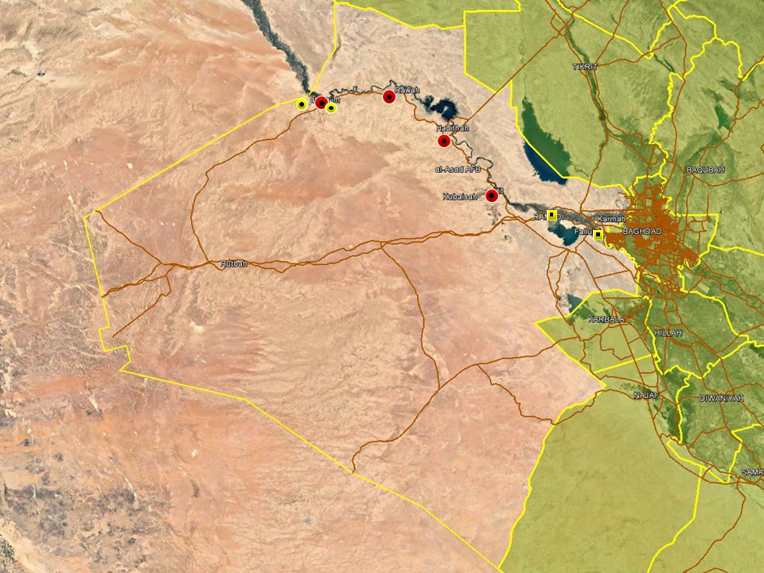

The western areas of Anbar province remain relatively active with high levels of violence noted around Qaim and Hadithah. This is attributable to the continuing presence of IS cells in the area, benefitting from being able to roam with relative impunity around the open desert areas. Several IED attacks were recorded in the Anah region, northwest of Hadithah, targeting and killing civilians and ISF; local security officials have attributed the attacks to IS. The group was also assigned blamed for the kidnapping of three civilians on February 15 near Haditha district; the victims were reportedly picking truffles in the district.

This week, the spokesperson of the Joint Operations Command, Yahia Razool, also said ISF have deployed additional forces to the western border areas with Syria following the start of the SDF-led operation to restore control over the last pockets of IS resistance in eastern Syria. Razool did not specify the size of the deployments but said a general effort is being made to shore up security along the border areas to prevent IS infiltration while mentioning that ISF, PMU and border guards all participate in providing security. Meanwhile, border guards near al-Qaim reportedly discovered and destroyed several tunnel systems used by IS militants to cross the border between Syria and Iraq over the past two weeks. According to media reports, quoting ‘military sources’ in the district, border guards have also foiled multiple infiltration attempts, killing several militants and engaging in gunfights on multiple occasions over the past weeks.

Eastern Anbar remains relatively calm in terms of hostile activity however multiple arrest operations were reported as usual in Ramadi and around Fallujah, targeting criminality and suspected terrorism. ISF also carried out a preventive security operation in areas south of Fallujah.
Capital Region (Including Baghdad City)

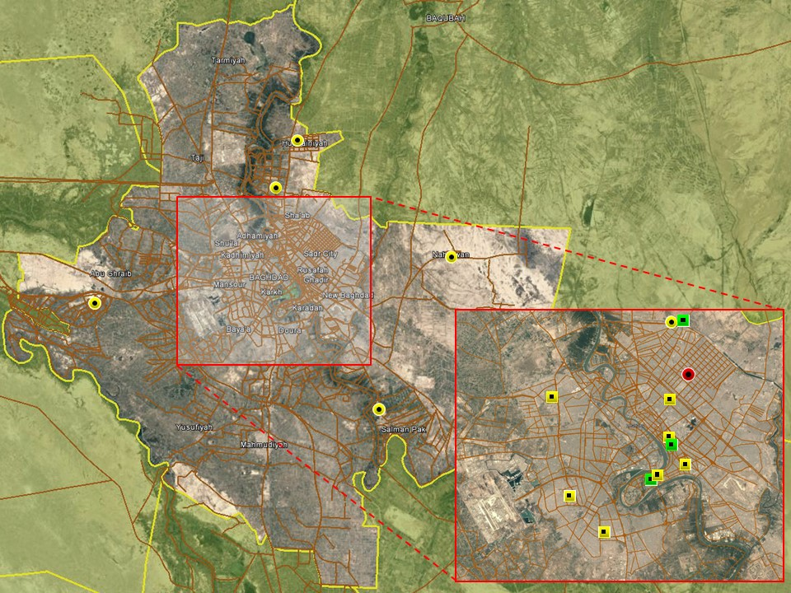

No significant hostile incidents were recorded in Baghdad City this week, with violence dominated by low-level activity driven by local disputes and criminality. For example, a low-yield IED detonated in Sadr City on the north of February 12, causing material damage and believed to have been intended for intimidation. ISF also defused an IED in Ghazaliyah area, northwest Baghdad, which was set and ready to detonate. In Doura district, two individuals on a motorcycle where detained in possession of an IED which they reportedly intended to plant as part of a tribal dispute in the district. Reporting in central Baghdad was otherwise dominated by an ongoing efforts by the PMU Security Directora to close down fraudulent PMU HQs in the city, with a series of operations recorded in Karada district. One of these operations last week led to the arrest of Aws al-Khafaji, commander of the Abu al-Fadhil al-Abbas PMU Brigade, and this prompted a demonstration by members of al-Khafaji tribe on the Karada peninsula on February 12. Another demonstration was held on Tahrir Square on February 15 to commemorate martyrs who died during the campaign against IS.

A relatively calm period was observed in the provincial areas, with minor incidents recorded in areas typically characterised by violence. In Hussainiyah district, north of Baghdad, one civilian was shot and killed on February 08 while another civilian was wounded in a similar incident in Bob al-Sham. Low-level SAF leading to minor injuries were also recorded in the districts of Mada’in and Nahrawan, south and east of Baghdad respectively. As always, attribution is not clear but activity in these areas is typically driven by a mix of tribal and local tensions while low-level insurgent sympathisers also remain active.

Southern Provinces

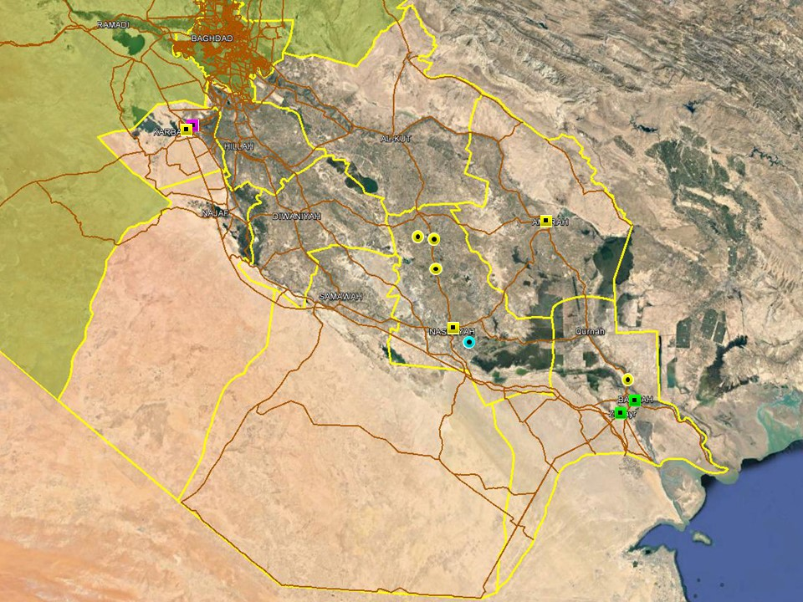

No notable changes were observed in the overall security situation in the southern region, with no large-scale incidents taking place this week. In Karbala, the victim of a recent kidnapping was released during a raid by ISF on February 10, arresting one individual during the operation. PMU forces also carried out a preventive search operation in the southwestern desert areas of Najaf, along the border with Anbar; the operation is assessed as precautionary measure to provide security and did not come in response to any particular threat or development.

Multiple incidents were recorded this week in Dhi Qar province, driven by a mix of personal and tribal tensions. In al-Shatrah district, north of Nasiriyah, two separate SAF attacks were recorded causing minor casualties. In an unusual incident in Suq al-Shuyukh area, south of Nasiriyah, the private residence of a former ISF member was targeted by RPG; no casualties were reported but the attack caused damage to the property. Local security officials indicated that the incident is related to a tribal dispute.

A relatively uneventful period was noted in Basra City where the overall secuirty situation remains unchanged. On February 10, gunmen opened fire against an ISF convoy transporting a detained criminal; the suspect managed to escape during the attack. Few instances of violence were otherwise recorded in the city where reporting was dominated by low-level protest activity related to local grievances.

ACRONYM LIST

AII - Area of Intelligence Interest
AKA - Also Known As
AO - Area of Operations
APC - Armored Personnel Carrier
APIED - Anti-Personnel IED
AQ - Al-Qaeda
AT - Anti-Tank
ATGW - Anti Tank Guided Weapon
AVIED - Anti-Vehicle IED
BBIED - Body Borne IED
Bde - Brigade
Bn - Battalion
BXP - Border Crossing Point
CET - Convoy Escort Team
CLC - Concerned Local Citizens
CoP - Chief of Police
CP - Check Point
C-PERS - Captured Personnel
CPX - Complex Attack (attack using multiple weapon systems)
CQA - Close Quarter Assassination/Attack
DBS - Drive by Shooting
Div - Division
DoD - Department of Defense
DoS - Department of State
DoS - US Department of State
ECP - Entry Control Point
EFP - Explosively Formed Projectile
EOD - Explosive Ordinance Disposal (Bomb Squad)
ERW - Explosive Remnants of War
FoM - Freedom of Movement
GoI - Government of Iraq
HCN - Host Country National
HG - Hand Grenade
HME - Home Made Explosive
HMG - Heavy Machine Gun
HVT - High Value Target
IC - International Community
IDF - Indirect Fire (i.e.: rockets, mortars)
IDP - Internally Displaced Persons
IEC - Independent Electoral Commission
IED - Improvised Explosive Device
IM - International Military
IOC - International Oil Company
IRAM - Improvised Rocket Assisted Mortar
IRL - Improvised Rocket Launcher
IS - Islamic State
IVCP - Illegal Vehicle Check Point
IVO - In Vicinity Of
IZ - International Zone
KIA - Killed in Action
LN - Local National/Iraqi Civilian
MAIED - Magnetically attached IED (aka UVIED)
MIA - Missing in Action
MoD - Ministry of Defense
MoF - Ministry of Finance
MoFA - Ministry of Foreign Affairs
MoHE - Ministry of Higher Education
MoI - Ministry of Interior
MoJ - Ministry of Justice

MoO - Ministry of Oil
MoT - Ministry of Transportation
MSR - Main Supply Route
NFDK - No Further Details Known
NGO - Non-Governmental Organization (aid/charity)
NSTR - Nothing Significant To Report
OCG - Organized Crime Group
OPF - Oil Protection Force
PAX - Person, Persons or Passenger
PBIED - Person-Borne Improvised Explosive Device (UN Term)
PMF – Popular Mobilisation Forces
PoI - Point of Impact (for IDF)
PoO - Point of Origin (for IDF)
PSAF - Precision Small Arms Fire
PSC - Private Security Company
PSD - Private Security Detail
RCIED - Remote-Controlled IED
RPG - Rocket Propelled Grenade
RTA - Road Traffic Accident
SAF - Small Arms Fire
SAFIRE - Surface to Air FIRE
SF - Special Forces
SVBIED - Suicide Vehicle Borne IED
SVEST - Suicide Explosive Worn Vest
TCN - Third Country National
TCP - Traffic Control Point
Technical - An improvised weapon-mounted pick-up truck
TTP - Tactics, Techniques and Practices
UVIED - Under Vehicle IED
UXO - Unexploded Ordnance
VBIED - Vehicle Borne IED
VCP - Vehicle Checkpoint
WIA - Wounded in Action

GARDAWORLD INFORMATION SERVICES

From our management offices and field offices in strategic locations our constant monitoring of the high-risk environments in which we work is conveyed through our range of .Xplored™ risk analysis reports. The reports contain detailed updates, delivering current and relevant ground-truth information to assist both our personnel and our clients in their decision-making.

Our wider risk management solutions provide members of the defense, diplomatic, development, oil & gas and infrastructure sectors operating in potentially high-risk and complex environments with a comprehensive range of risk analysis, intelligence, crisis response, and training services. These services are designed to provide clients with the proactive capability to remain aware in potentially hostile environments and identify risks while strengthening their reactive capacity in emergency situations.

Our current regular reporting geographies include: Nigeria, Mali, Libya, Iraq, Afghanistan and Yemen on a daily, weekly, fortnightly, and monthly basis.

Through our constant monitoring and predictive threat analysis our Information Services team help you plan for, manage, and respond to risks.

For more information on our .Xplored reports or for information about our special-to-task reports tailored to individual client requirements, please contact us: informationops@garda.com or contact our regional representative iraq.ram@garda.com (Mobile: +964 7823 783 972)

For more information on how our services can support your business in Iraq contact:
Daniel Matthews, Senior Director Iraq daniel.matthews@garda.com

GARDAWORLD

A global leader in comprehensive security and risk management

GardaWorld International Protective Services is the international security division of GardaWorld Security Corporation, the world's largest privately owned security company with over 62,000 global staff.

We support clients in emerging, complex and high-risk markets around the world with static security, security consulting, risk analysis and reporting, crisis management and business continuity, mobile security, close protection, training and kidnap for ransom and extortion response solutions.

We work across multiple business sectors to provide protection and security for clients in the extractives, aerospace and defense, critical infrastructure, government and diplomatic and development sectors to secure employees, assets, and reputation so clients can focus solely on running daily operations and growing their business.

Discover more about the markets we serve and to learn how our international security solutions can help you contact us today: gwinfo@garda.com

Middle East
International Protective Services Headquarters
Office 2502, Tower 2, Currency House
DIFC, PO Box 482069
Dubai, United Arab Emirates

United States
1101 Wilson Boulevard
Suite 1725
Arlington, VA, 22209
United States

UK
5th Floor
1, London Bridge
London
SE1 9BG

Europe
37-39 rue des Deux Eglises
1000 Brussels
Belgium

garda.com

