
Weekly Iraq .Xplored report
09 March 2019

Prepared by Risk Analysis Team, Iraq

garda.com

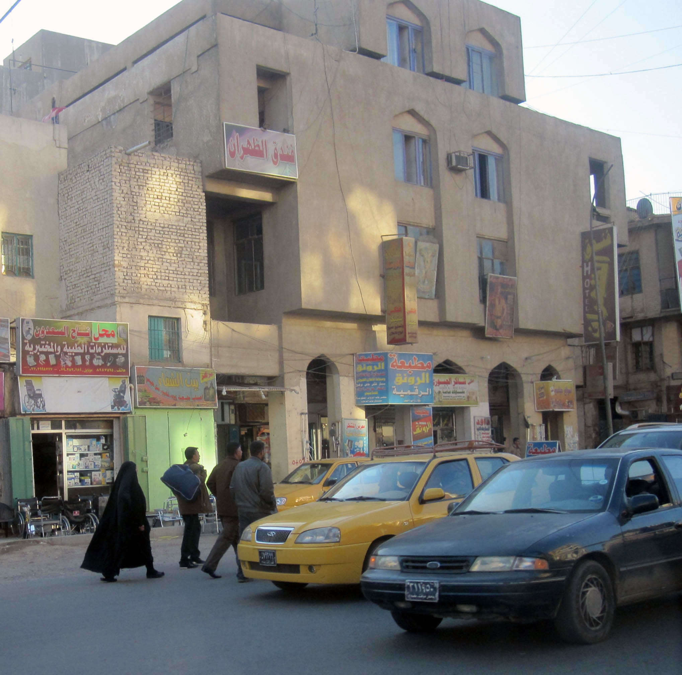

TABLE OF CONTENTS

TABLE OF CONTENTS 2
Activity Map 3
OUTLOOK 4

Short term outlook 4

Medium to long term outlook 4
Significant events 5

US and UK impose sanctions on Hezbollah and Nujaba Movement 5

Iraqi officials discuss deepening cooperation with Syria and Saudi Arabia 5

Date for provincial elections yet to be confirmed 5
THREAT MATRIX 5
OVERVIEW 6

Political & Security 6
WEEKLY OPERATIONAL ASSESSMENT 8

Countrywide Military/Security Situation 8
ACRONYM LIST 13
GARDAWORLD INFORMATION SERVICES 14
GARDAWORLD 14

This report is an abridged version of GardaWorld Weekly Iraq .Xplored February 09, 2019. To subscribe to the full versions of the daily/weekly Iraq .Xplored reports, or for enquires relating to other GardaWorld services, please contact daniel.matthews@garda.com

Disclaimer: The information and opinions expressed in this Report are the views of GardaWorld and constitute a judgment as at the date of the Report and are subject to change without notice. The information and opinions expressed in this Report have been formed in good faith on the basis of the best information and intelligence available at the time of writing, but no representation or warranty, express or implied, is made as to its accuracy, completeness or correctness. GardaWorld accepts no liability arising out of or in connection with the comments made or the information set out in this Report and the reader is advised that any decision taken to act or not to act in reliance on this Report is taken solely at the reader’s own risk. In particular, the comments in this Report should not be construed as advice, legal or otherwise.

Activity Map

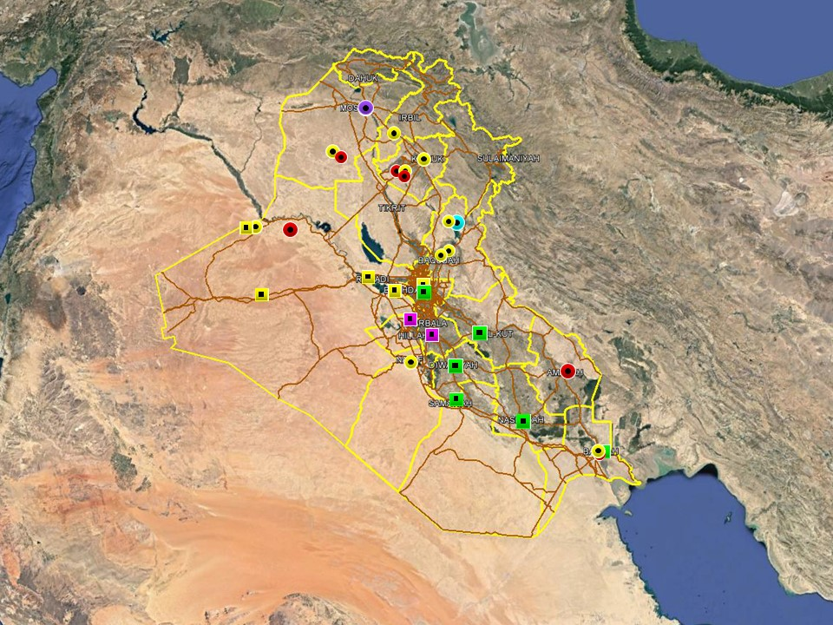

OUTLOOK

Short term outlook

- Hostile rhetoric towards the US from pro-Iranian and hardline Shia factions underline heightened anti-US sentiments following President Trump’s comment about continued US troop presence to counter Iran. This is not unprecedented however and is unlikely to affect commercial operations on the ground. The GoI’s response also highlight that US-Iraqi relations remain driven by pragmatic recognition of the necessity of continued western military and commercial support which is unlikely to change.

- The imminent territorial defeat of IS in Syria will likely incentivise IS cells and sympathisers to stage retaliatory attacks in permissive areas of Iraq. VBIED attacks in Mosul City and continuing high levels of IS activity in northern Diyala province and western Anbar province underline that the group continues to pose a long-term security challenge. While retaining intent to stage attacks in Baghdad and the South, the group remains restricted in terms of capability to escalate operations in these areas.

- An increase in protest activity has been witnessed in the southern region in recent weeks, coinciding with an expected uptick ahead of the spring and summer when temperatures rise. Protests have for the most part remained peaceful, with limited effect on commercial operations, but protests this week in Basra City where dispersed with tear gas following a confrontation with security forces, underlining that tensions remain high.

- PM Mahdi’s office announced that parts of the International Zone will soon be open for public access for 24hrs each day, without specifying a date. The protest by families of ISF ‘martyrs’ on January 23, saw the crowd pass through ECP 5 to the south of the International Zone (IZ) but were halted before entering the IZ proper. Although the IZ was not breached, this event serves as a reminder that the drawing down of some physical security measures around the IZ may embolden demonstrators to attempt to march into the IZ during future protests.

- Political focus now remains on the four Cabinet of Minister positions that remain unresolved, including those of the Defence and Interior Ministers. Opposition from Moqtada Al-Sadr’s Sairoun alliance to the selection of partisan figures for the remaining posts means that there is an associated risk of demonstrations as tensions remain high, especially in Baghdad.

Medium to long term outlook

- Sectarian violence can be expected to continue in areas of Northern Iraq which remain permissive to IS operations, including Nineveh, Salah al-Din, Diyala and southwestern Kirkuk. Attacks will continue to target security checkpoints and outpost, especially in Sunni dominated areas controlled by Shia dominated security forces.

- Islamic State activity will continue to dominate security reporting with focus on the potential resurgence of an insurgent campaign in northern and western Iraq. Despite ongoing ISF efforts to clear remaining IS pockets, the group retains a degree of freedom of movement in the desert regions of Anbar, near the Syrian border, and along the Hamrin Mountains.

- Low-level incidents related to criminality, personal disputes and tribal tensions are likely to continue in Basra and the southern region. Long-term tensions are also expected to be driven by the return of militia factions expecting material and social rewards for their contribution in the campaign against IS.

Significant events

US and UK impose sanctions on Hezbollah and Nujaba Movement
The US Treasury Department announced this week the imposition of sanctions on Harakat Hezbollah al-Nujaba (aka the Nujaba Movement) and its leader Akram Kaabi, as part of a tougher US stance on Iranian proxy groups operating in Iraq and Syria. This follows a decision by the UK earlier this month to place Lebanon’s Hezbollah on its list of designated terrorist organisations and ban participation or support for the group. As expected, the US decision was met with strong reactions by pro-Iranian factions who continue to denounce the presence of US forces and reiterate calls for their expulsion.

Iraqi officials discuss deepening cooperation with Syria and Saudi Arabia
Senior Iraqi officials have held meetings with Syrian and Saudi counterparts this week to discuss enhancing cooperation in a number of fields, including security and trade. The meetings corroborate the Government of Iraq’s (GoI) intention to pursue a policy of non-alignment in the region and to cooperate with regional neighbours to further specific interests rather than take sides in any regional rivalries.

Date for provincial elections yet to be confirmed
As parliament commences the second legislative term, one of the key issues that remains to be resolved is to approve the date for the provincial elections, initially slated for November 2019. Earlier in the week, a Sairun MP, Mohammed Redha al-Haider, said the elections must proceed on time and that the alliance would not accept any further delays, citing the need to rid the provincial councils of corruption and mismanagement.

THREAT MATRIX

Region | Political | Terrorism | Militancy | Crime | K&R
KRG* | Moderate | Low | Moderate | Low | Low
North** | Moderate | High-Extreme | High | High | High
Baghdad | Moderate | Moderate | Moderate | Moderate | Moderate
Anbar | Moderate | High | High | High | High
South*** | Moderate | Low | Moderate | Moderate | Moderate
Threat Scale | Minimal | Low | Moderate | High | Extreme

* KRG – Dohuk, Erbil & Sulaymaniyah
** North – Nineveh, Salah ad-Din, Kirkuk & Diyala
*** South – Babil, Wasit, Karbala, Najaf, Diwaniyah, Dhi Qar, Muthanna, Maysan & Basra

OVERVIEW

Political & Security

US and UK impose sanctions on Hezbollah and Nujaba Movement
The US Treasury Department announced this week the imposition of sanctions on Harakat Hezbollah al-Nujaba (aka the Nujaba Movement) and its leader Akram Kaabi, as part of a tougher US stance on Iranian proxy groups operating in Iraq and Syria. This follows a decision by the UK earlier this month to place Lebanon’s Hezbollah on its list of designated terrorist organisations and ban participation or support for the group. In a statement, UK Home Secretary Sajid Javid cited Hezbollah’s ‘continuing attempts to destabilize the fragile situation in the Middle East’ and said it is no longer possible to distinguish between the political party and its military wing.

As expected, the US decision was met with strong reactions by pro-Iranian factions who continue to denounce the US and reiterate calls for the expulsion of US forces. The spokesperson for Nujaba said the US ‘does not have the legitimacy to accuse us of terrorism’ while Kataib Hezbollah and Asaib Ahl al-Haq issued separate statements calling for resistance to the US presence. Pointing to US’ support for Israel and Saudi Arabia, AHH’s statement also denounced US’ definition of terrorism as hypocritical and ‘completely opposite to reality’. Several PMU aligned members and MPs were also quoted this week calling for the need to speed up legislation to expel foreign forces from the country.

Iraqi officials discuss deepening cooperation with Syria and Saudi Arabia
Senior Iraqi officials have held meetings with Syrian and Saudi counterparts this week to discuss enhancing cooperation in a number of fields, including ‘Parliamentary cooperation’, security and trade, further corroborating efforts by GoI to strengthen regional ties. On the side-lines of the Arab Inter-Parliamentary summit in Amman, Parliament Speaker Mohammed Halbusi met with his Syrian counterpart Hammoudeh Sabbagh and discussed activating ‘joint committees’ to deepen cooperation between the two Parliaments. Both sides also agreed on the need to deepen security cooperation against IS beyond the territorial defeat of the group. Separately, Iraqi Ambassador to Saudi Arabia Qahtan Taha Khalaf met with Saudi Interior Minister Prince Abdulaziz in Riyadh and discussed the signing of a memorandum of understanding to enhance security cooperation and explore joint efforts to combat terrorism. The two also agreed on the need to expand trade relations between the two countries.

Ambassador Yildiz reaffirms Turkey’s role in the reconstruction effort
Turkey’s Ambassador to Iraq, Fatih Yildiz, reaffirmed Turkey’s intention to play an important role in the reconstruction effort while adding that the country has already committed five billion USD to rebuild infrastructure in affected provinces. Yildiz also confirmed that President Recep Erdogan will pay a visit to Iraq sometime after the Turkish local elections which go ahead on March 31. The visit will include Baghdad and Erbil, and in addition to reconstruction, the President will also discuss water quotas, Yildiz said. In a separate statement, Turkish Foreign Minister Mevlut Cavusoglu said Ankara intends to open another border crossing and increase bilateral trade between the two countries.

Date for provincial elections yet to be confirmed
As parliament commences the second legislative term, one of the key issues that need to be resolved remains the provincial elections, initially slated for November 2019. Earlier in the week, a Sairun MP, Mohammed Redha al-Haider, said the elections must proceed on time and that the alliance would not accept any further delays, citing the need to rid the provincial councils of corruption and mismanagement. In January, the Independent High Electoral Commission (IHEC) issued a formal proposal to hold elections on November 16, 2019 and stated separately that they need at least six months to prepare for the elections. IHEC also submitted 15 recommendations to amend the existing provincial elections law, including the introduction of electronic voting, which have yet to be discussed and approved by Parliament.

WEEKLY OPERATIONAL ASSESSMENT

Countrywide Military/Security Situation

Northern Provinces
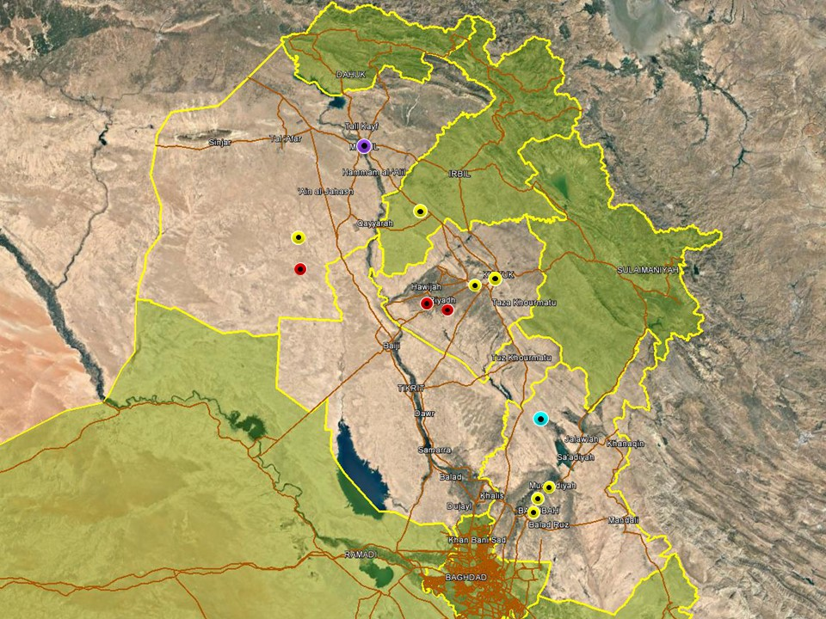

Further corroborating reports of increased IS activity in northern Iraq, two civilians were killed and at least six others wounded when a VBIED detonated in Muthanna neighbourhood in east Mosul on March 06. The vehicle was parked in front of a restaurant and detonated in the evening on March 08. No group claimed immediate responsibility for the attack, but security officials attributed the attack to IS and the incident is characteristic of IS’ modus operandi. This is the second VBIED to target east Mosul in little over a week, following an attack near Mosul University on February 28 and as such highlights the group’s intent and capability to escalate operations in and around the city. ISF also foiled two repeated attacks involving multiple suicide bombers in areas northwest of the city in mid-February. This raises the short-term outlook for further attacks in and around Mosul and other permissive areas of northern Iraq especially in response to its imminent territorial defeat in eastern Syria which is likely to incentivize the group to stage retaliatory attacks.

In another notable incident this week, a PMU convoy was targeted in a large-scale ambush by IS while transiting in Makhmour district on March 06, killing six PMU members and injuring another 31 according to the Security Media Cell of the ISF. The PMU were predominantly Shia Turkmen transiting from Mosul to Tuz Khourmatu. The next day, a delegation of the General Security Directorate of the PMU arrived in the district and launched an investigation to determine the circumstances of the incident. The number of IS members involved in the ambush is still not clear, but the group claimed responsibility for the incident. Local, unconfirmed reports also indicate that the PMUs were unarmed at the time of the attack and affiliated with the Sadrist Peace Brigades.

A typical reporting period was noted in Kirkuk province, with continuing levels of IS activity concentrated in the southwestern areas of the province around Hawijah district. A federal police officer was killed when an IED detonated near a patrol in the district on March 02 and on the same day clashes were reported nearby between PMU forces and IS in the district. ISF also continued to carry out security operations in the southwest during the week, including around al-Rashad sub-district. In Daquq district, Oil Protection Force members were reportedly involved in a gunfight with oil smugglers in the vicinity of Jambour oilfield on March 05. The assailants reportedly managed to escape after an unsuccessful arrest operation which according to media reports failed when they ran out of ammunition.

In Salah al-Din, PMU forces announced the start of a preventive security operation around Samarra City ahead of the commemoration of Imam al-Hadi, the tenth Imam, on March 10 when large numbers of Shia pilgrims are expected to visit the al-Askari Mosque. As with all Shia festivities, the commemoration is associated with heightened IS’ intent to stage signature attacks against Shia civilians. Activity in Salah al-Din was otherwise confined to the eastern border areas with Diyala province, where ISF security operations continued to target IS cells in the area. Iraqi airstrikes were also carried out in the districts of al-Koush and al-Aura, northeast of Samarra, targeting and destroying an IS hideout on March 06.

No significant changes were noted in Diyala province where high levels of hostile activity continue in Diyala River Valley. Multiple, separate SAF attacks were recorded in the districts of Abu Saida, the Waqf Basin and Muqdadiyah district, targeting civilians and believed to be related to a mix of IS activity and local disputes. One rocket attack was also recorded in al-Askari neighbourhood of Muqdadiyah, impacting without casualties on March 02 near a residential area. Further north, ISF operations continued in Khanaqin district, as part of an ongoing security response to increased IS activity in the region.

Anbar Province
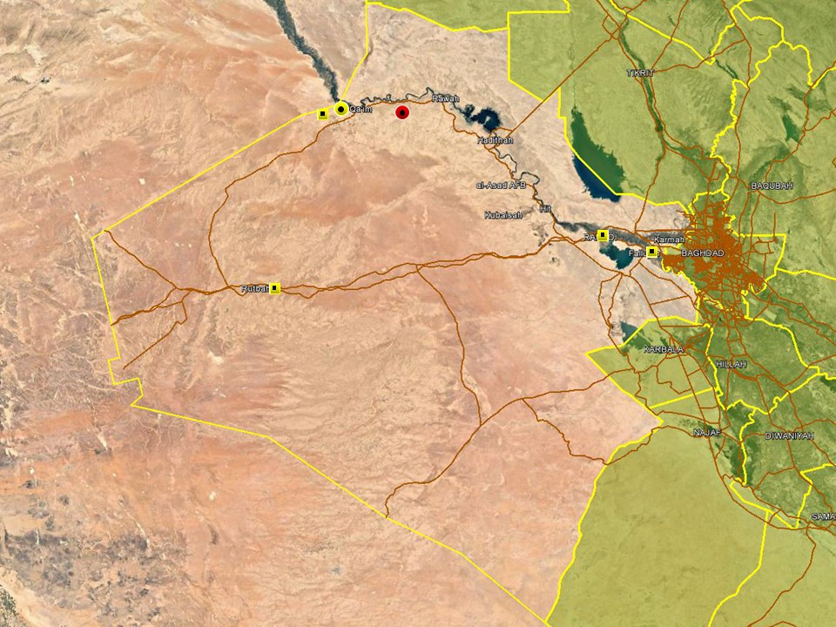

An intensification in ISF operations was noted this week in Anbar province, with multiple operations carried out in the western desert areas around Rutbah, Hit and Nukhaib, targeting IS cells operating in these areas. The Iraqi Army has also distributed leaflets to the population of the province, warning citizens not to venture into the desert given ongoing military operations in response to increased IS activity. Media reports did not specify whether any specific areas were mentioned but current operations have focused on the districts of Nukhaib, Rutbah and Hadithah, and shepherds in these areas have been encouraged to relocate towards population centres.

Activity in eastern Anbar was subdued in terms of hostile activity, with only minor attacks recorded around Fallujah and likely related to local disputes rather than terrorism. Multiple arrest operations were also carried out in Ramadi and Fallujah targeting criminal activity.

Capital Region (Including Baghdad City)

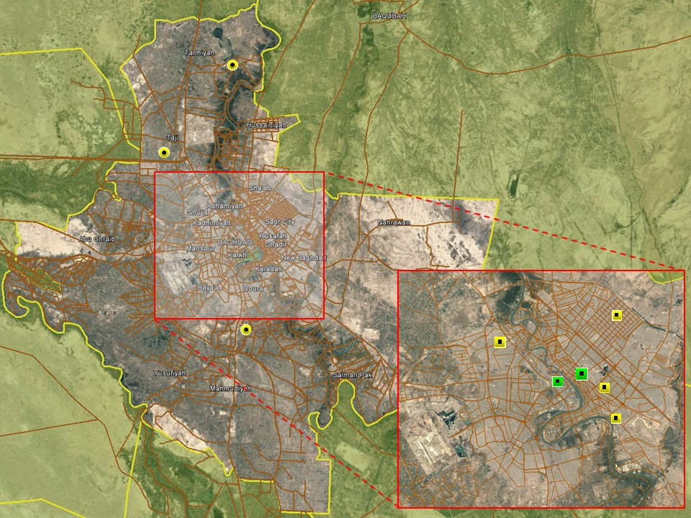

Another calm reporting period was noted in Baghdad City and in the provincial areas, with no significant hostilities recorded. As usual, hostile activity in Baghdad city comprised low-level activity driven by local disputes and predominantly confined to less affluent areas associated with high levels of violence. For example, one civilian was wounded when an argument escalated to a gunfight in Sadr City on March 03. Reporting was otherwise as usual dominated by arrest operations targeting criminality, with multiple raids and arrests reported in different areas of the capital during the week. No large-scale gatherings were reported but multiple minor protests took place in central Baghdad. Temporary contractors of the Independent High Electoral Commission (IHEC) demonstrated outside ECP2 of the International Zone on March 04 and held separate gatherings on Tahrir Square during the week. Employees of IHEC have been demonstrating over employment related issues several times in the past. Most are been organised by temporary contractors demanding full time employment amidst political pressure to amend labour laws to make it harder for private and public institutions to hire temporary workers. As a result, public sector employees have repeatedly staged demonstrations in Baghdad recently to increase pressure on parliament to amend the laws.

Activity in the provincial areas was as usual related to low-level hostilities and again reported in areas traditionally associated with high levels of violence including Tarmiyah, Taji and Abu Ghraib. Five ISF members were killed when one of their colleagues opened fire inside an ISF compound in Abu Ghraib on March 08. Baghdad Operations Command confirmed that one ISF member was behind the shooting and have launched an investigation to determine the circumstances of the incident

Southern Provinces

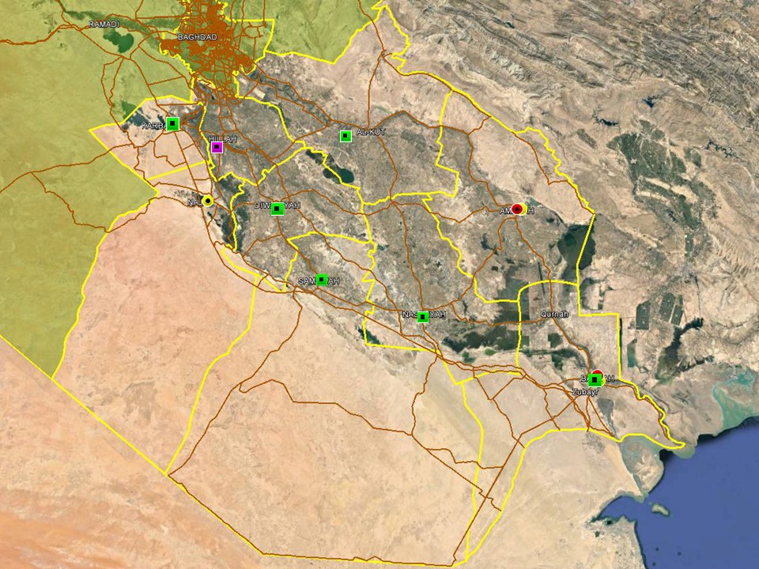

Demonstrations continue to pick up in the southern region, with multiple low-level gatherings recorded this week in the provincial capitals. The gatherings remain low-level and related to separate, local grievances, but this trend is consistent with a general increase typically seen in the southern region as spring and summer approaches In another sign of growing tensions in Basra, ISF dispersed another demonstration near the Provincial Council building on March 08, arresting three protesters who reportedly set tyres alight. The protest involved approximately 100 individuals who reiterated their demands for employment opportunities, better services and the dissolution of the provincial council. Earlier in the week, ISF used teargas to disperse a protest after some demonstrators threw stones and attempted to storm the main entrance gate

Separately, there were three violent events recorded in Basra city this week; an IED detonation resulted in property damage at the home of a Ministry of Electricity employee. The attack was likely intended for intimidation after the MoE announced that it was to re-activate last year’s project of charging for electricity provision. A second event centred on criminal elements operating within the city where a HG was thrown at a police patrol charged with apprehending know drug traffickers (three police officers were injured) and in the third incident an extremely small explosive device targeted a lawyers residence in the Shatt al-Arab.

ACRONYM LIST

AII - Area of Intelligence Interest
AKA - Also Known As
AO - Area of Operations
APC - Armored Personnel Carrier
APIED - Anti-Personnel IED
AQ - Al-Qaeda
AT - Anti-Tank
ATGW - Anti Tank Guided Weapon
AVIED - Anti-Vehicle IED
BBIED - Body Borne IED
Bde - Brigade
Bn - Battalion
BXP - Border Crossing Point
CET - Convoy Escort Team
CLC - Concerned Local Citizens
CoP - Chief of Police
CP - Check Point
C-PERS - Captured Personnel
CPX - Complex Attack (attack using multiple weapon systems)
CQA - Close Quarter Assassination/Attack
DBS - Drive by Shooting
Div - Division
DoD - Department of Defense
DoS - Department of State
DoS - US Department of State
ECP - Entry Control Point
EFP - Explosively Formed Projectile
EOD - Explosive Ordinance Disposal (Bomb Squad)
ERW - Explosive Remnants of War
FoM - Freedom of Movement
GoI - Government of Iraq
HCN - Host Country National
HG - Hand Grenade
HME - Home Made Explosive
HMG - Heavy Machine Gun
HVT - High Value Target
IC - International Community
IDF - Indirect Fire (i.e.: rockets, mortars)
IDP - Internally Displaced Persons
IEC - Independent Electoral Commission
IED - Improvised Explosive Device
IM - International Military
IOC - International Oil Company
IRAM - Improvised Rocket Assisted Mortar
IRL - Improvised Rocket Launcher
IS - Islamic State
IVCP - Illegal Vehicle Check Point
IVO - In Vicinity Of
IZ - International Zone
KIA - Killed in Action
LN - Local National/Iraqi Civilian
MAIED - Magnetically attached IED (aka UVIED)
MIA - Missing in Action
MoD - Ministry of Defense
MoF - Ministry of Finance
MoFA - Ministry of Foreign Affairs
MoHE - Ministry of Higher Education
MoI - Ministry of Interior
MoJ - Ministry of Justice

MoO - Ministry of Oil
MoT - Ministry of Transportation
MSR - Main Supply Route
NFDK - No Further Details Known
NGO - Non-Governmental Organization (aid/charity)
NSTR - Nothing Significant To Report
OCG - Organized Crime Group
OPF - Oil Protection Force
PAX - Person, Persons or Passenger
PBIED - Person-Borne Improvised Explosive Device (UN Term)
PMF – Popular Mobilisation Forces
PoI - Point of Impact (for IDF)
PoO - Point of Origin (for IDF)
PSAF - Precision Small Arms Fire
PSC - Private Security Company
PSD - Private Security Detail
RCIED - Remote-Controlled IED
RPG - Rocket Propelled Grenade
RTA - Road Traffic Accident
SAF - Small Arms Fire
SAFIRE - Surface to Air FIRE
SF - Special Forces
SVBIED - Suicide Vehicle Borne IED
SVEST - Suicide Explosive Worn Vest
TCN - Third Country National
TCP - Traffic Control Point
Technical - An improvised weapon-mounted pick-up truck
TTP - Tactics, Techniques and Practices
UVIED - Under Vehicle IED
UXO - Unexploded Ordnance
VBIED - Vehicle Borne IED
VCP - Vehicle Checkpoint
WIA - Wounded in Action

GARDAWORLD INFORMATION SERVICES

From our management offices and field offices in strategic locations our constant monitoring of the high-risk environments in which we work is conveyed through our range of .Xplored™ risk analysis reports. The reports contain detailed updates, delivering current and relevant ground-truth information to assist both our personnel and our clients in their decision-making.

Our wider risk management solutions provide members of the defense, diplomatic, development, oil & gas and infrastructure sectors operating in potentially high-risk and complex environments with a comprehensive range of risk analysis, intelligence, crisis response, and training services. These services are designed to provide clients with the proactive capability to remain aware in potentially hostile environments and identify risks while strengthening their reactive capacity in emergency situations.

Our current regular reporting geographies include: Nigeria, Mali, Libya, Iraq, Afghanistan and Yemen on a daily, weekly, fortnightly, and monthly basis.

Through our constant monitoring and predictive threat analysis our Information Services team help you plan for, manage, and respond to risks.

For more information on our .Xplored reports or for information about our special-to-task reports tailored to individual client requirements, please contact us: informationops@garda.com or contact our regional representative iraq.ram@garda.com (Mobile: +964 7823 783 972)

For more information on how our services can support your business in Iraq contact:
Daniel Matthews, Senior Director Iraq daniel.matthews@garda.com

GARDAWORLD

A global leader in comprehensive security and risk management

GardaWorld International Protective Services is the international security division of GardaWorld Security Corporation, the world's largest privately owned security company with over 62,000 global staff.

We support clients in emerging, complex and high-risk markets around the world with static security, security consulting, risk analysis and reporting, crisis management and business continuity, mobile security, close protection, training and kidnap for ransom and extortion response solutions.

We work across multiple business sectors to provide protection and security for clients in the extractives, aerospace and defense, critical infrastructure, government and diplomatic and development sectors to secure employees, assets, and reputation so clients can focus solely on running daily operations and growing their business.

Discover more about the markets we serve and to learn how our international security solutions can help you contact us today: gwinfo@garda.com

Middle East
International Protective Services Headquarters
Office 2502, Tower 2, Currency House
DIFC, PO Box 482069
Dubai, United Arab Emirates

United States
1101 Wilson Boulevard
Suite 1725
Arlington, VA, 22209
United States

UK
5th Floor
1, London Bridge
London
SE1 9BG

Europe
37-39 rue des Deux Eglises
1000 Brussels
Belgium

garda.com

