The British Council Iraq is advertising an opportunity to find a suitable provider For Event Management and Communication services to manage the launching the programme in Najaf, Iraq. The event consists of a number of youth led activities to showcase the project objectives of youth and peace keeping.

For more details, please refer to the specification on the RFP.

To express an interest in the project and download the tender documentation, bidders are requested to register on our e-Tendering portal (In-Tend) hosted at https://in-tendhost.co.uk/britishcouncil Once registered, navigate the list of available opportunities until you find “Event Management and Communication services – Najaf, Iraq ” and then click the Express Interest button.”
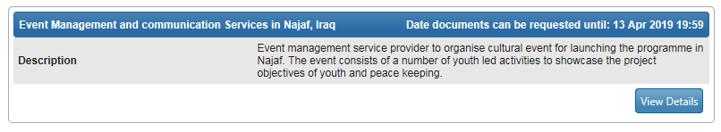
Deadline for offers submission is 13 April 2019

