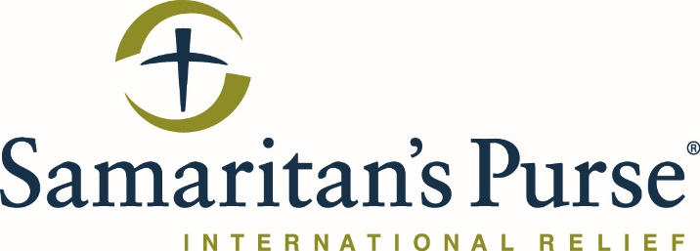

TENDER FOR Al Zab Sub-Canal Rehabilitation

This is the 1st of two tender meeting advertisements with that will be posted by SP for the Al Zab irrigation scheme rehabilitation. This tender is associated with the following code: 06302AAW34
Companies may apply to both tender advertisements, but each company must attend the meeting and site visit for each tender, and must submit two separate sealed bids. Samaritan’s Purse will not accept one single combined bid for both tenders.

NGO Samaritan’s Purse invites all suppliers to participate in tendering to the rehabilitation of the Al Zab irrigation canal system.

Brief Project Description:
Samaritan's Purse, intends to rehabilitate the Al Zab Irrigation system located in the Hamdaniya District, Nimrud Sub-District. The rehabilitation project will work on the upper, lower, and sub-canals of the system.
With this call for tender, Samaritan’s Purse intends to engage the services of a contractor to complete rehabilitation works, which includes the following type of civil works: construction of rain water drains, construction of box culverts, and repairing of damaged cement linings of upper and lower canals. The location of the project is solely along the sub, upper and lower canals in Nimrud.

Instructions:
- Attending both the meeting and the site visit will be mandatory for all interested companies. Companies that do not attend both the site visit and the meeting will not be allowed to submit a sealed bid.
- A technical meeting will be held on Thursday 2nd May at 9:00am. See below for a map location of the Samaritan’s Purse office in Qaraqosh. For directions, contact Aras Merkhael at AMekhael@Samaritan.org or 0751-656-2445.
- Immediately following this meeting, there will be a site visit.
- Following the meeting and site visit, formal BOQs will be issued as a soft copy via email to each vendor to prepare their sealed bids. Only companies who attend the meeting and conduct the site visit will receive bid documents.
- The entire meeting and site visit should take around 4 hours in total.
- Bids are to be delivered at the same location as the initial meeting at the Samaritan’s Purse office in Qaraqosh or the Samaritan’s Purse office in Erbil in Atconz, New Azadi Complex, building S10-23. For directions to the Erbil Office, please contact Samer Sanaa at SSanna@Samaritan.org or 0750-481-8179.

QQ Office location below:
