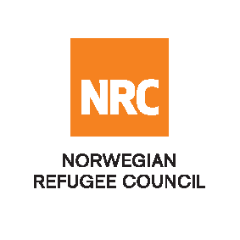

Tender Advert FWA 2019

Stationery Framework Agreement

The Norwegian Refugee Council (NRC) is a non-governmental, humanitarian organization with 60 years of experience in helping to create a safer and more dignified life for refugees and internally displaced people.

NRC advocates for the rights of displaced populations and offers assistance within the Shelter, Education, Emergency food security, Legal assistance and Water, sanitation and hygiene sectors.

NRC has been present in Iraq since 2010, with offices located in Anbar province, Baghdad, Erbil, Dohuk, Hamam Al Alil, Mosul and Kirkuk. We have scaled up our response across Iraq to meet the large-scale crisis facing the country, reaching Iraqis with emergency assistance and supporting Syrian refugees as they live in exile. Our goal is to always be prepared to work in new settings, so we are establishing more local partnerships in Iraq.

The Norwegian Refugee Council (NRC) Office in Iraq invites eligible and interested suppliers to participate in the tender as per attached documents that will lead into Framework Agreements for at least 1 year: Refer to the table below;

Code# | Description | Tender Number
 | Contract Name: Stationery Framework Agreement | ITB/DHK/2019-003

Deadline : Tender closing is at 14:00 Hrs (Iraq time) on 4th June 2019

NOTE! NOTE! NOTE! NOTE! NOTE! NOTE!

- If your company is interested in participating in the tender it required to pay a visit to the address below to receive tender document by hand;

Norwegian Refugee Council, Zirka Bangawan street 52 house Z007/179/009/01 Kurdistan Region, Duhok–Closed to Duhok University 2nd Gate

- Submission: For all completed bids for tender should be submitted in a sealed envelope (by hand delivery) to address above;

NRC reserves the right to select/reject any bids, in part or full, as it may deem necessary without providing feedback on this regard. No liability or claim in that respect would be admissible or entertained whatsoever. For more info contact (07515140698)

