The British Council Iraq is advertising an opportunity to find a suitable provider for Printing and Promotional material- Annual Contract
To express an interest in the project and download the tender documentation, bidders are requested to register on our e-Tendering portal (In-Tend) hosted at https://in-tendhost.co.uk/britishcouncil Once registered, navigate the list of available opportunities until you find “Printing and Promotional material Service Provider Iraq’
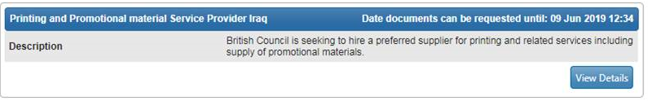

and then click the Express Interest button.

