LOT 1 – Workshop Tools

No. | Item name | Description | Quantity | Reference Picture
1 | Workshop Tool Trolley عربة ادوات الورشة | - Empty trolley dimensions Approx. (1000h x 1070w x 460d mm)  - Drawers: min. 10 drawers  - Material: Metal  - Rigid design with work top.  - Side plates with holes to attach accessories.  - Rubber corners for impact protection.  - Heavy duty transport for comfortable steering content label on each drawer or similar product. | 24
  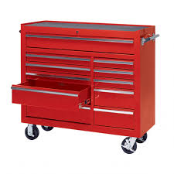
2 | Portable Engine Stands حامل المحرك | - Approx. Dimensions: 90*40*17  - Material: Steel  - Movable engine stands with a net weight of 40-60 Kg  - Capable of lifting 900-1100Kg smoothly and safely with gearbox  - Universal Fit, 4-point Universal Mounting Brackets that Fits Most Engines  - Practicality, 360º Swiveling & Locking Wheels for Easy Maneuverability and Extra Stability | 12 | 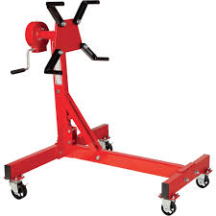
3 | Air Compressor ضاغط الهواء | - Discharge / Operating Pressure: min. 10 bar  - Dimension Approx.: 1600*575*1090MM  - Horse Power: min 10hp  - Min. 350 lt. capacity  - Belt driven single stage twin cylinder compressor. The compressor has two quick – action couplings. One coupling for regulated pressure and one for full, unregulated tank pressure | 12 | 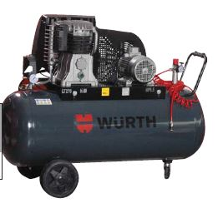
4 | Battery Charger Station  (Middle) "محطة شاحن البطارية  الوسطية" | - Input Voltage 220V.  - Instant electric current 1250A -1450 A Force start, slow and fast charge 12-24 v  - Protection device for over loading and short circuit. Display for voltage and current. Unique automatic monitor for voltage and current. Time regulation system with high accuracy.  - Double - layer bridge communication. With fast charge & slow charge (12/24). (HUA) curve silicon steel chip 100% copper core transformer. | 12 | 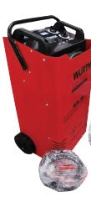
5 | Brake Fluid Tester Pen قلم فحص سائل الفرامل | - Auto Power off, 1 LR03 AAA Battery  - Size: 15-19cm Length (Approx.)  - Material: Plastic  - Weight: Approx. 150-250g | 12 | 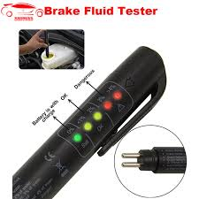
6 | Parallel Vice Swivel Large ملزمة رابطة ذات قطب متوازي كبير (منكنة) | - Bench Vice.  - All steel  Fixed / Swivel Base  Casted Iron  Painted Body approx. 6inch  - Jaw Opening: approx. 6 inch  Jaw Width: 6”.  - Approx. Dimensions: 40 x 23 x 20.6 cm | 12 | 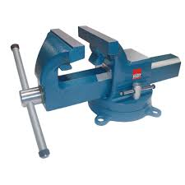
7 | Air Impact Wrench مفتاح براغي انج | - Screwdriver: approx.1 inch  - Bolt Capacity: approx. 45mm  - Max. Torque min. 1800ft.lb (2,445Nm)  - Net Weight approx.: 10.61kg  - Length approx. :537mm  - Air cons approx.: 0.85m³ /min  - Air Inlet :1/2 inch  - Air Pressure approx. :90-115 Psi  - Sound Pressure: max. 98dBA Vibration: max. 9.6m/S 2 | 12 | 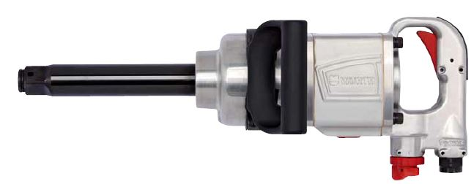
8 | Hand Pallet Jack Wide Forks جك يدوي نقال | - Approx.2 Ton load capacity  - Wide forks standard with fork width of approx. 600- 685 mm and length of 100-1.22m | 24 | 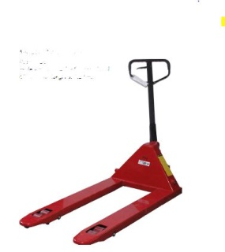
9 | Manual Hydraulic Press منصة الضاغط الهيدروليكي اليدوي | - 10 ton Stand  - Material: Iron  - Height approx.: 2-2.5m  - Width approx.: 1.2-1.6m  - Movable piston,  - overload safety valve, double speed control unit, pressure gauge,  - manual up/down control unit 10-20 ton | 12 | 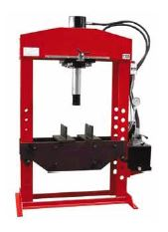
10 | Pneumatic Axle Jack جاك هوائي محور العجلة | - Two stage pneumatic jack with approx. 100-111mm height at 80ton +93mm at 50 ton and min height of 255mm | 12 | 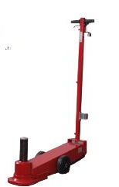
11 | Axle Stand حامل محوري | - Min. 20 Ton Heavy Duty jack stand with max height of 1.05M and minimum height of 675mm  - Dimensions: 12 x 12 x 14.5 inches | 24 | 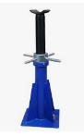
12 | Crawler Board عربة او نقال زاحفة | - Capacity approx.: 140 -200 Kg.  - Weight approx.: 7-11 Kg  - Color approx.: Orange or Red  - Dimension approx.: 40-42” L 15-17” W & 4”H  - Caster wheels: min. Six Rotating Caster wheels with 3-5” Inch  - Padded seat & Headers for ultimate comfortable  - Practical gap for the tool’s storage Easy cleaning | 48 | 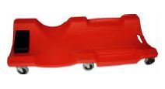
13 | Stand Drill دريل ثابت ملم | - Drill stand cast iron base, Size approx.: ᴓ43mm,  - Volts approx. / hz 230 - 240 volt / 50 hz 1000W  - Hight approx.: 1800-2000mm  - Depth adjustment scale for drilling depth 150-200mm  - Three speeds with the safety switch off | 12 | 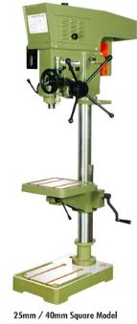
14 | Grinder كوسرة مع حمالة واط | - Approx. Volts / hz 230 - 240 volt / 50 hz RPM 2000-2800  - wattage 550W -1000W  - Bench top grinding machine complete with 200mm grinding  - wheel grade 60 and grade 30  - preferable with bench grinder stand | 12 | 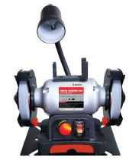

LOT 2 – Safety Equipment’s

No. | Item name | Description | Quantity | Reference Picture
1 | First Aid Kits حقيبة اسعافات اولية | First aid, middle size  This kit contains:  Scissor 1 Pc  Dettol Liquid 1 Pc  Paracel 500 Tab 1 Pc  Nicip Tab 1 Pc  Cotton 15 gm 1 Pc  Micropore 1 Inch  Betadine Point 15g  Burnell Cream 10gm  Lop amide Tab 1 Pc  Soft swab 10 cmx 10 cm  Bandage (3m/10cm) 1 Pc, with all necessary medical needs. | 24 | 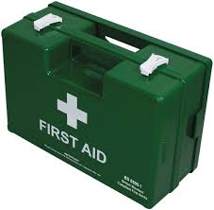
2 | Fuel fire extinguisher type مطفأة حريق امكافحة حرائق الوقود | Are fires involving flammable liquids such as fuel, size 6-12 liter with expiry date more than 1 year. The origin must be similar to EU standards or other equivalent standards. | 24 | 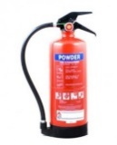
3 | Electrical fires extinguisher type مطفأة حريق امكافحة حرائق الكهرباء | Are fires caused by electricity, size 6-12 liter with expiry date more than 1 year. The origin must be similar to EU standards or other equivalent standards. | 24 | 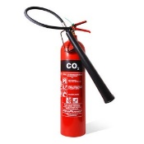

LOT 3 – Truck Tire Equipment’

No. | Item name | Description | Quantity | Reference Picture
1 | Truck Tire Changer مغير اطار الشاحنة | Portable console, for wheel with a max Diameter of 1.5M wheel width up to 1M, 8.5 thickness rein forced plates on the lifting arm 130-150 bar,  Rim diameter 14 inch to 26 inches. | 12 | 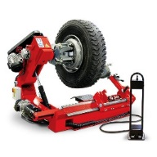
2 | Truck Wheel Balance موازن عجلة الشاحنة | Tier lifter. Have 3 kinds of ALU mode and STA mode, two different function for cars and trucks 1.2M max width of 512mm  Power Supply: 220V  Wheel weight: 100-160kg  Imbalance Resolution: ±1g/±10g  Working ambient: 5°C-40°C  Noise: <70db. | 12 | 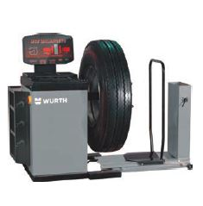

Remarks
- Bidder can apply for all LOTS or One LOT individually.
- Minimum 1 years warranty period for all goods are required. Please specify.
- All reference pictures are not an indication for any specific brand but only to understand the description.
- All dimensions and physical characteristics are approximate not exact.
- Supplier must submit Technical Data Sheet / catalogue or brochures of offered product (Please specify the exact model).
- DAP, Baghdad (Iraq).

