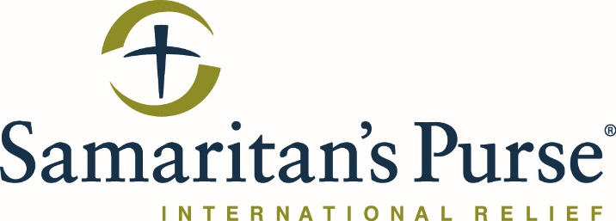

TENDER FOR Erbil Base lunch contract

NGO Samaritan’s Purse invites all suppliers to participate in attending this tender meeting and submit a bid for consideration.

Brief Project Description:
Samaritan's Purse works in numerous areas all around the KRG and GOI. This tender specifically applies for the Base of operations in Erbil only. This tender meeting will be to explain what SP is looking for in a company or companies who will be awarded the bid.
Instructions:
- Attending the meeting will be mandatory for all interested companies. Companies that do not attend the meeting will not be allowed to submit a sealed bid.
- A technical meeting will be held on Thursday 27 June at 9:30am. See below for a map location of the Samaritan’s Purse Country Office in Erbil in Atconz, New Azadi Complex, building R2-16. For directions, contact Sargon Benjamin at SBenjamin@Samaritan.org or 0750-465-2495.
- Following the meeting, formal RFQs will be issued as a soft copy via email to each vendor to prepare their sealed bids. Only companies who attend the meeting will receive bid documents.
- The entire meeting should take around 1 hour in total.
- Bids are to be delivered to the Samaritan’s Purse Operations Office in Erbil in Atconz, New Azadi Complex, building S10-23. This is approximately 100m from the Country Office. For directions, contact Sargon Benjamin at SBenjamin@Samaritan.org or 0750-465-2495.

Erbil Office location below:
