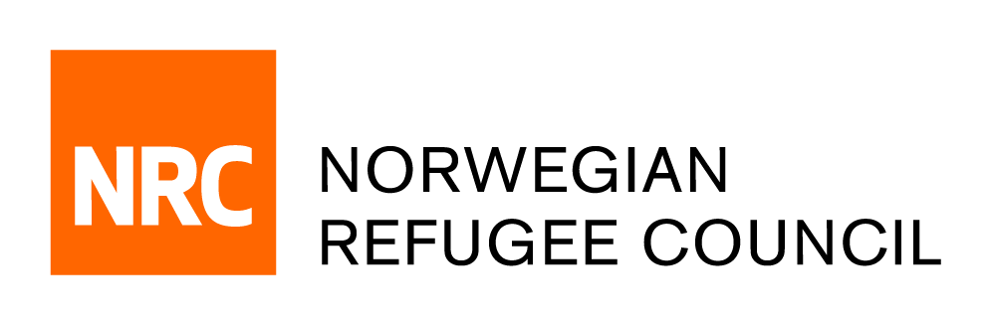

Tender Notice

Invitation to Tender for the provision of consultancy services
to evaluate OFDA projects
IRAQ/ITB/2019/004

NRC – IRAQ office is soliciting bids from companies or Individual Service Provider for the provision of consultancy services to evaluate OFDA projects

OFDA awarded $9 million to NRC for a 12 month multi-sector, multi-location project which started on 1st October 2018. The goal of the project was to meet the immediate and recovery Shelter, WASH, Information and Coordination needs of vulnerable IDPs, returnees and host community in both camp, and non-camp settings in Ninewa, Kirkuk, and Anbar Governorates.

In order to respond to the arising needs of a portion of the conflict-affected population in Iraq, NRC targeted conflict-affected women, men, girls and boys in urban and peri-urban settings with an integrated response combining Shelter upgrades, Camp Management, and site maintenance, WASH and Community Centre Programming in Anbar, Ninewa and Kirkuk governorates. The Shelter upgrade approach was designed to support the rehabilitation of damaged shelters by providing the technical, financial and material means to rehabilitate shelters in Anbar, Ninewa and Kirkuk governorates. Under WASH the activities focused on Environmental Health, Hygiene Promotion and Water Supply sub-sectors in the same governorates and targeted areas as the shelter programming in Anbar. Additionally, NRC continued to implement OFDA funded Urban Displacement Out of Camp (UDOC) response through activities conducted from the Community Centres (CC) in Ramadi and West Mosul (Anbar and Ninewa Governorates respectively) which were set up under previous OFDA funded action and NRC coordinates with the national framework for National Community Return Centres (CRC) in coordination with the Government of Iraq

The primary purpose of the evaluation is inform organisational learning while the second objective is accountability to donor and to establish if the project has met its intended goals and outcomes.

Obtain of Tender package:
Complete tender documents can be obtained by e-mail, free of charge from the 25th of July 2019 until the closing date on the 08th of Aug 2019. The tender documents should be requested by emailing:
iq.procurement@nrc.no. The email titel should clearly indicate (IRAQ/ITB/2019/004 – Consutlancy)

Deadline for the tender:
The deadline for submission of tenders is 15:00 on the 08th of August 2019. Companies who do not submit their quotation by this deadline will not be considered.

