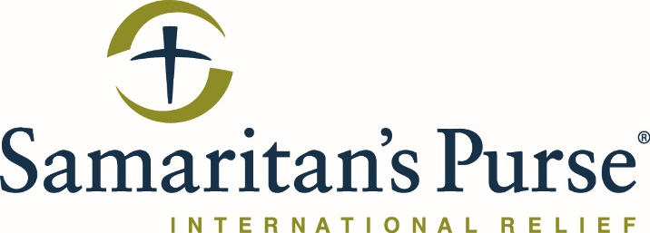

TENDER FOR TYPE-A HOMES RECONSTRUCTION

This is the tender meeting advertisement by Samaritan’s Purse for Nehemiah reconstruction project to rebuild two demolished homes.
Each company must attend the meeting to submit its sealed offer. Samaritan’s Purse will not accept any external offer without attending this meeting.

Brief Project Description:
Samaritan's Purse intends to reconstruct two homes after they were demolished by ISIS. These homes located in Bashiqa town, Mosul city, Nineveh Plains.
With this call for tender, Samaritan’s Purse is seeking companies interested in work on rebuilding two homes to be qualified for habitation with good quality materials for the families who are in need. The rebuild includes all civil, structural, electrical and mechanical works that which are listed in the BOQ which was prepared by Samaritan's Purse engineers with all the engineering design drawings and technical engineering specifications.
All companies should have experience in large scale reconstruction works.

Instructions:
- A technical meeting will be held on Sunday 1st September at 9:30am. See below for a map location of the Samaritan’s Purse office in Qaraqosh. For directions, contact David at Dastifo@Samaritan.org or 0770-044-5762.
- Attending the meeting will be mandatory for all interested companies. Companies that do not attend the meeting will not be allowed to submit a sealed bid.
- Immediately following this meeting, there will be a site visit.
- Following the site visit, formal BOQs, engineering drawings and technical specifications will be issued as a soft copy via email to each vendor to prepare their sealed bids. Only companies who attend the meeting will receive bid documents.
- All information and other details relating to work will be discussed during the meeting.
- The entire meeting should take around 3 hours in total.
- Sealed bids are to be delivered at the same location as the meeting at the Samaritan’s Purse office in Qaraqosh or the Samaritan’s Purse office in Erbil in Atconz, New Azadi Complex, building S10-23. For directions to the Erbil Office, please contact Sargon Benjamin at SBenjamin@Samaritan.org or 0750-465-2495.

QQ Office location below:
