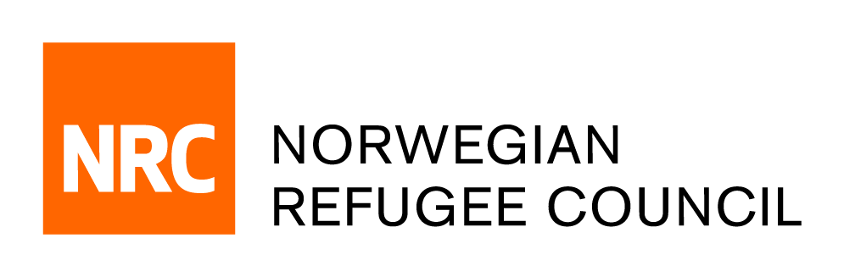

Tender Notice – Deadline Extend
for the establishment of a Framework Agreement for
Fuel supplies and services in IRAQ
IRAQ/ITB/2019/002

NRC – IRAQ office is soliciting bids from reputable Suppliers that are duly registered/licensed with the Republic of IRAQ for the provision of Fuel supplies and services.

Complete tender documents can be obtained by e-mail, free of charge from the 18th of July 2019 until the closing date on the 25th of Aug 2019. The tender documents should be requested by emailing:
iq.procurement@nrc.no

Deadline for the tender:
The deadline for submission of tenders is 15:00 on the 25th of August 2019. Companies who do not submit their quotation by hand on this deadline will not be considered.

(No quotations should be submitted to this e-mail address, any offers sent to this e-mail will be disregarded.)

