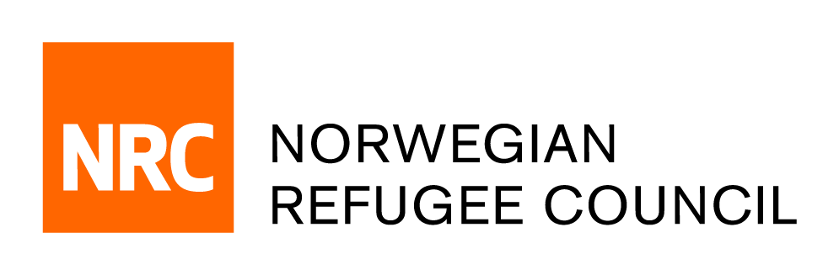

Tender Notice

Invitation to Tender for the provision of legel services for employment law issues
IRAQ/RFQ/2019/064

NRC – IRAQ office is soliciting bids from companies or Individual Service Provider for the provision of consultancy legal services for employment law issues,
NRC`s Information, Counselling and Legal Assistance (“ICLA”) programme in Basra, Iraq, includes the provision of legal support for employment law issues, particularly for people benefitting from NRC-facilitated job placement in the private sector. Under the IQFM1948 project, 100 trained low skilled job seekers, or graduates of vocational training/apprenticeship courses will be referred to private companies after skills matching to benefit from at least 6 months of job placement. The role of the legal adviser will be to develop and monitor contracts, letters or agreements, or MoUs; and to monitor employment conditions to ensure that beneficiaries are being treated fairly and their rights under Iraqi employment law are being respected. The adviser will also provide information on employment rights under Iraqi law to both the beneficiaries of the job placement, as well as the employment law obligations of the private employers.

Obtain of Tender package:
Complete tender documents can be obtained by e-mail, free of charge from the 27th of Oct 2019 until the 5th of Nov 2019. The tender documents should be requested by emailing:
iq.procurement@nrc.no. The email title should clearly indicate (IRAQ/RFQ/2019/064 – Legel Consultancy)

Deadline for the tender:
The deadline for submission of tenders is 15:00 on the 5th of Nov 2019. Individual/Companies who do not submit their quotation by this deadline will not be considered.

