Fixed office chair:  Low back leather office chair fixed chair. Including padded arms. Steel frame and leather seat. Total height 80cm and width of the seat 55cm. | 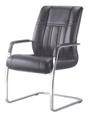
Sofa Set (10 seats):  Sofa set shall fully cushion leathered, including arms, wooden frame, webbing and injection molded PU foam. PU foam finished.  Dimensions:  - 3 seats: 200x87x 82 cm  - 2 seats: 140x87x82 cm  - 1 seat: 85x87x82 cm | 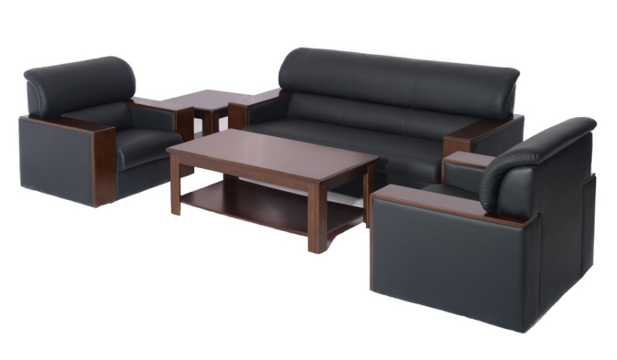
Special office desk:  Office desk wooden melamine large size L200xW90xH76 cm, including buffet small table and mobile storage unit with 3 drawers. | 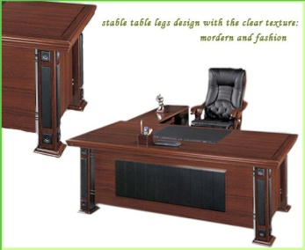
Office desk:  Melamine wood office desk. Dimensions W140xD80xH75cm. | 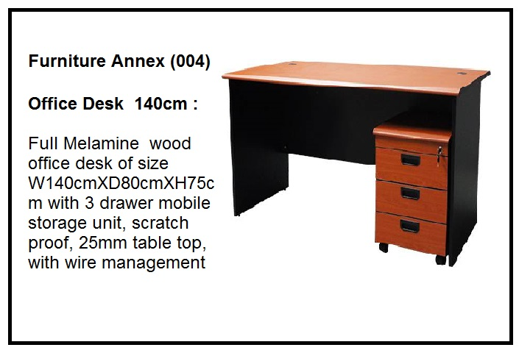
Swivel chair:  Low back leather swivel office chair, padded arms, adjustable seat height and 5 double wheel casters for easy movement. Dimensions 118cm height and 75 cm back. | 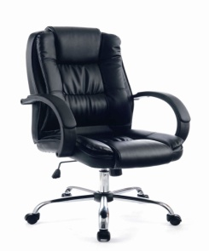
Steel Filing Cabinet:  Steel Filing cabinet 4 drawers, size W47cm X D62.5cm X H132.1cm, 0.7mm metal thickness, manufactured from prime quality cold rolled coil annealed mild steel, fitted with lock and 2 keys. | 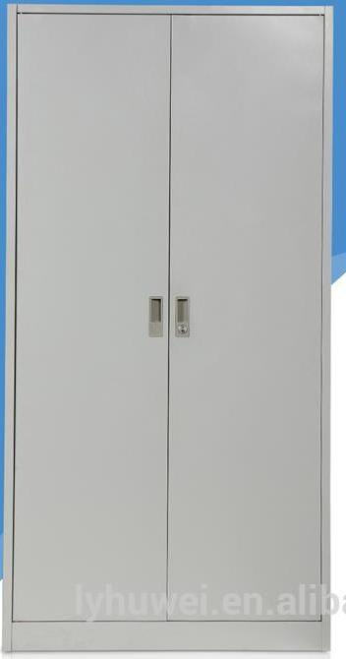
Curtains:  Supplying and installation of sliding curtains (type zebra), with all accessories | 