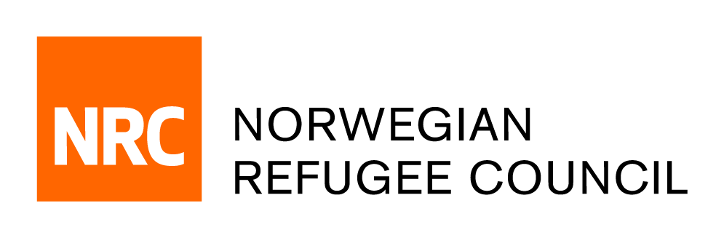

Tender Notice

Invitation to tender for the provision of ‘External Evaluation of NRC Teachers in Crisis Contexts Projects’ services in IRAQ
IRAQ-ITB-2019-011

NRC is currently seeking companies or Individual Service Provider for the provision of consultancy services to evaluate the Teachers in Crisis Contexts Teacher training projects. NRC started providing teacher training to education personnel, including teachers, lecturers, unpaid volunteers and NRC incentive teaching staff in 2017, using the Teachers in Crisis Context (TICC) training package which was contextualized for Iraq in 2015 and endorsed by the National Education Cluster, the Ministry of Education of Iraq (MoE) and the Inter-Agency Network for Education in Emergencies (INEE). The TICC training package was first rolled out to the NRC education team in Dohuk and Erbil in 2017, followed by the teams in Mosul and Anbar.

In 2017 and 2018, NRC focused on providing TICC training to NRC incentive teaching staff who provided non-formal education classes to refugee, IDP, and returnee children. It was only in mid-2018 that NRC began providing TICC training to formal schoolteachers, lecturers, and volunteer teachers. NRC typically provides TICC training in tandem with NRC’s psychosocial support training, the Better Learning Programme (BLP). Together they are usually implemented in a six-day training course that is either implemented back to back or where possible spread out over the course of a number of months. Post training support included lesson observations, teacher feedback and mentoring as well as the establishment of teacher learning circles. When training NRC incentive teaching staff, the education teams are able to monitor the training outcomes, while for formal schoolteachers, there is limited ability to reinforce training topics after the conclusion of the training. To date, NRC has provided training to over 1,400 formal school teachers, lecturers, volunteer teachers and NRC incentive teaching staff in Ninewa, Dohuk, Erbil and Anbar Governorates of Iraq. To this end, NRC seeks the services of an external evaluator to review the impact, relevance, effectiveness and sustainability of teacher professional development support in in NRC education projects in Iraq.

To this end, NRC is seeking consulting companies to conduct an external programmatic evaluation of the programmes implementing the Teachers in Crisis Context training package in Iraq. The evaluation will review all programmes implemented by NRC in Anbar, Ninewa, Dohuk and Erbil between 2018 and 2019. A final external evaluation report is expected to be submitted no later than 15th February 2020. The full tender package can be obtained as per the details below:

Obtain of Tender package:
Complete tender documents can be obtained by e-mail, free of charge from the 2nd of Nov 2019 until the 17th of Nov 2019. The tender documents should be requested by emailing:
iq.procurement@nrc.no. The email title should clearly indicate (IRAQ-ITB-2019-011 – Education External Evaluation Consultancy).

Deadline for the tender:
The deadline for submission of tenders is 15:00 on the 17th of Nov 2019. Individual/Companies who do not submit their quotation by this deadline will not be considered.

